

New Zealand Diploma in System Administration Level 6

# **IAC601: Infrastructure as Code**

# Assessment/Aromatawai - Assessment 1 Version 1 Credits 12

# Practical Assessment

|  |  |  |  |
| --- | --- | --- | --- |
|  | Submission | FER1 | FER2 |
| Result | Click or tap here to enter text. |  |  |
| Date |  |  |  |
| Assessor’s Signature |  |  |  |

|  |  |
| --- | --- |
| Student Name | Sanjay Bhatia |
| Student ID | AEU3000128 |
| Student Signature | S. Bhatia |
| Assessor | Mr. Syed Hafiz. Hussain |

|  |
| --- |
|  |
| Click or tap here to enter text. |

|  |
| --- |
| FER1 |
| Click or tap here to enter text. |

|  |
| --- |
| FER2 |
| Click or tap here to enter text. |

Click or tap here to enter text.

# Part 1 – Silent Deployment of Operating System and Applications for Media Labs

## Task 1: Planning for Pre-Deployment Processes

### Task 1.1

**Preparing the Deployment Environment**

We begin by installing a server machine. To do that, we open the Hyper-V Manager and create a new switch and a virtual machine for the server. Click on “Action” tab followed by “Virtual Switch Manager” from the options.

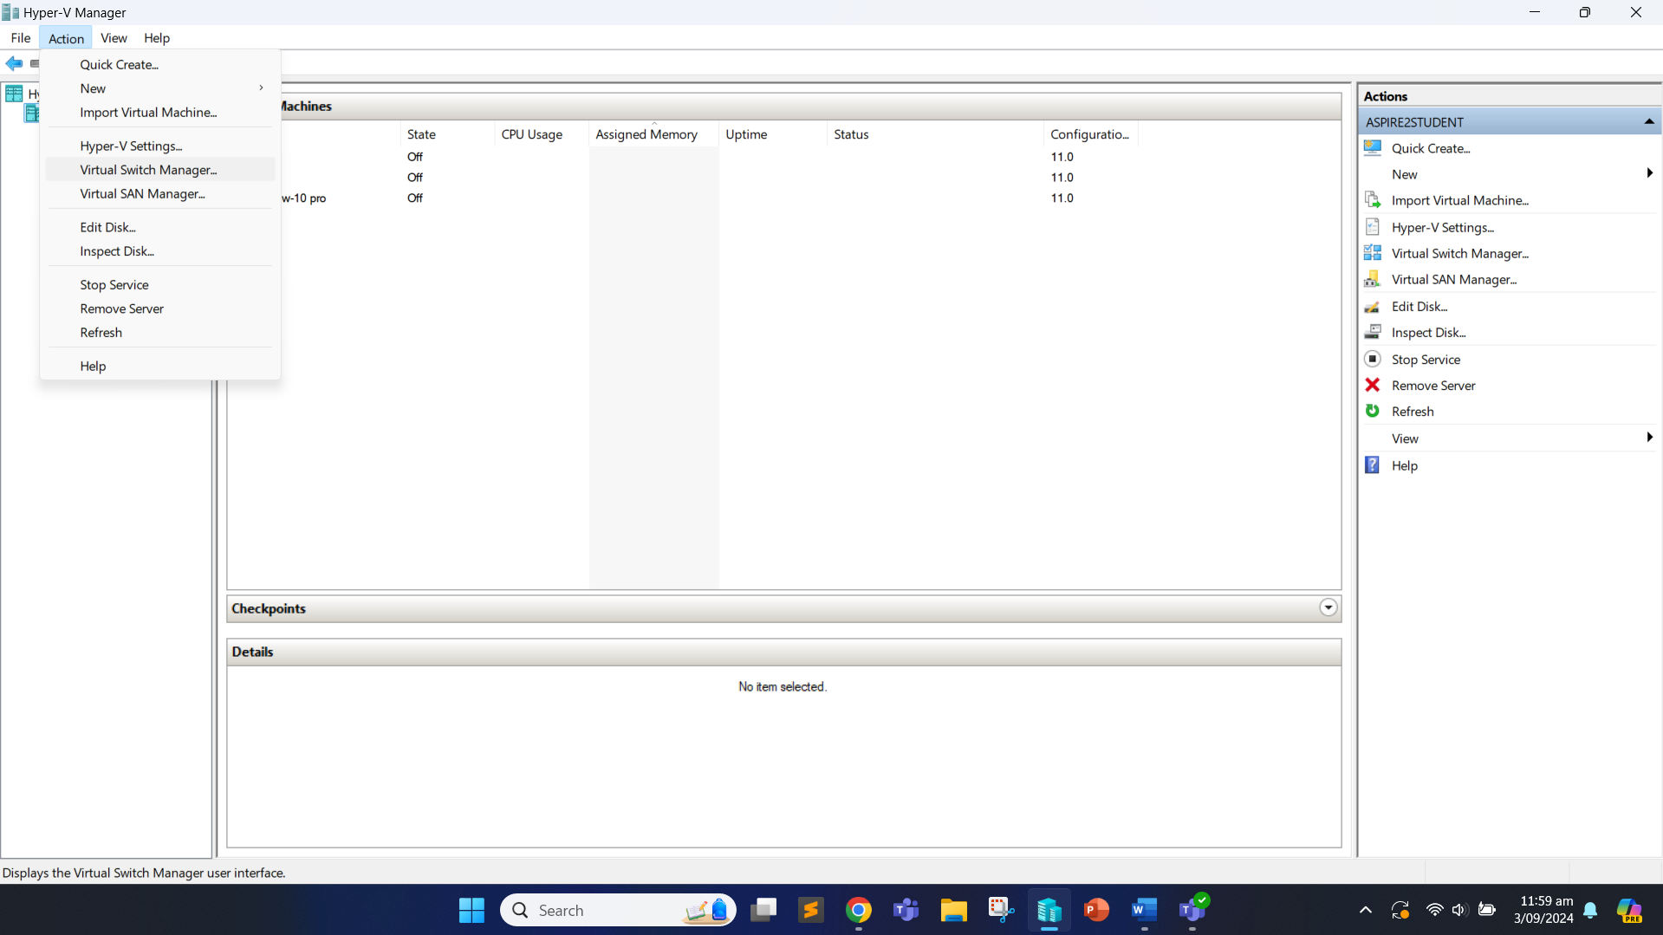

We are then prompted to choose the type of virtual switch. We will select the Internal virtual switch and click “Create Virtual Switch”.

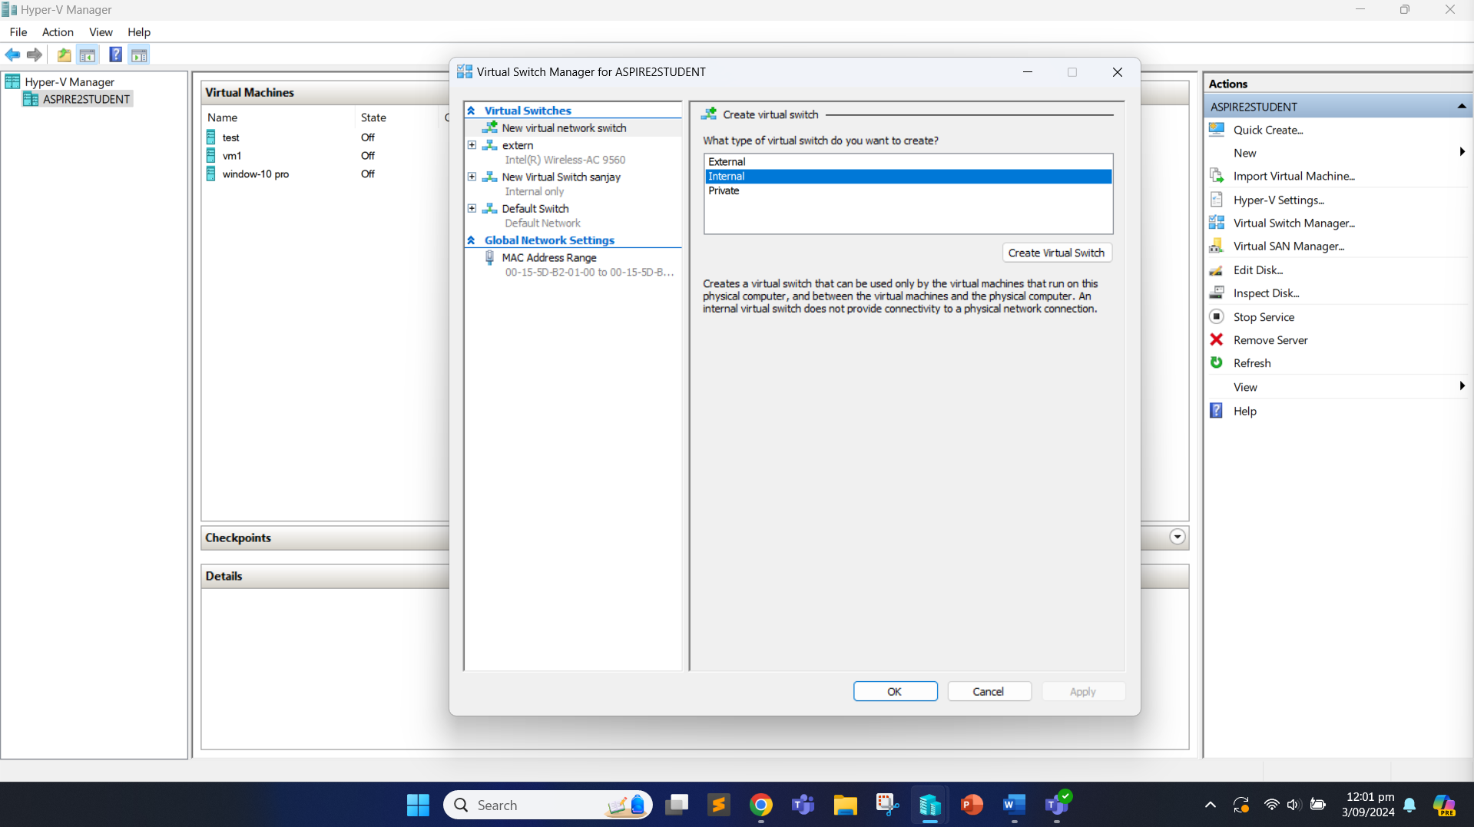

We change the default virtual switch name to “medialabs”. We then click “Apply” to rename the switch and click “OK”.

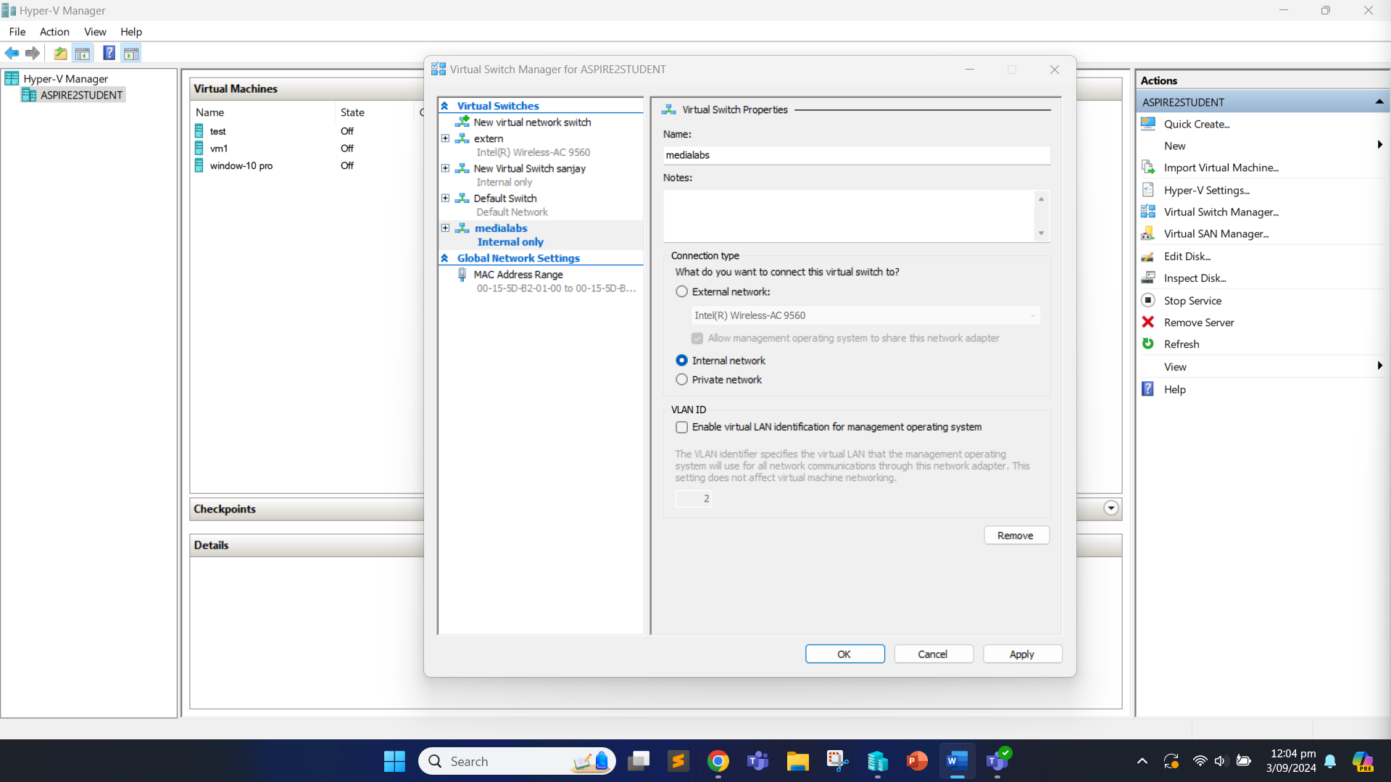

We now need to create a new virtual machine. We do so by clicking on the “Action” tab again and clicking the “New” followed by “Virtual Machine”.

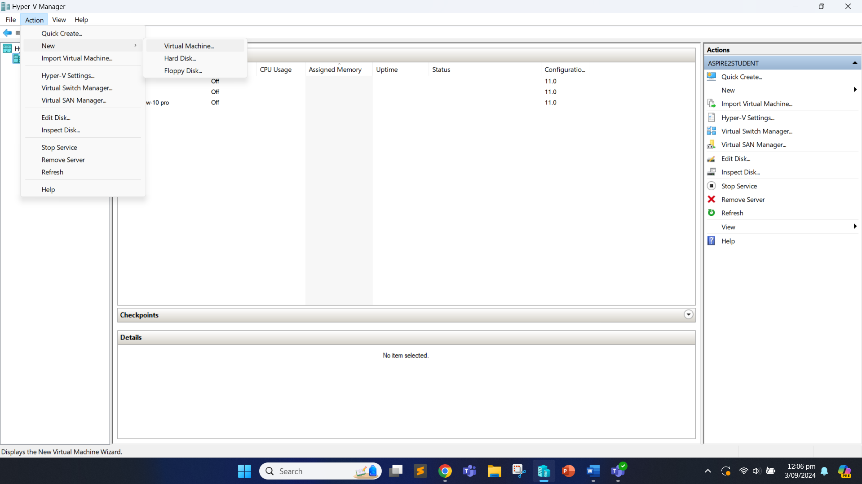

We can specify the name for our new virtual machine and click “Next”.

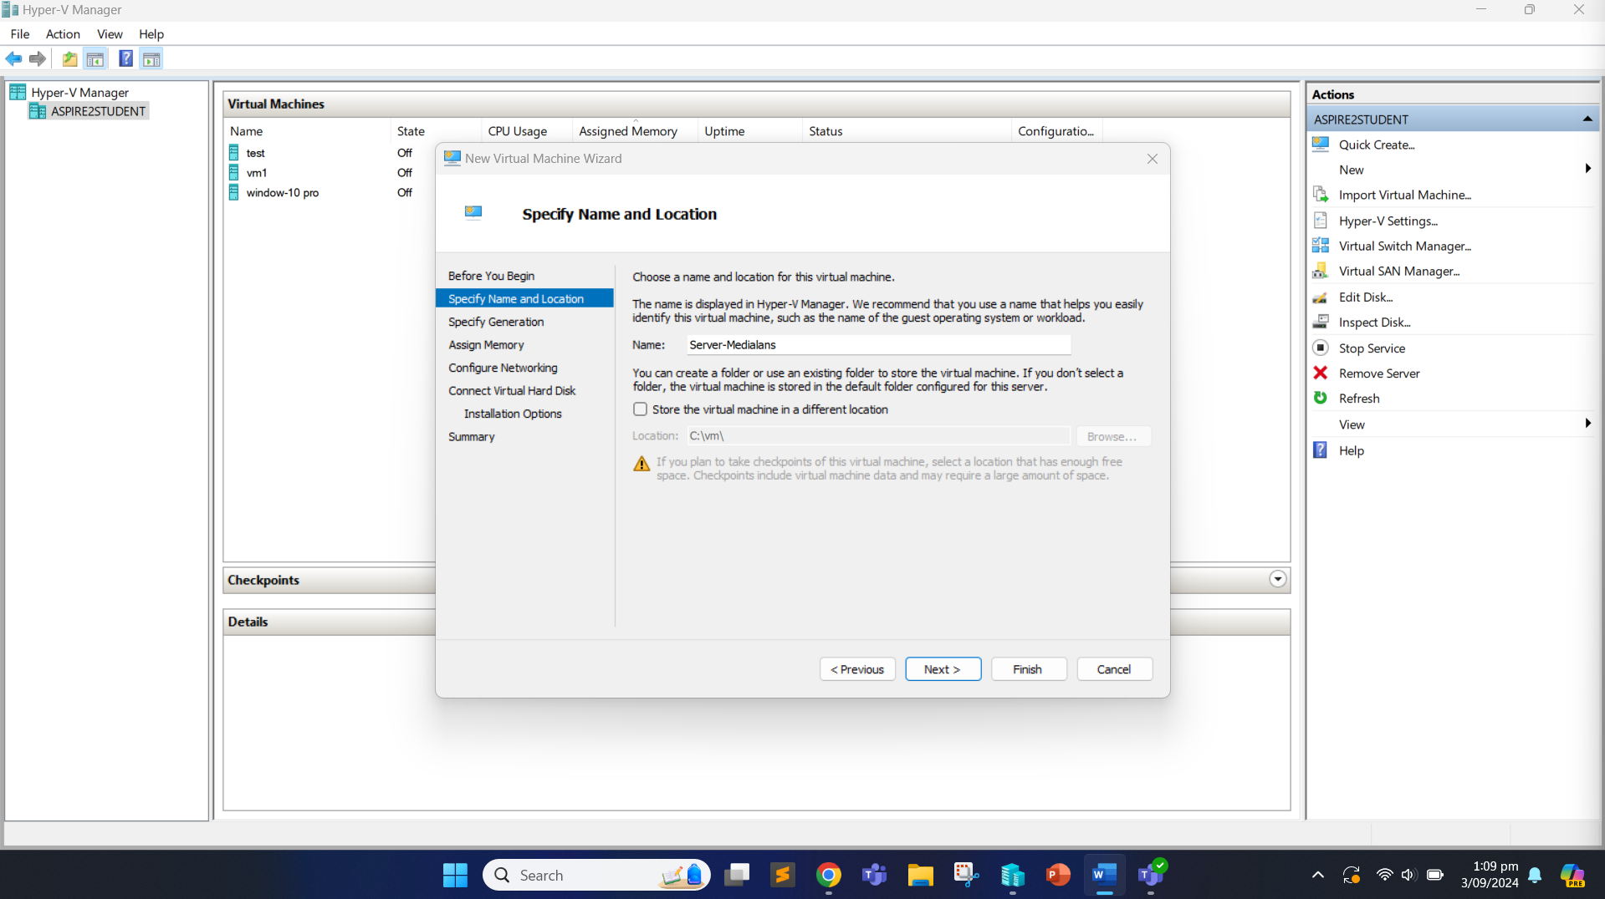

We then specify the generation of the virtual machine as Generation 2 and click “Next”.

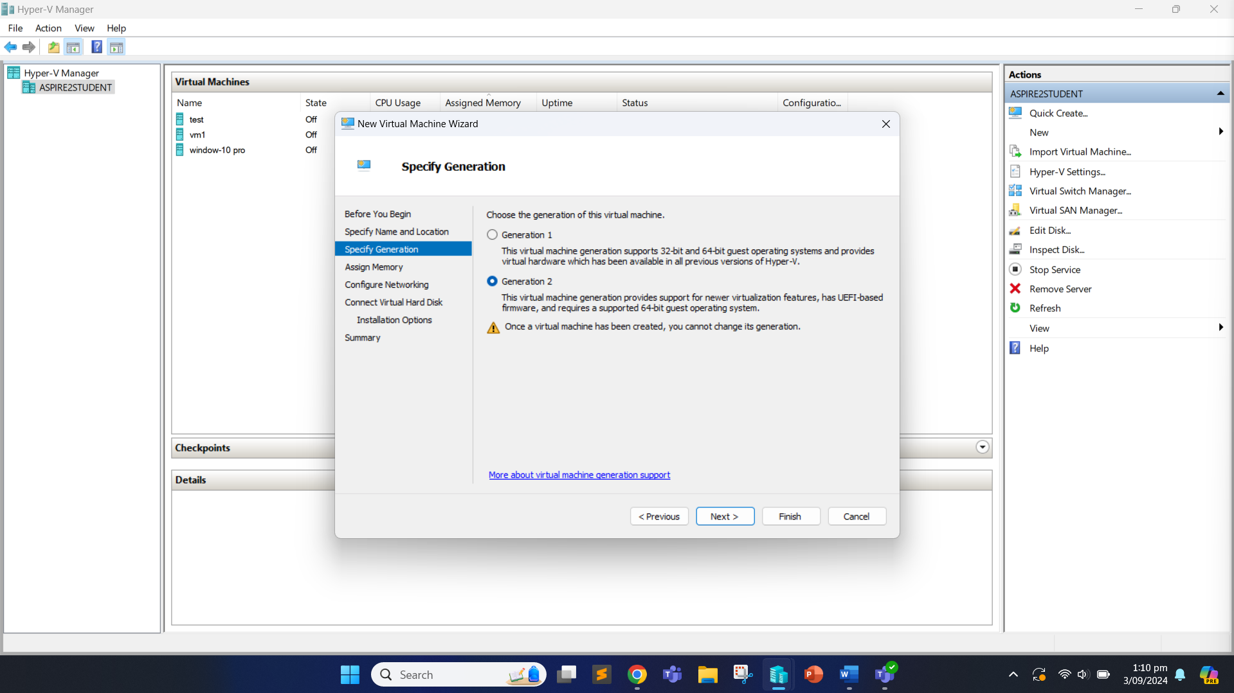

We allocate 4096MB of memory for the virtual machine and click “Next”.

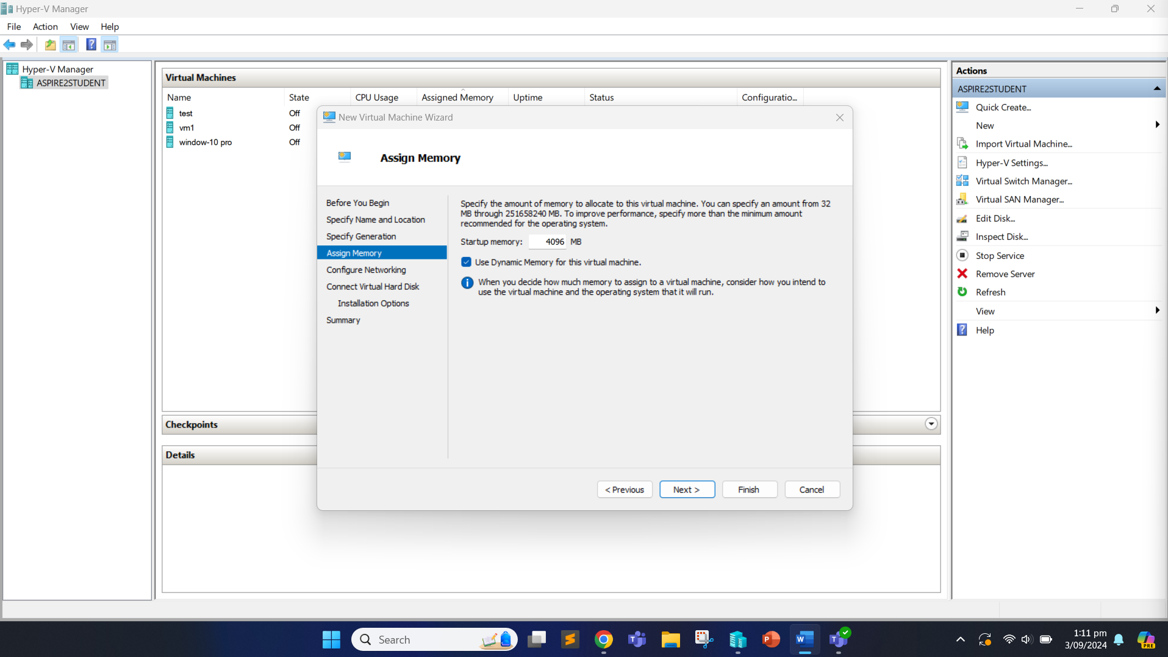

We now choose the internal virtual switch we created as “medialabs” for the network adapter.

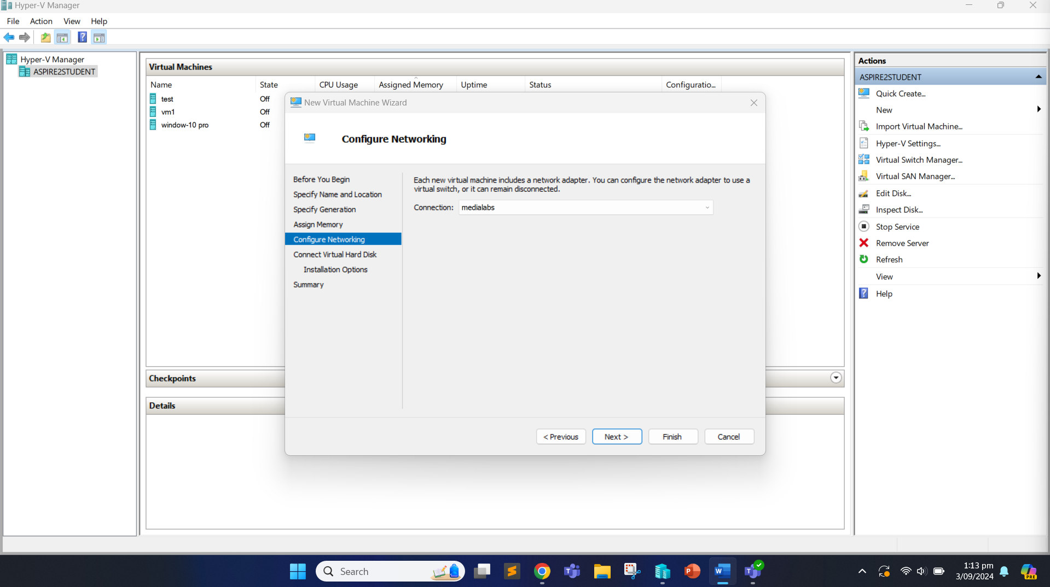

We create a virtual hard disk and allocate the size of 127GB for it and click “Next”.

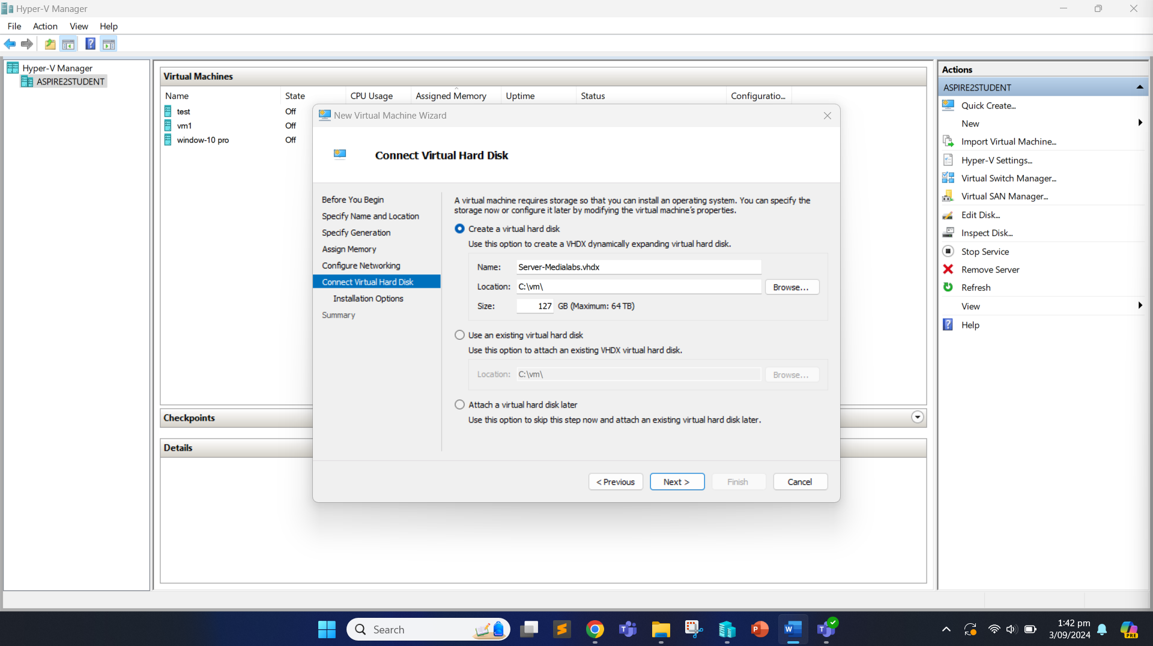

Now, we can select the image file to install an operating system from the bootable image file. We can browse the file location of the image file and load it.

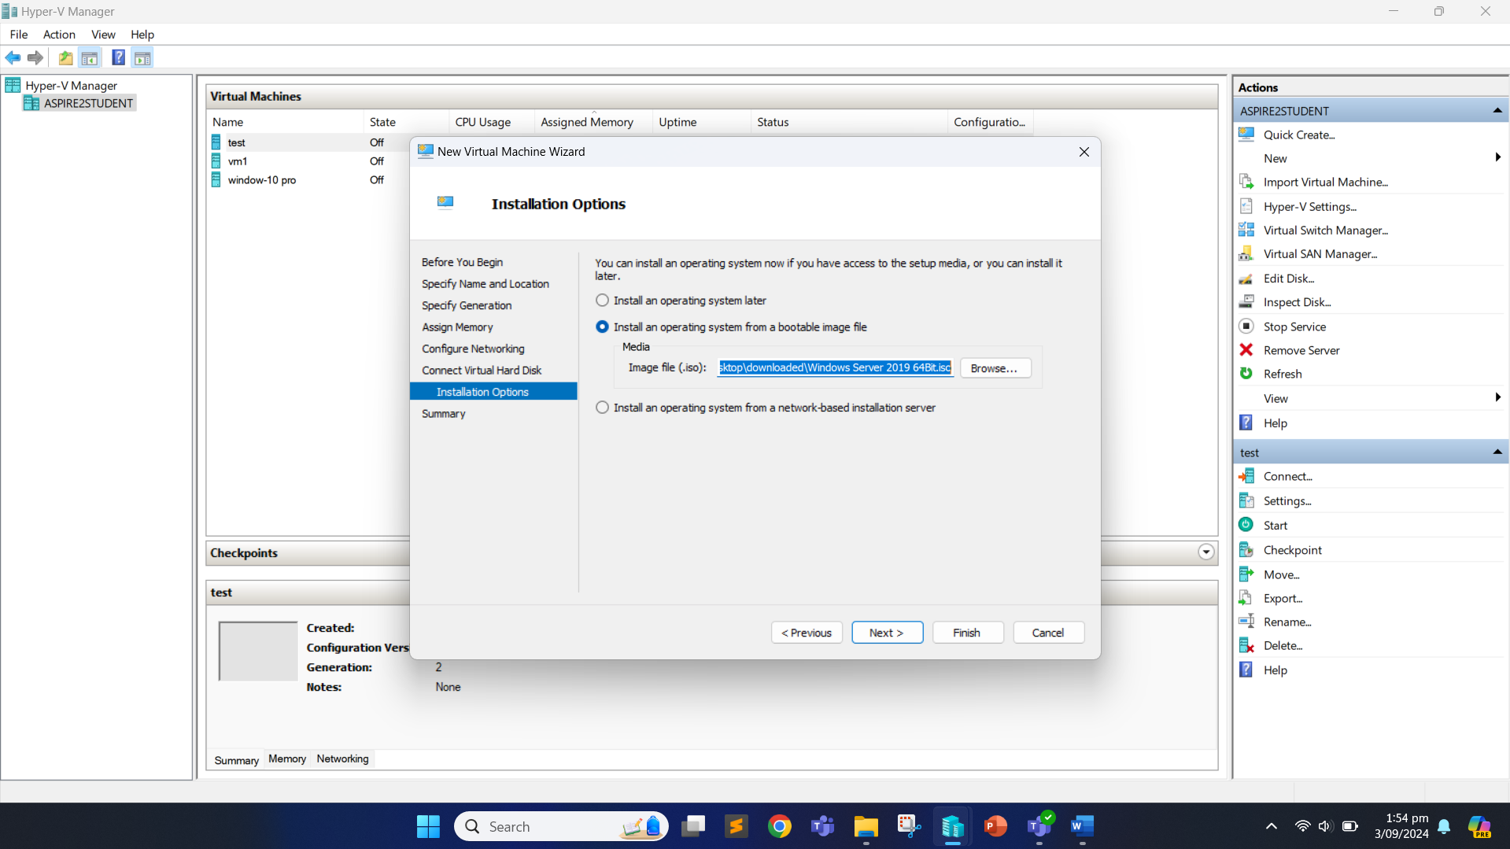

Click “Finish” and the server has been created. We now need to install the server by double clicking it.

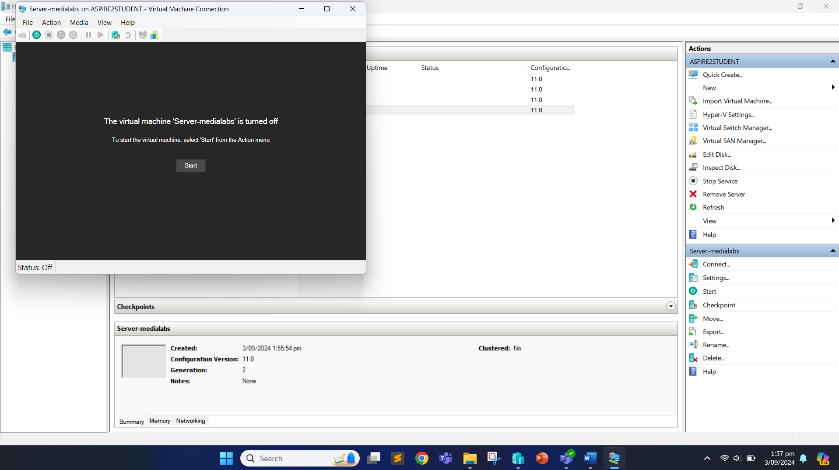

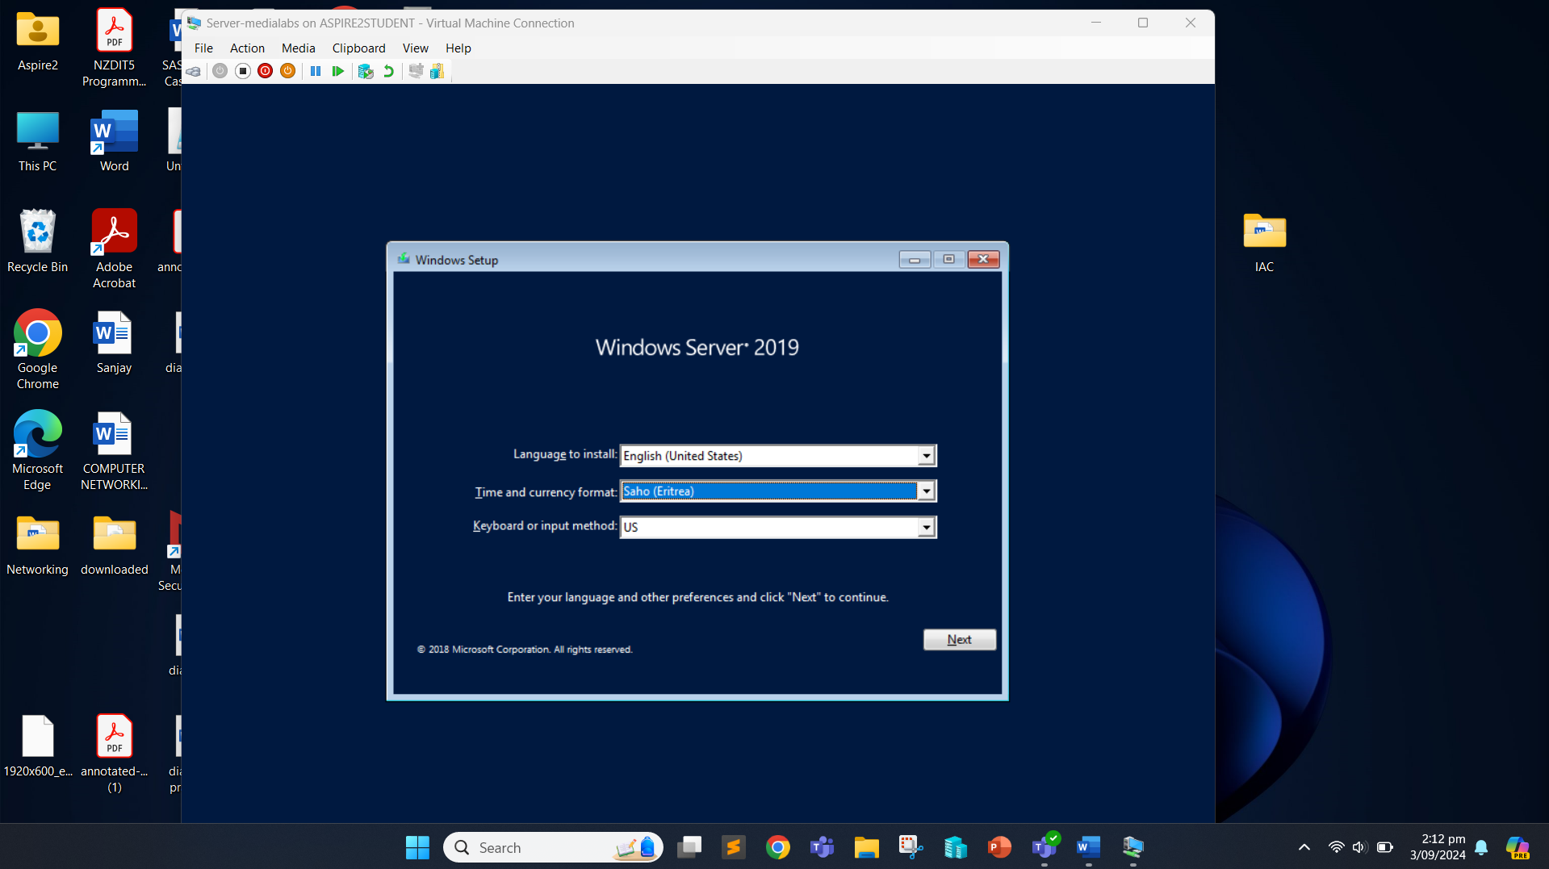

Now, click on “install Now” button.

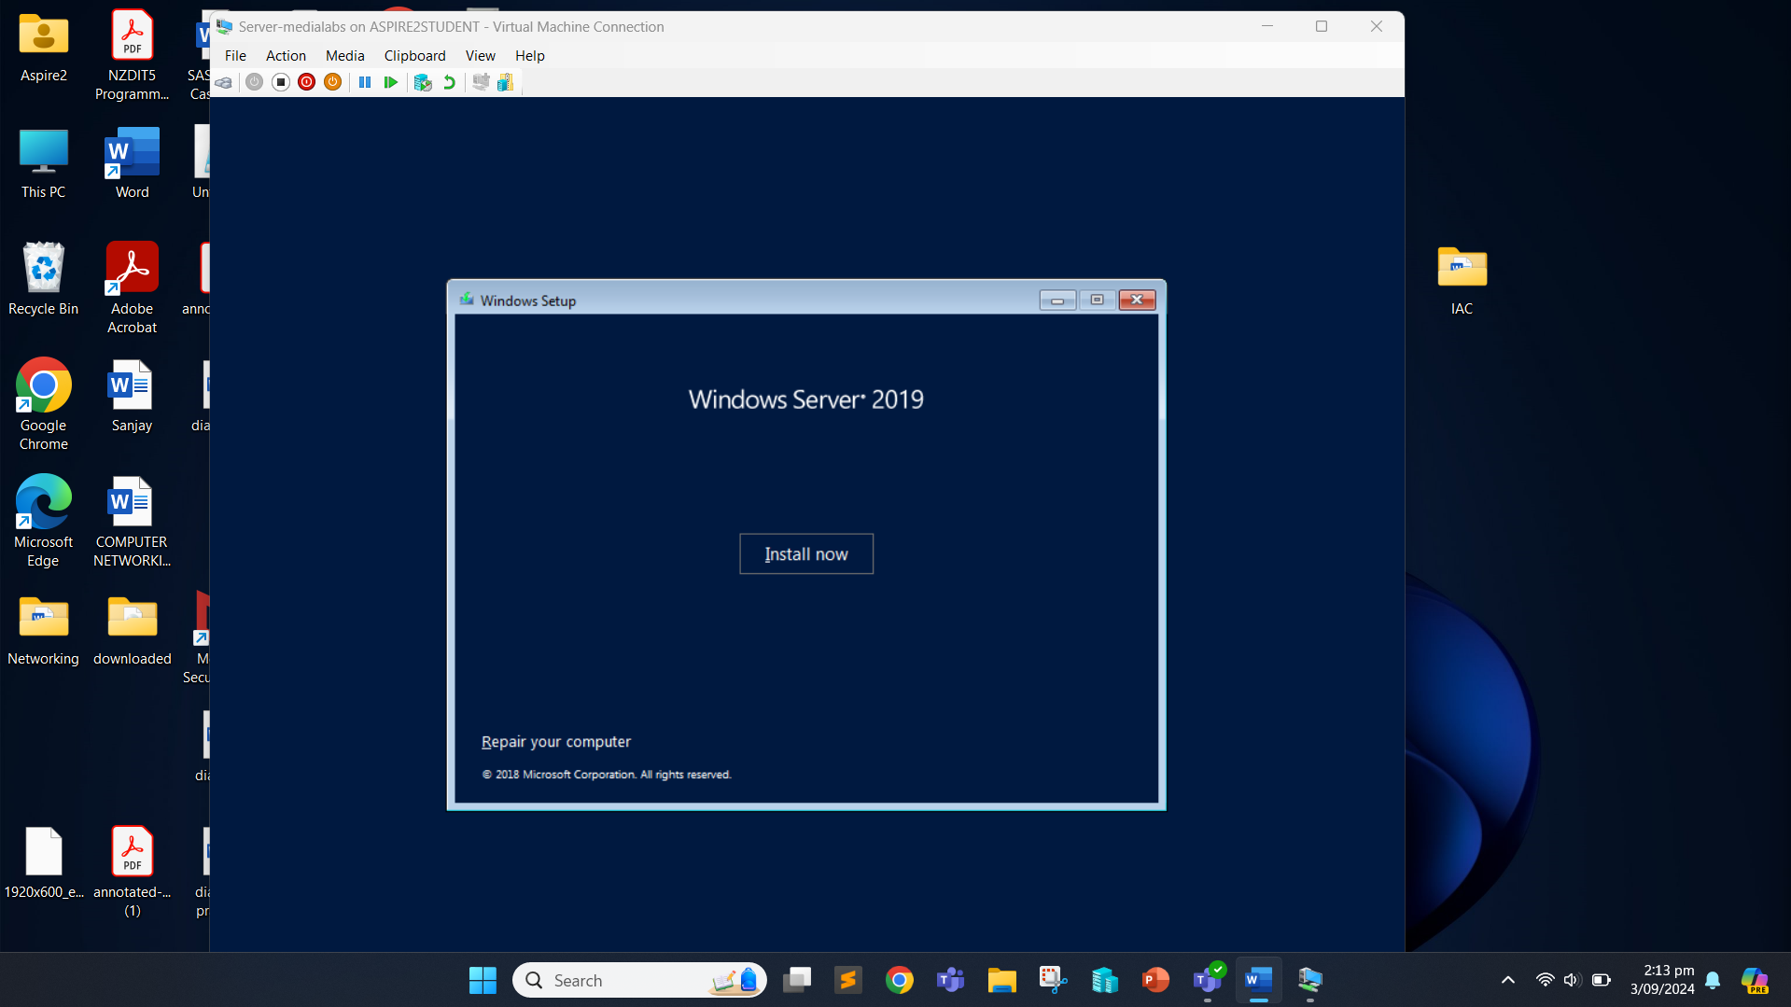

Next, we select the Windows Server 2019 Standard Evaluation (Desktop Experience) x64 and click “Next”.

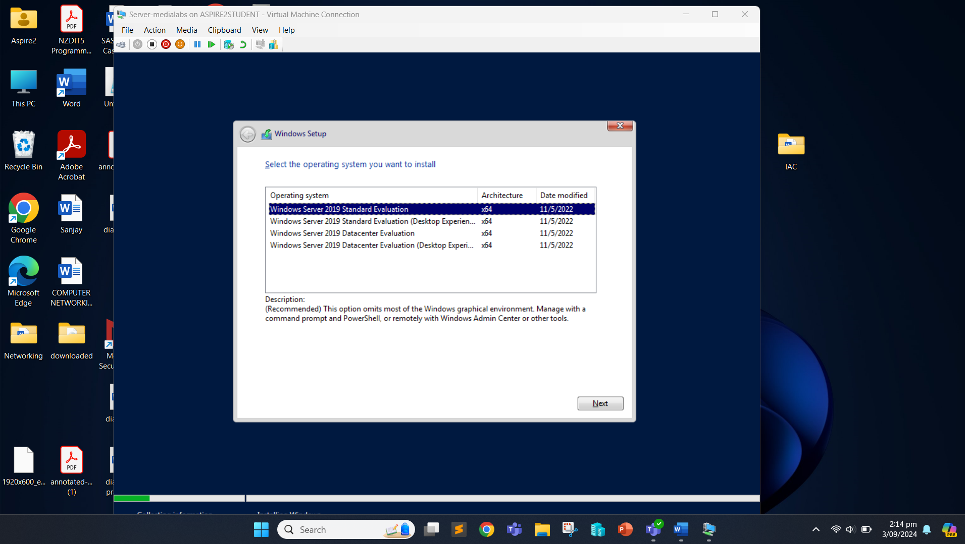

Accept the license terms and click “Next”.

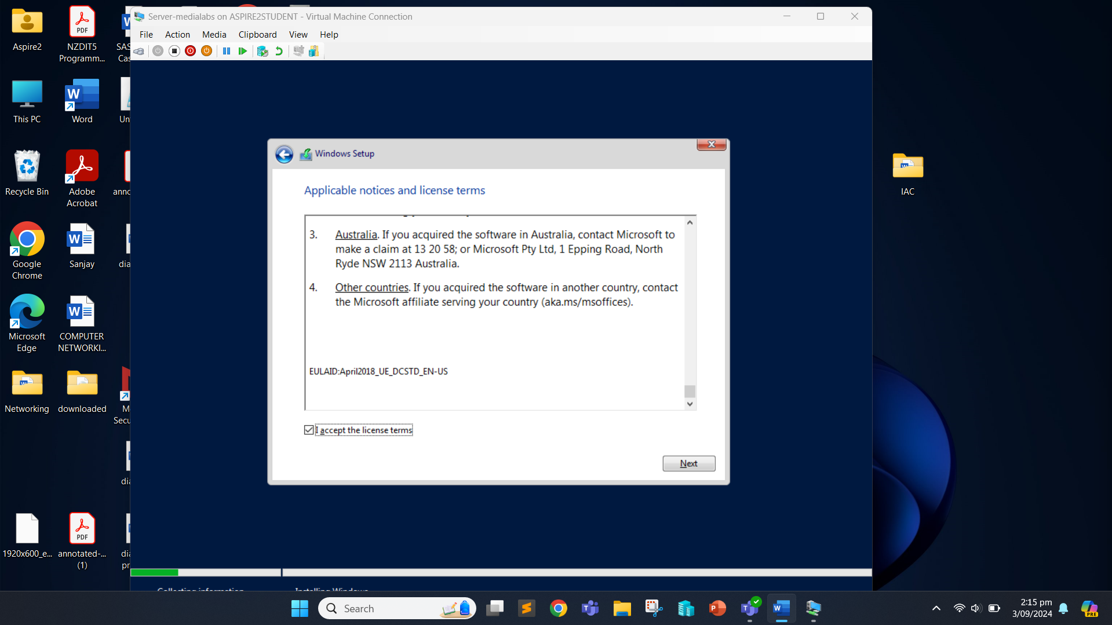

We choose the custom installation: Install Windows only (advanced).

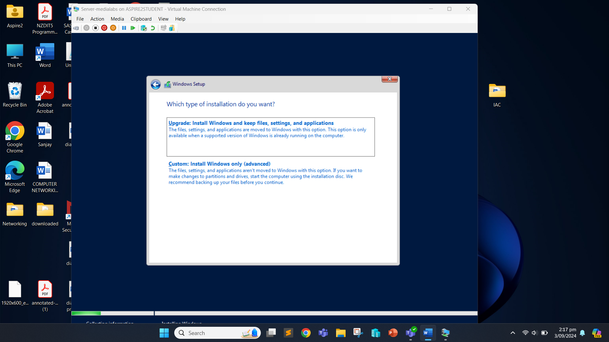

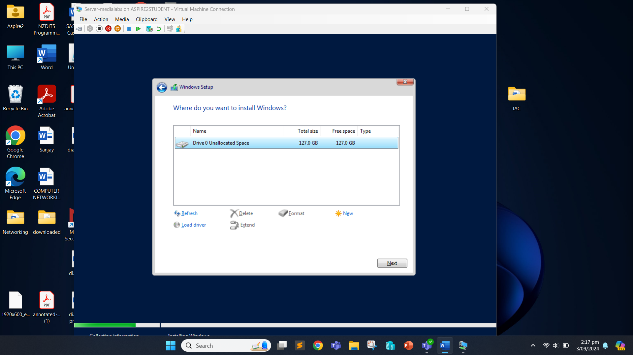

We select the allocated space and click “Next” to start the installation process. 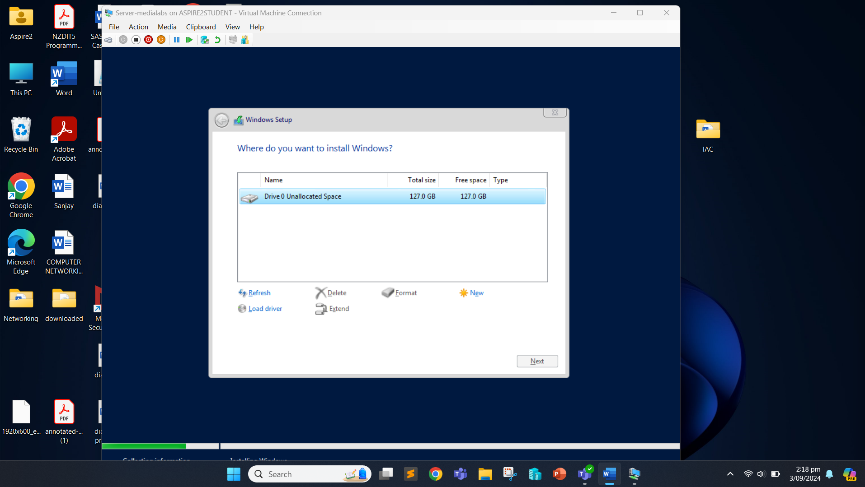

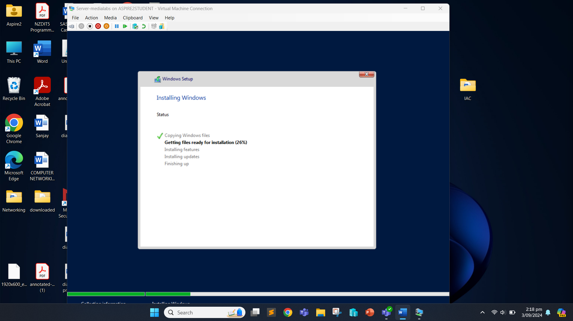

Once the installation is complete, we set the password for the administrator and click “Finish”.

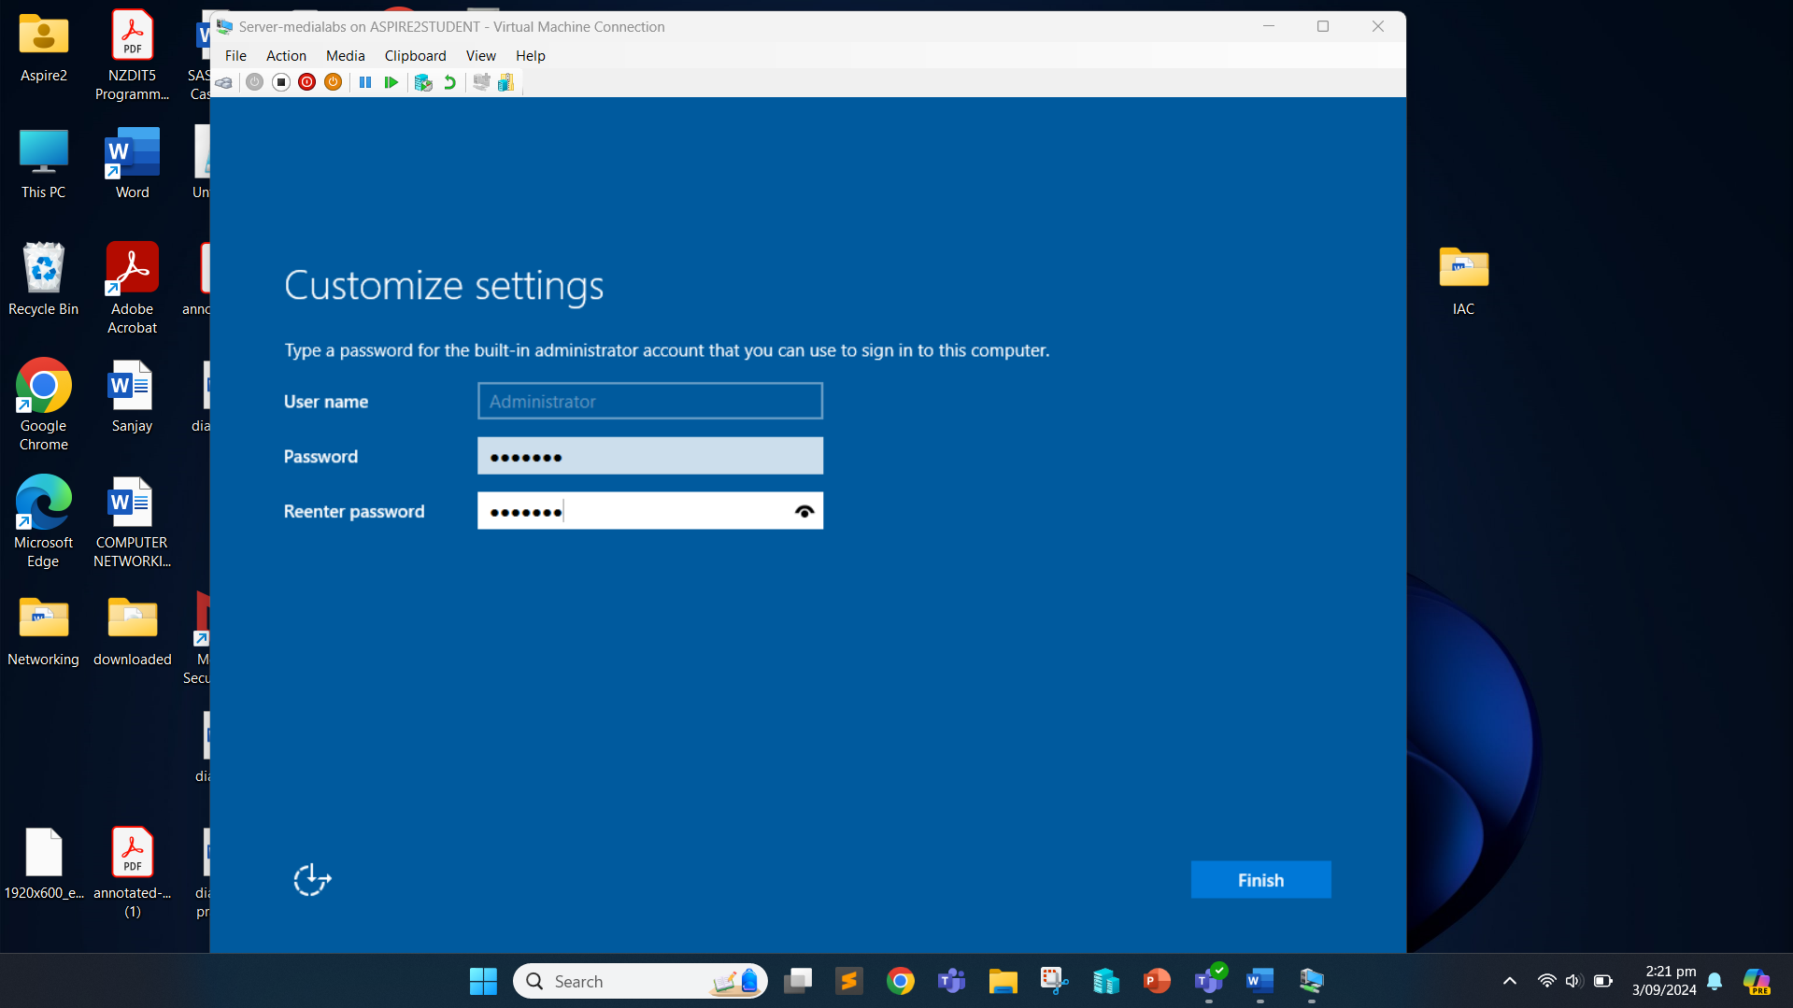

Once this is done, we can login.

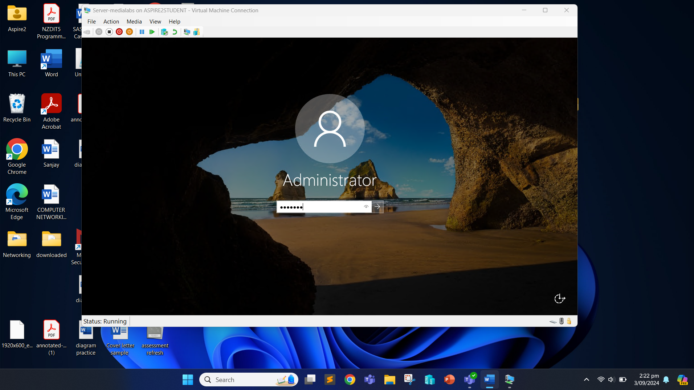

Now the server has been installed.

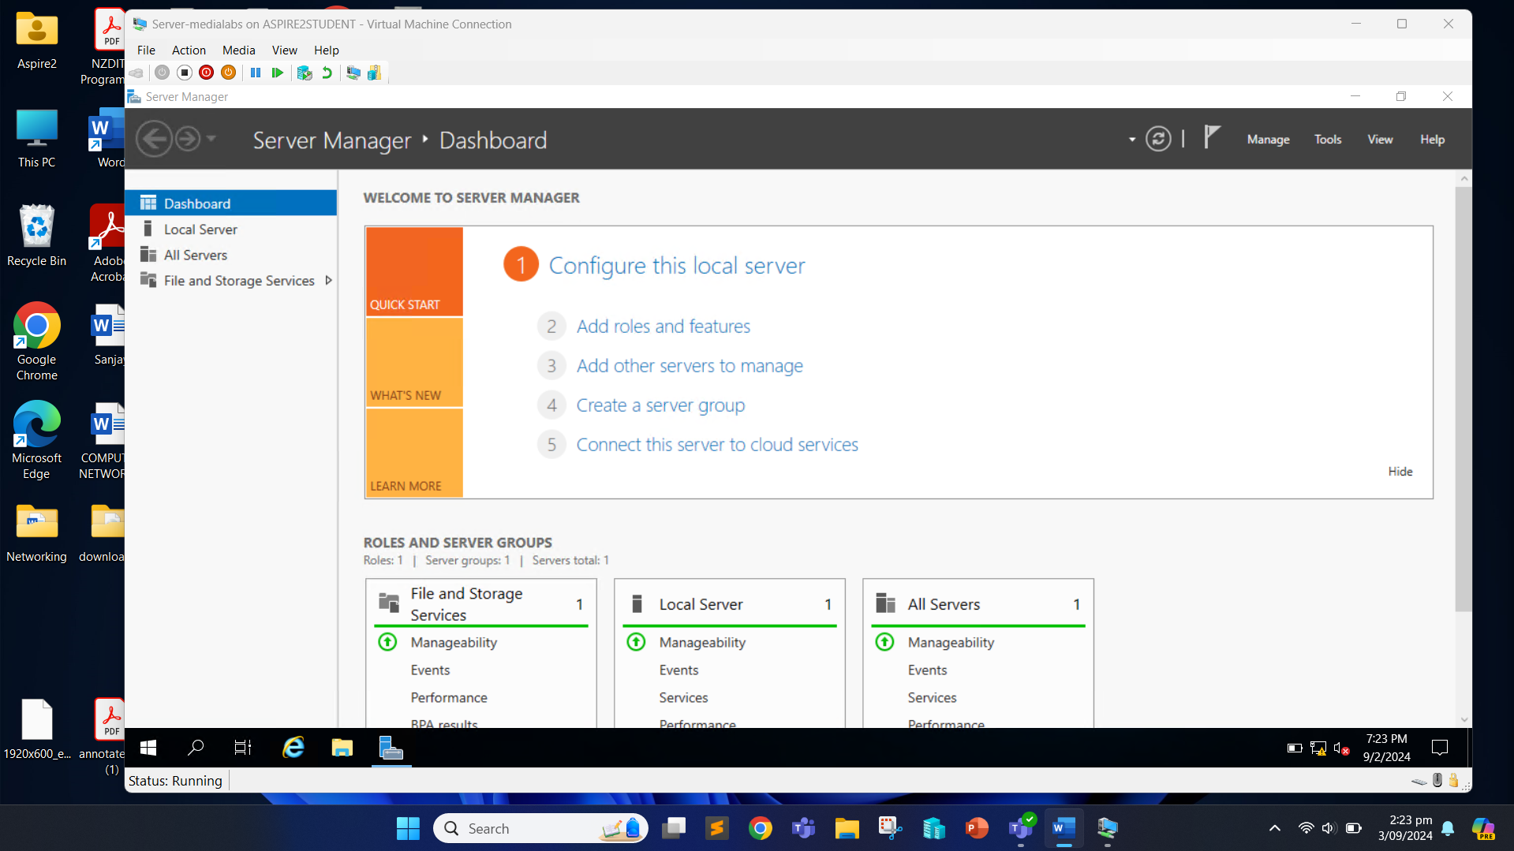

We now need to change the time to New Zealand. For that, we need to open setting and choose “Time & Language”. After that we can change the time zone to New Zealand.

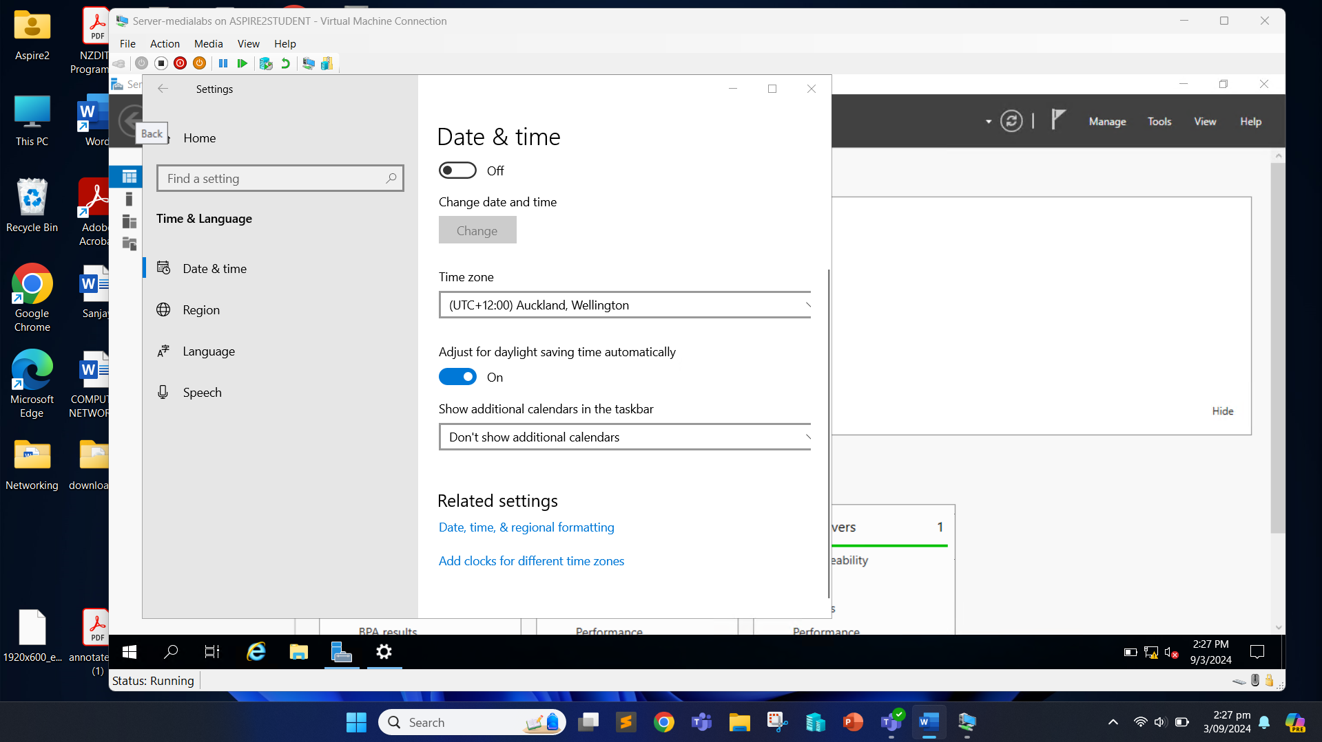

Now that we have our server, we need to configure it according to the requirements.

We open the server manager and click on the local server and “Computer name”.

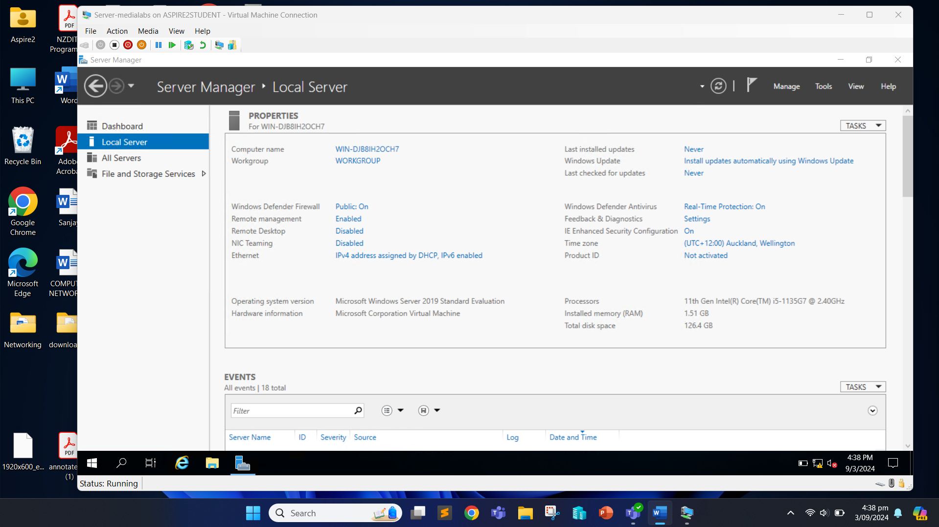

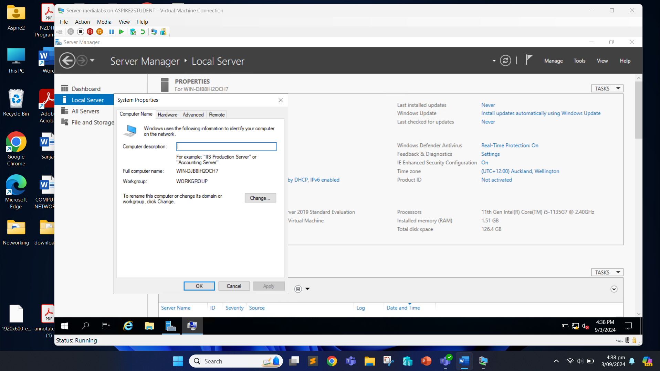

Now click on “Change” button.

We set the computer name as MediaLabs and click “OK”.

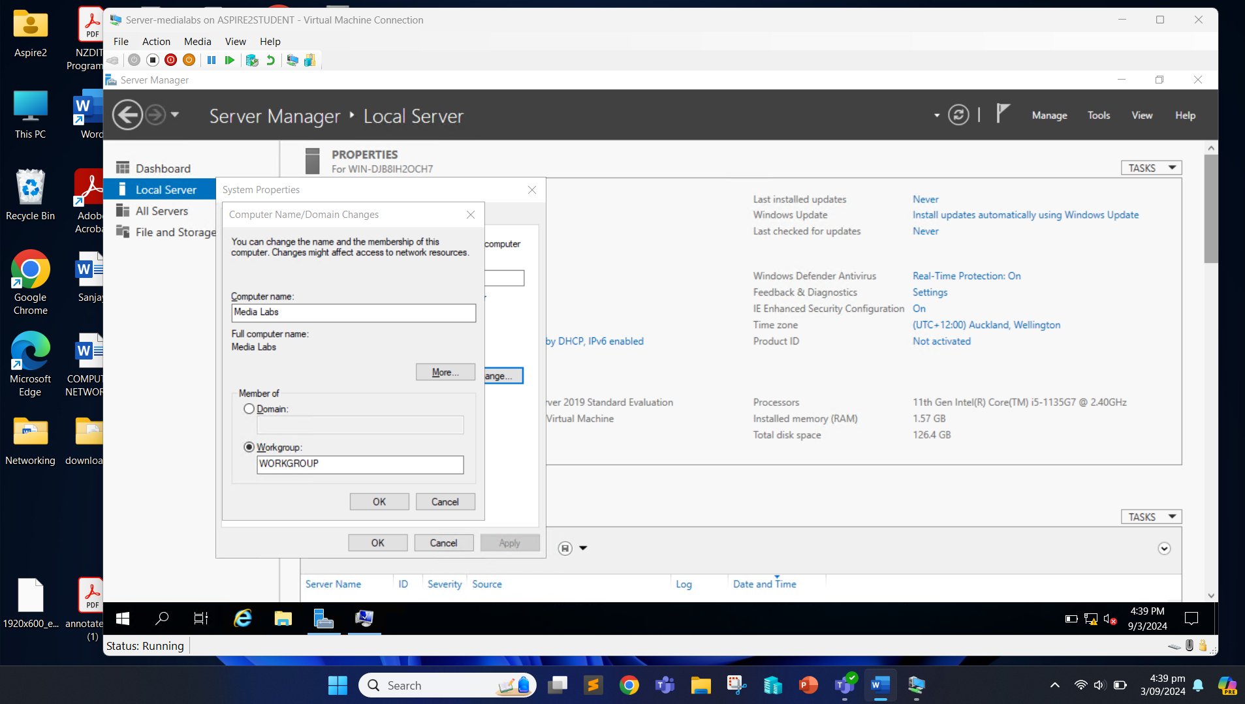

We need to start the machine for the change to happen.

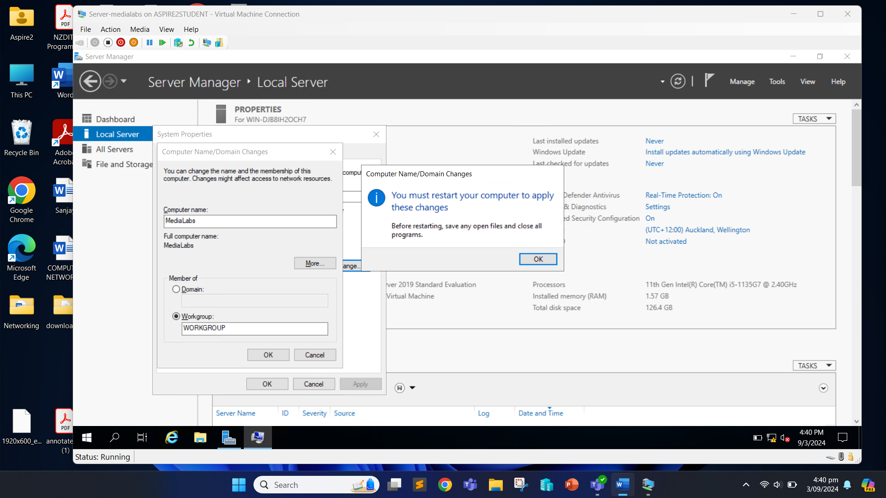

After restarting the server, we again open the Server Manager and click “Local Server” and on the Ethernet.

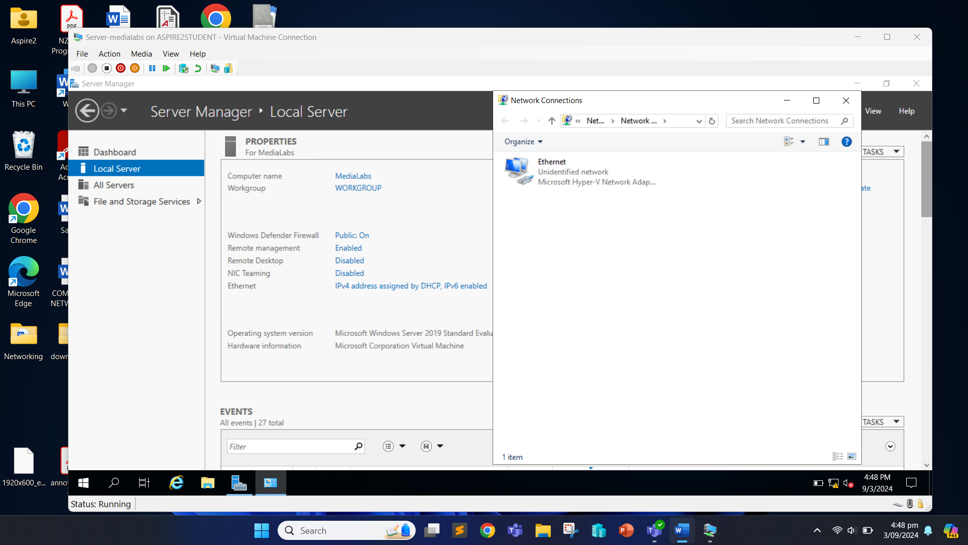

Right click on the Ethernet and click on Properties.

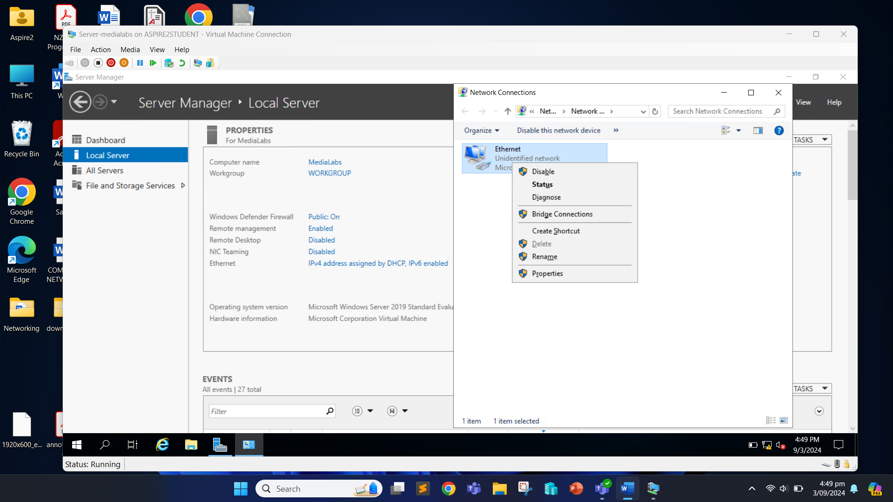

Double-click on the Internet Protocol Version 4 (IPv4).

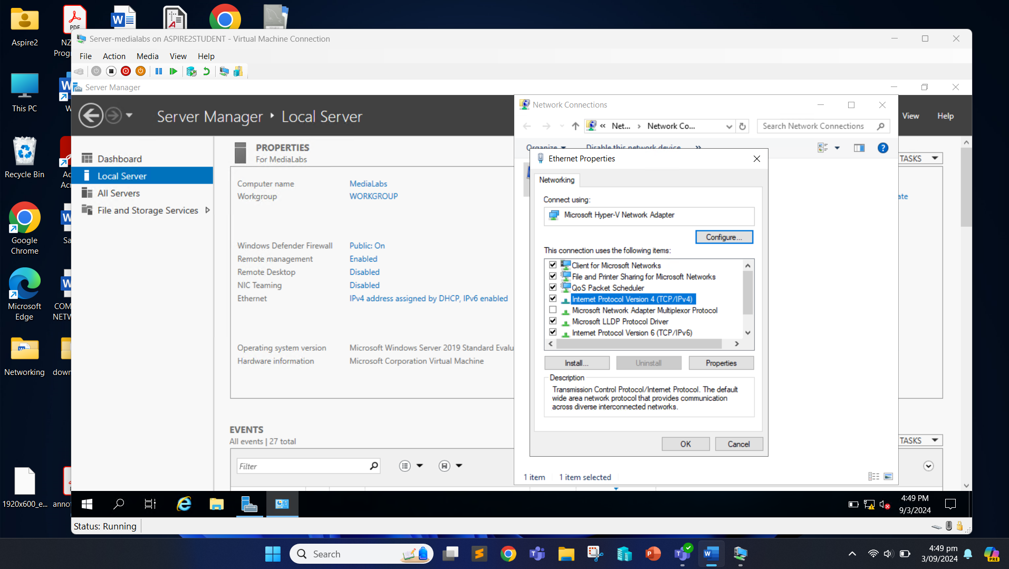

We can now set the IP address. After we set the IP address, we can click “OK”.

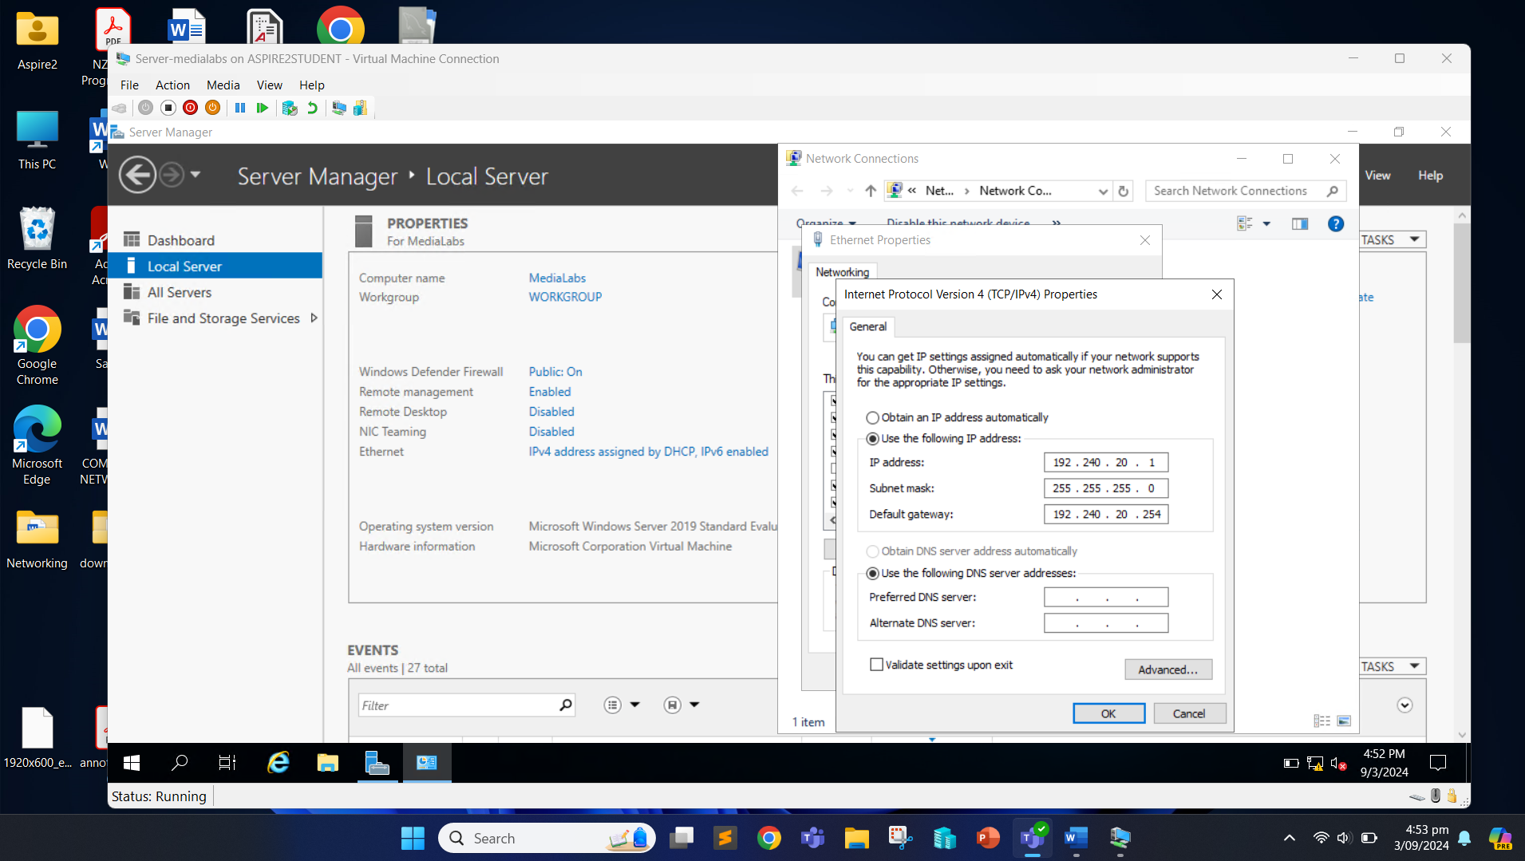

Now, we can move towards configuring roles in the server. In the Server Manager, click on the “Manage” option and click on the “Add Roles and Features”.

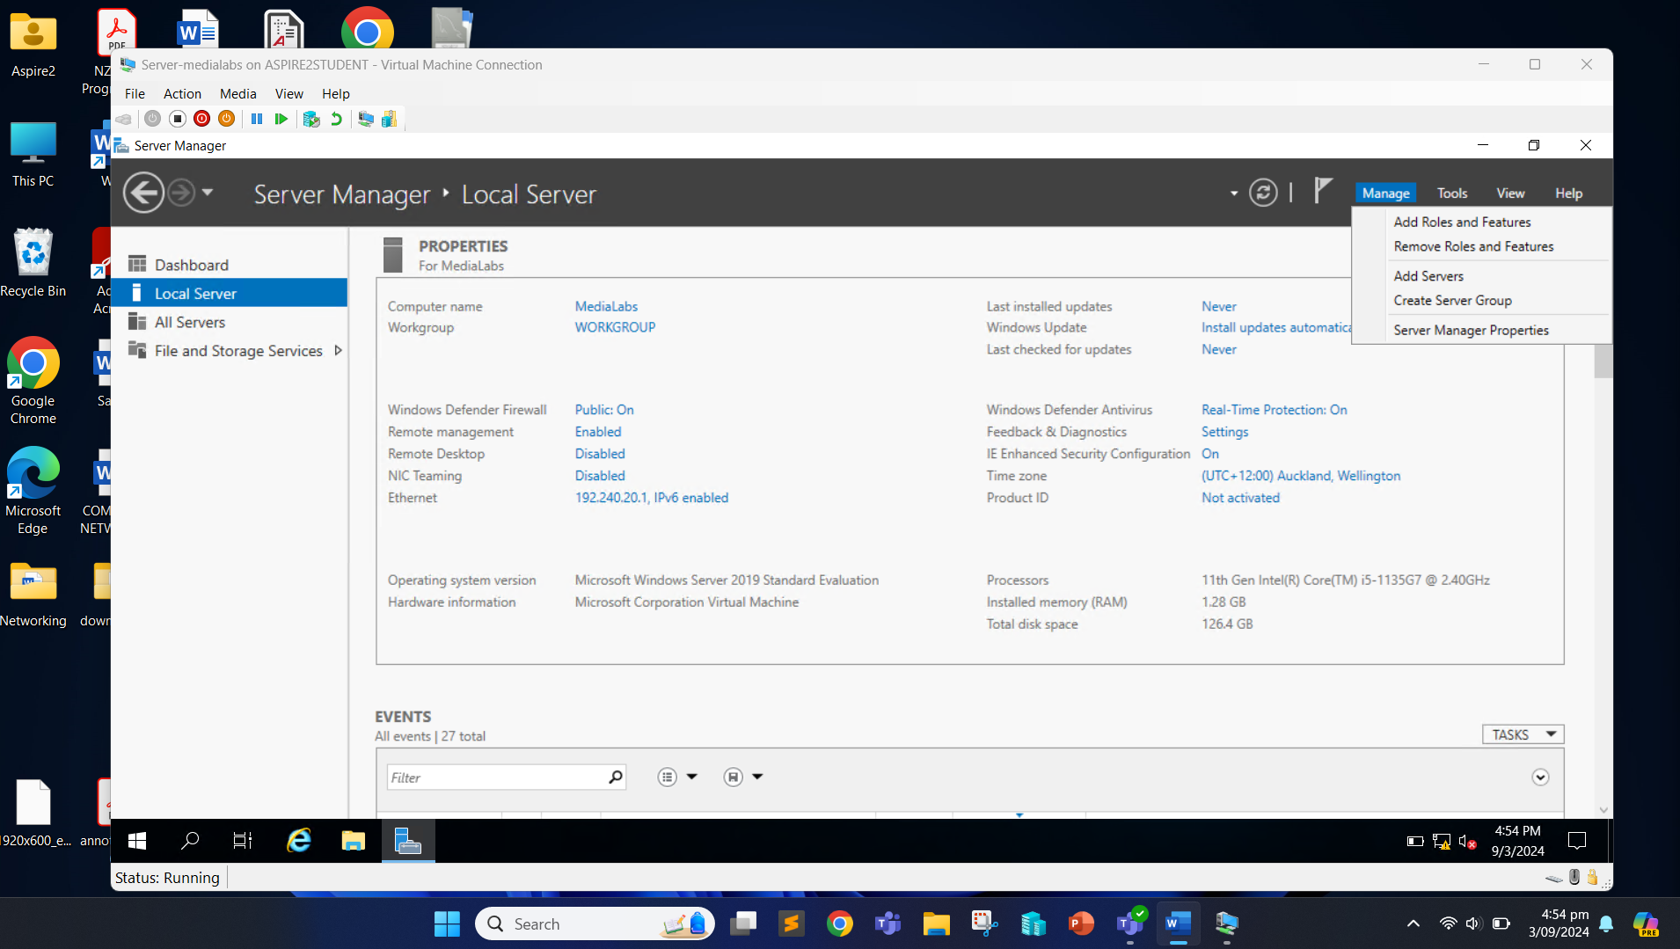

Click “Next”.

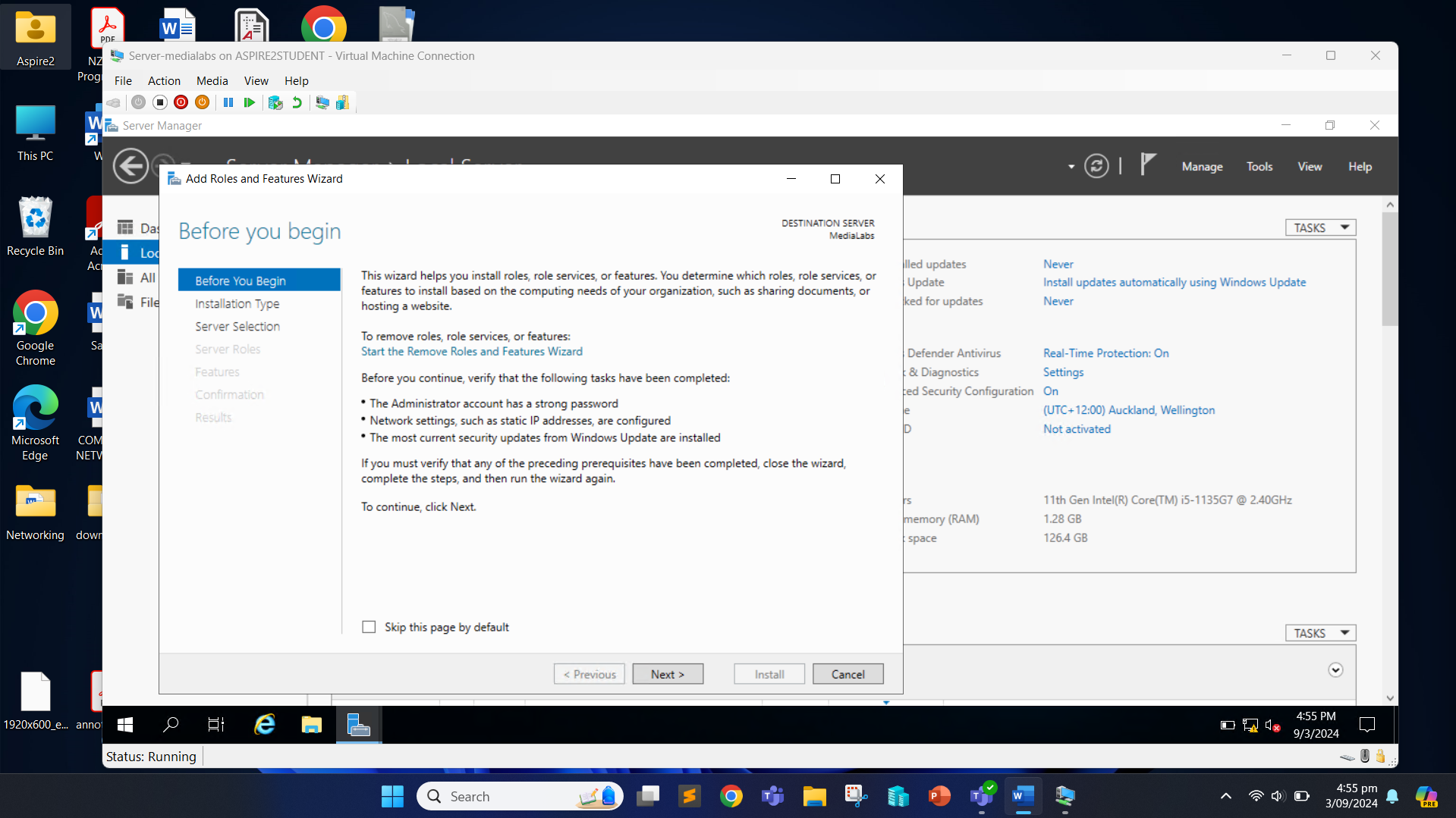

Click “Next”.

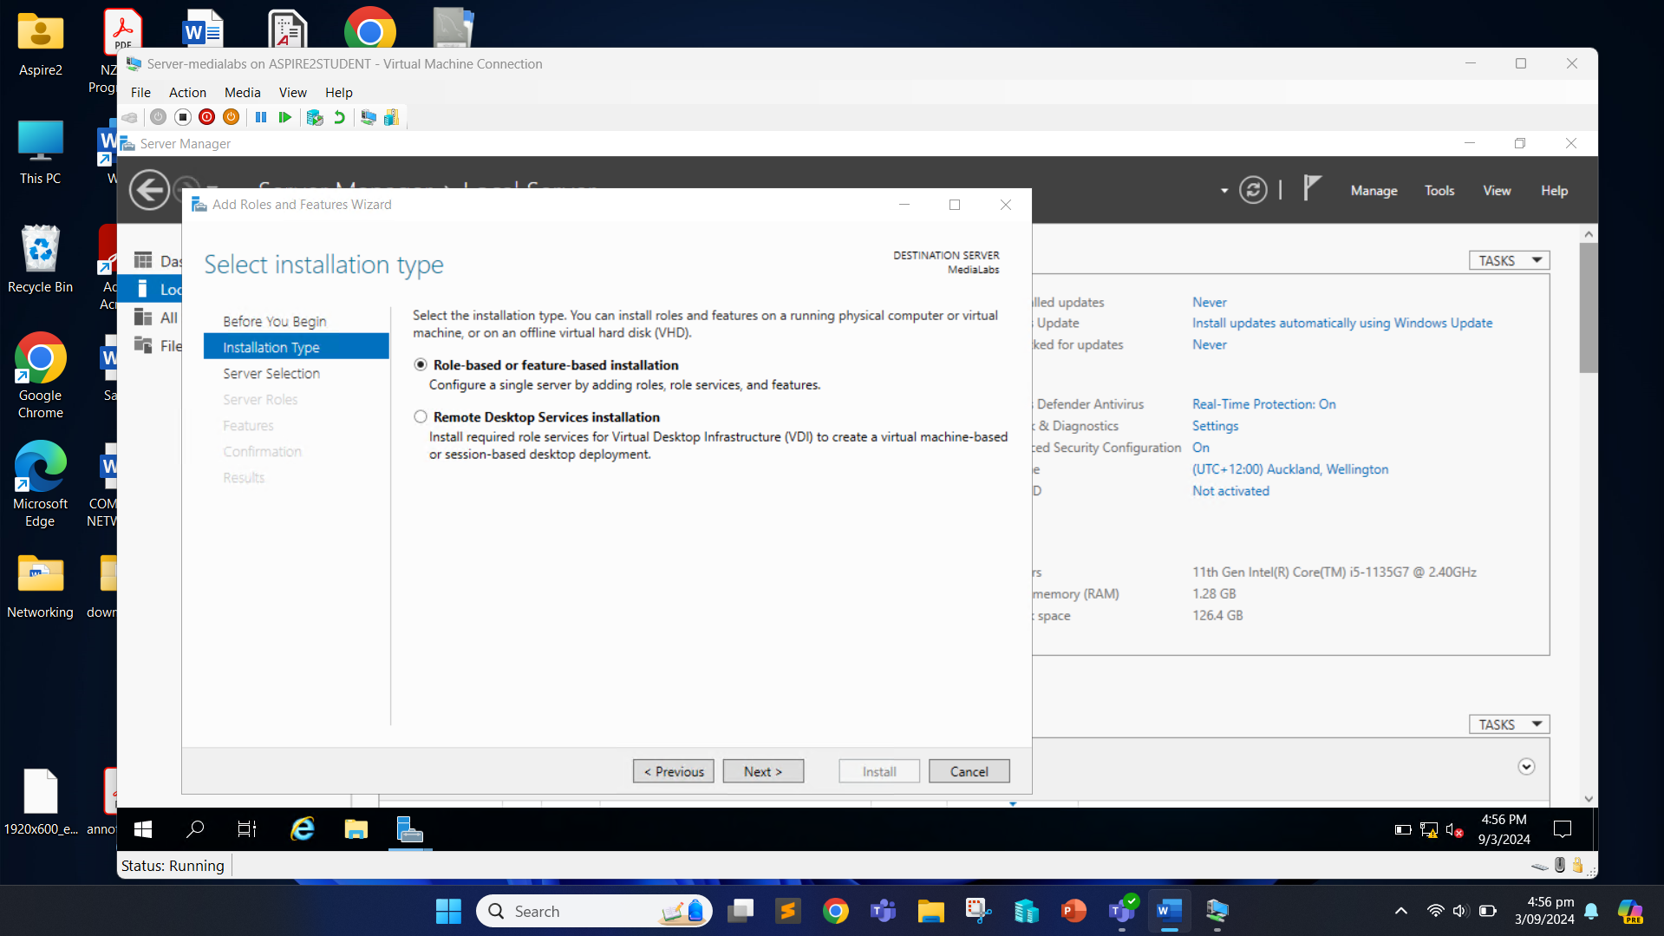

Click “Next”.

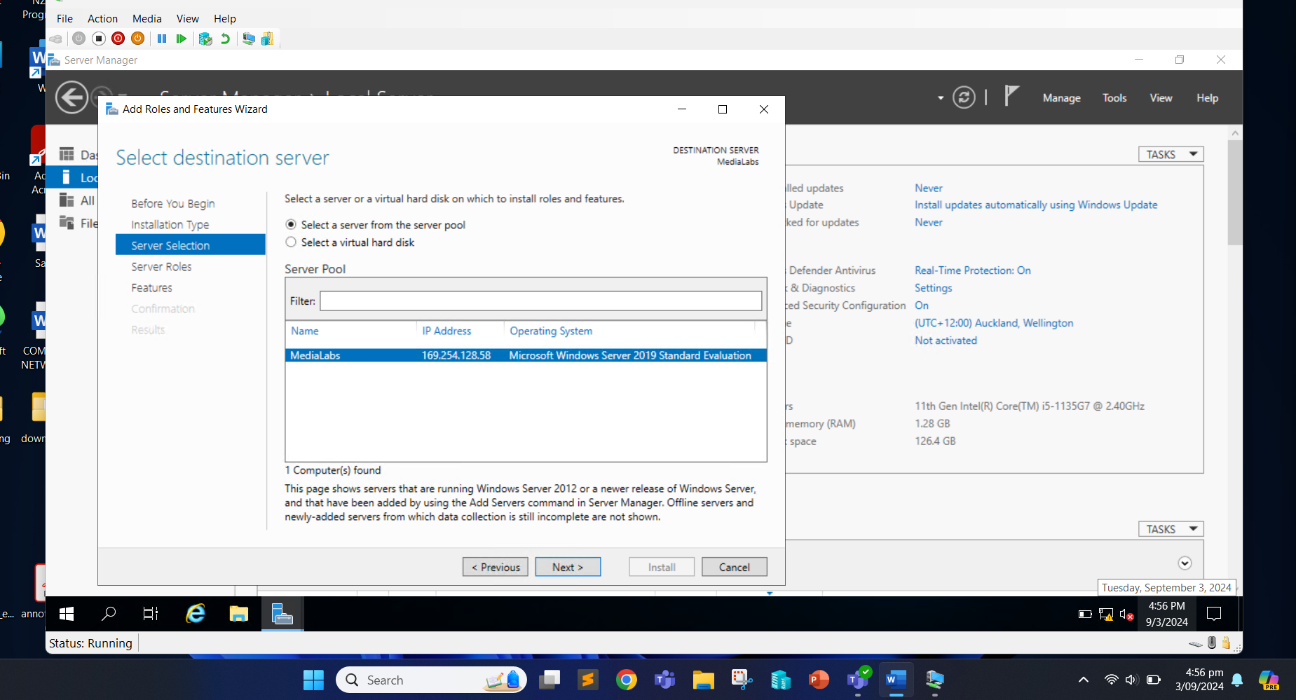

We can now select the server roles that we want to install on the server. Check the box of “Active Directory Domain Services”.

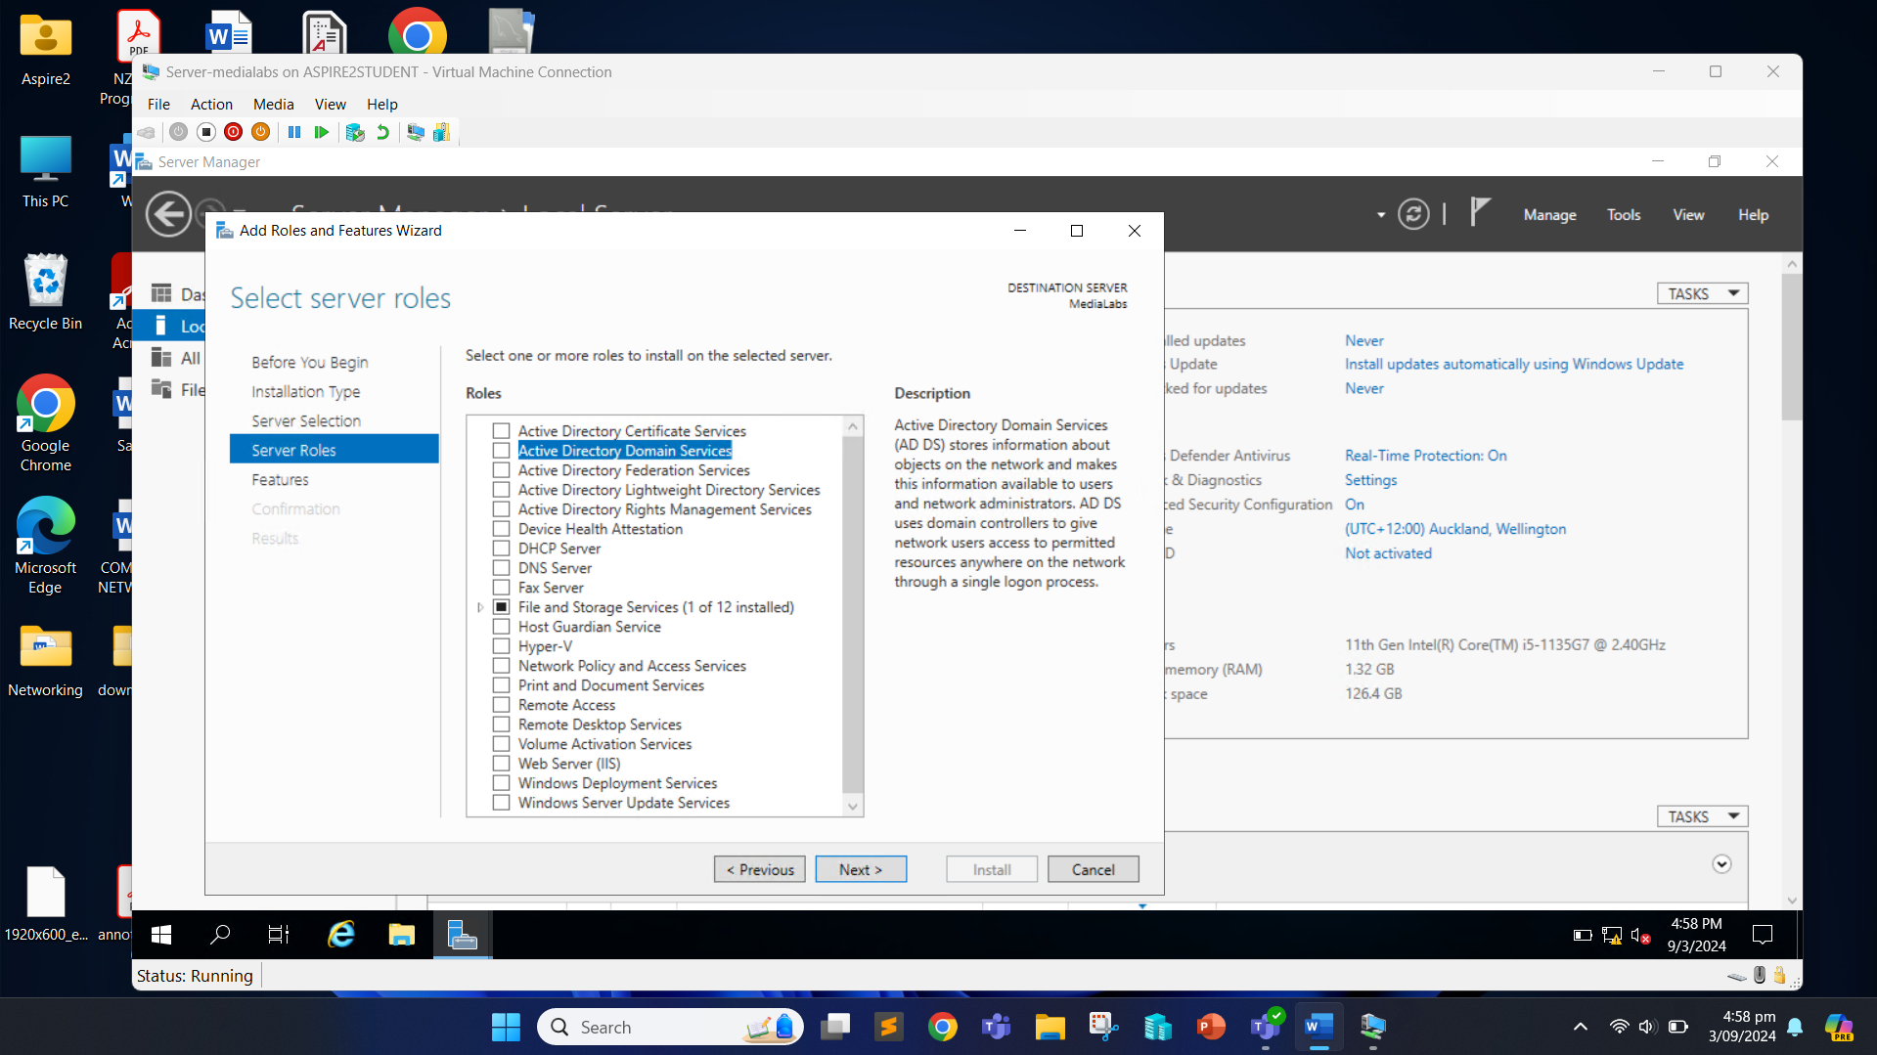

Click the “Add Features” button.

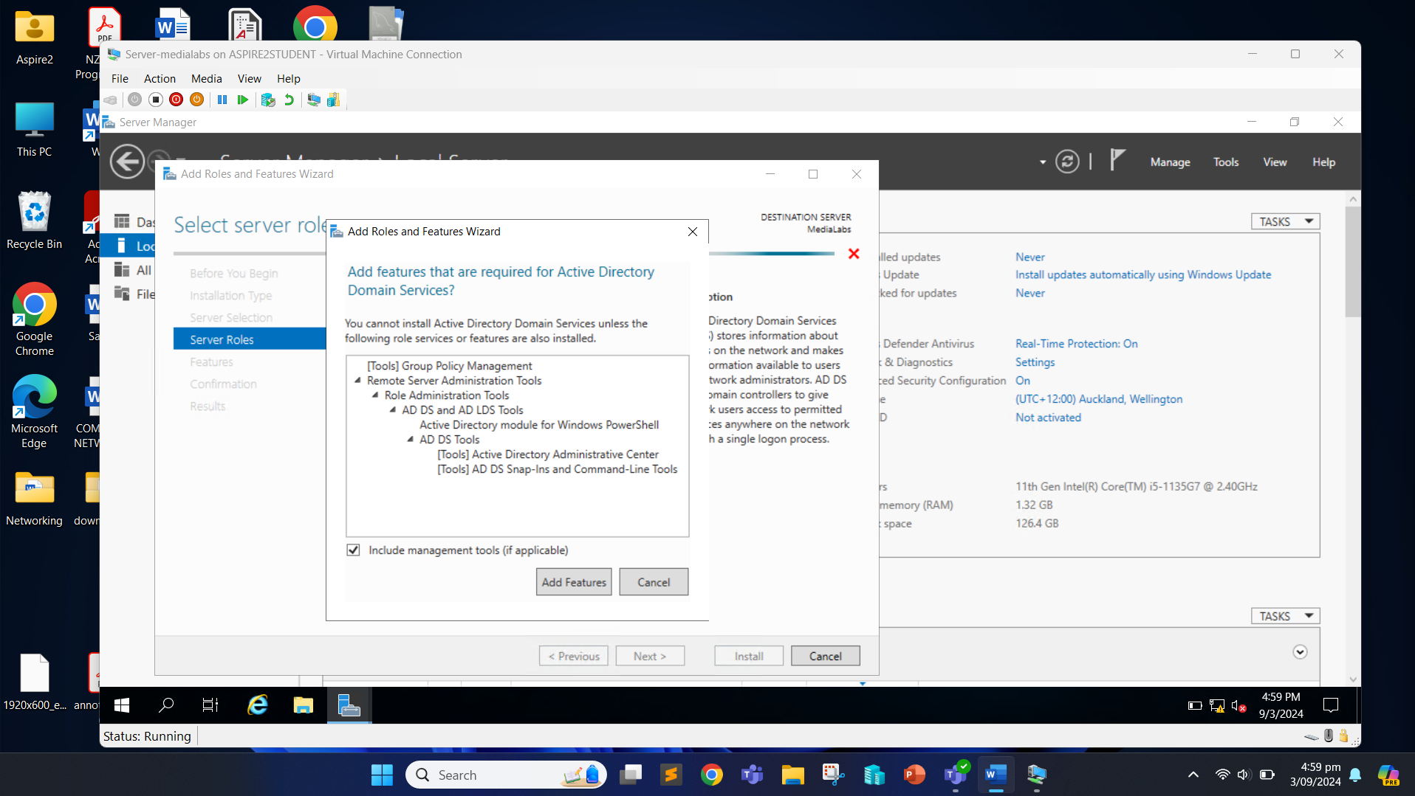

Also check the “DHCP Server” box.

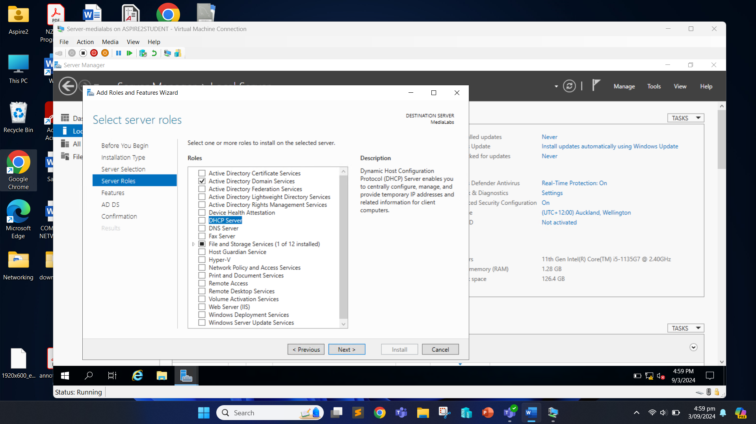

Click on “Add Features” button.

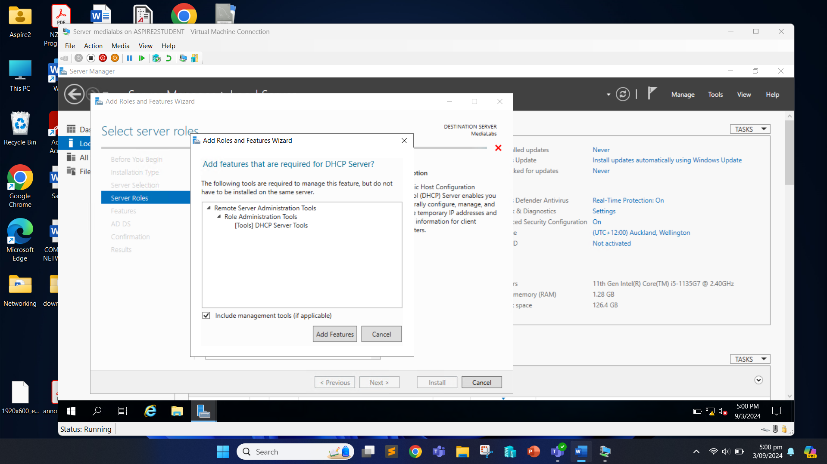

Check the “DNS Server”.

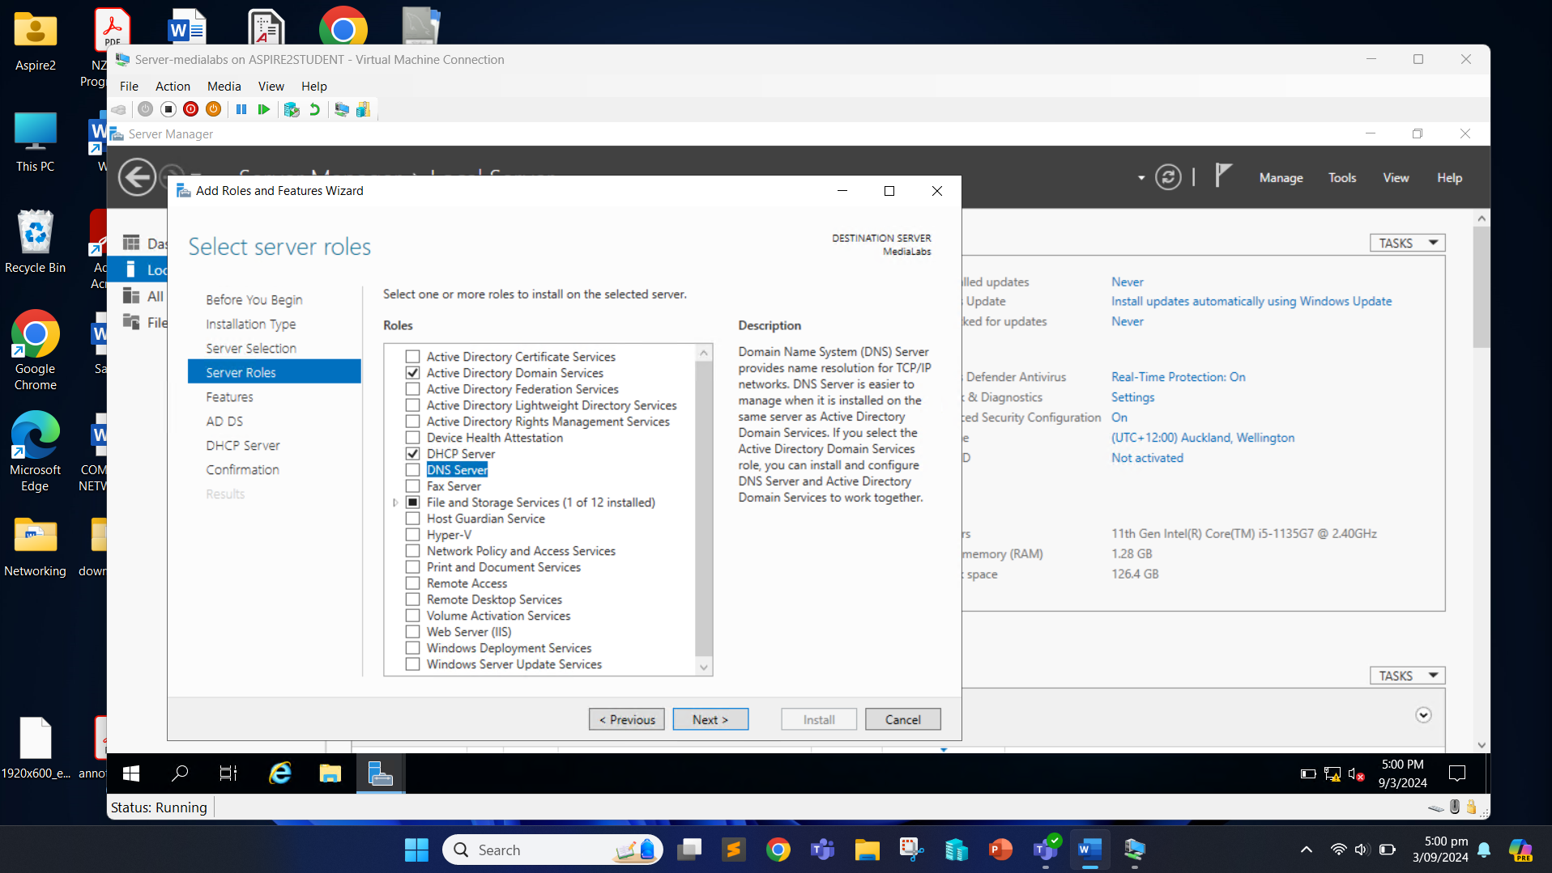

Click “Add Features” button.

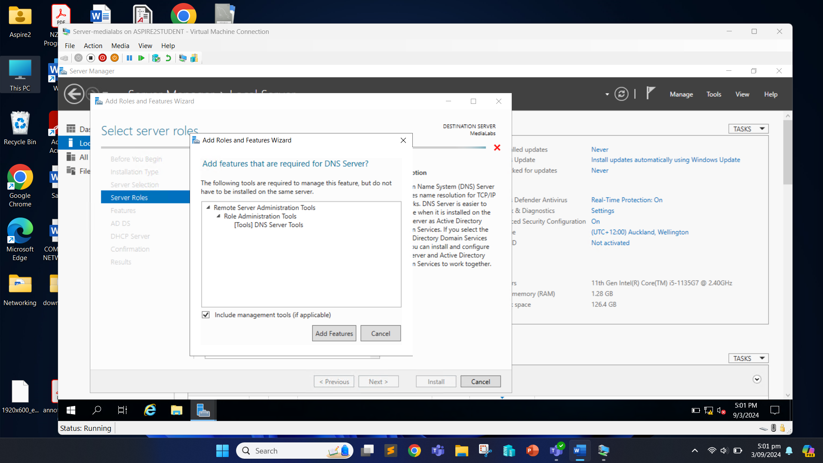

Now, click “Next” until the installation. Confirm the installation of selected roles by clicking the “Install” button.

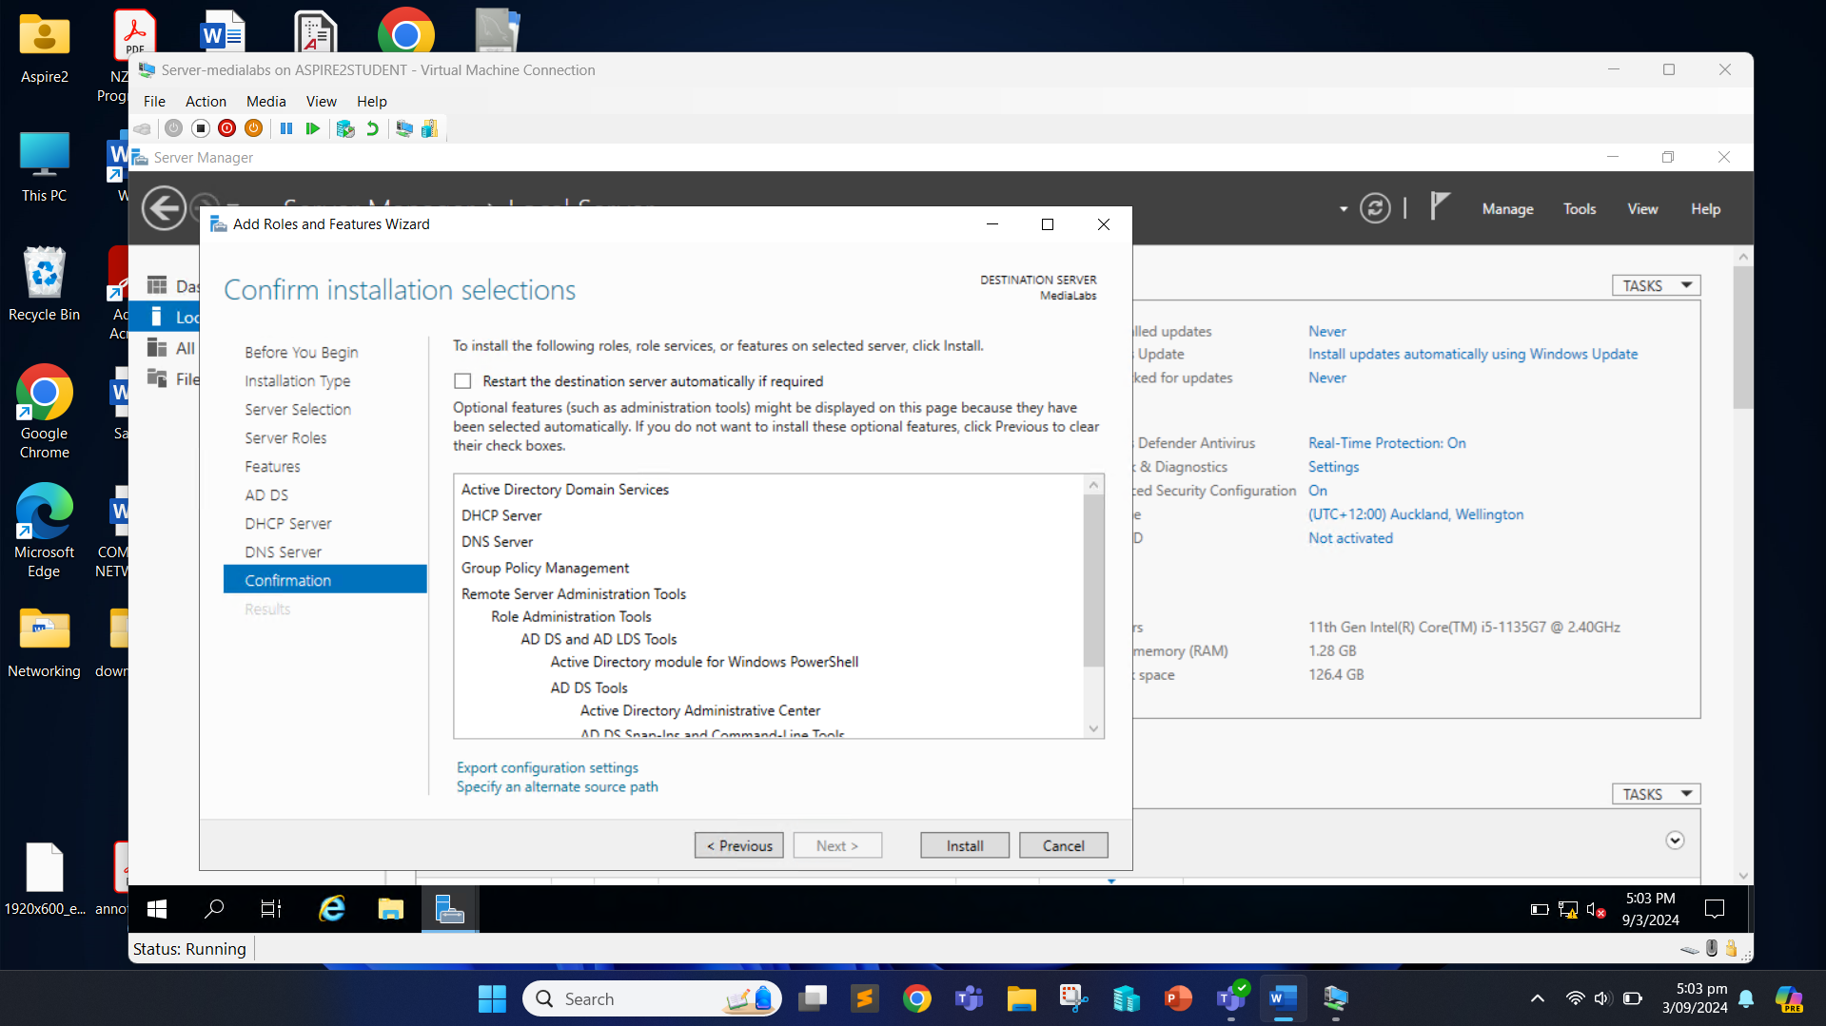

This should start the installation process.

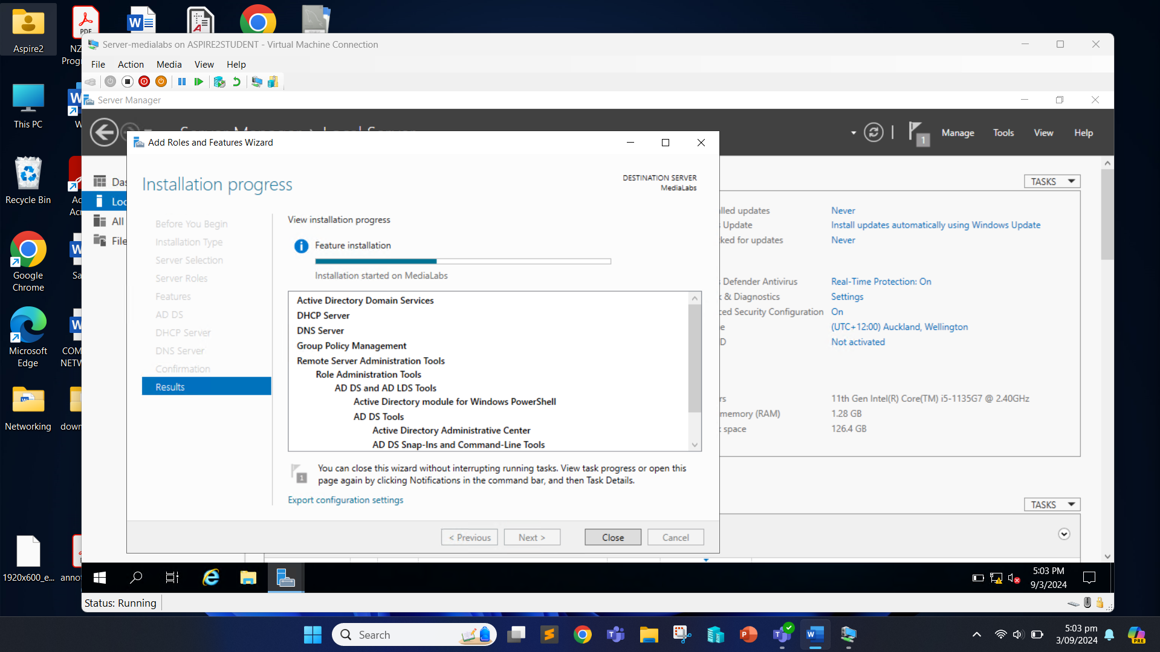

When the installation is complete, click the “Close” button.

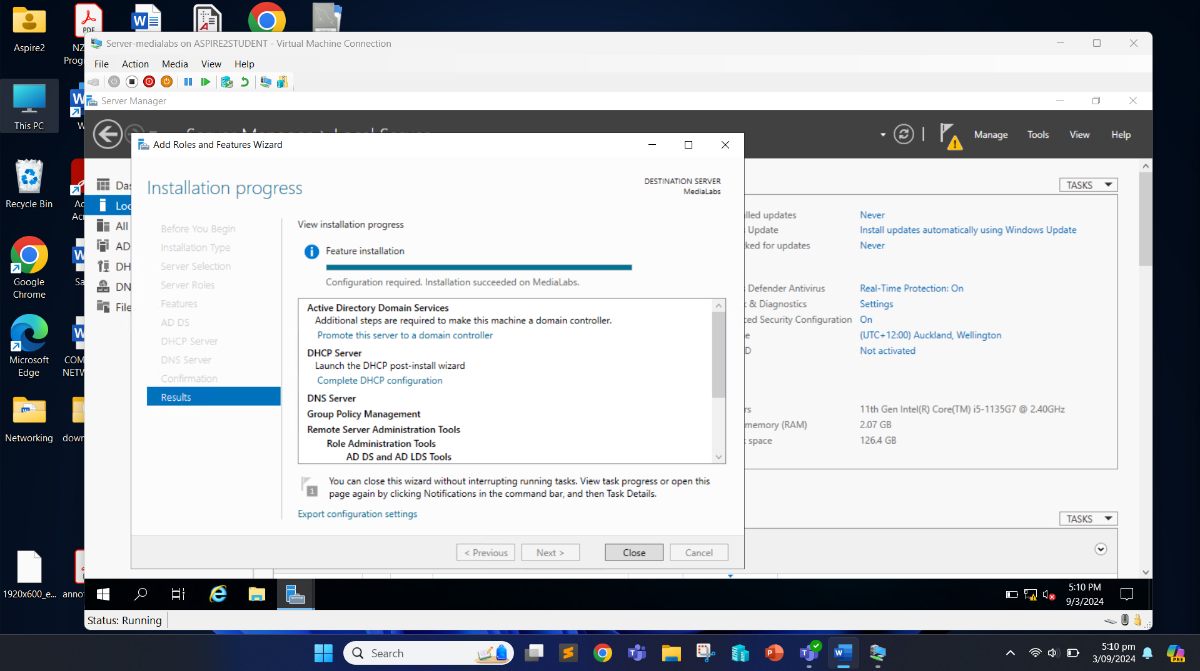

Click on the flag icon and click “Promote this server to a domain controller”.

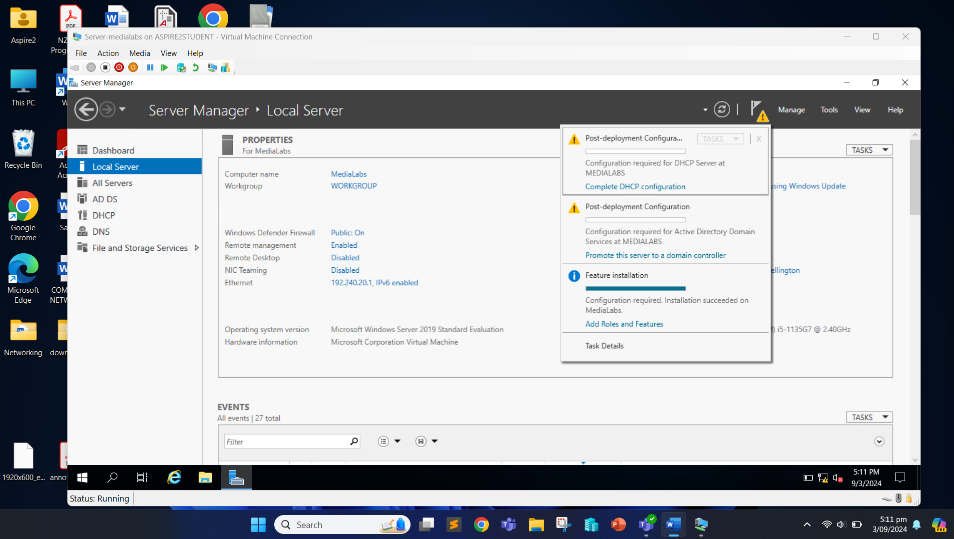

Choose “Add a new forest” and insert “medialabs.com” as root domain name. Click “Next”.

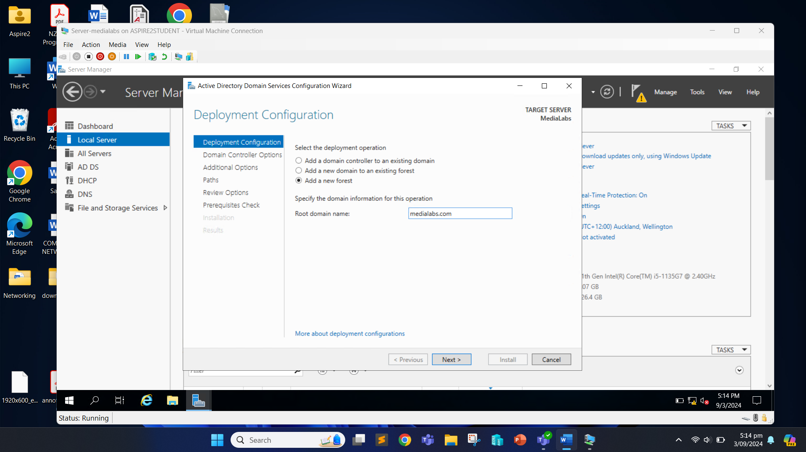

We need to set the password and click on “Next”.

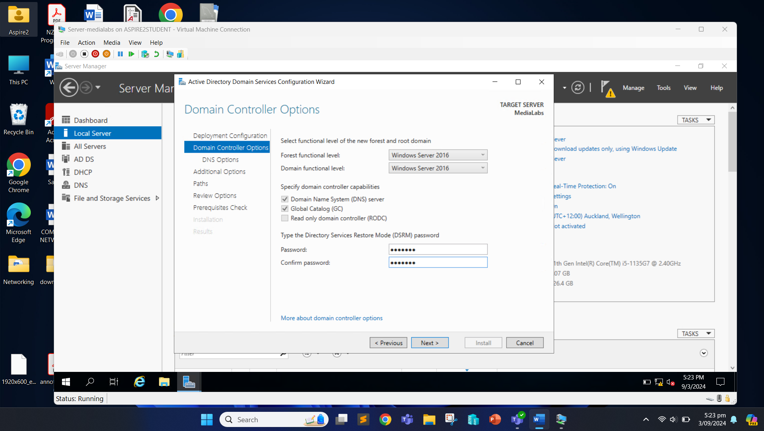

Click Next.

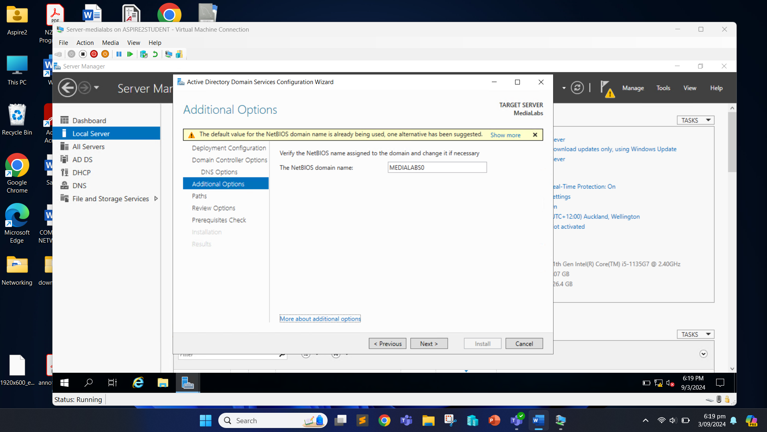

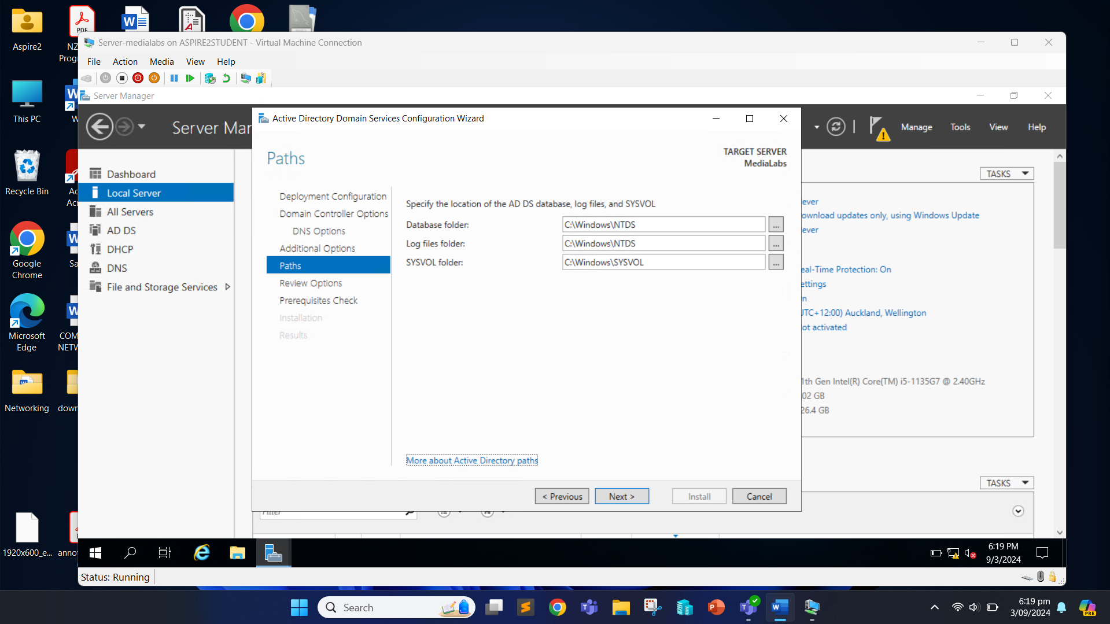

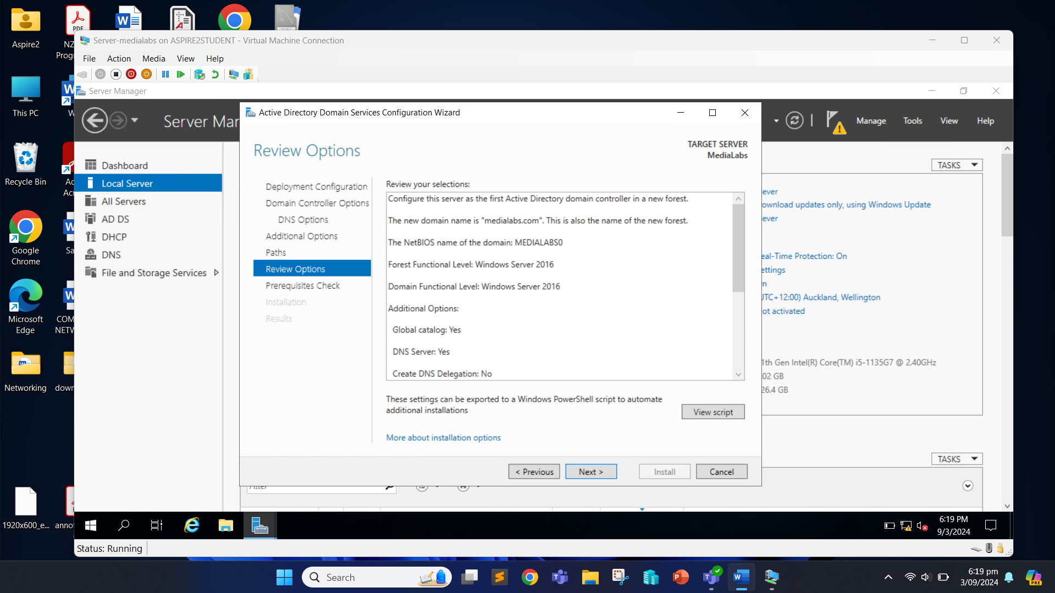

Now, we can start the installation process by clicking the “Install” button.

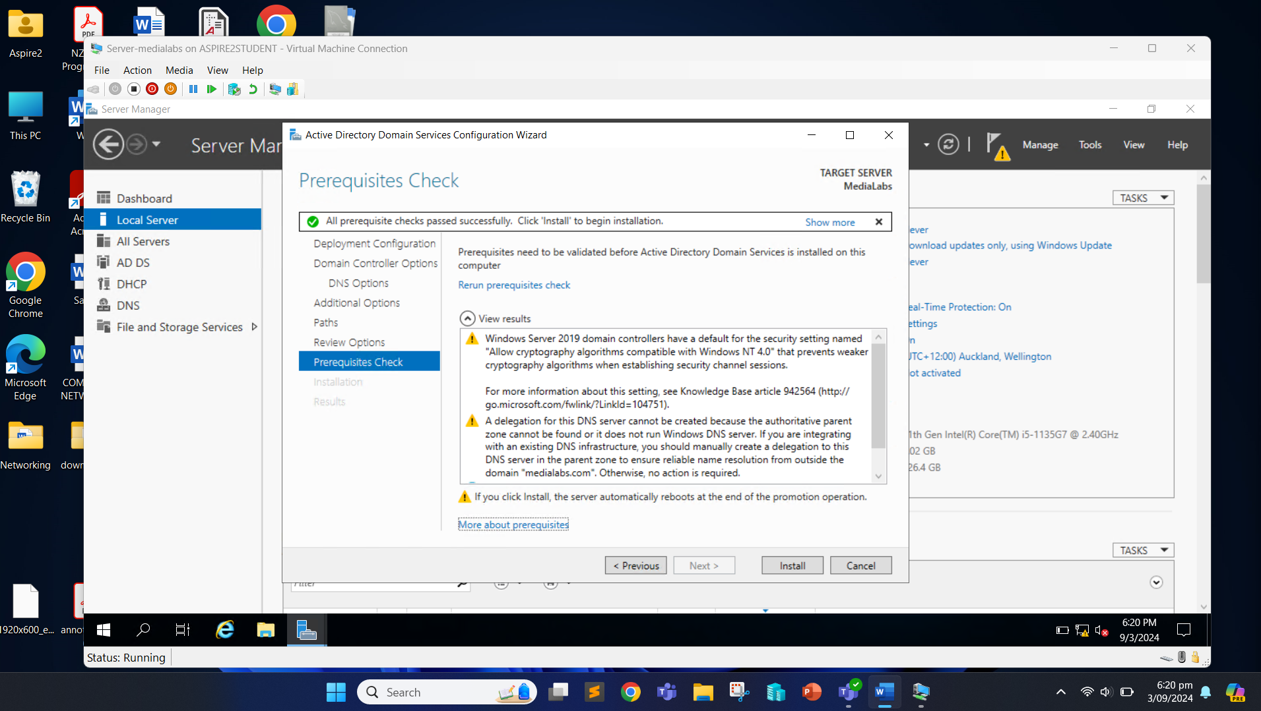

Once the domain controller is configured, the computer restarts.

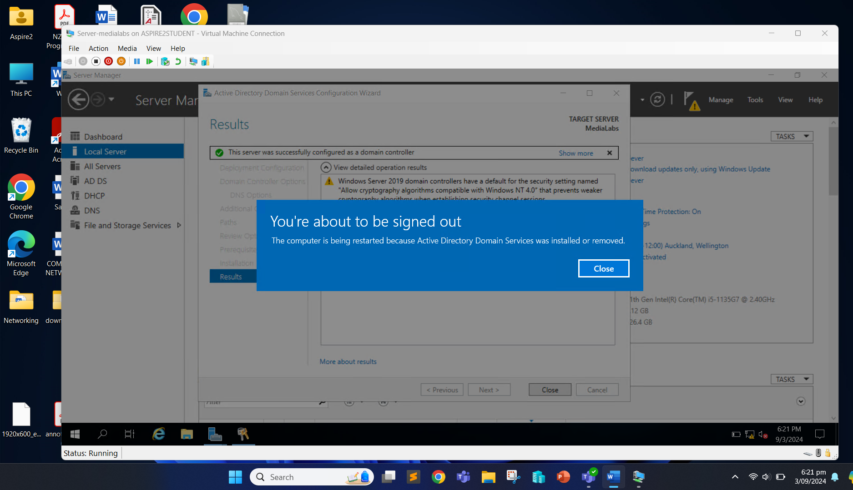

Now, we can login with the password we set.

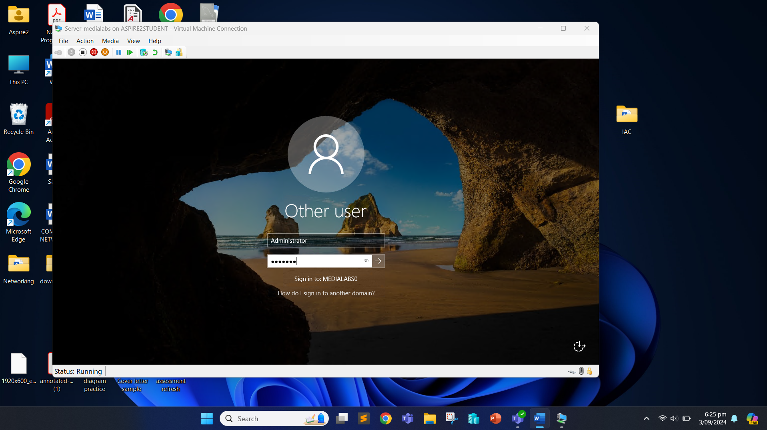

Once again, we open the Server Manager, and click on the flag icon and “Complete DHCP configuration”.

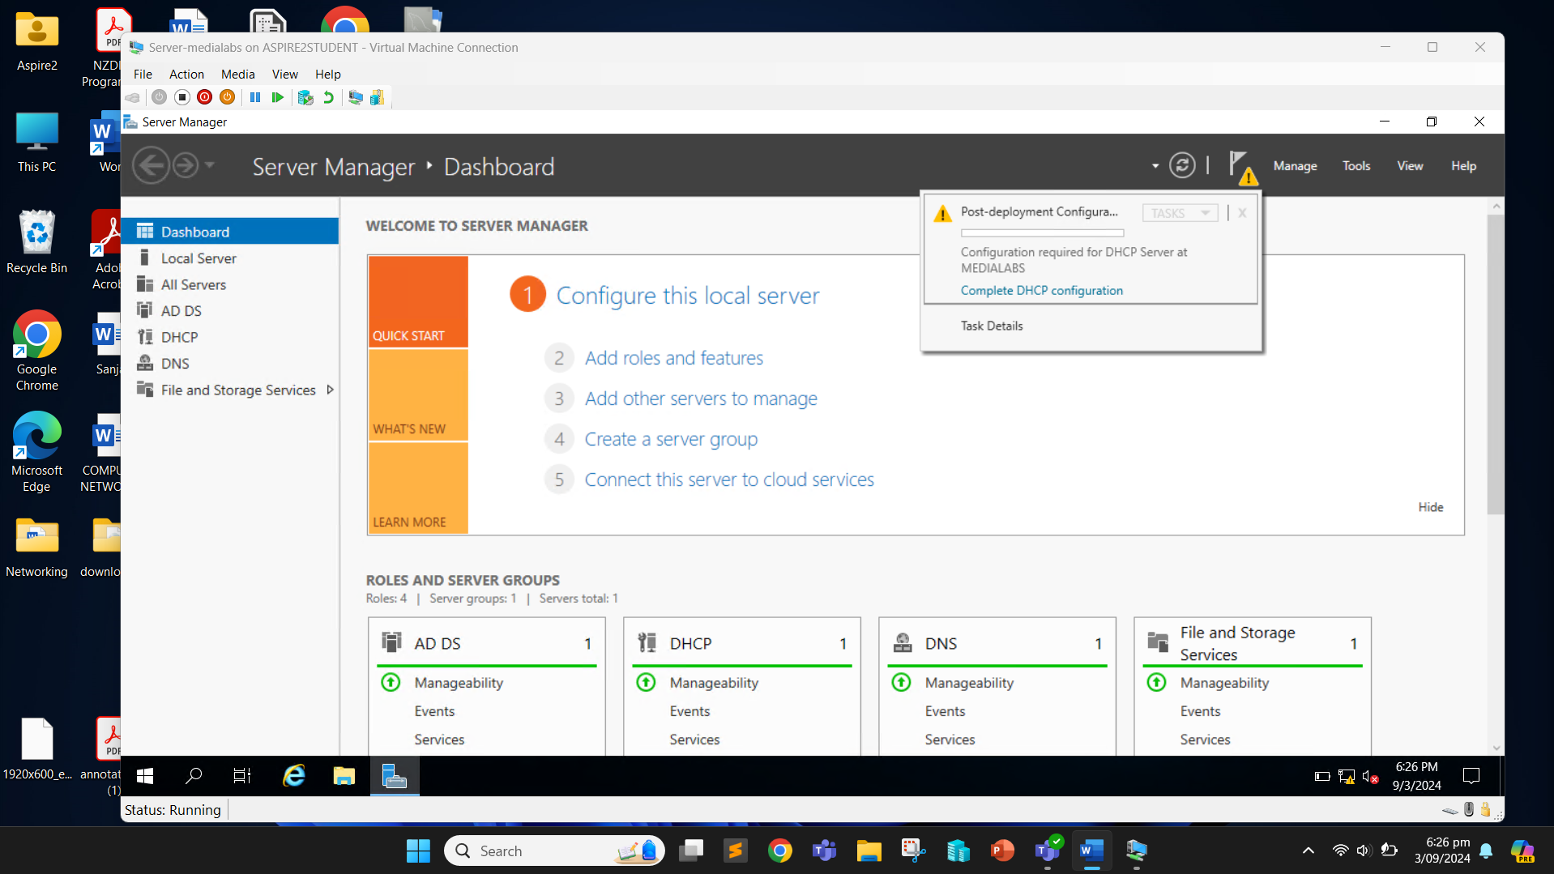

Click “Next”.

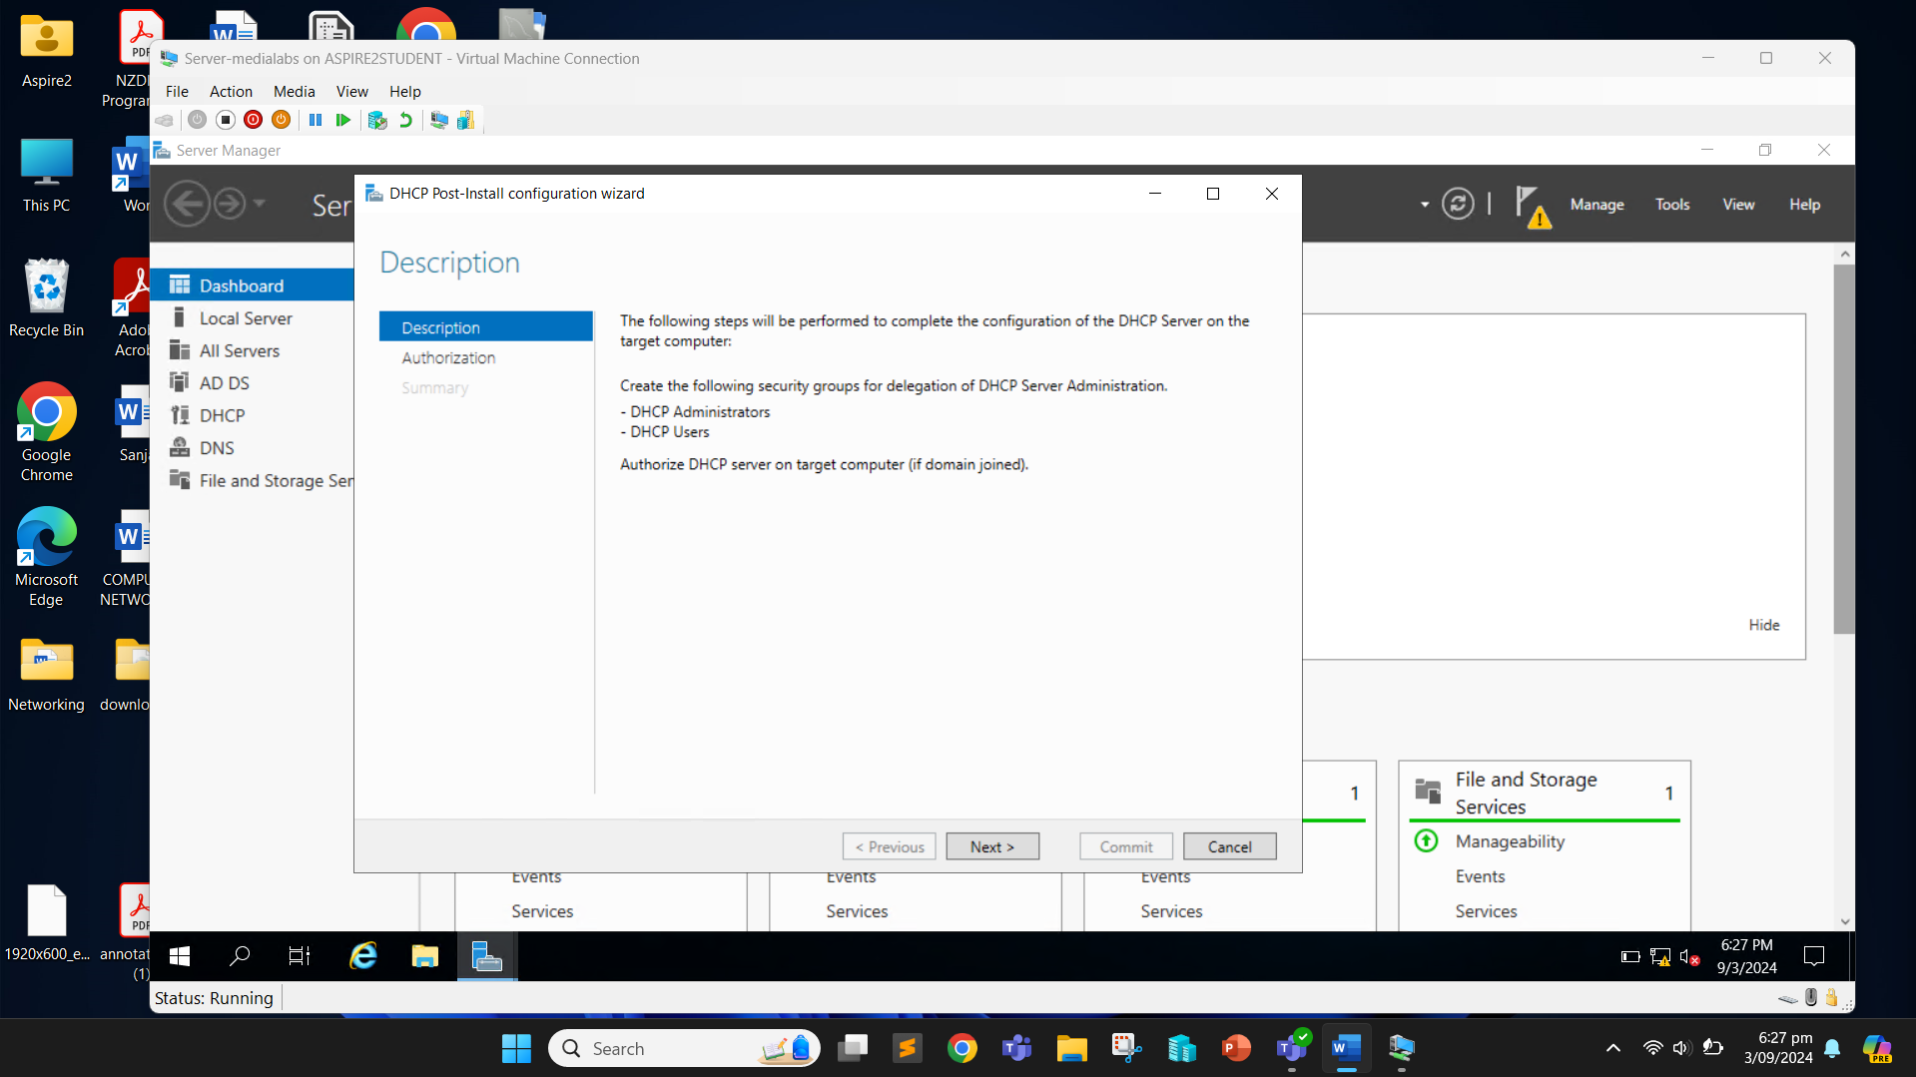

Click “Commit” and the configuration will be completed.

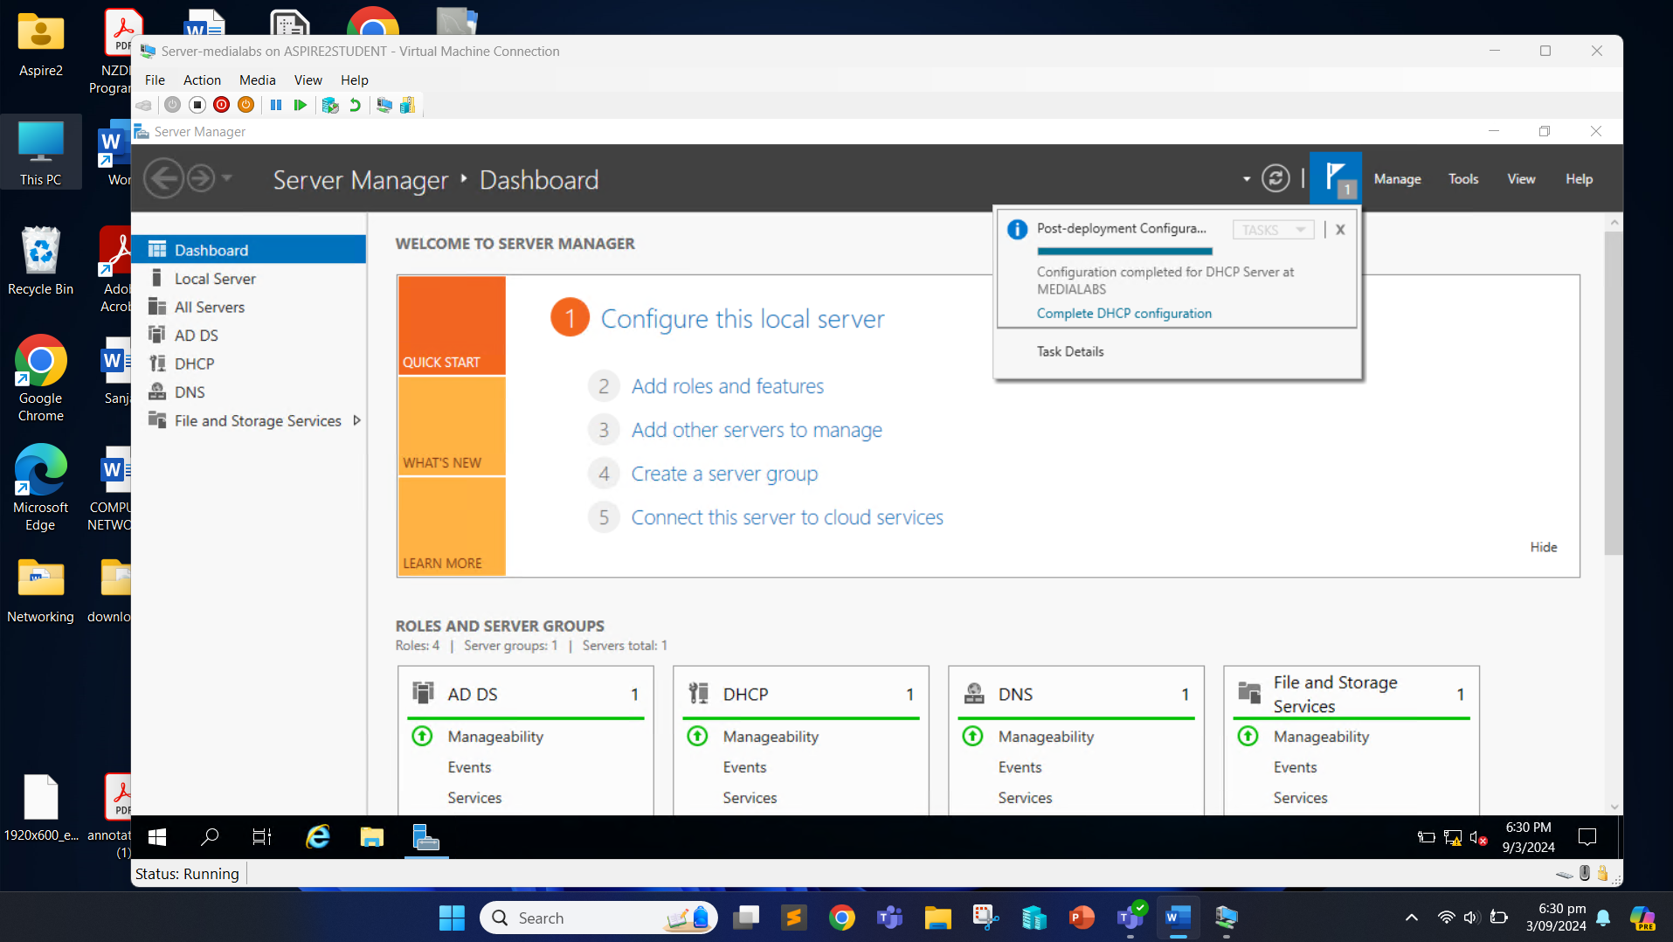

Now we have successfully installed Domain Services, DHCP and DNS on the server. We will now proceed to create a PowerShell script to create a new OU, new user and add that user to the group.

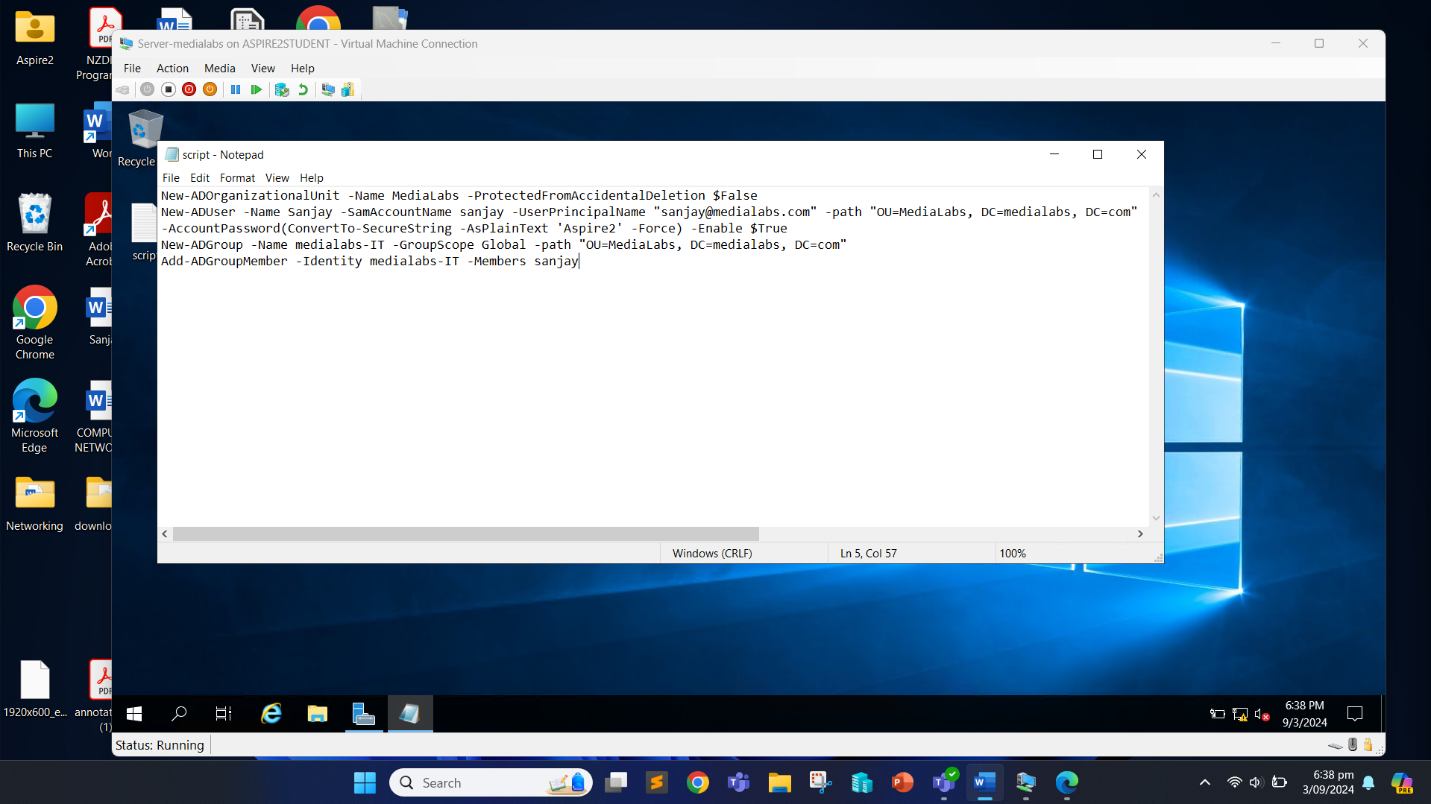

Create a batch file so we can run the PowerShell script we created earlier.

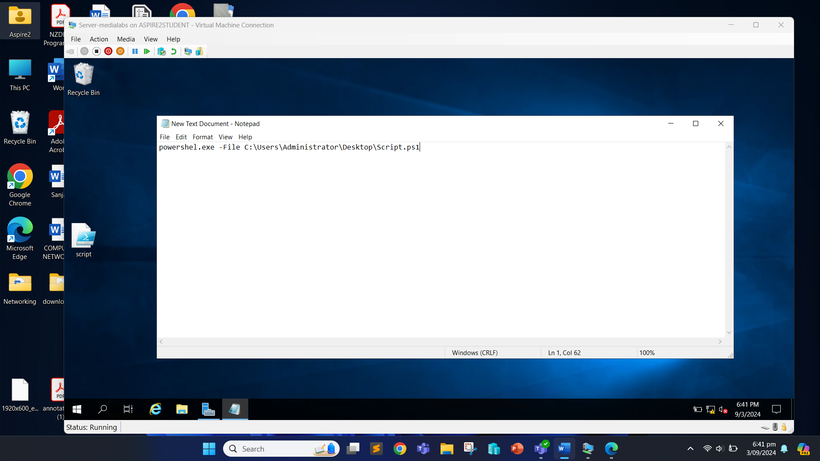

Now, after the run, when we open the Server Manager, click “Tools” and “Active Directory Users and Computers” we can see that the Organization Unit (OU) “MediaLabs” has been created.

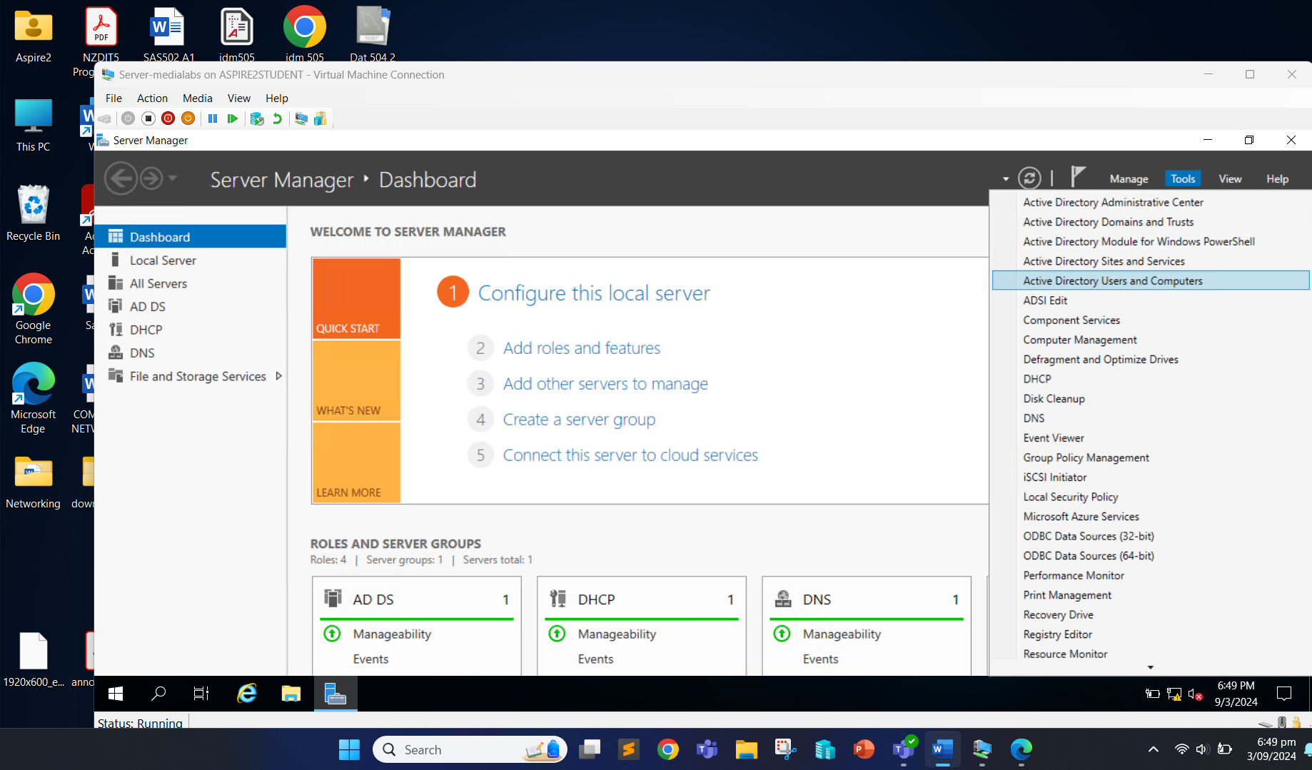

In the MediaLabs OU, it shows that user Sanjay has been created and user group of medialabs-IT.

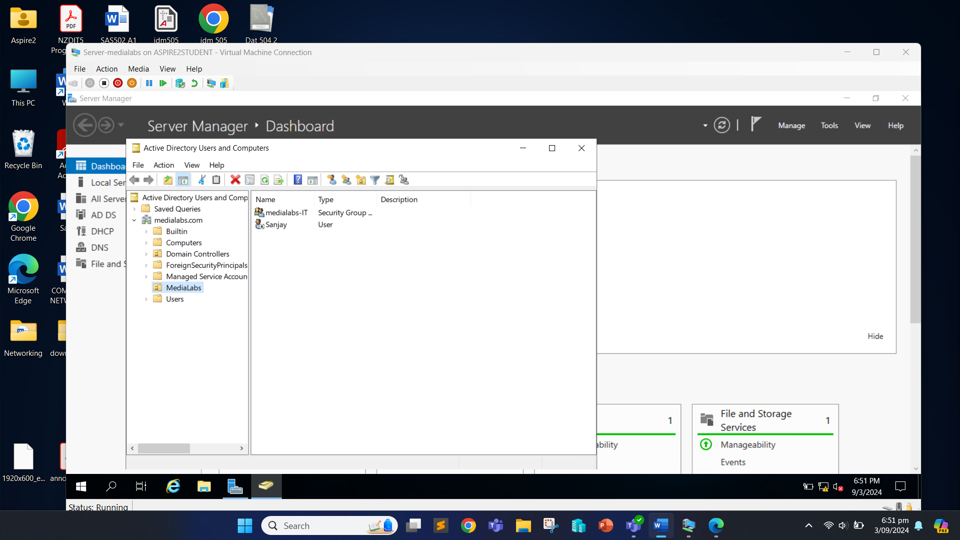

Right click on the medialabs-IT group and click on “Properties”.

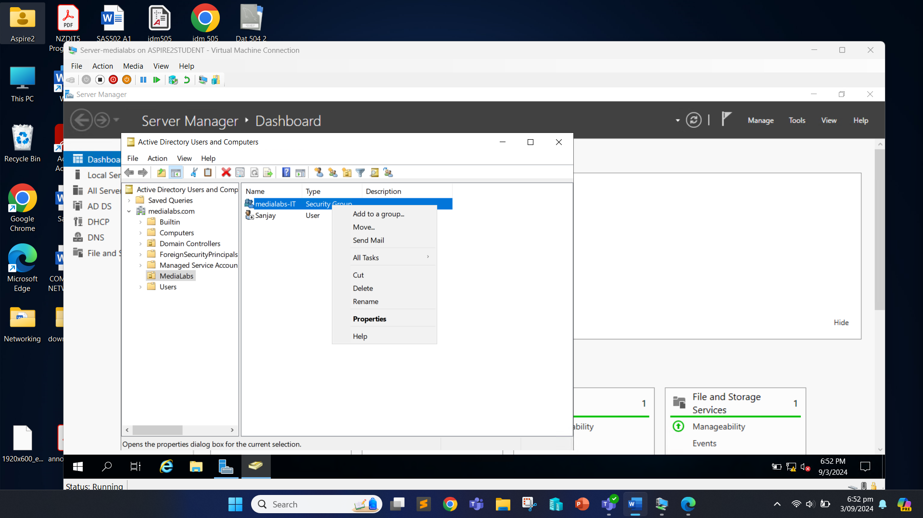

Click on the “Members” tab to see if the user Sanjay has been added to the group.

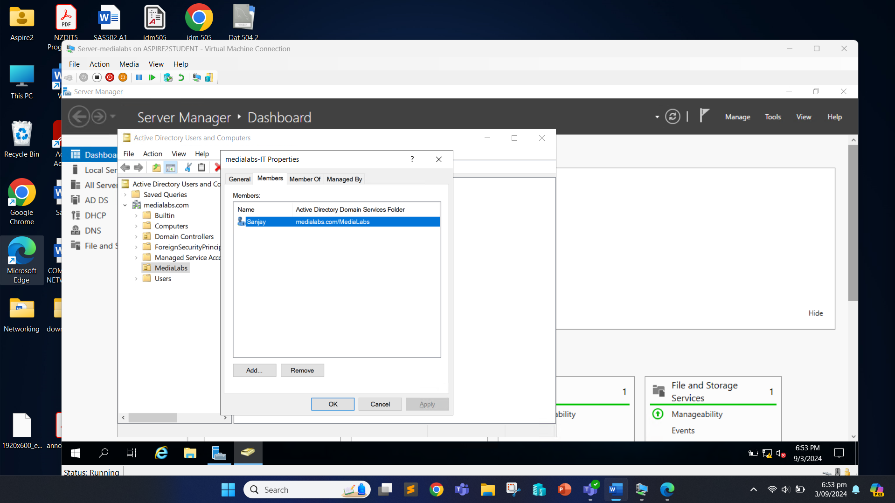

We can see that the user Sanjay has been successfully added to the group.

Now, we will click on the DHCP on Server Manager and click on the “DHCP Manager”.

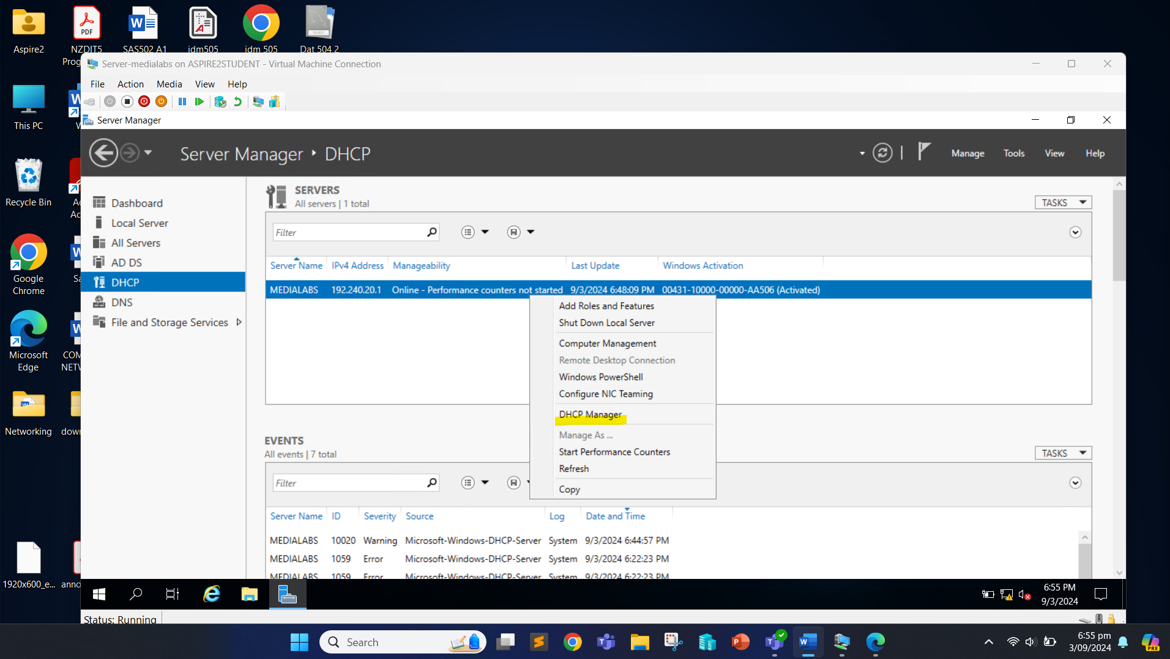

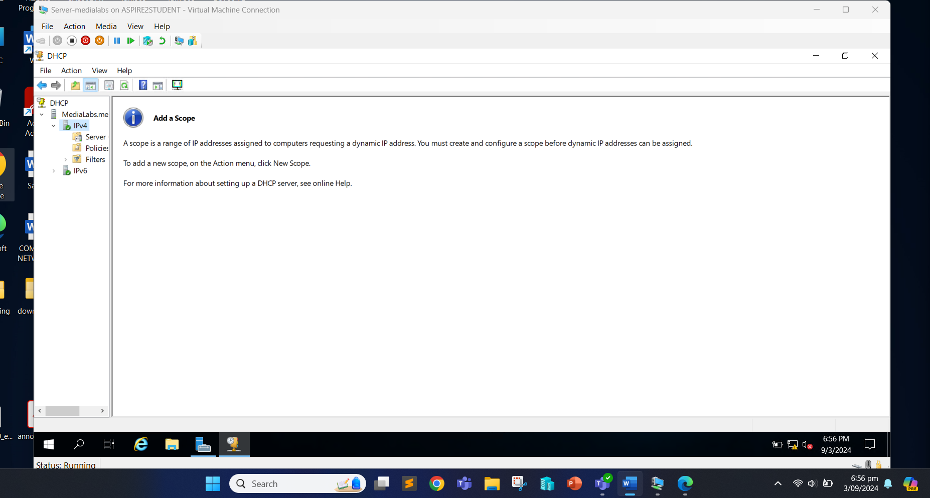

Right click on the IPv4 and click on “New Scope”.

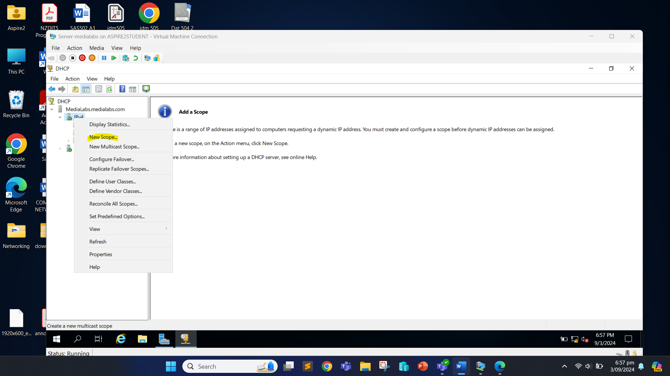

Click Next.

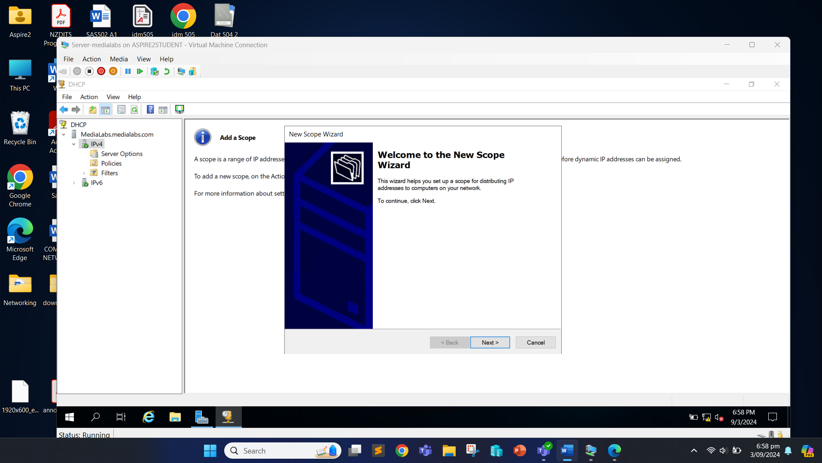

Click Next after setting the name.

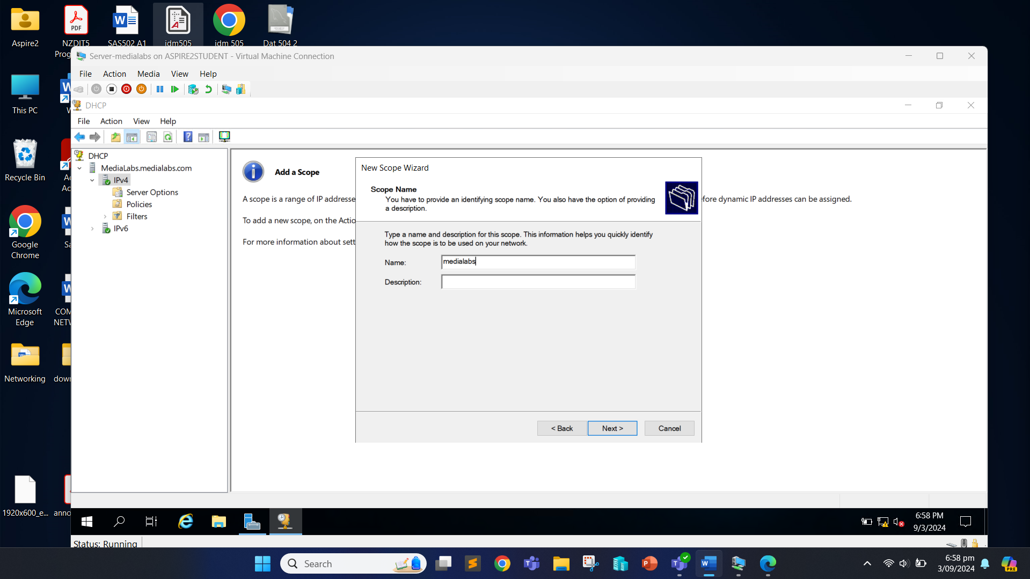

We configure the IP address range (192.168.20.10 to 192.168.20.70) and subnet masks. Click Next after done.

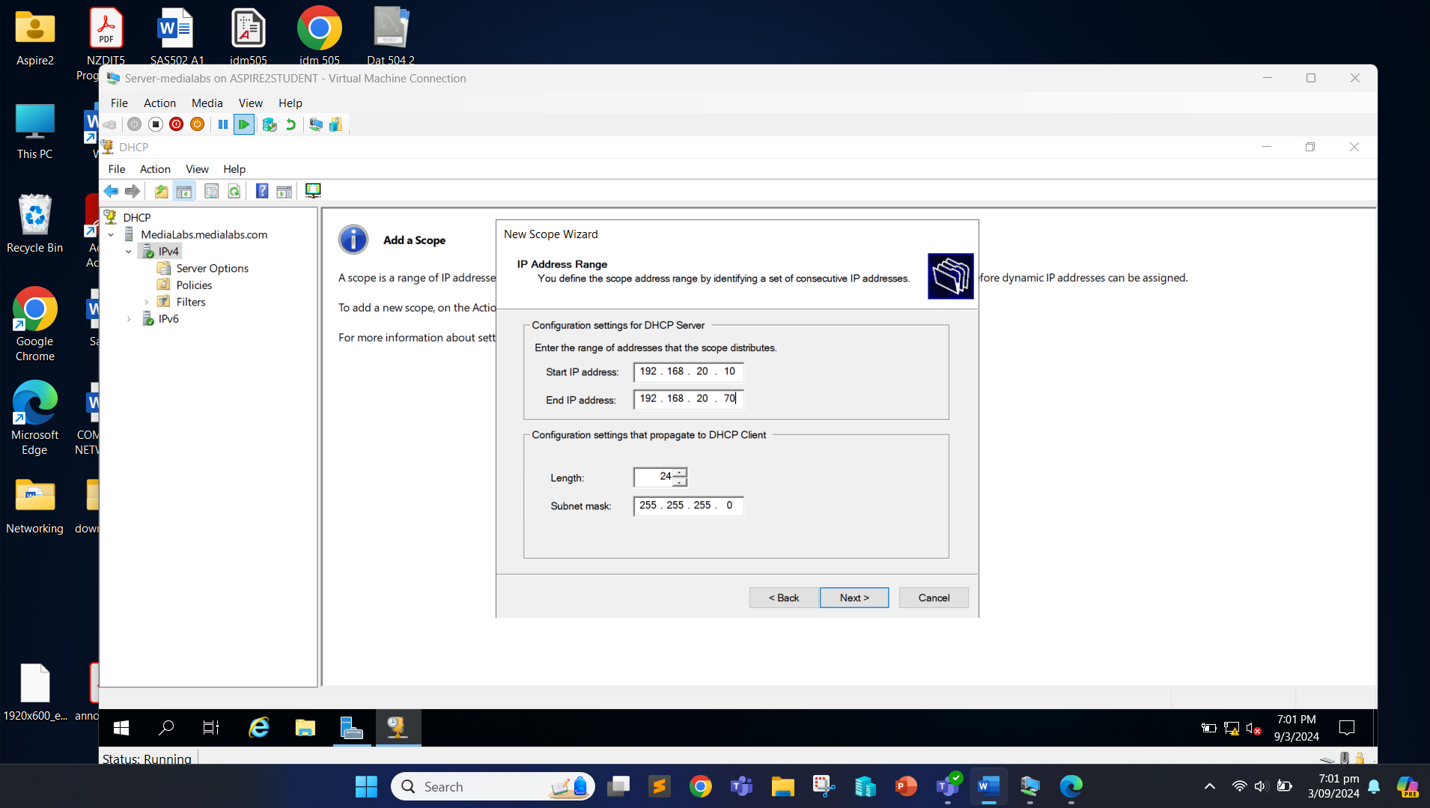

We can set the exclusion range from 192.168.20.30 to 192.168.20.40 and click Add. Once the exclusion range is set, click Next.

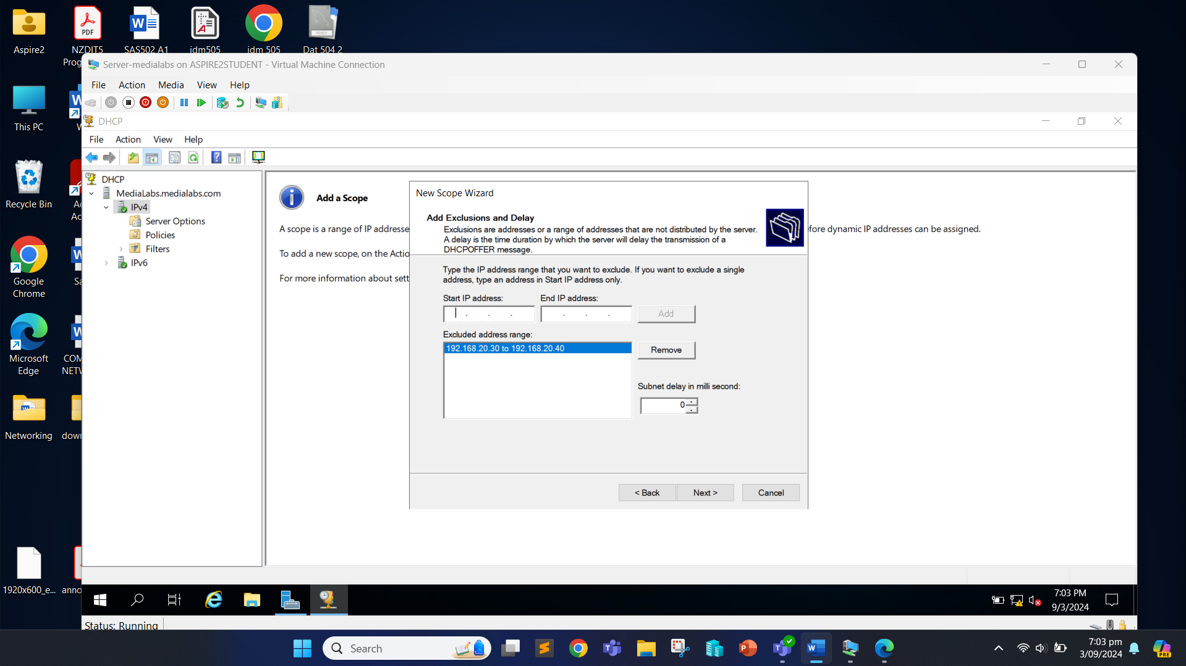

We can keep everything as default and proceed with “Next” until the last.

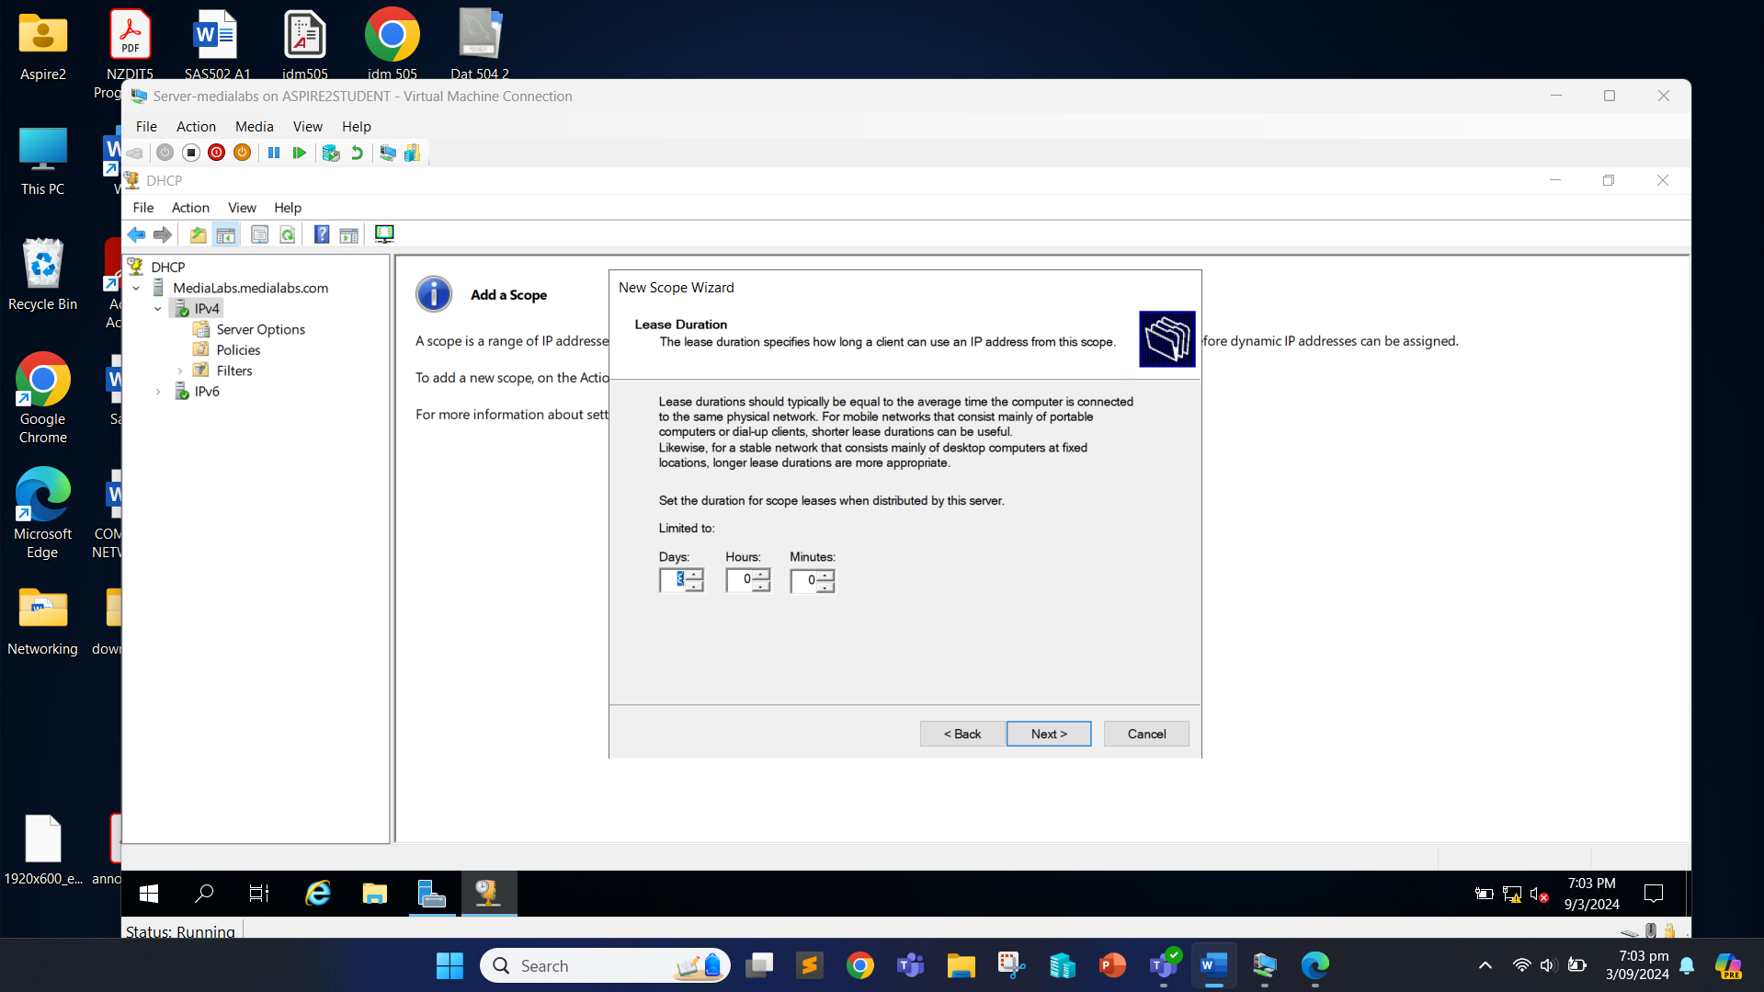

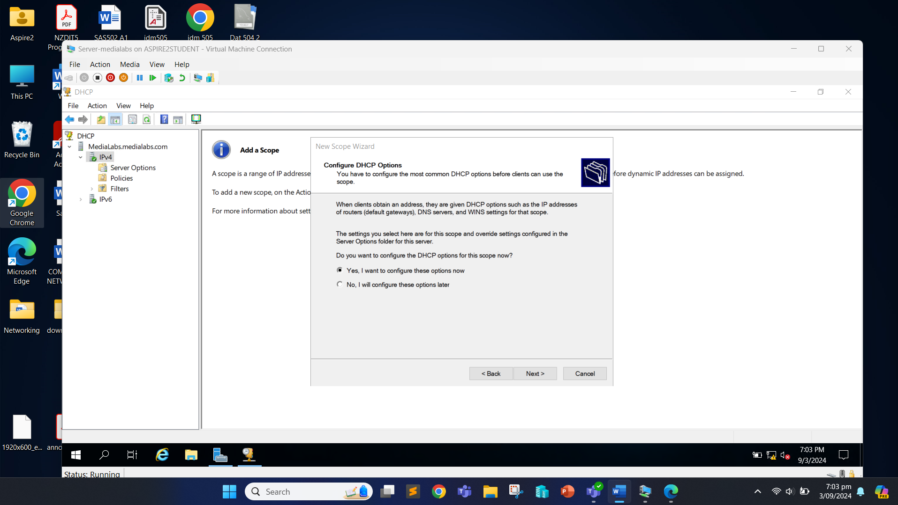

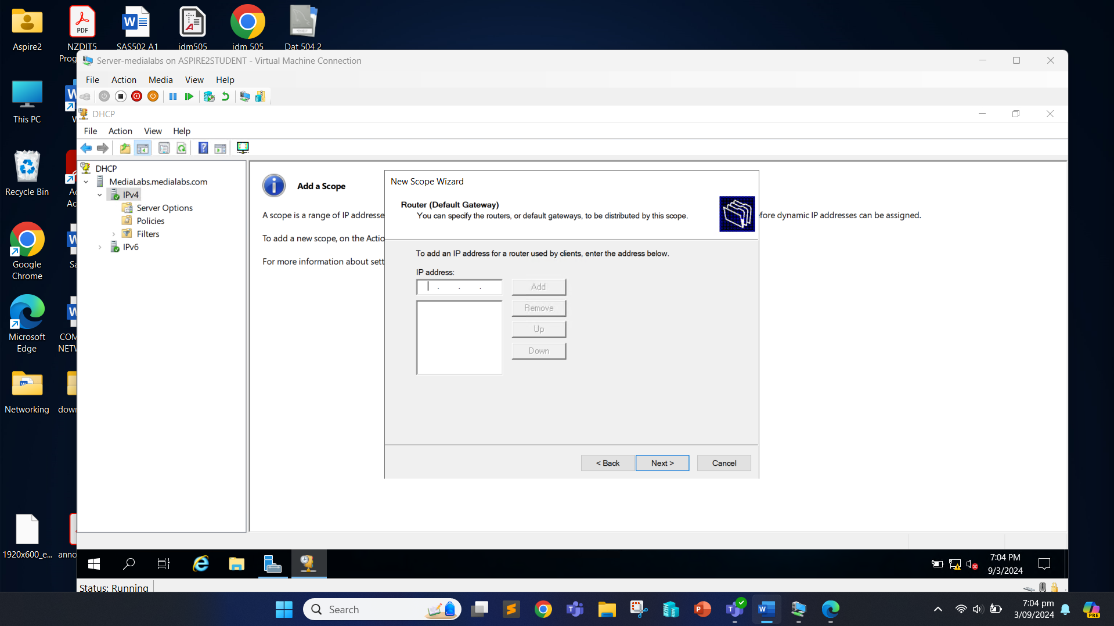

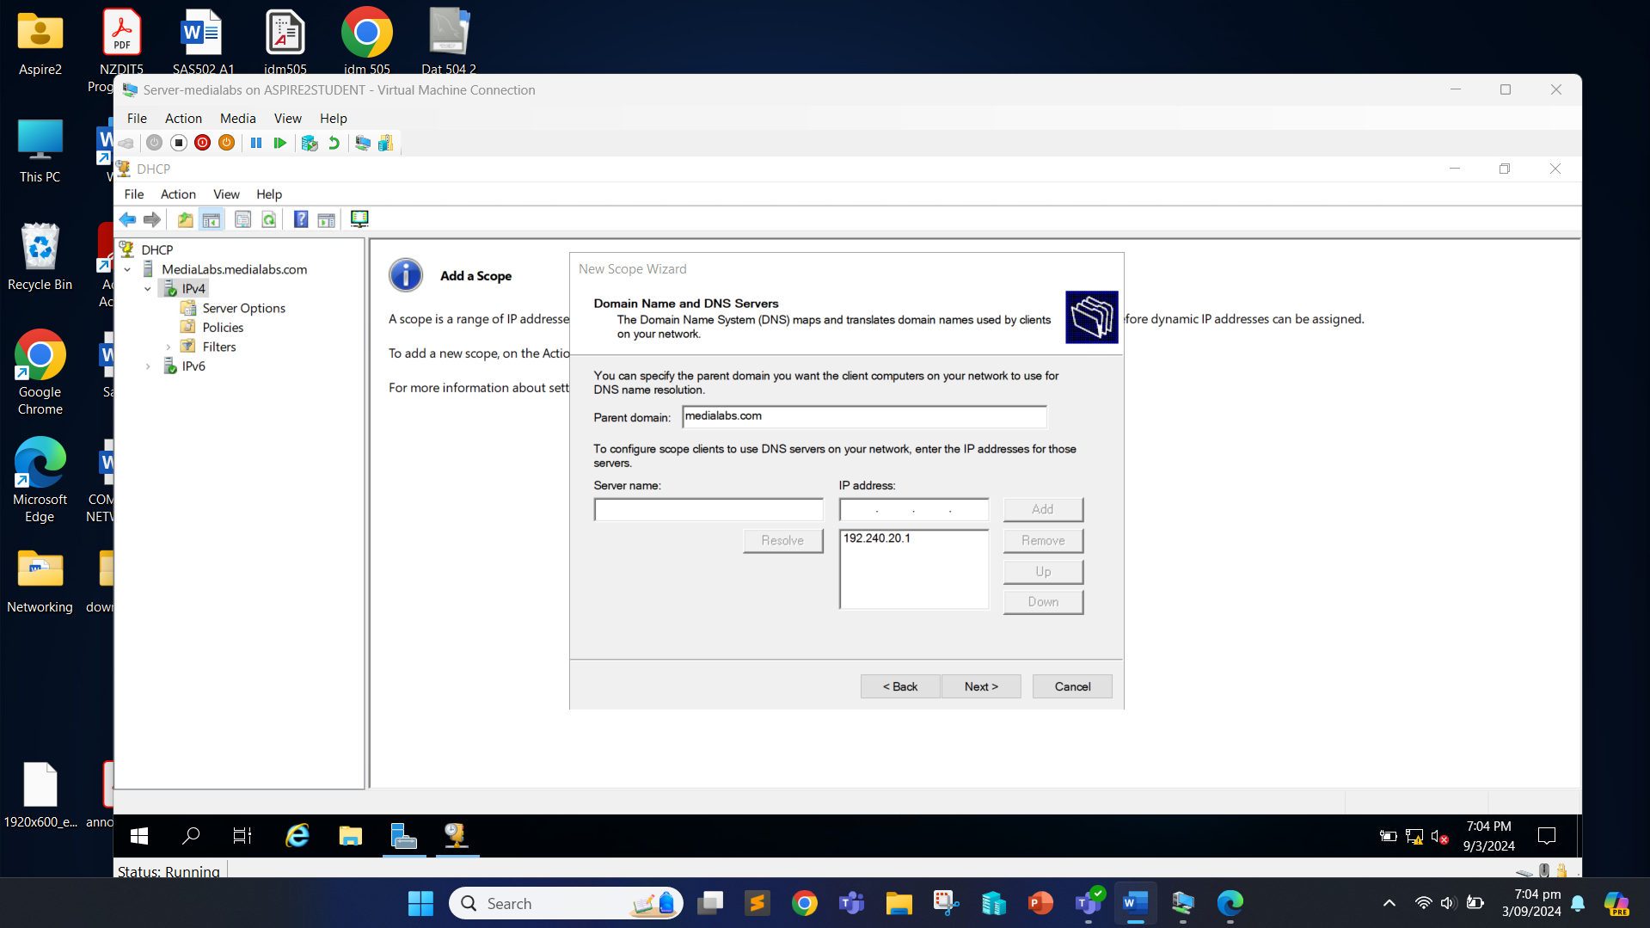

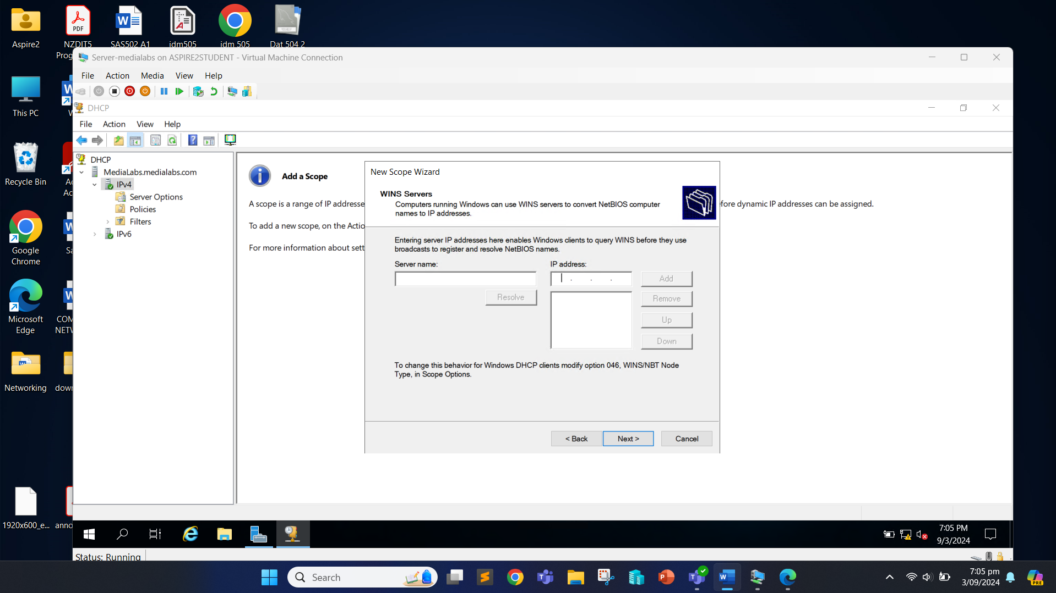

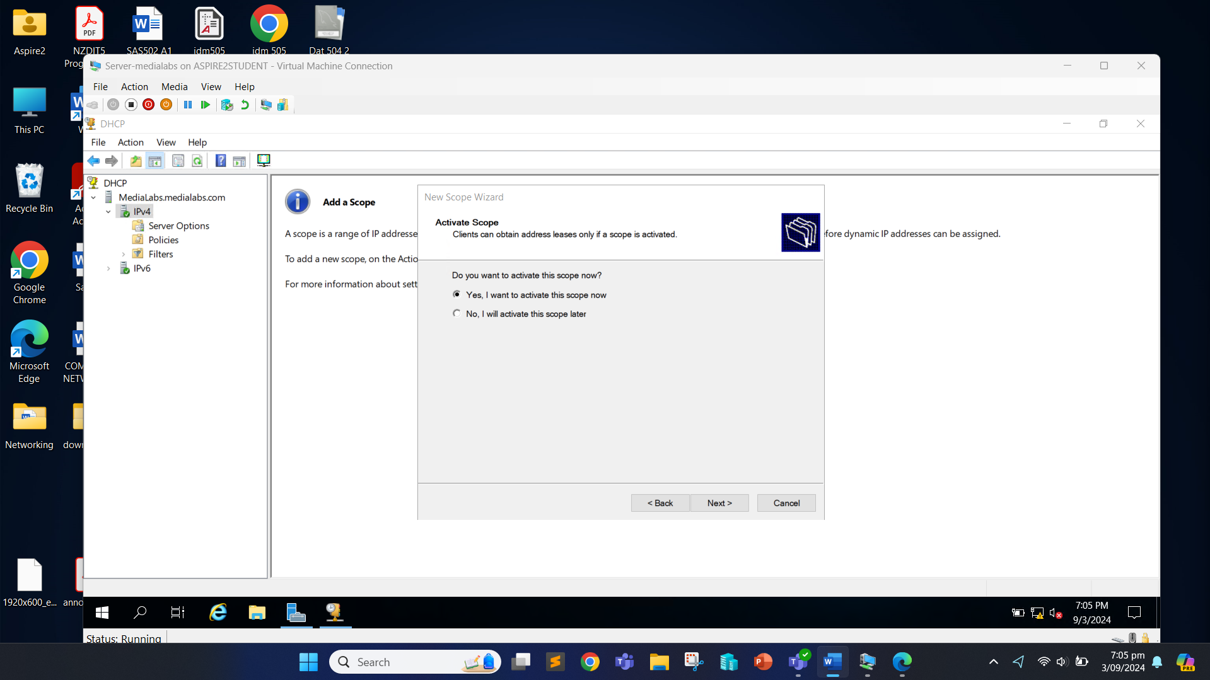

Click “Finish”.

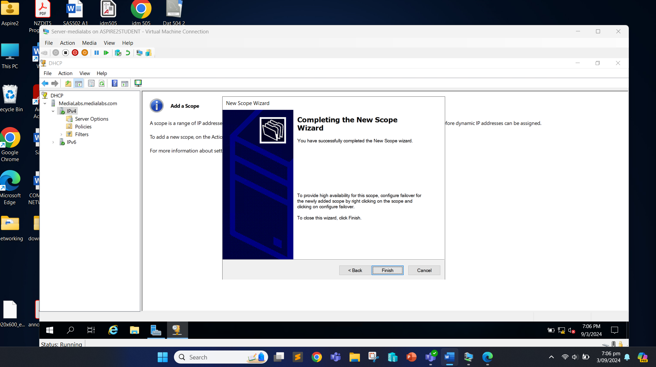

Now, right click on the scope name and click “All Tasks” and then click on “Restart”.

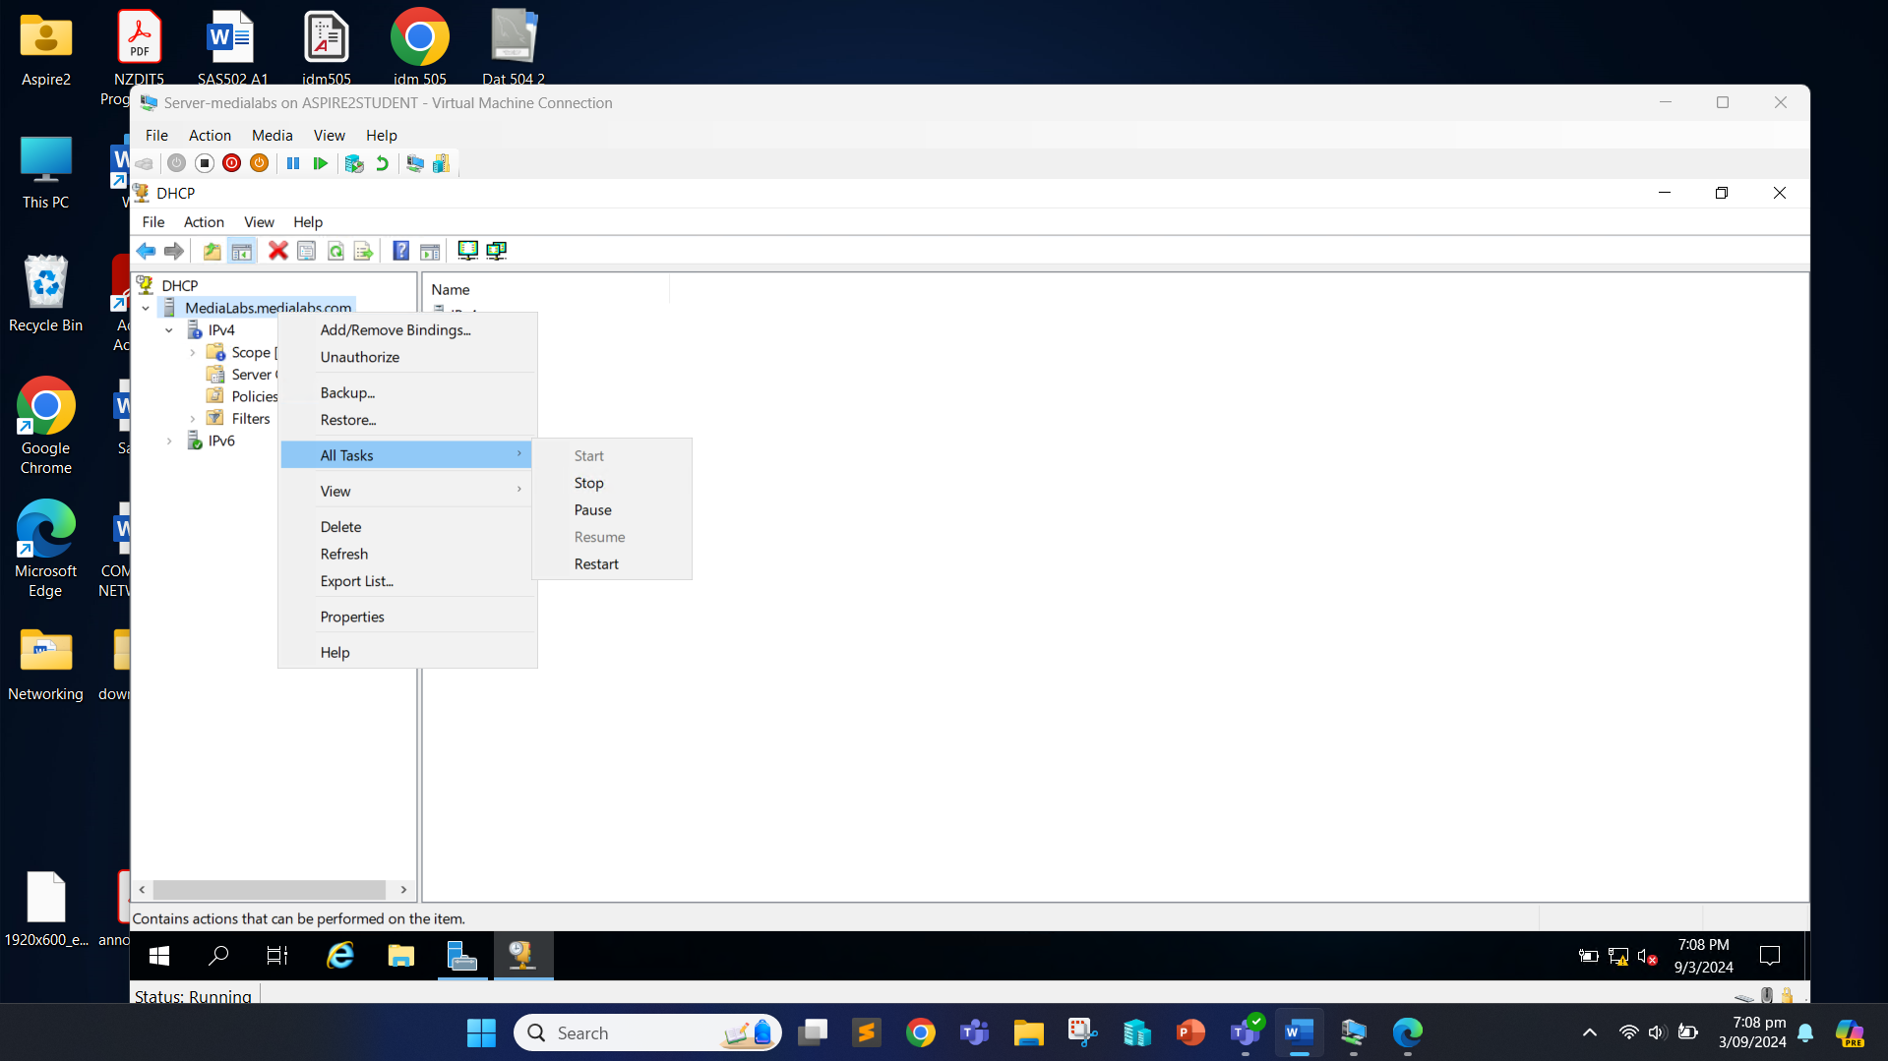

The new scope will now be added.

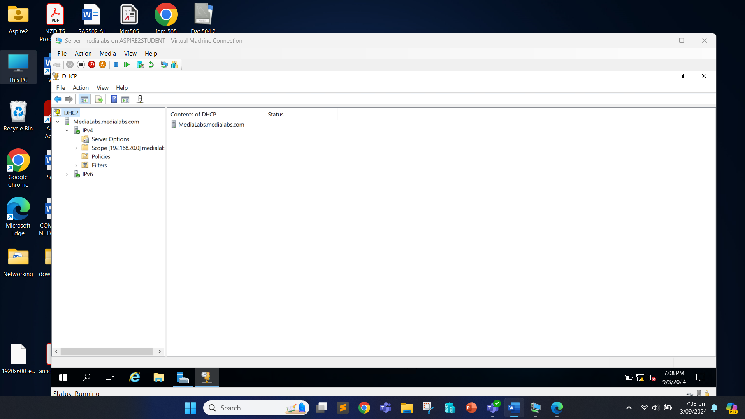

Next, we can install MDT.

We can copy the downloaded Microsoft Deployment Kit (MDT), Windows ADK, Windows PE add-ons and Windows 11 iso file to the server.

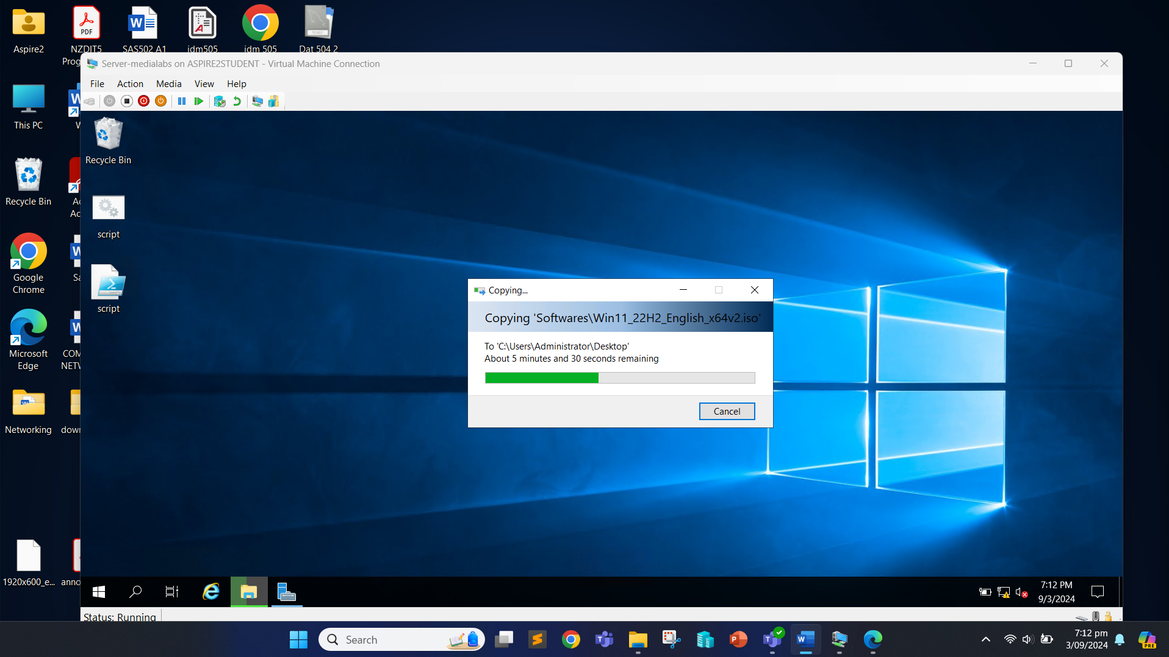

Once we have all the applications, we mount the iso file by right clicking on the image file and click “Mount” to create a DVD Drive.

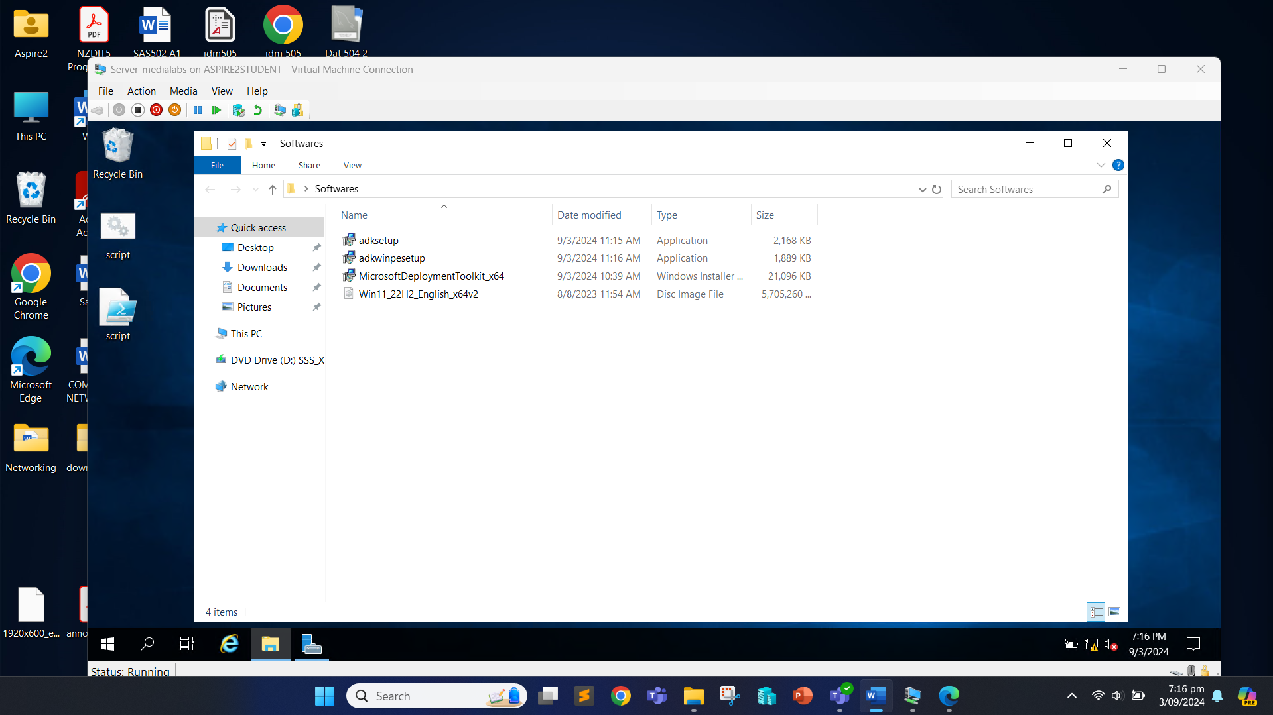

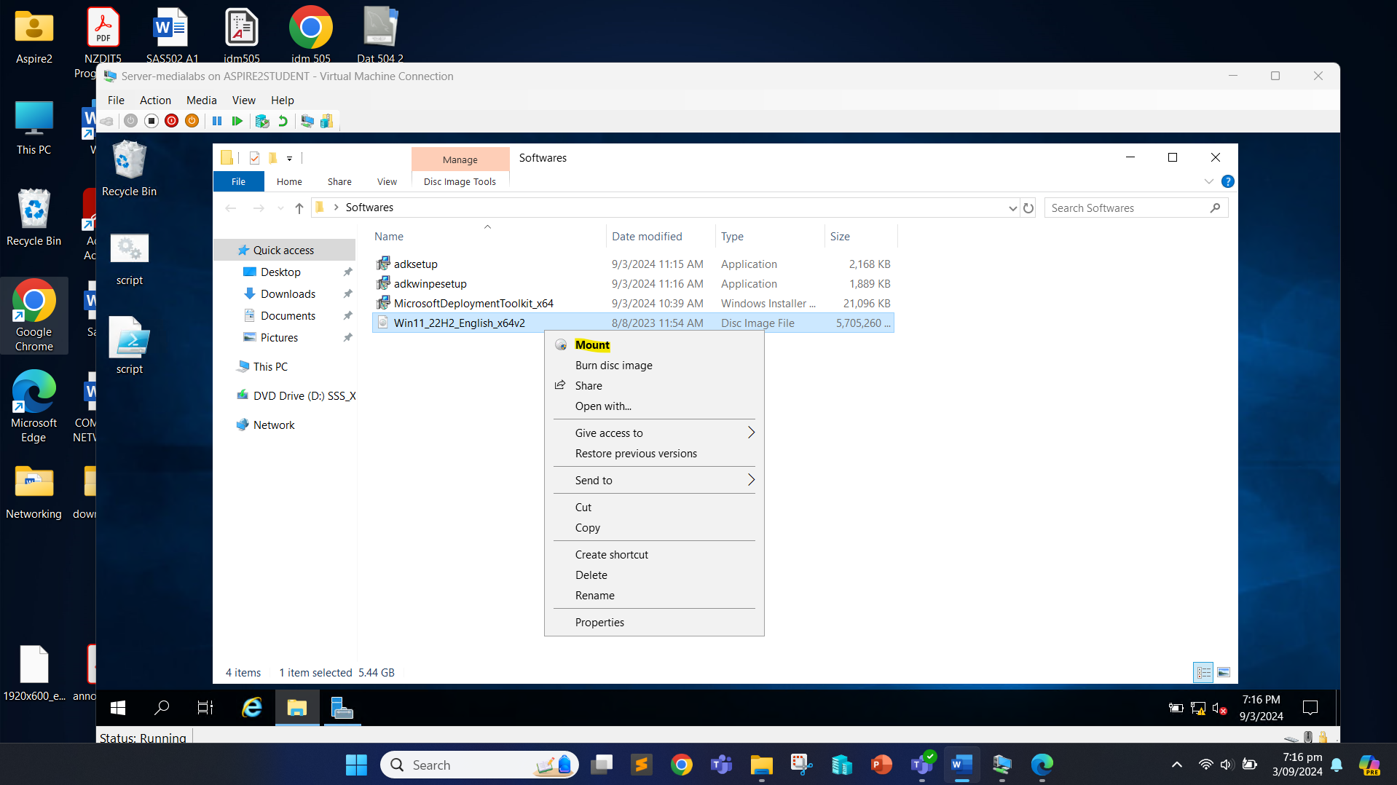

The image is then mounted to DVD Drive (E:).

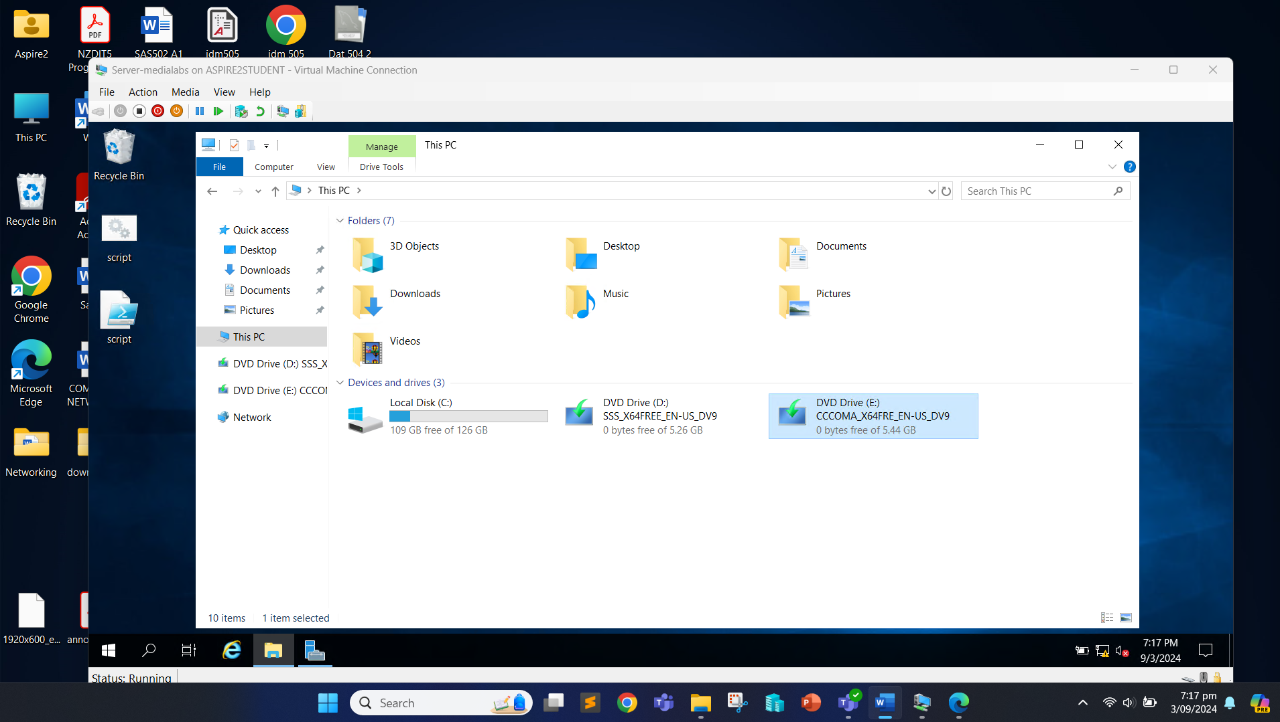

Now, we will install Windows ADK.

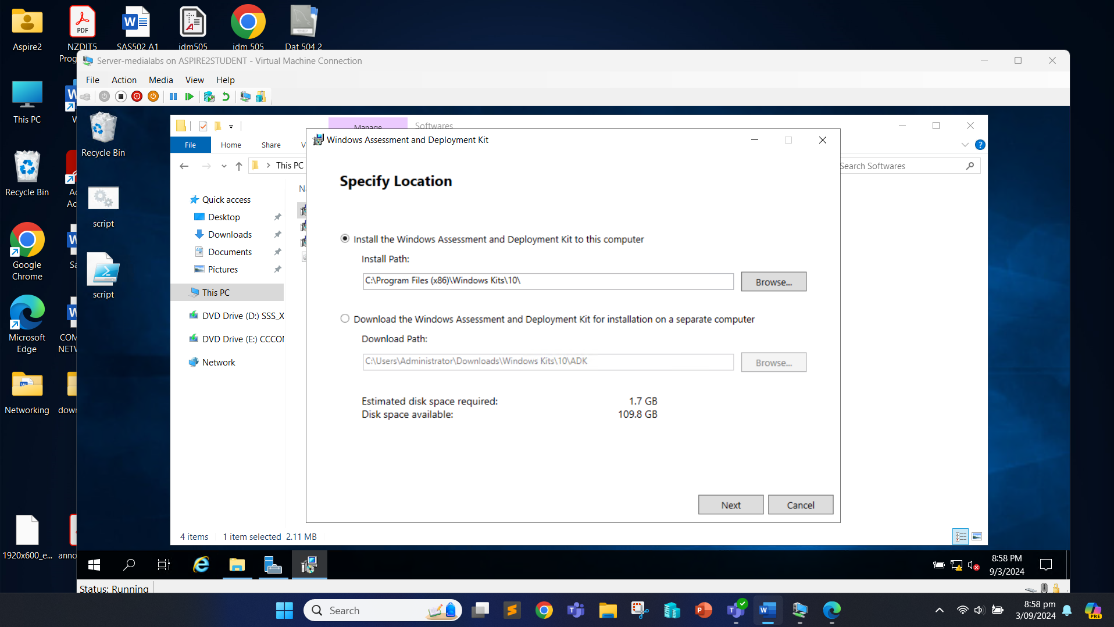

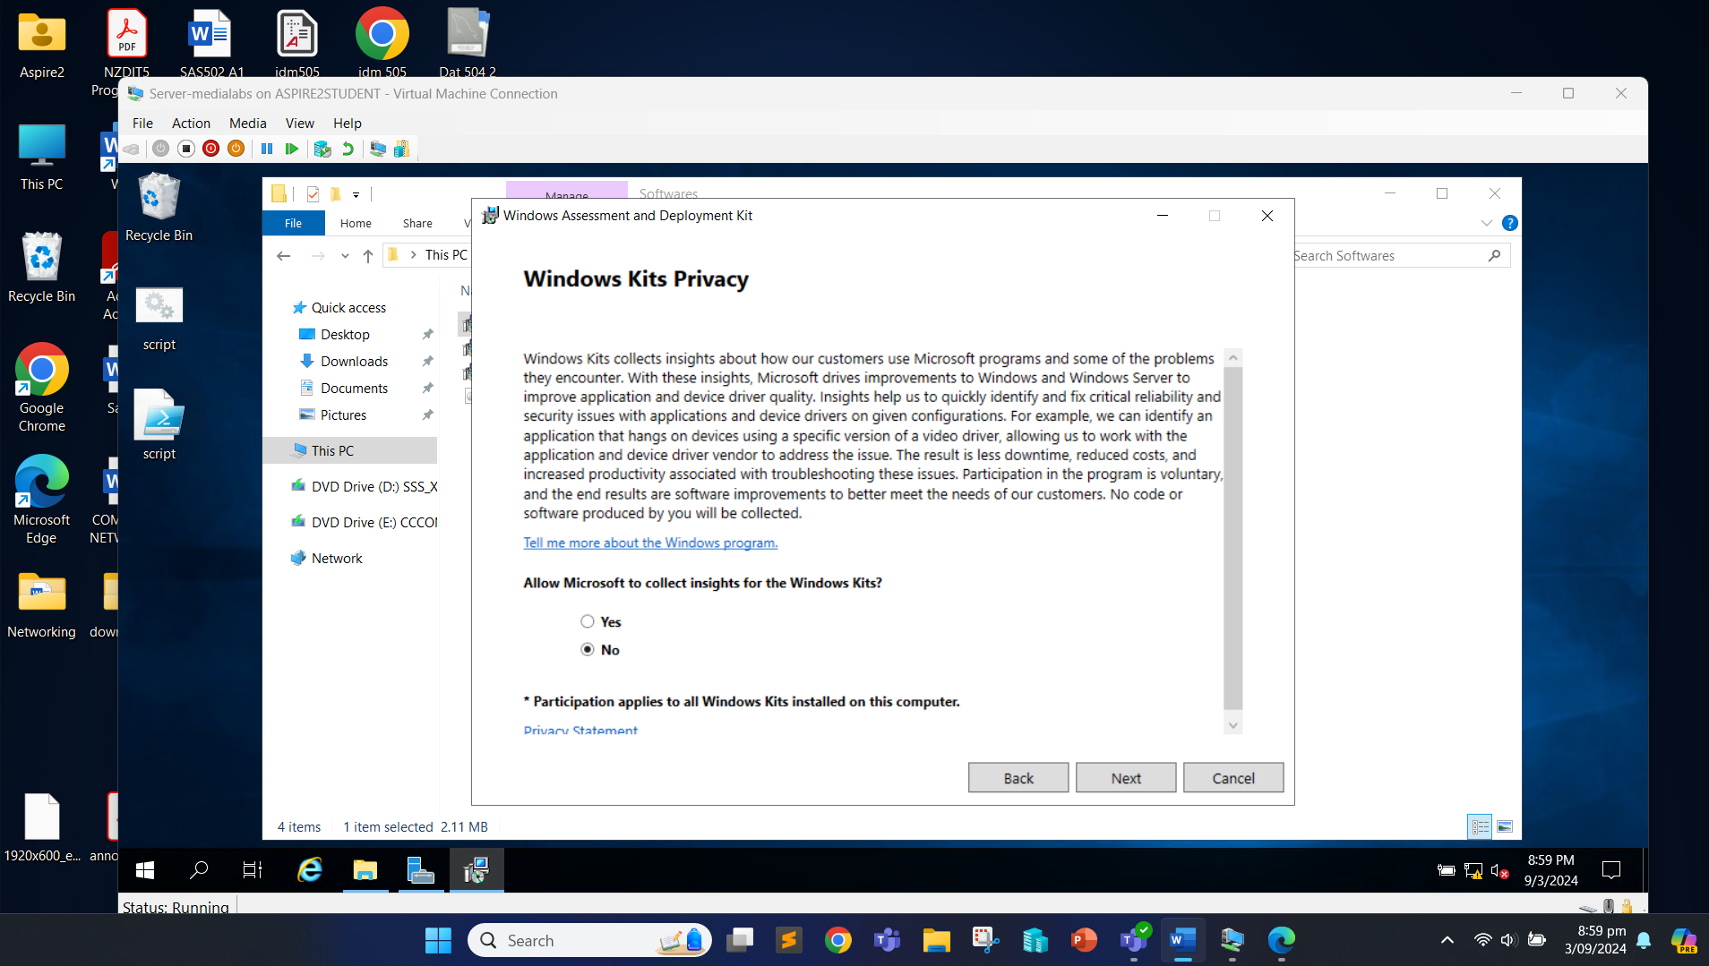

Click “Accept”.

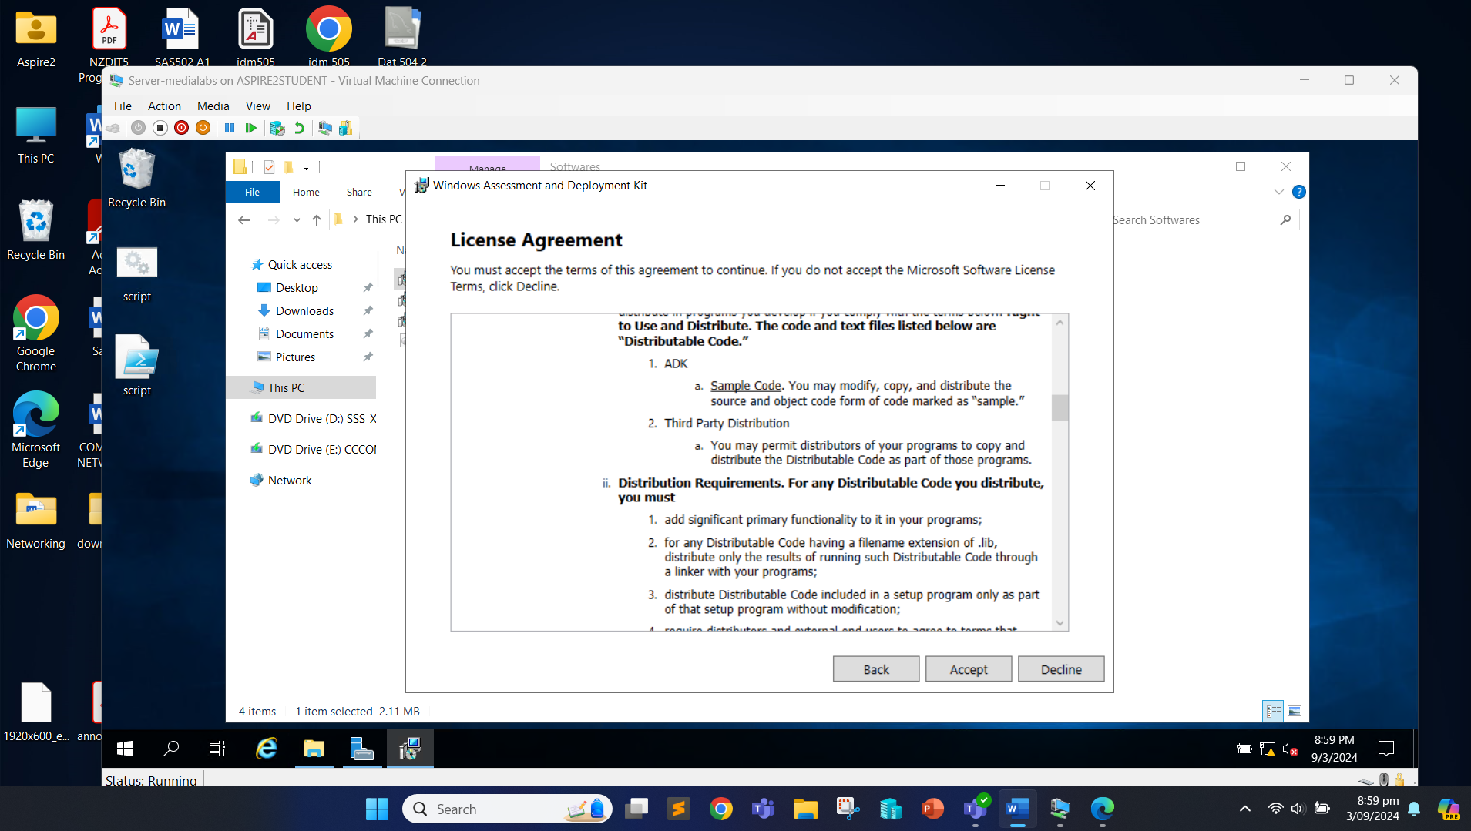

Click “Install”.

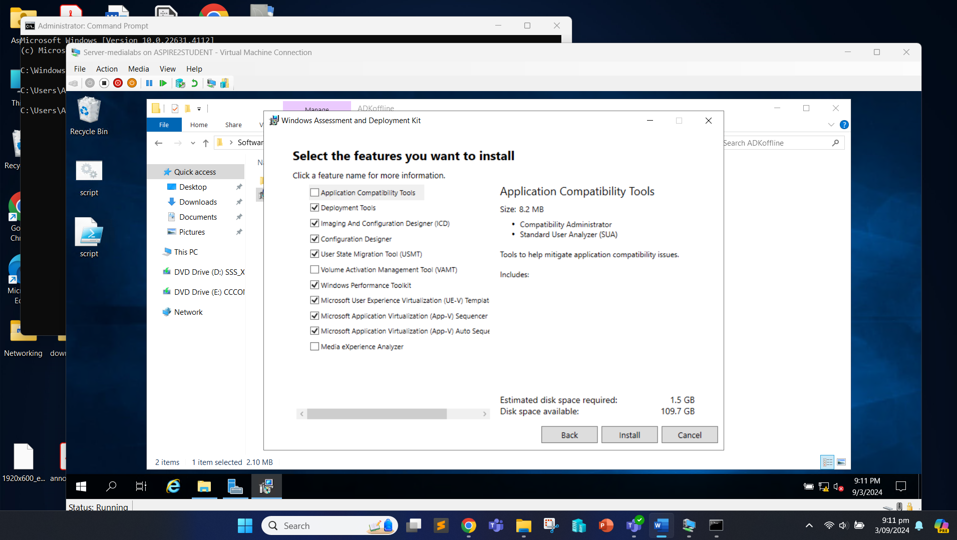

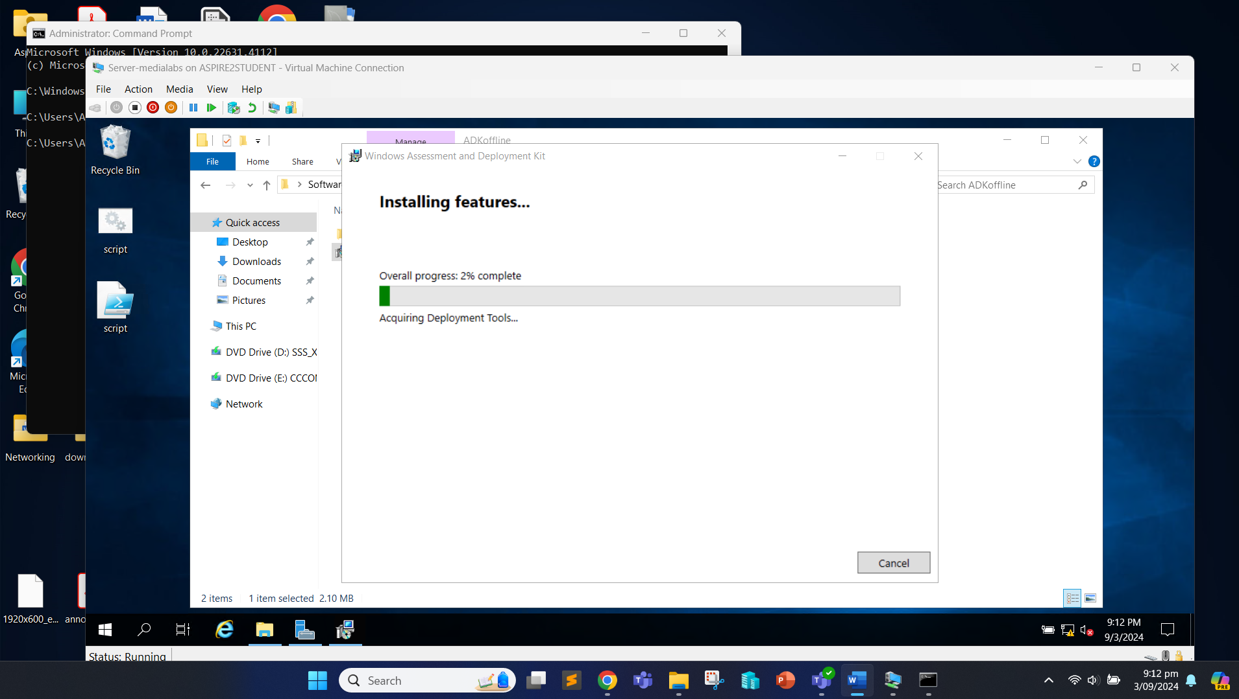

Once the installation is complete, click “Close”.

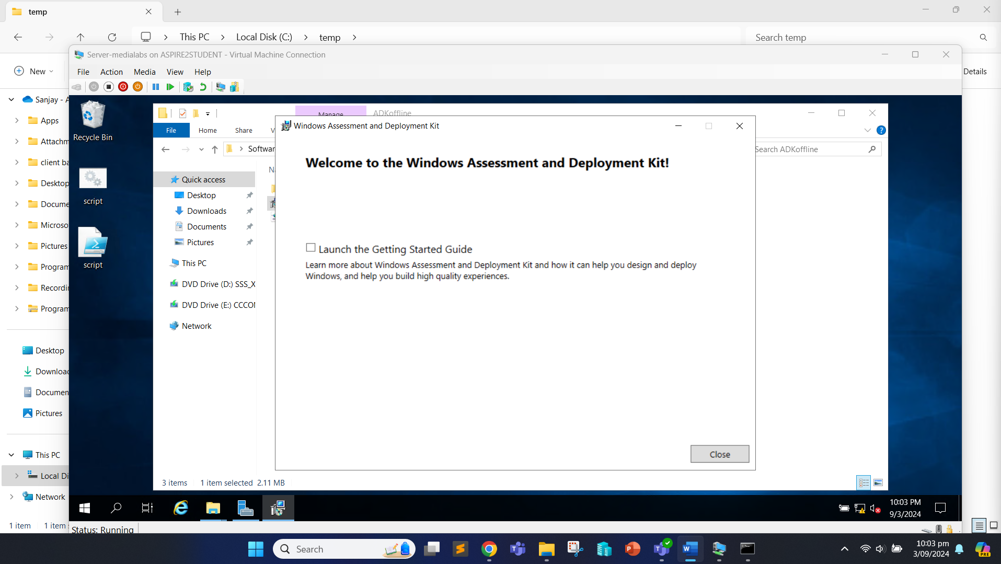

Now, we move to install Windows PE add-ons.

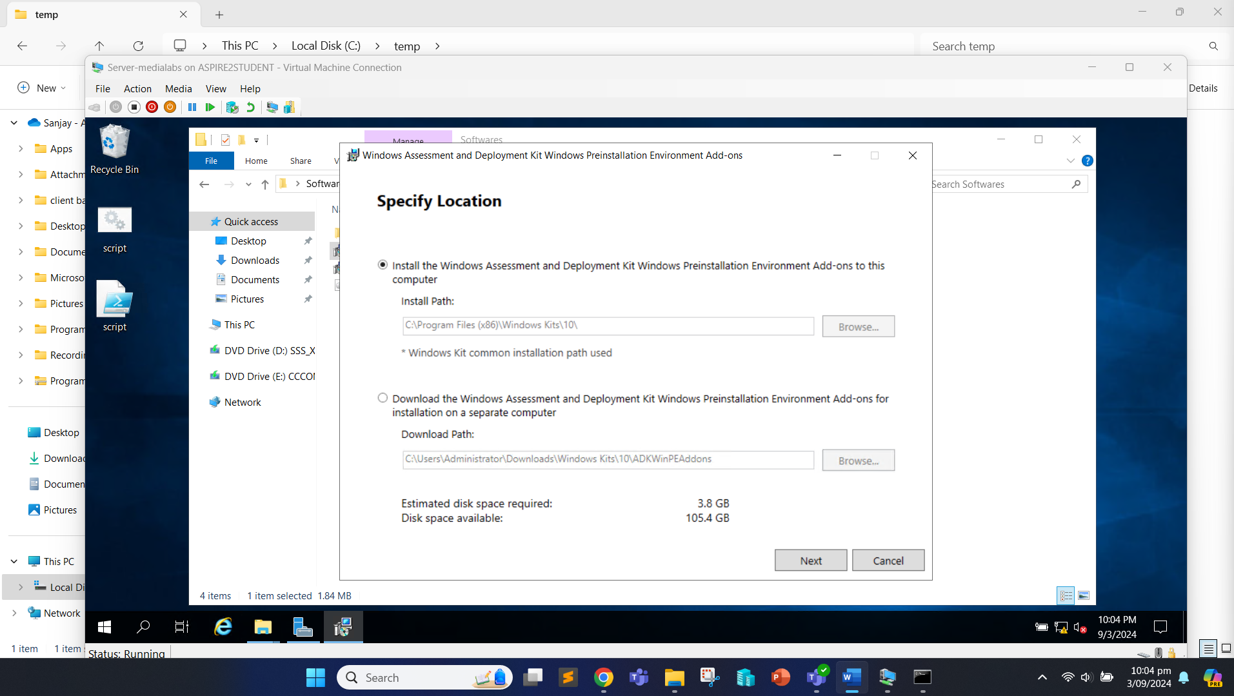

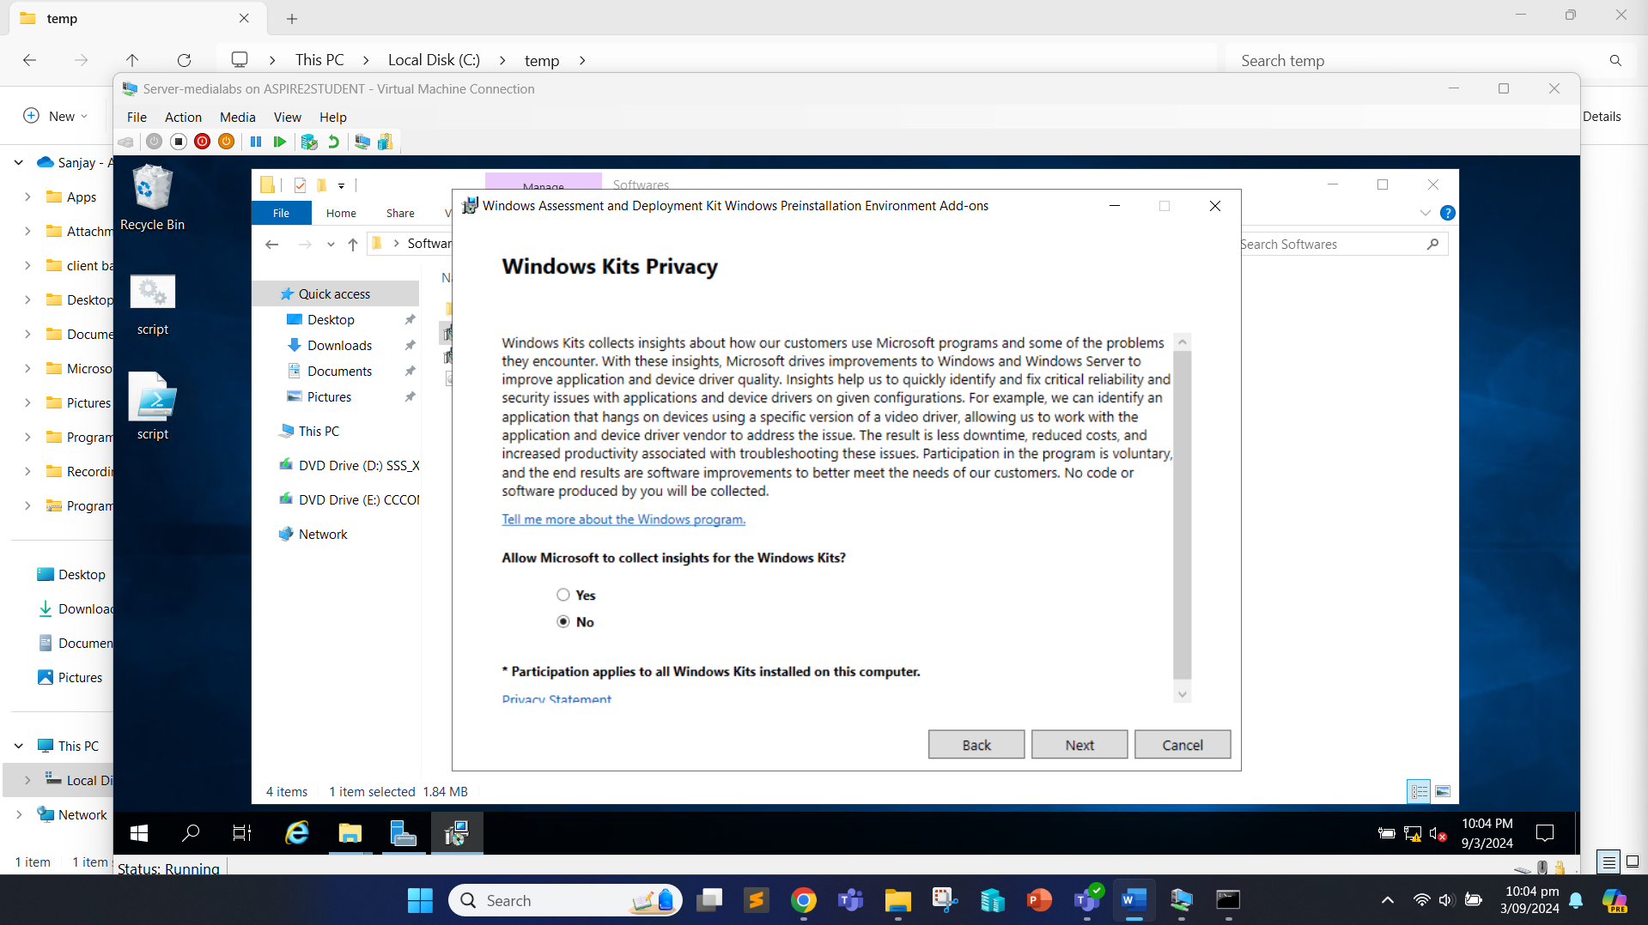

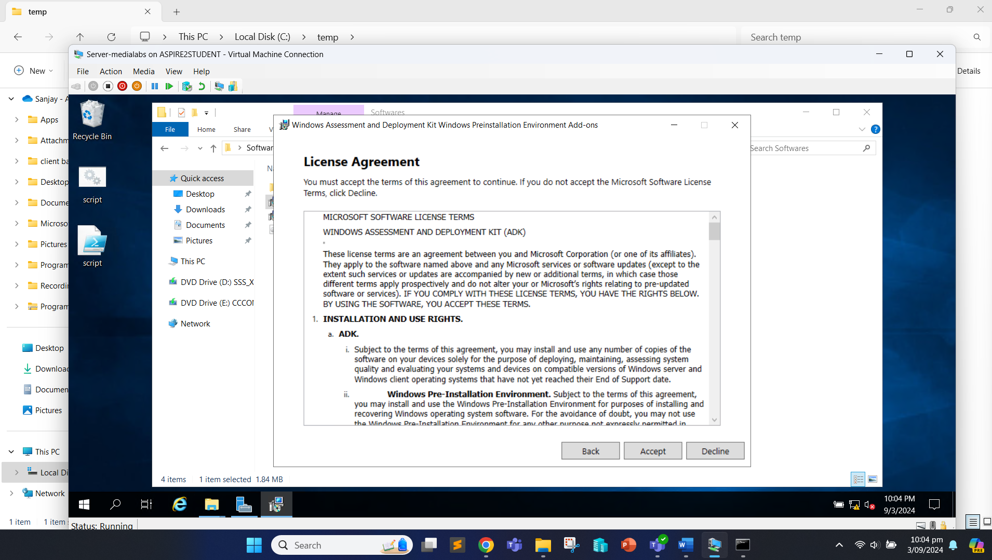

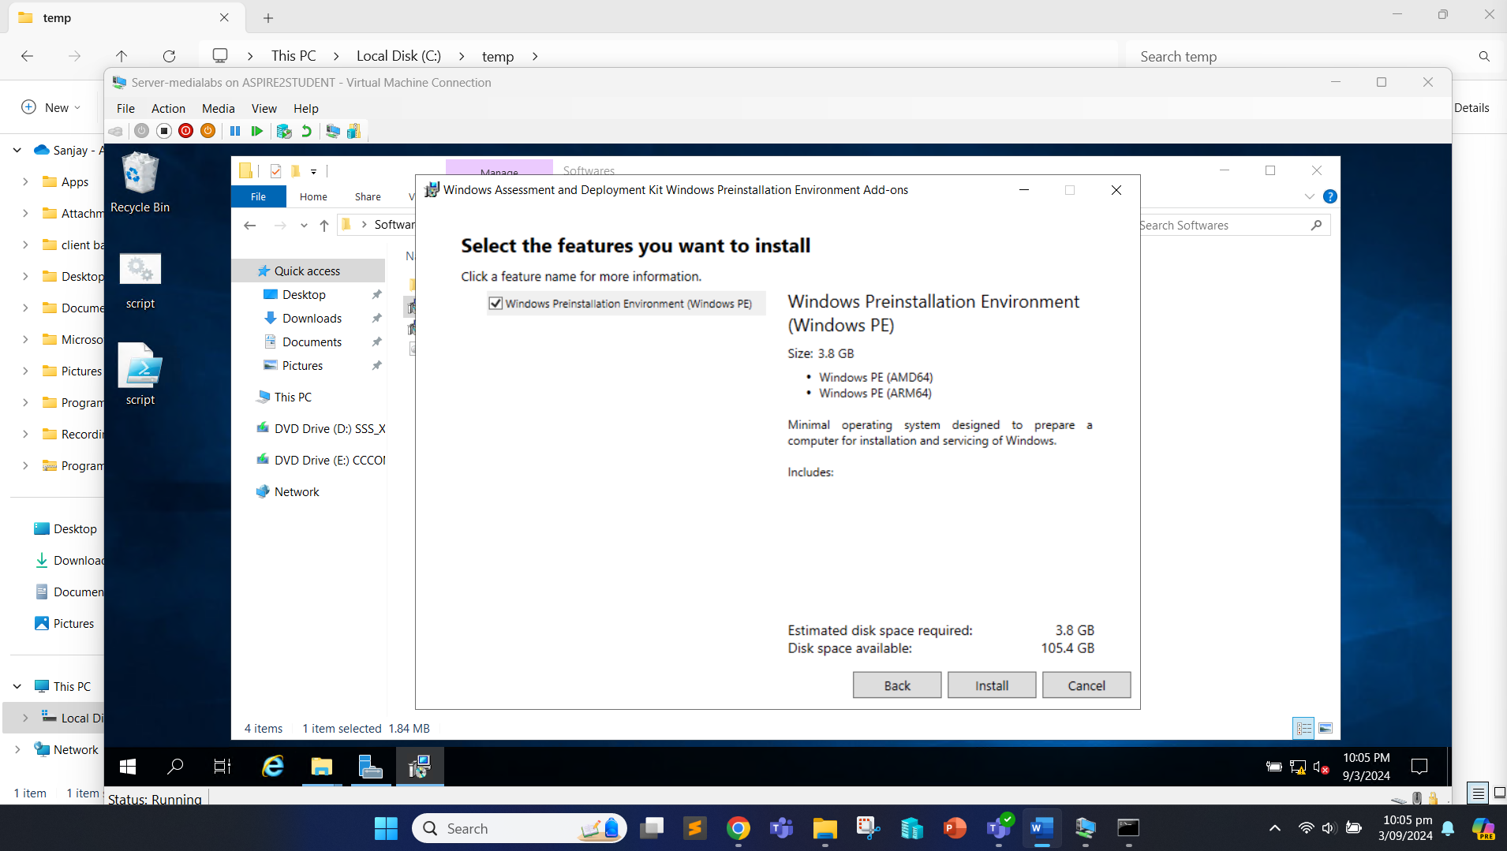

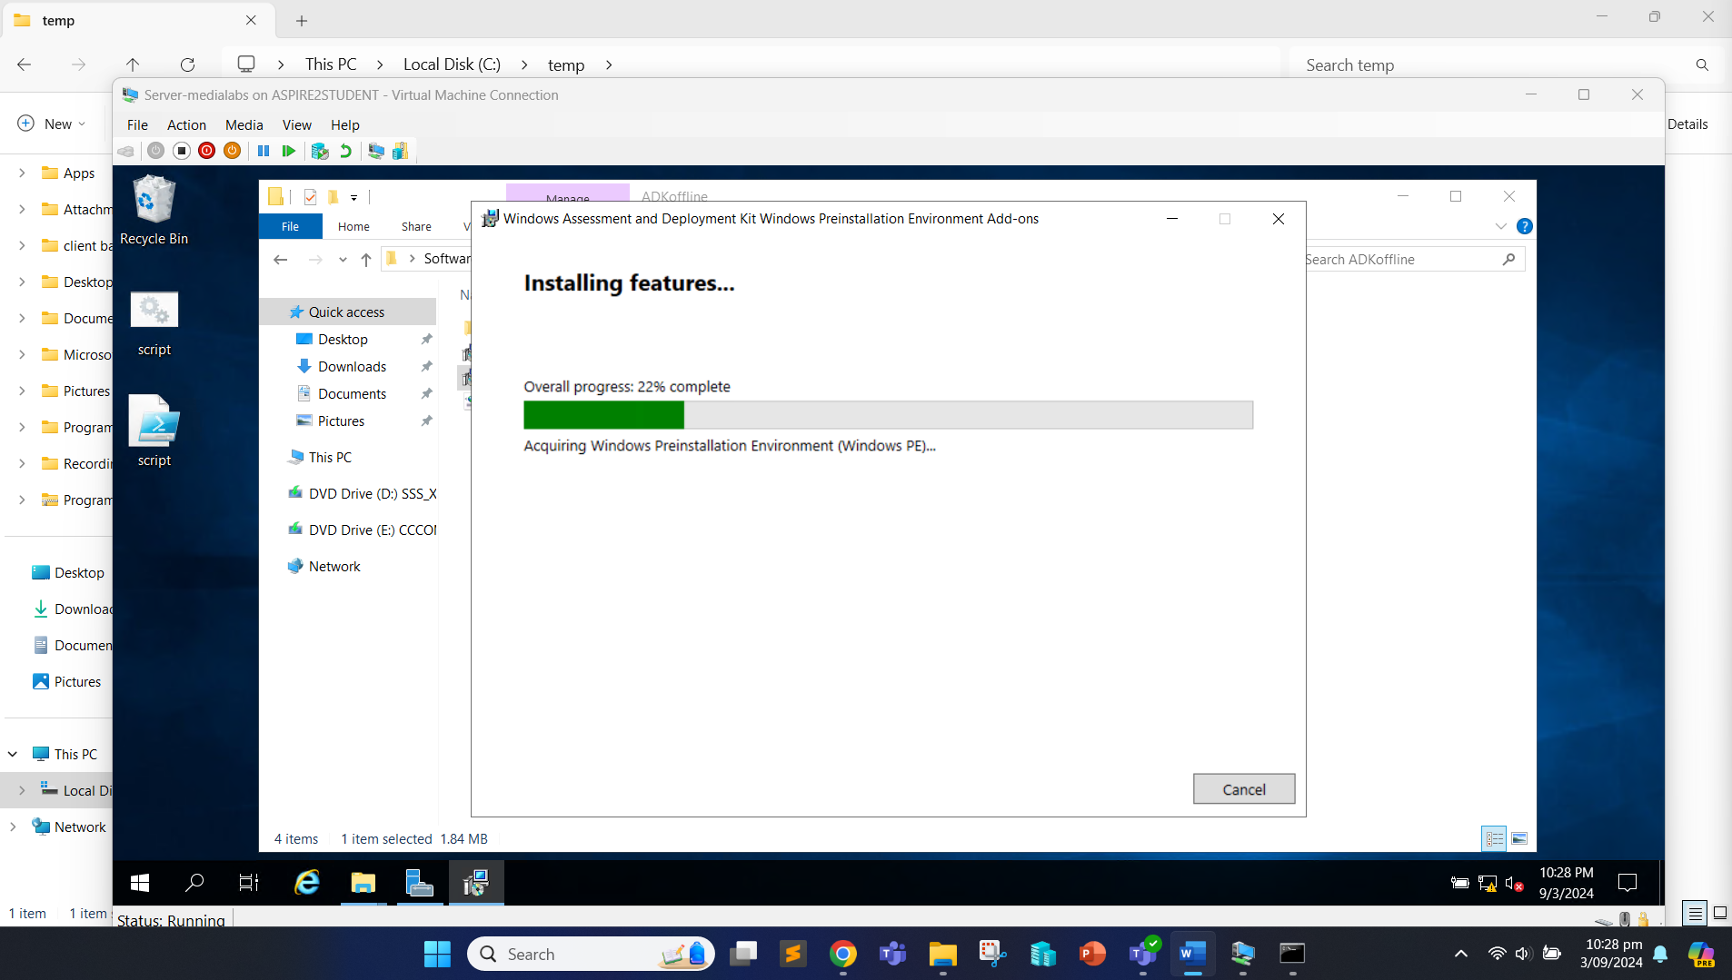

Now the installation is complete.

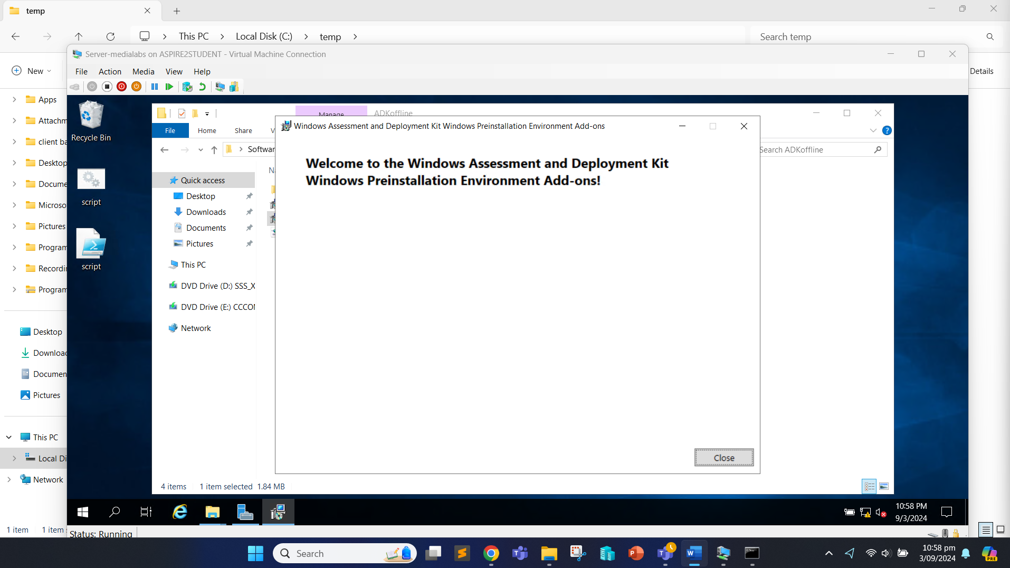

Now, we have installed required applications on the server, next we can install MDT.

**Script:**

#Define the path of the installer

$MDTInstallerPath = "C:\Users\Administrator\Desktop\Softwares\MicrosoftDeploymentToolkit_x64.msi"

# Install MDT

Start-Process -FilePath msiexec.exe -ArgumentList "/i `"$MDTInstallerPath`" /quiet /norestart" -Wait

We can verify the installation by opening “Deployment Workbench”.

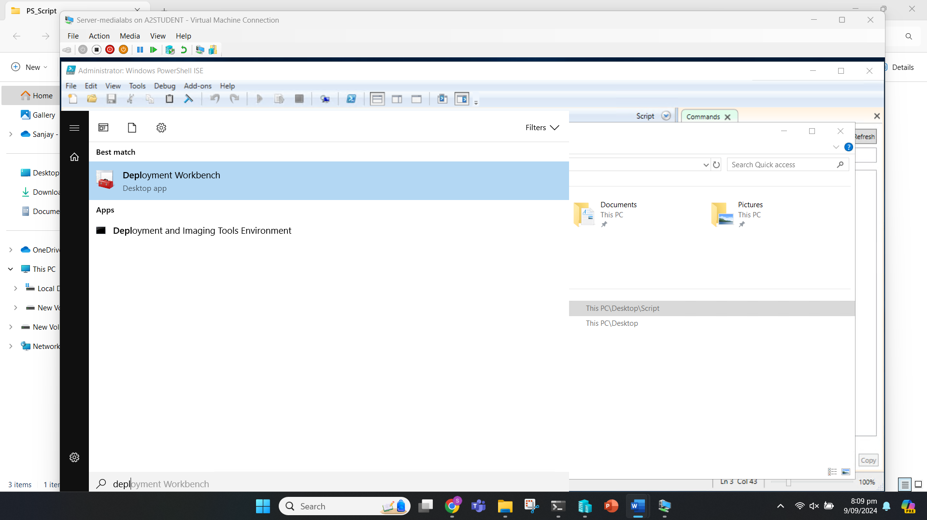

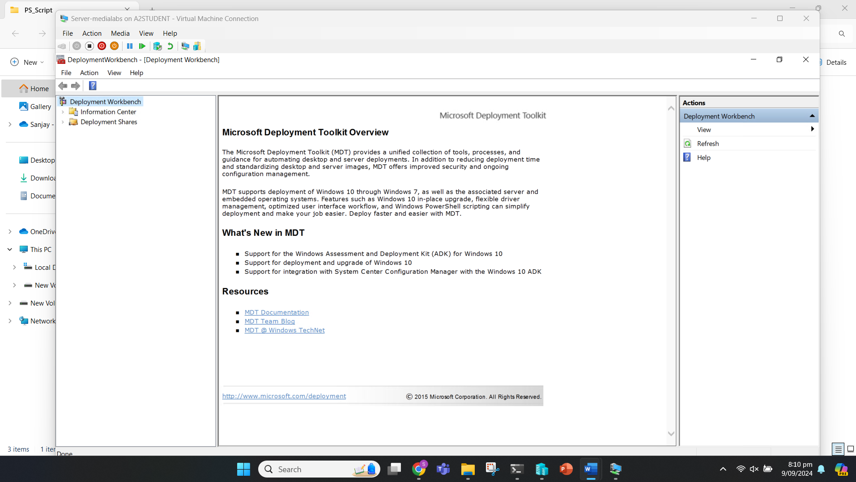

## Task 2: Analysis and Evaluation of Legal and Regulatory Requirements

### Task 2.1

**Legal Requirements**

**Software Licensing Compliance:** Software licensing compliance is crucial to ensure that Media Lab is using all software legally and in accordance with the terms set by the software providers.

**Implementation Strategy:**

* Maintain an up-to-date inventory of all software licenses.
* Implement a system to track software installations and usage across all deployed machines.
* Ensure that the number of installations does not exceed the number of licenses owned.
* Ensure all software being deployed (Windows 11, Chrome/Firefox, VLC, Adobe Acrobat Reader) is properly licensed for the number of machines being set up.
* Include a step in the deployment script to log the software installations, including version numbers and license information.

**Regulatory Requirements**

**Data Protection (GDPR Compliance):** Assuming Media Lab operates or has clients in the European Union, GDPR compliance is necessary to protect personal data processed during and after the deployment.

**Implementation Strategy:**

* Minimize collection of personal data during deployment.
* Implement strong access controls and encryption for any personal data stored on client machines.
* Ensure that user accounts are created with the principle of least privilege.
* Modify the deployment script to create user accounts with minimal privileges by default.
* Include a step to encrypt any local storage on the client machines.
* Add a process to generate and securely store unique, complex passwords for each user account.

## Task 3: Plan, Design and Create a Deployment script

### Task 3.1

**Configuring MDT Deployment Share**

**Script:**

# Create a new Folder

New-Item -Path C:\DeploymentShare -Type directory -Verbose

# Share Folder

New-SmbShare -Name "DeploymentShare" -Path "C:\DeploymentShare" -FullAccess "medialabs.com\administrator","everyone"

# Import MDT Module

Import-Module "C:\Program Files\Microsoft Deployment Toolkit\bin\MicrosoftDeploymentToolkit.psd1"

# Create a new Deployment Share

New-PSDrive -Name "DS001" -PSProvider "MDTProvider" -Root "C:\DeploymentShare" -Description "MDT Deployment Share" -NetworkPath \\MEDIALABS\DeploymentShare | add-MDTPersistentDrive

# Import operating system into MDT deployment share

Import-MDTOperatingSystem -path "DS001:\Operating Systems" -SourcePath "E:\" -DestinationFolder "Windows 11" -Verbose

# Add VLC

Import-MDTApplication -path "DS001:\Applications" -enable "True" -Name "VLC" -ShortName "VLC" -CommandLine "vlc-3.0.21-win64.exe /L=1033 /S"`

-WorkingDirectory ".\Applications\VLC" -ApplicationSourcePath "C:\Users\Administrator\Desktop\Apps" -DestinationFolder "VLC" -Verbos

# Add Adobe Acrobat Reader

Import-MDTApplication -path "DS001:\Applications" -enable "True" -Name "Adobe Acrobat" -ShortName "Adobe Acrobat" -CommandLine "Reader_en_install.exe /sAll /rs /msi EULA_ACCEPT=YES"`

-WorkingDirectory ".\Applications\Adobe Acrobat" -ApplicationSourcePath "C:\Users\Administrator\Desktop\Apps" -DestinationFolder "Adobe Acrobat" -Verbos

# Add Google Chrome

Import-MDTApplication -path "DS001:\Applications" -enable "True" -Name "Google Chrome" -ShortName "Google Chrome" -CommandLine "ChromeSetup.exe /silent /install"`

-WorkingDirectory ".\Applications\Google Chrome" -ApplicationSourcePath "C:\Users\Administrator\Desktop\Apps" -DestinationFolder "Google Chrome" -Verbos

# Import task sequence

Import-MDTTaskSequence -path "DS001:\Task Sequences" -Name "OS with APPs" -Template "Client.xml" -Comments "" -ID "1" -Version "1.0"`

-OperatingSystemPath "DS001:\Operating Systems\Windows 11 Home in Windows 11 install.wim" -FullName "Windows User" -OrgName "Media Labs" -HomePage "about:blank" -Verbose

# Update CustomSettings.ini and Bootstrap.ini

$CSpath = "C:\DeploymentShare\Control\CustomSettings.ini"

$BSpath = "C:\DeploymentShare\Control\Bootstrap.ini"

$CScontent = @'

[Settings]

Priority=Default

Properties=MyCustomProperty

[Default]

OSInstall=Y

SkipCapture=YES

SkipAdminPassword=YES

SkipProductKey=YES

SkipComputerBackup=YES

SkipBitLocker=YES

SkipBDDWelcome=YES

SkipUserData=YES

SkipTimeZone=YES

SkipLocaleSelection=YES

SkipComputerName=YES

SkipSummary=YES

SkipDomainMembership=YES

SkipApplications=YES

KeyboardLocale=en-US

TimeZoneName=GMT Standard Time

EventServices=http://Deployment:9800

'@

$BScontent = @'

[Settings]

Priority=Default

[Default]

DeployRoot=\\MEDIALABS\DeploymentShare

UserID=Administrator

UserPassword=Aspire2

UserDomain=medialabs.com

TaskSequenceID=1

SkipTaskSequence=YES

KeyboardLocale=en-US

SkipBDDWelcome=YES

'@

Set-Content -Path $CSpath -Value $CScontent

Set-Content -Path $BSpath -Value $BScontent

Set-ItemProperty -Path DS001: -Name SupportX86 -Value 'False'

# update deployment share

update-MDTDeploymentShare -path "DS001:" -Verbose

# Install WDS

Install-WindowsFeature –Name WDS -IncludeManagementTools

# Initialize server

wdsutil /initialize-server /remInst:"C:\DeploymentShare"

# Respond to all the clients

wdsutil /Set-Server /AnswerClients:All

# start the server

wdsutil /start-Server

#Import Boot image file

Import-WdsBootImage -Path "C:\DeploymentShare\Boot\LiteTouchPE_x64.wim"

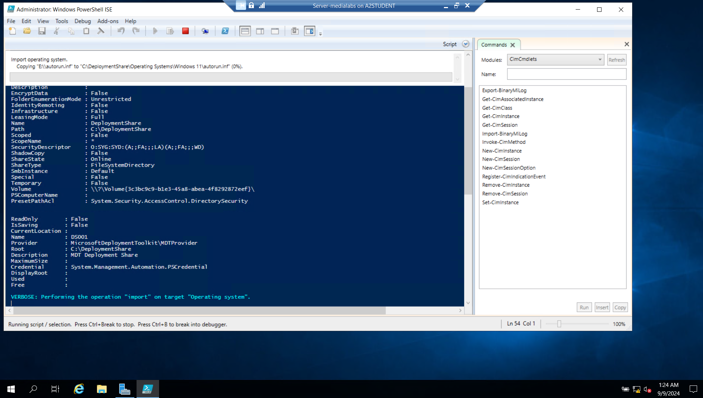

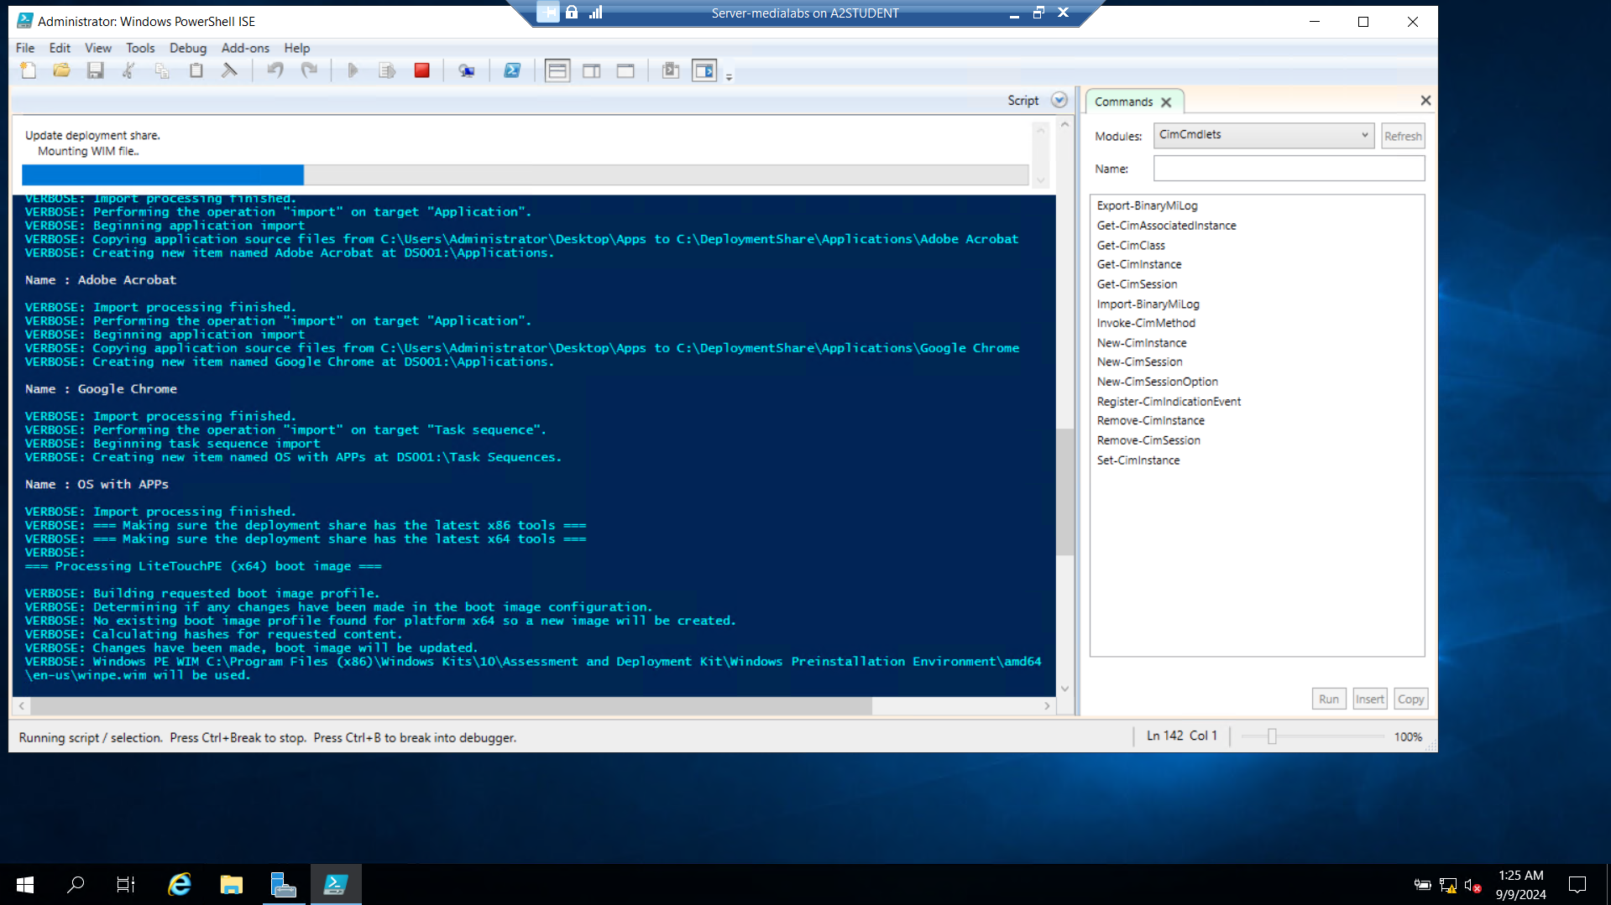

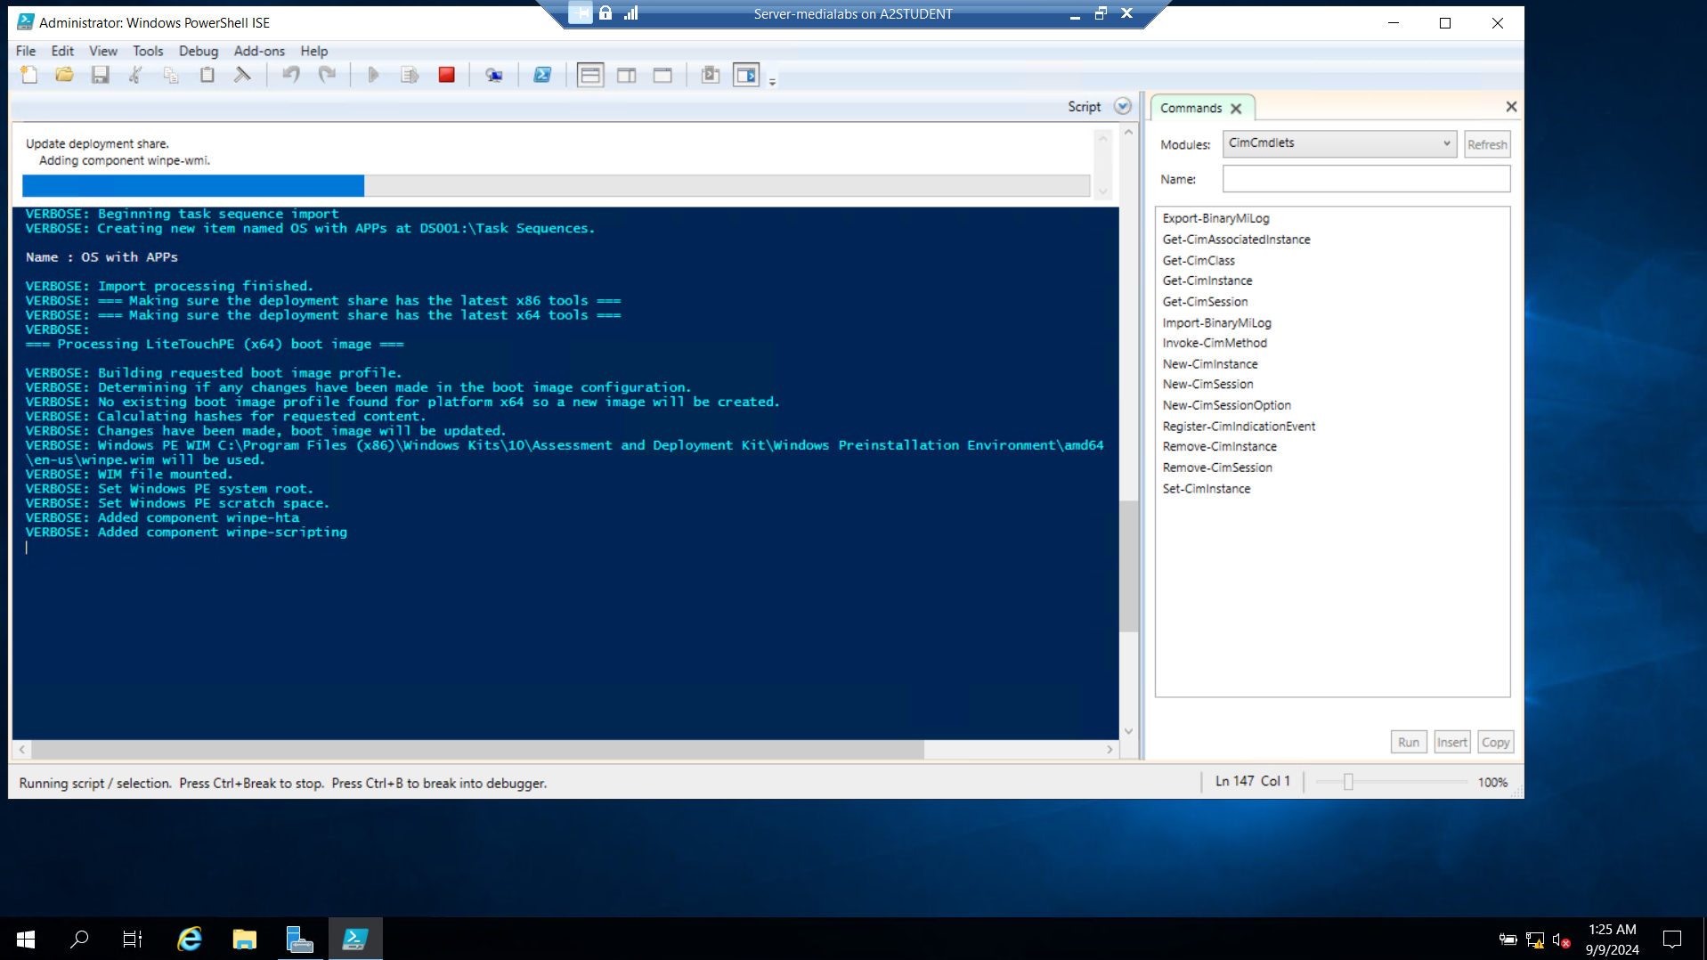

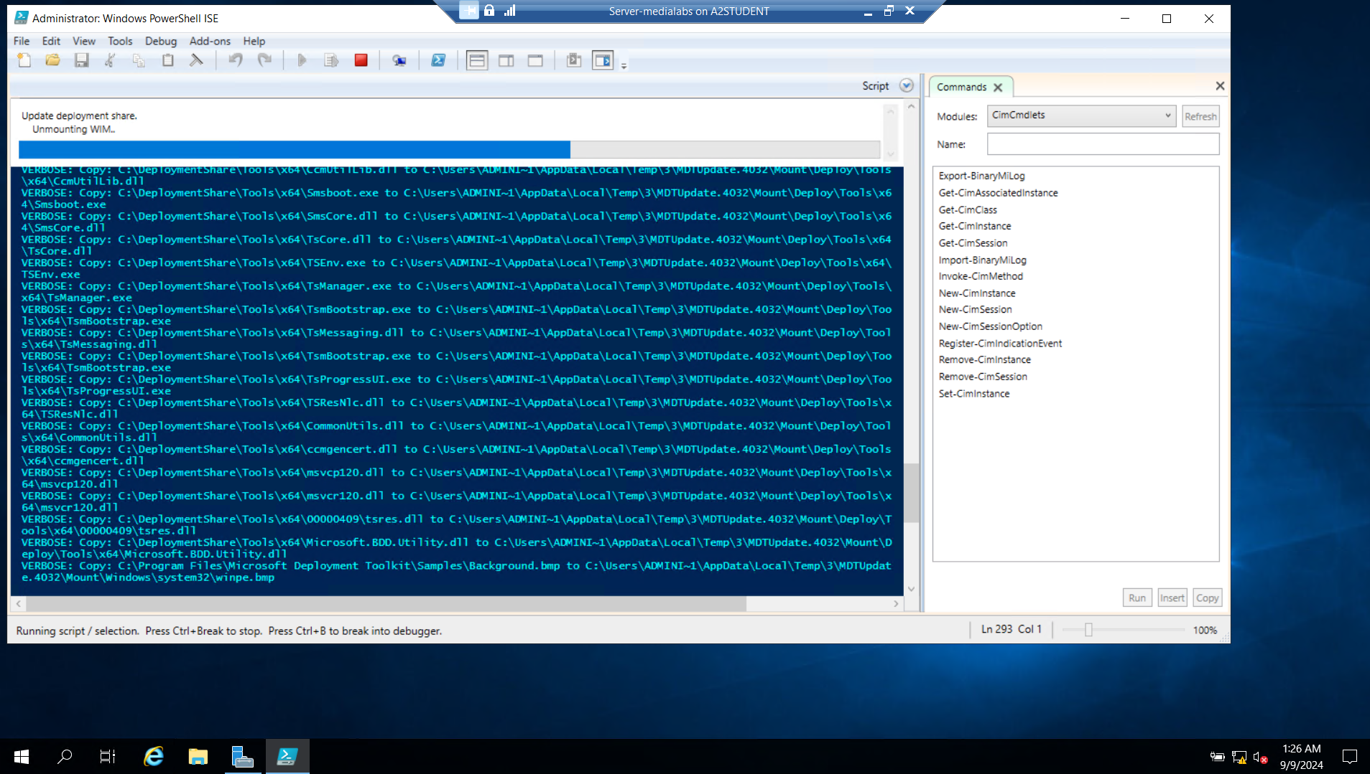

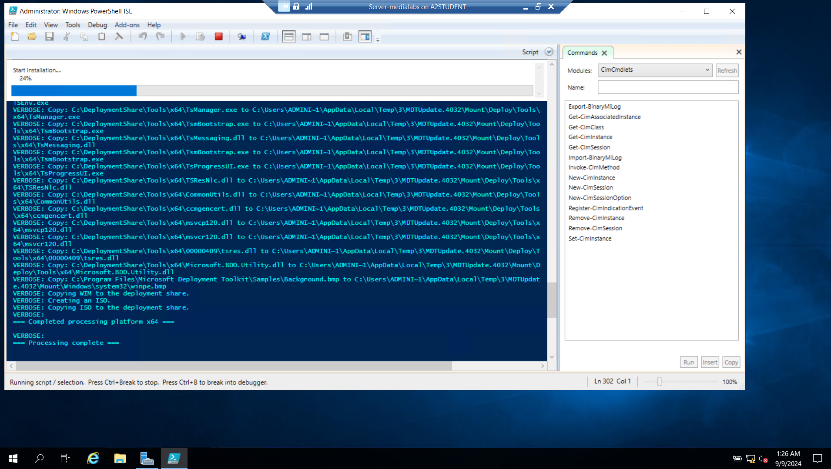

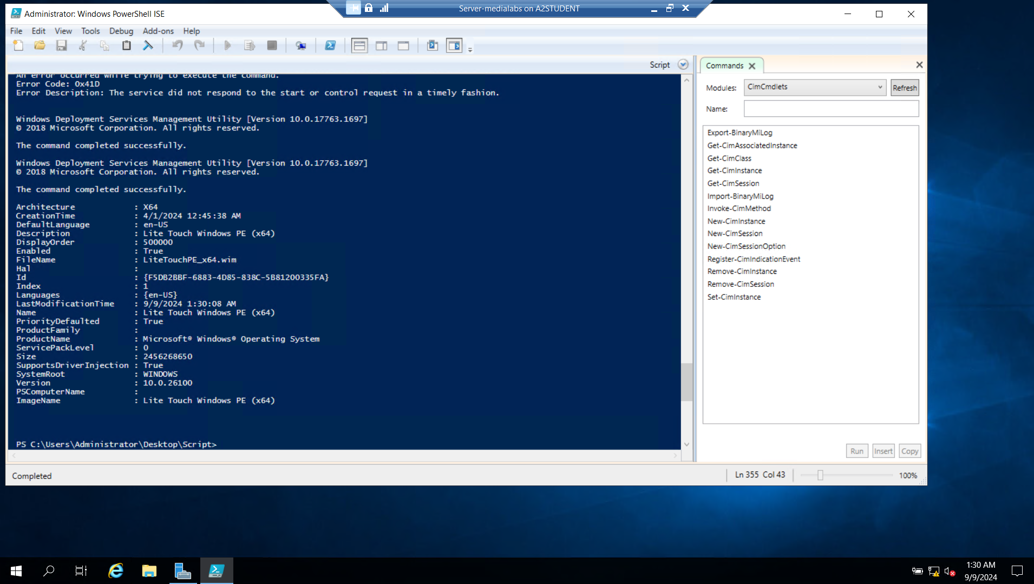

## Task 4: Post-Deployment Implementation for a new client machine.

### Task 4.1

We are now ready to start the deployment of the script on a new client machine.

Open the Hyper-V manager and click on “Action” tab, “New” and “Virtual Machine” to create a new fresh virtual machine.

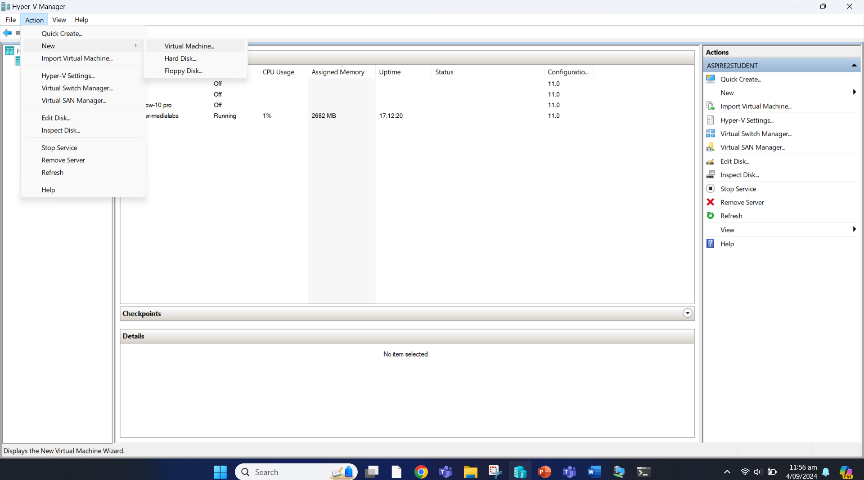

Click Next.

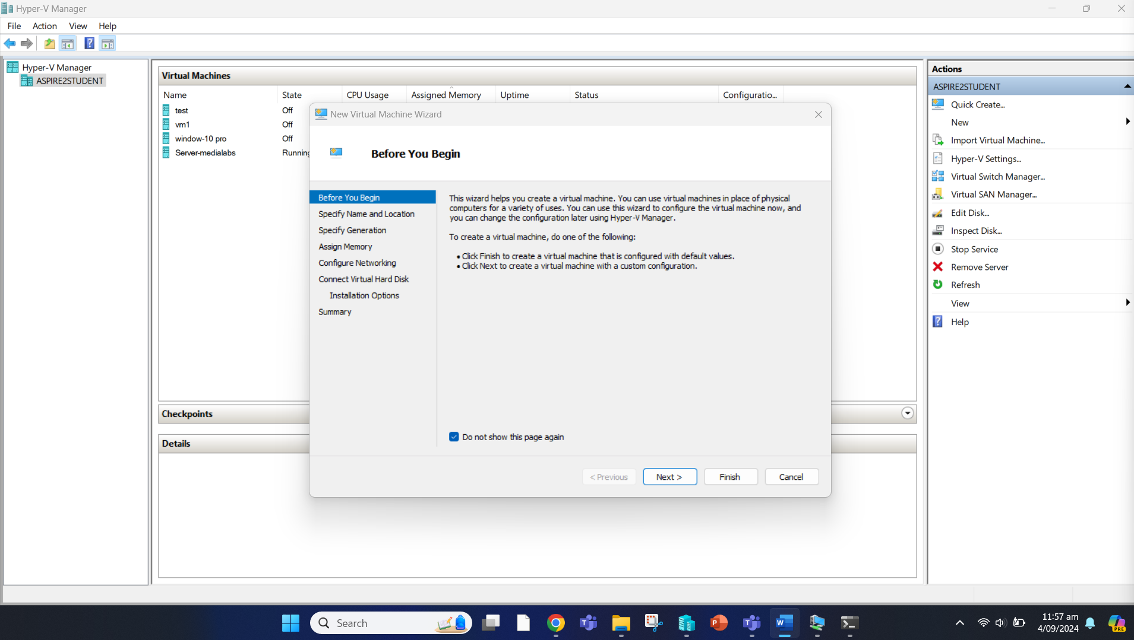

Give it a name as “Client-medialabs” and click Next.

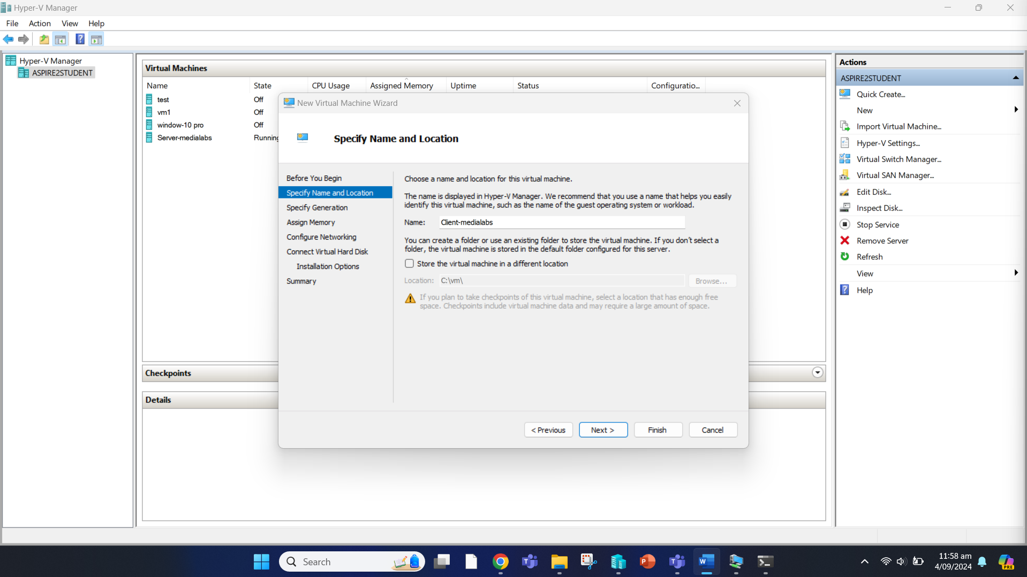

Choose Generation 2 and click Next.

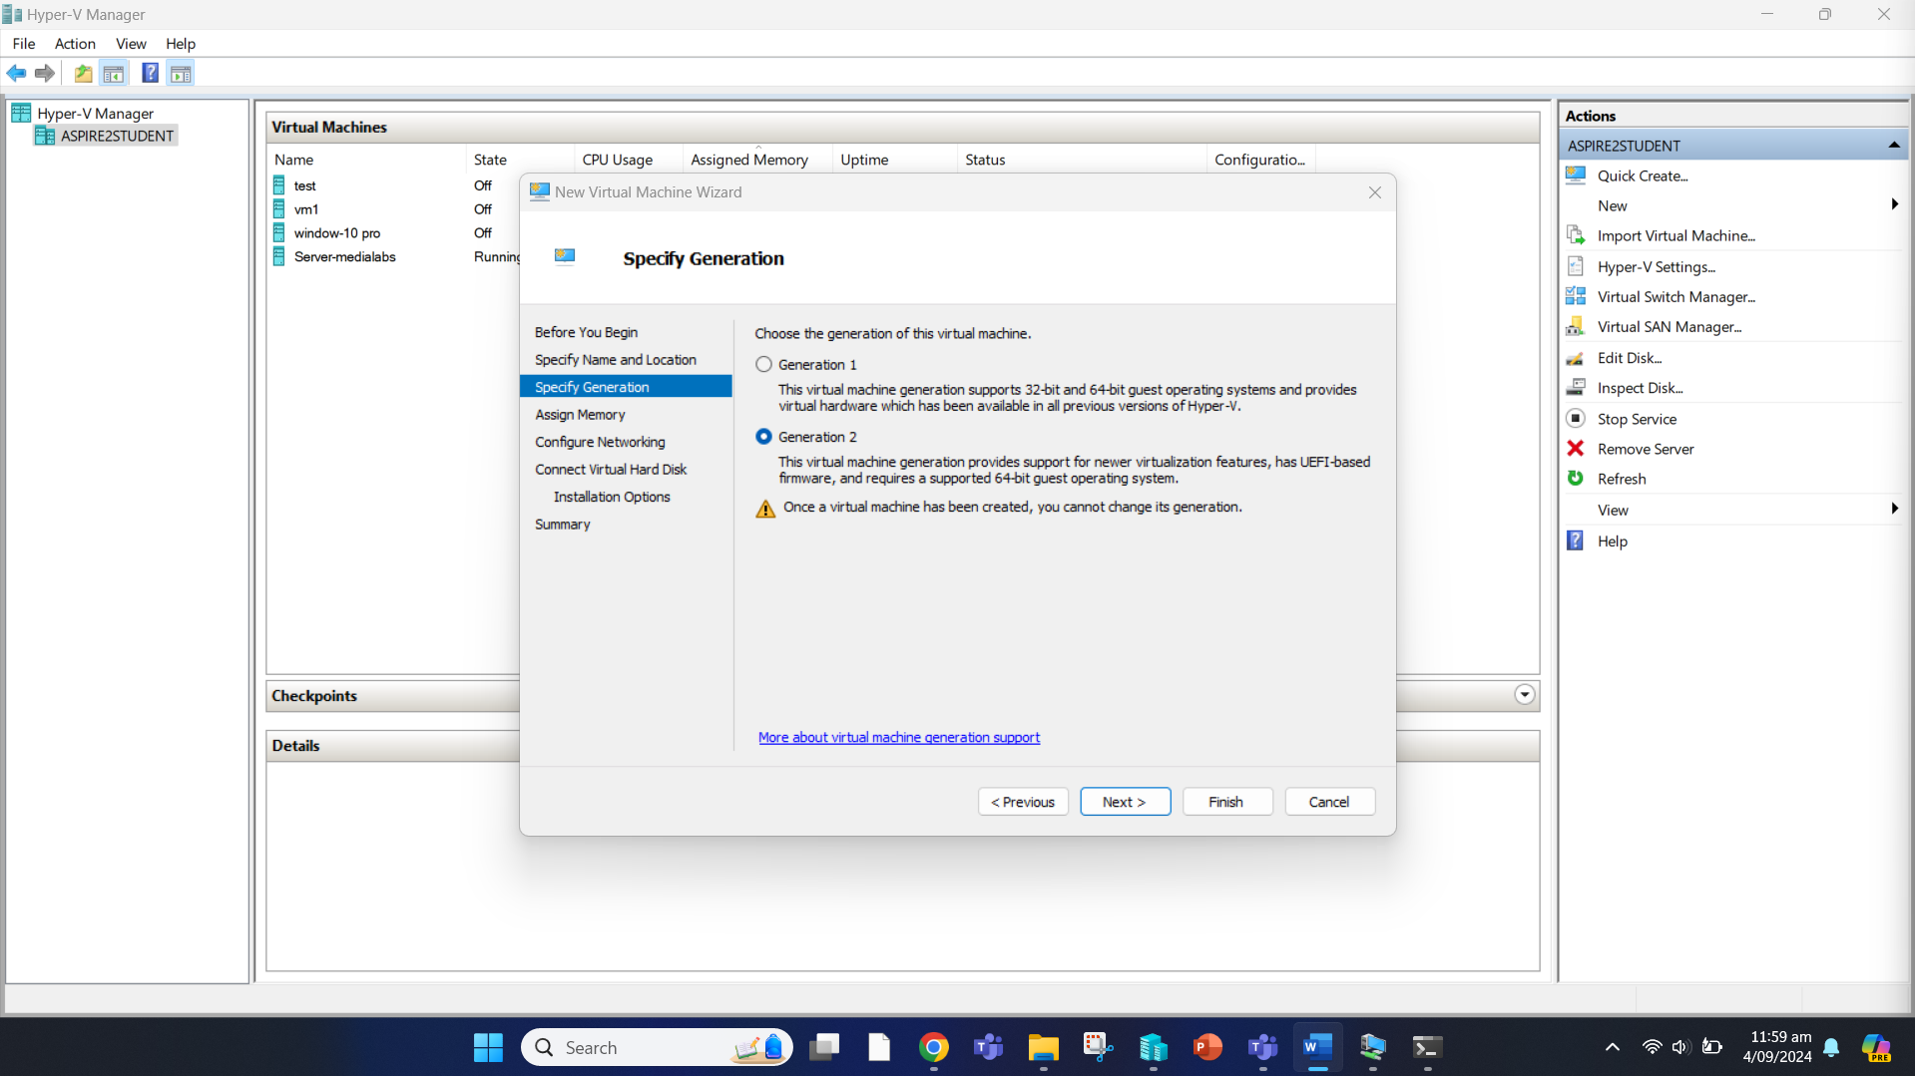

Allocate it a memory of 4096MB and click Next.

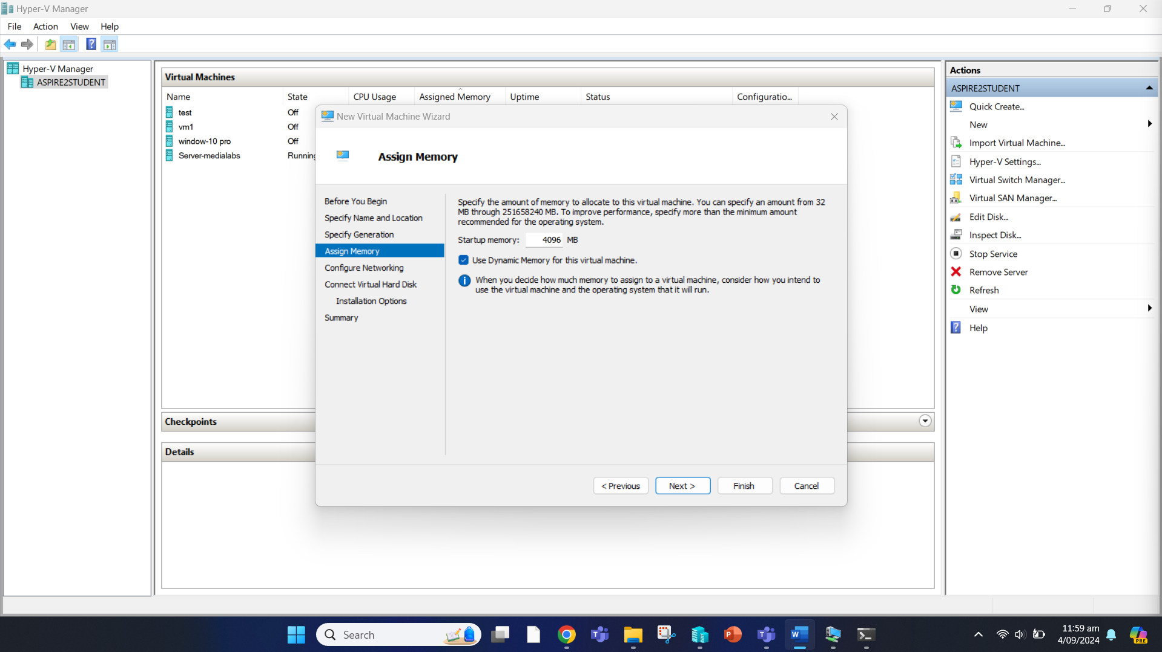

Select medialabs as the internal switch and click “Next”.

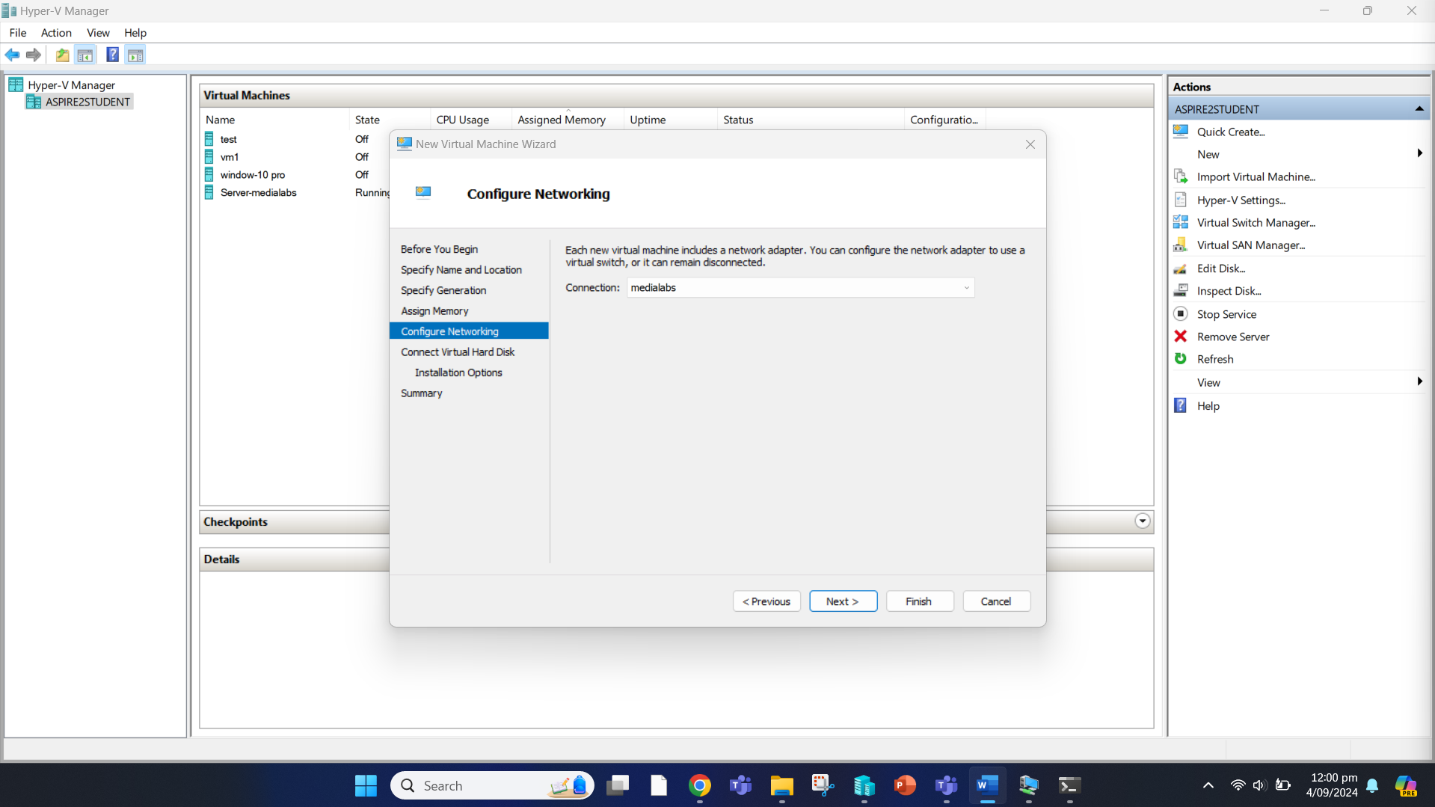

Allocate 50GB disk size for virtual hard disk and click Next.

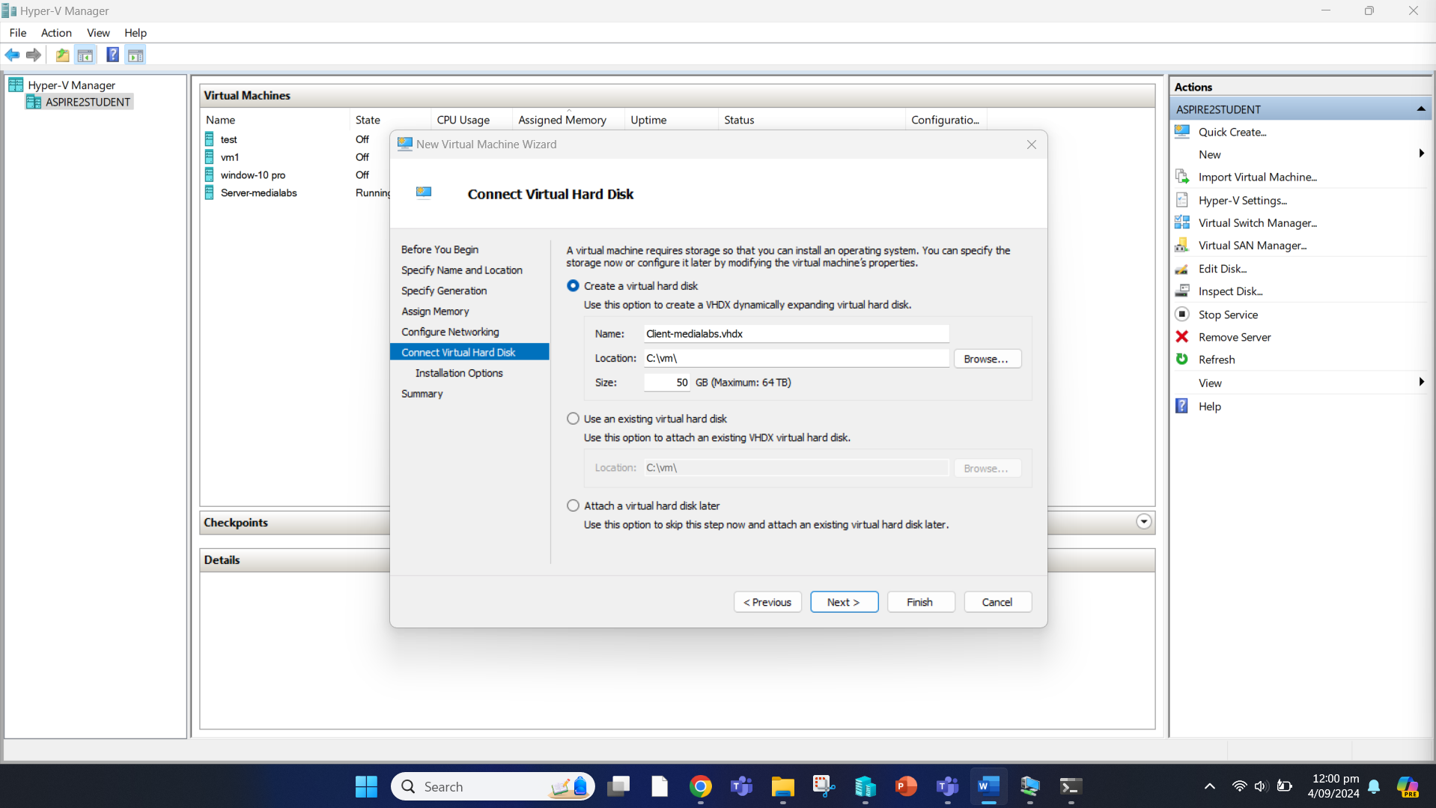

Choose “Install an operating system from a network-based installation server” and click Next.

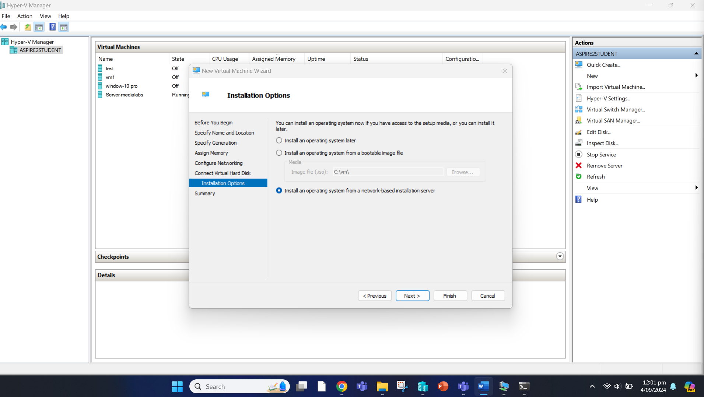

Click on “Finish”.

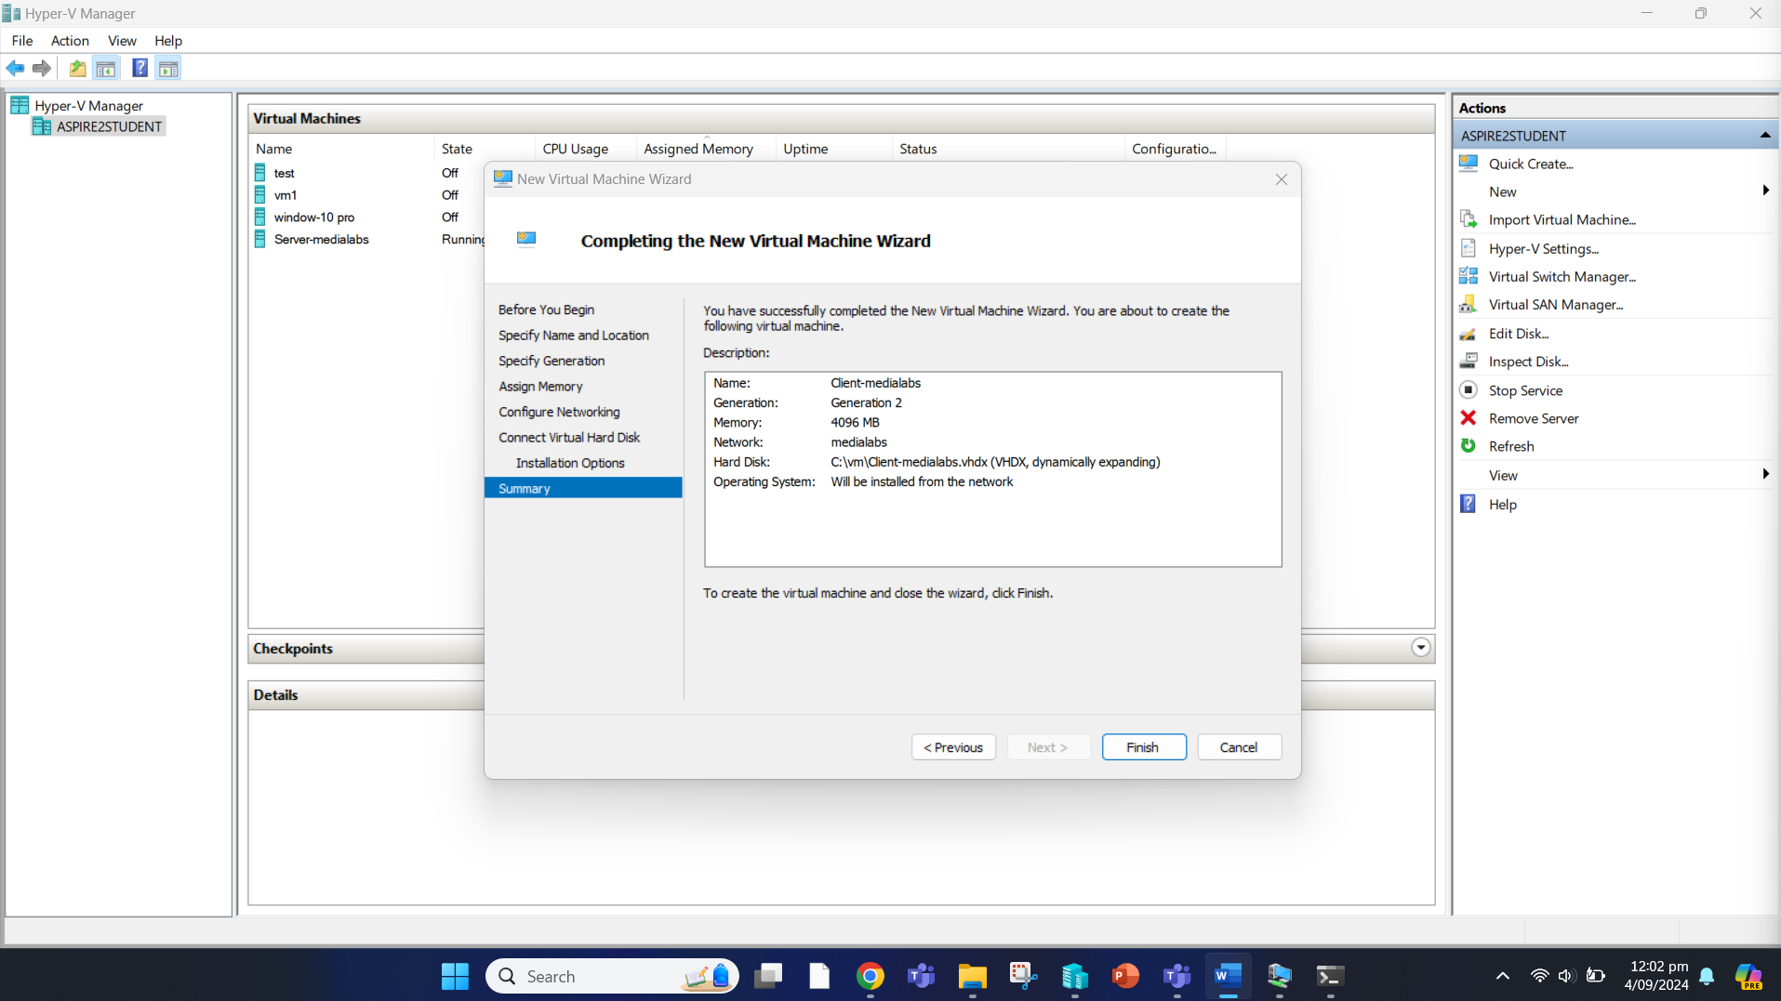

The client virtual machine has been created. We can double click on it to install Windows 11 automatically.

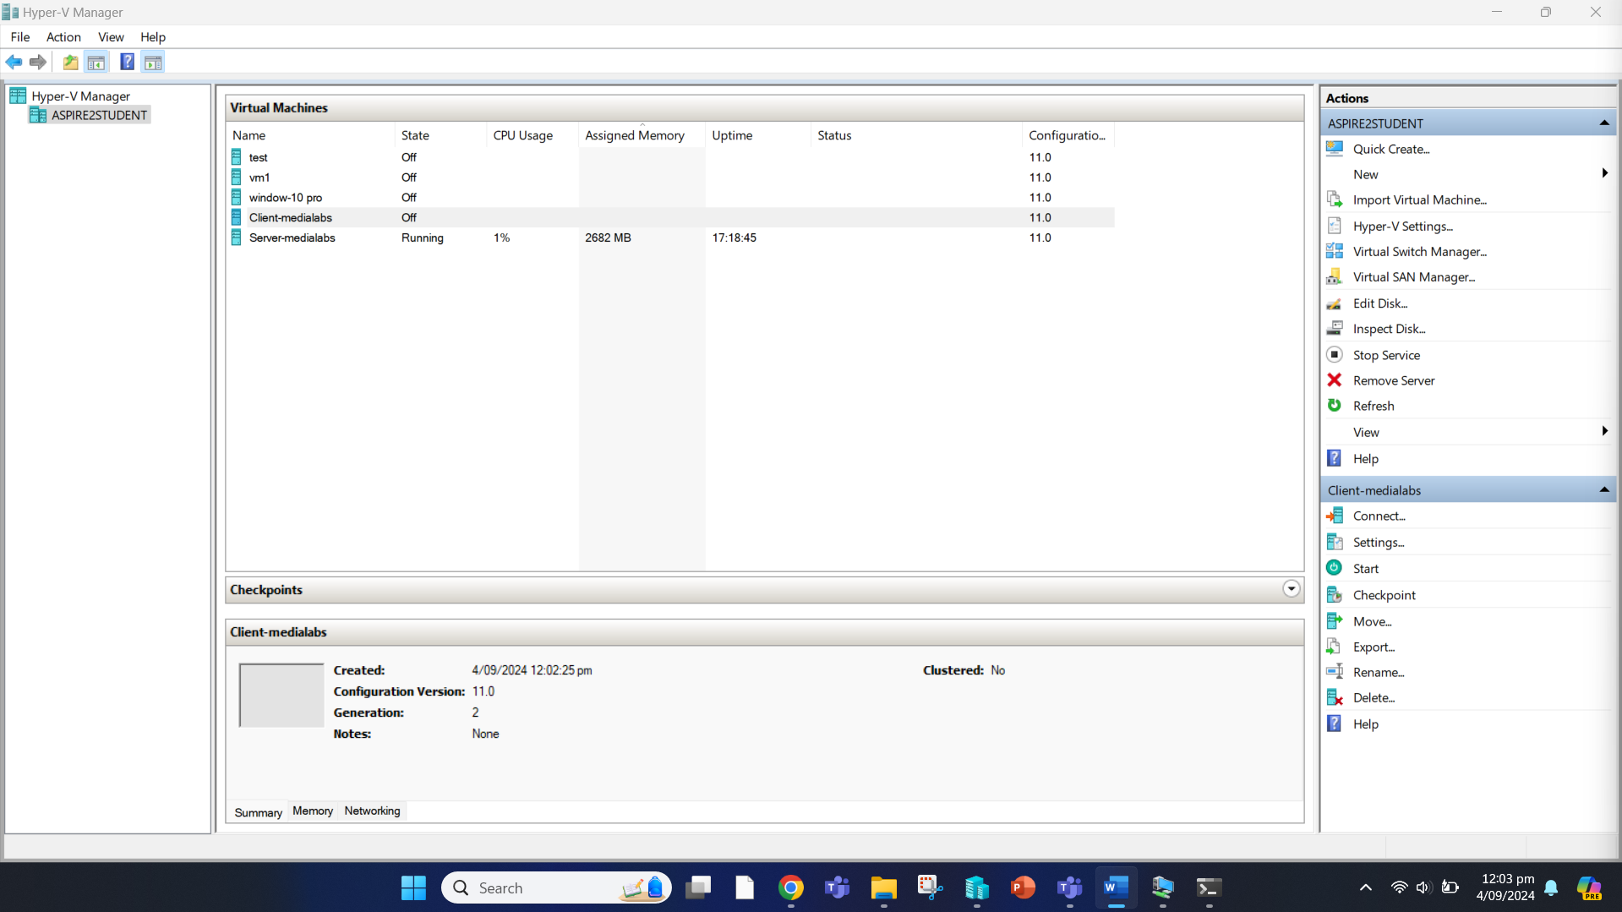

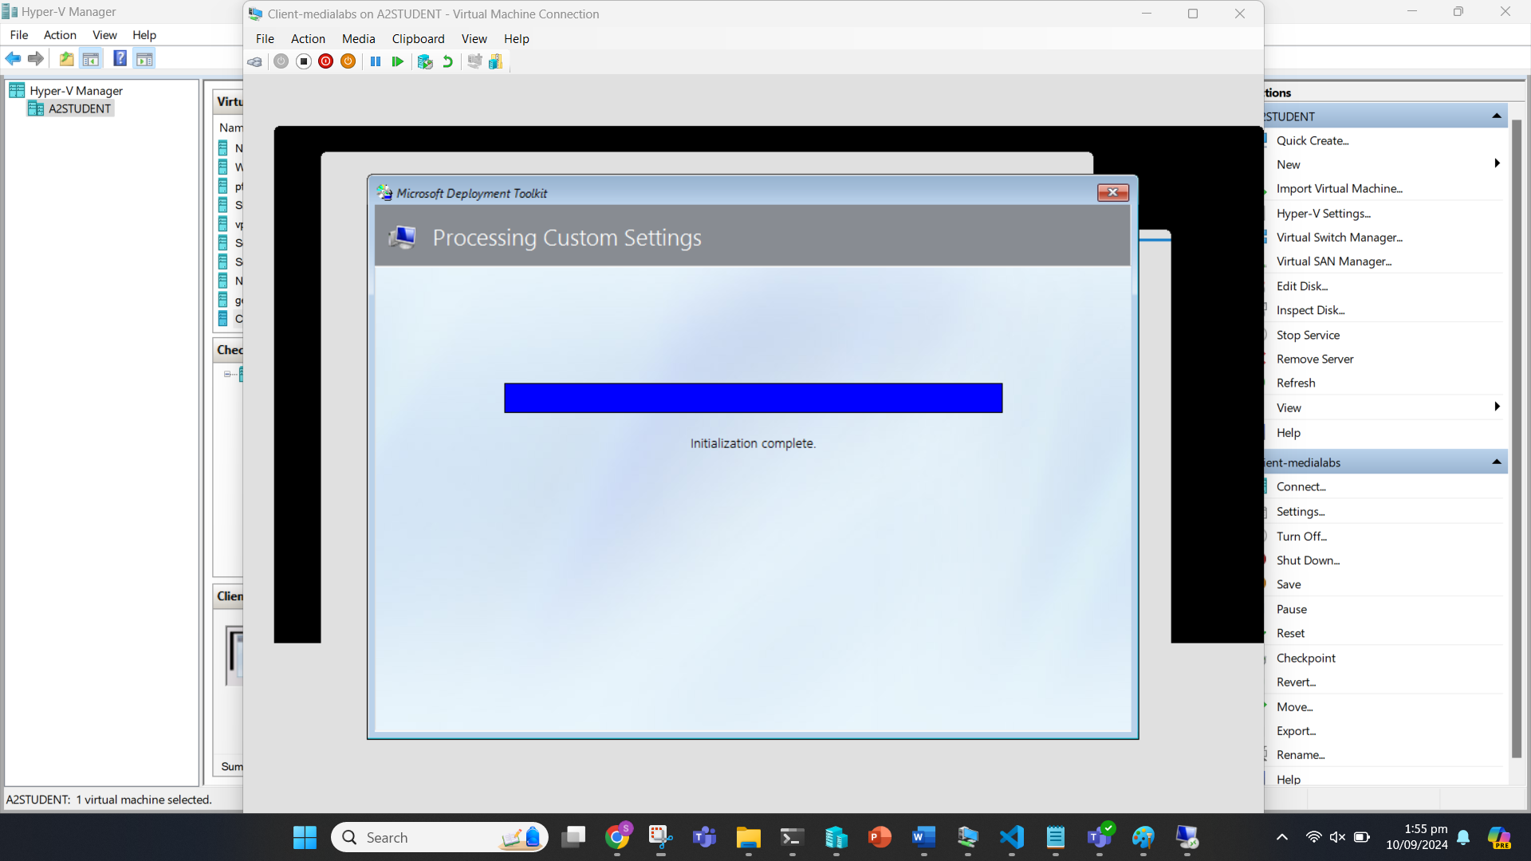

The operating system is being installed silently.

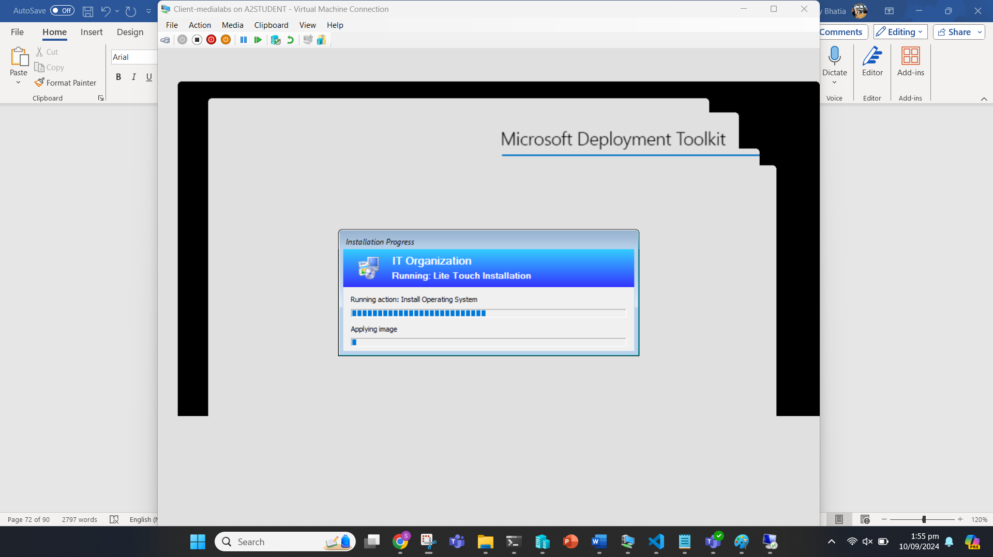

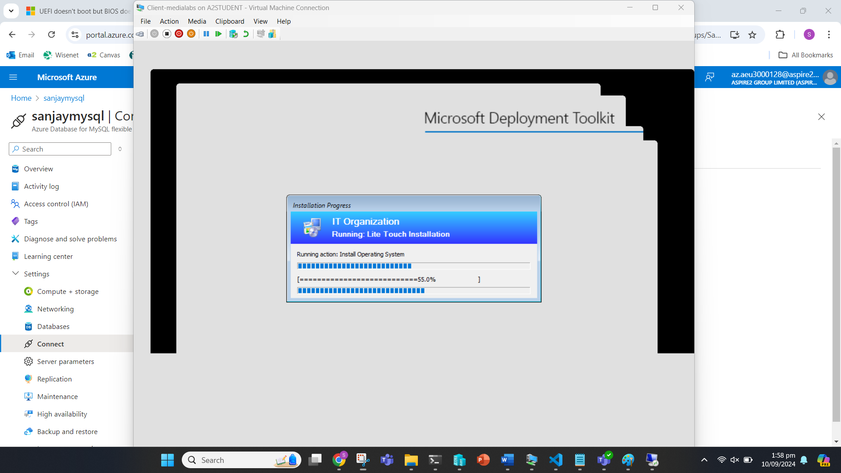

Windows 11 has been installed with the latest versions of Adobe Acrobat, VLC, and Google Chrome.

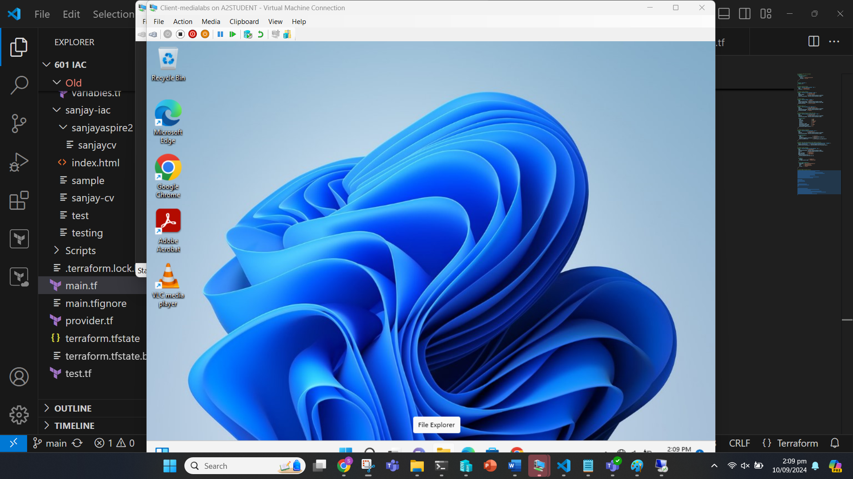

**Verifying the Installation of Applications:**

We can check if the applications are installed or not by opening them.

Open VLC.

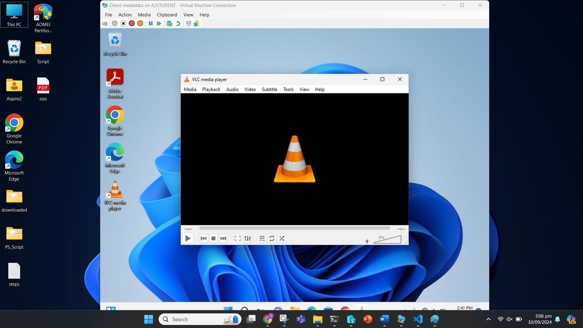

Open Chrome.

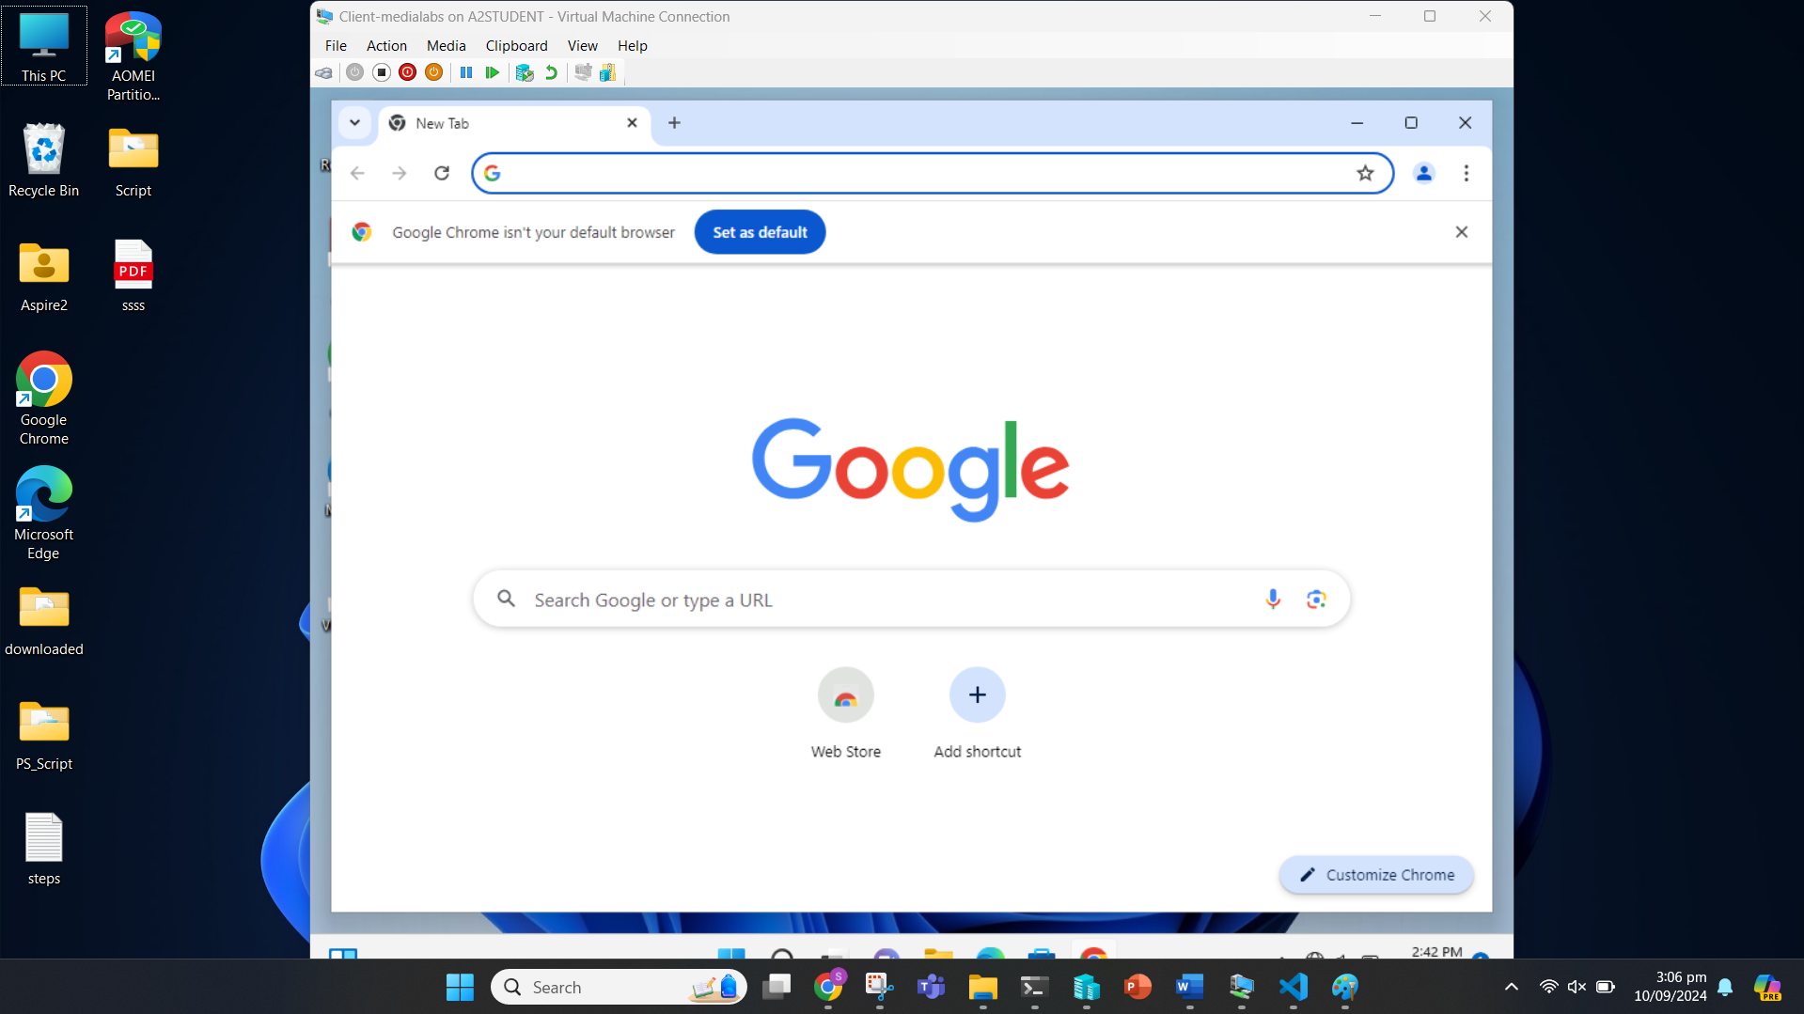

Open Adobe Acrobat.

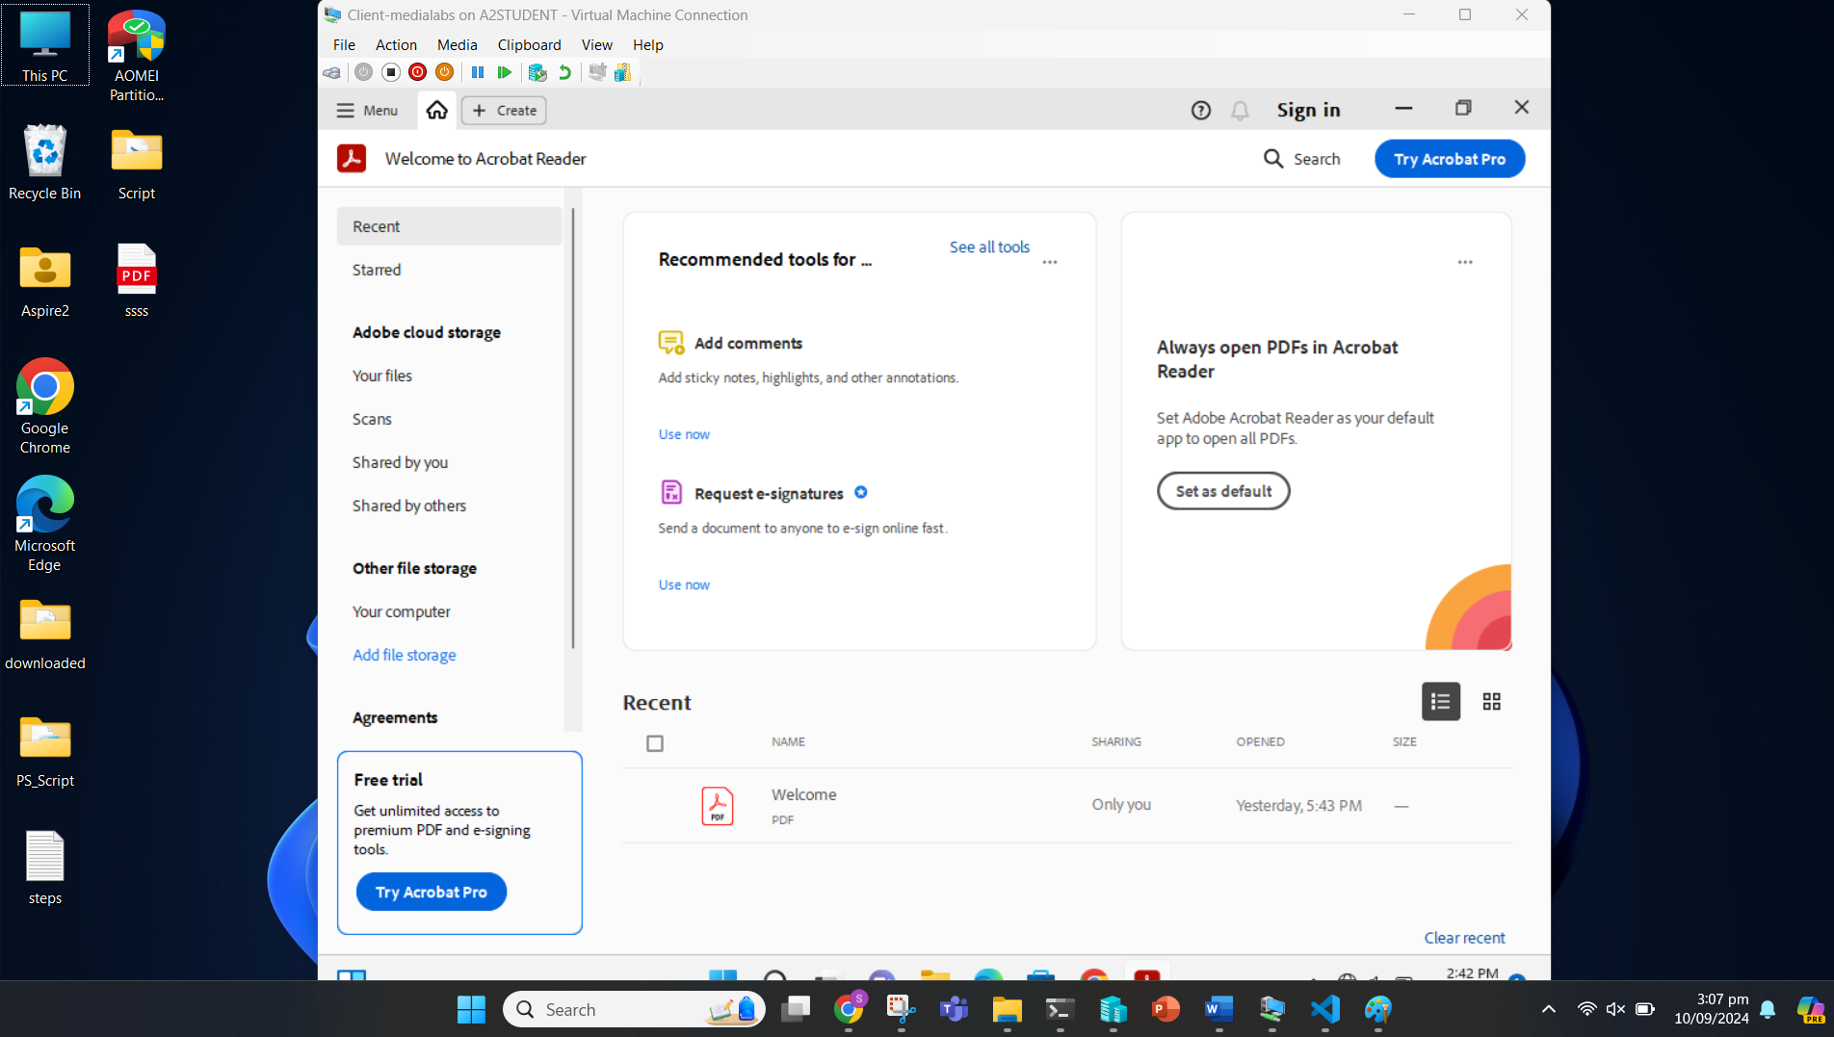

## Task 5: Version Control with Git/GitHub Repository

### Task 5.1

We first create a repository on GitHub.

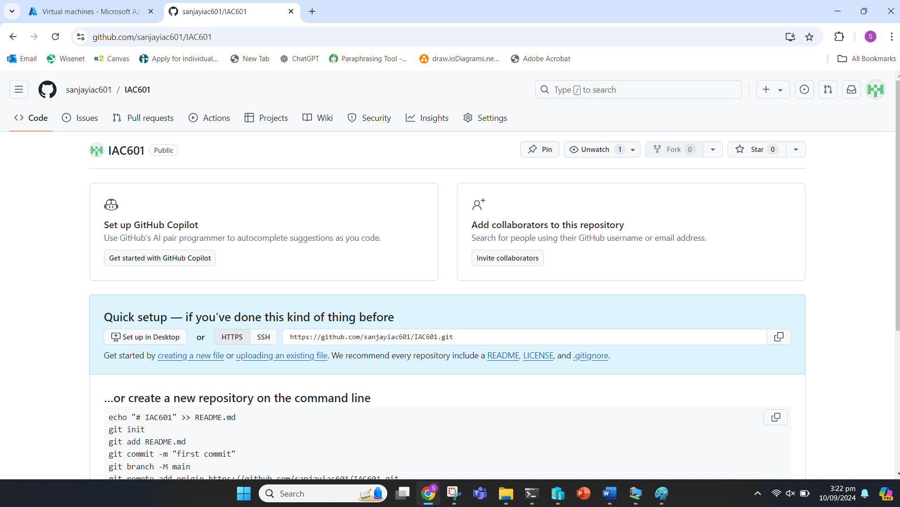

We then open the Git CMD and navigate to the directory where we save our documentation and script.

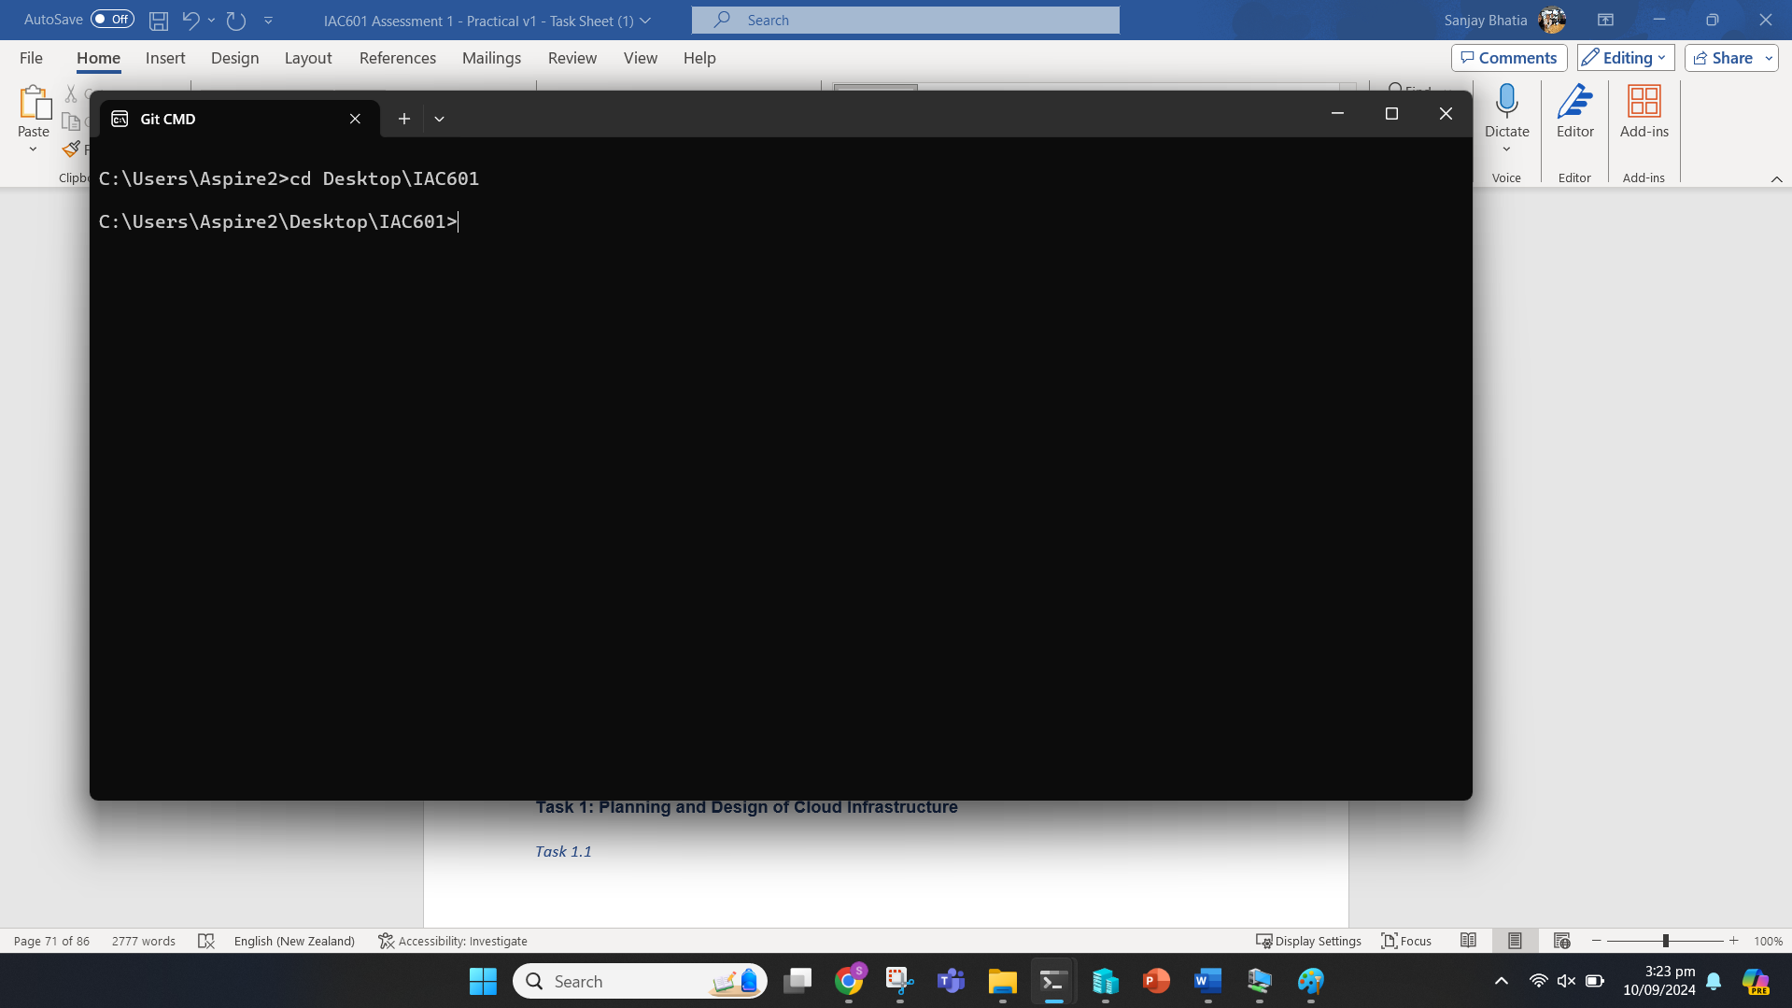

We can initialize git in the directory with “git init”.

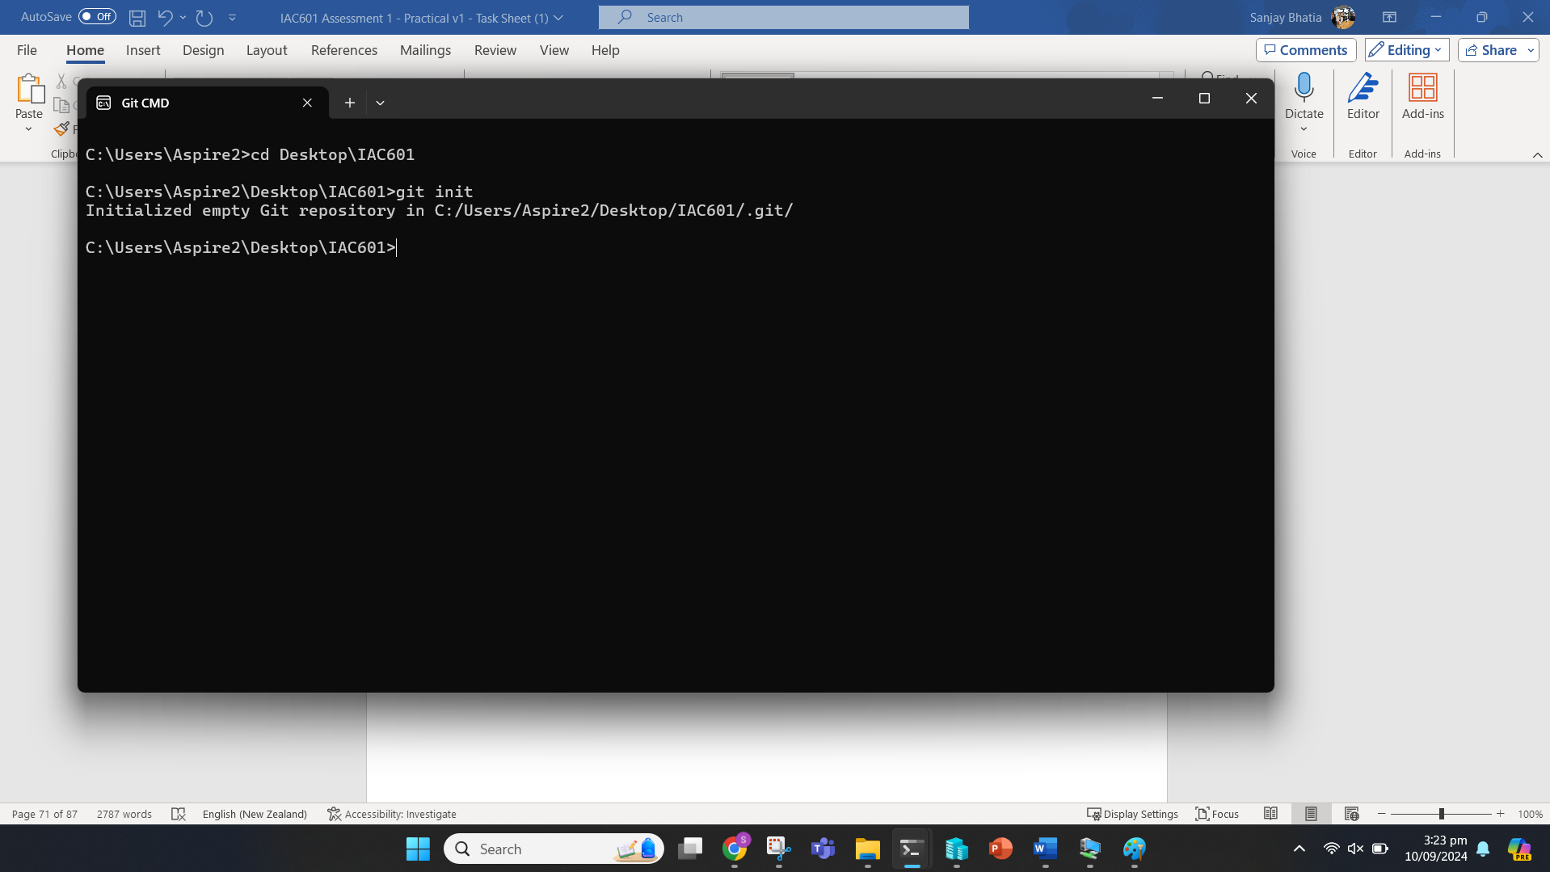

We can add the content on the folder to git with “git add” command.

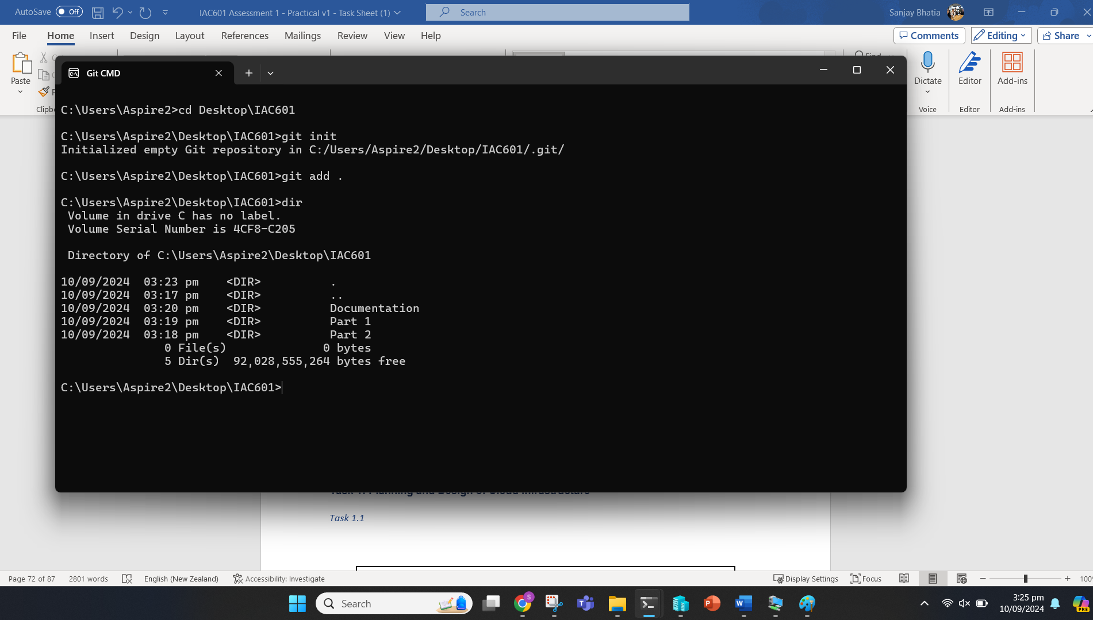

Next, we can commit.

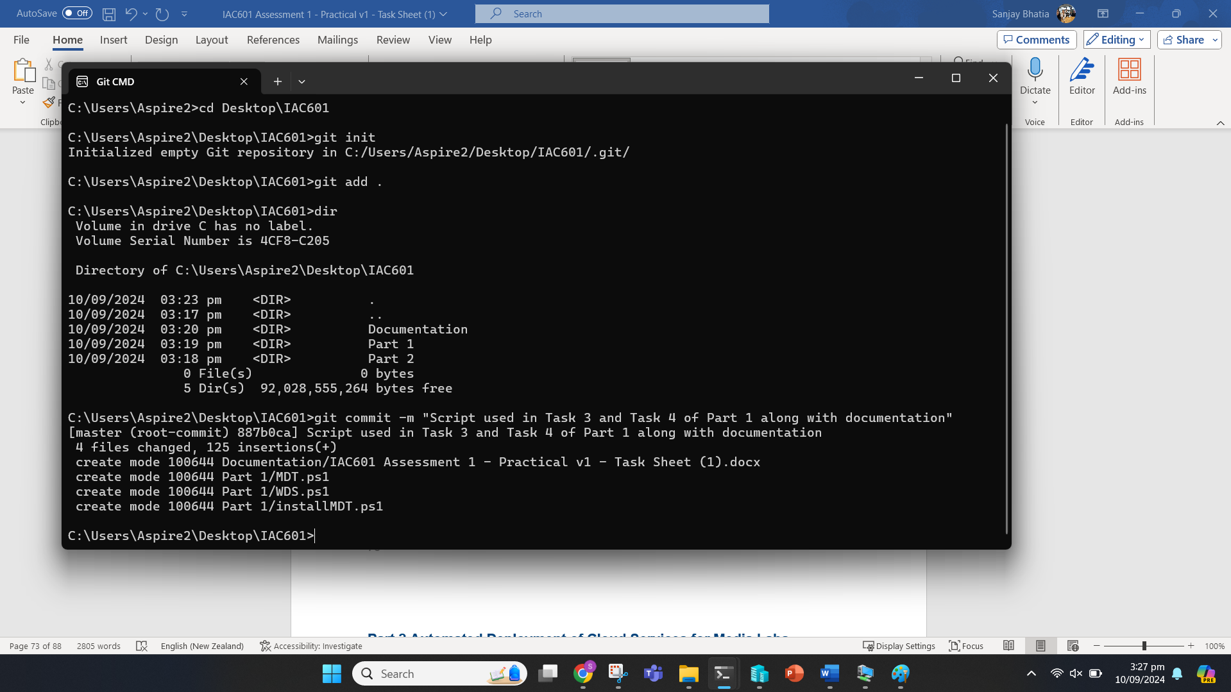

Now we add the repository link.

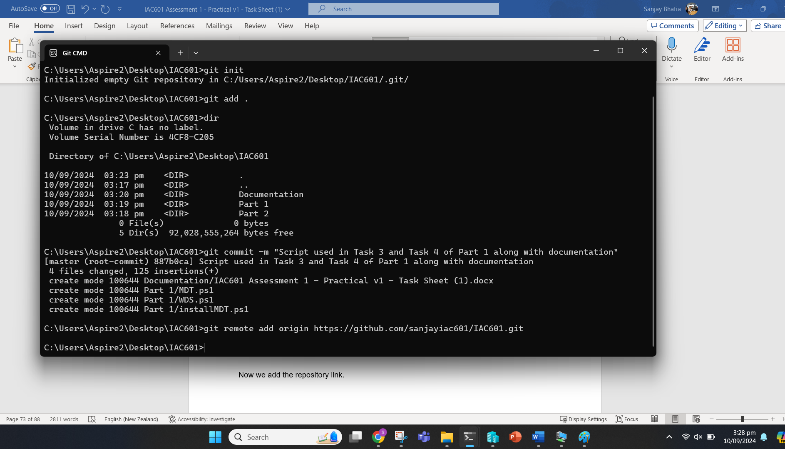

We can push this after creating the ‘main’ branch and push now to GitHub with “git push -u origin main” command.

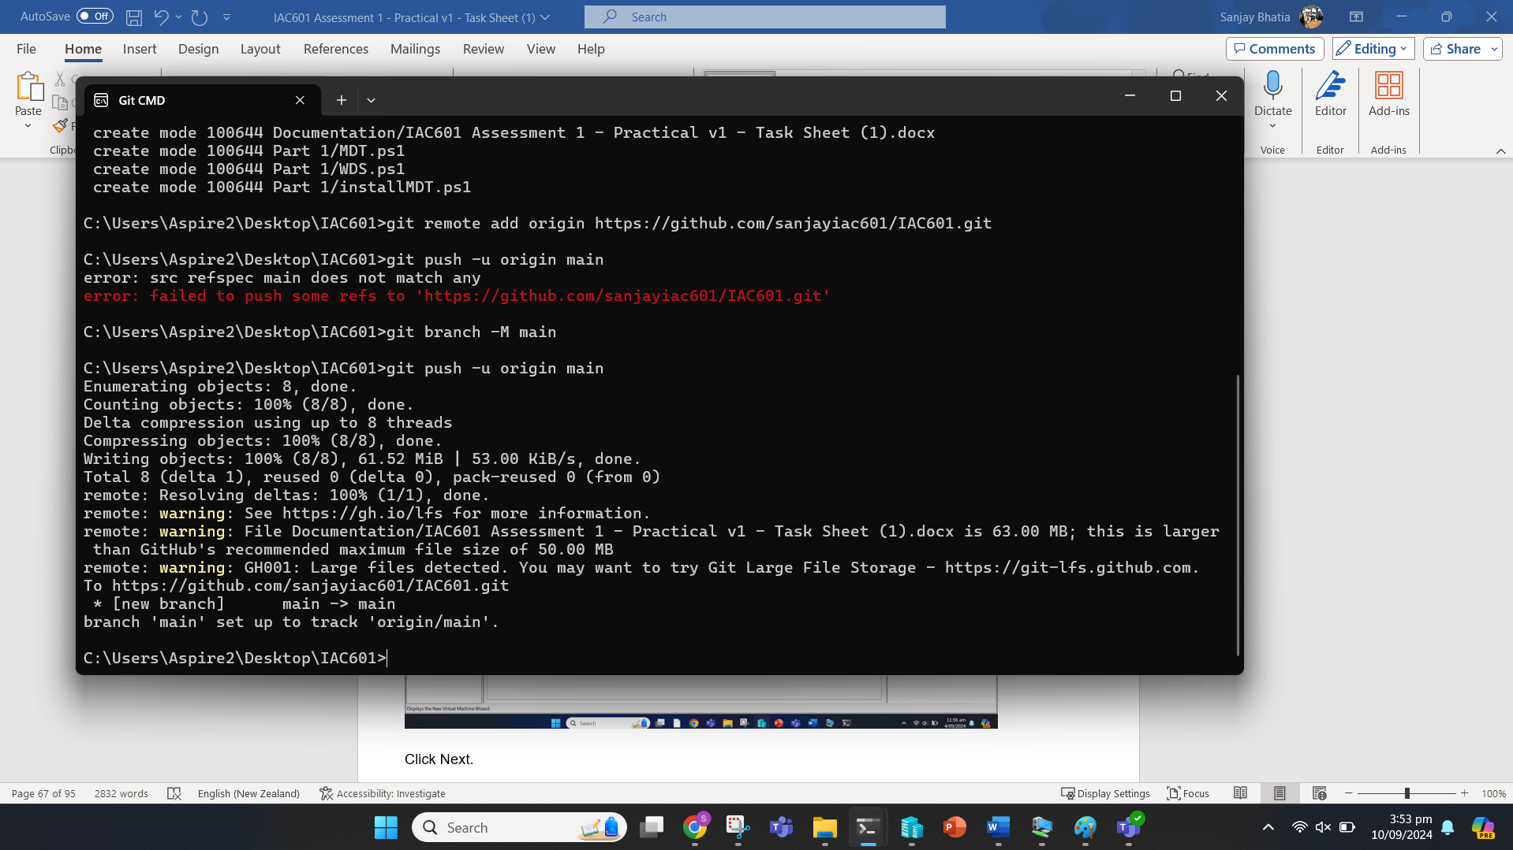

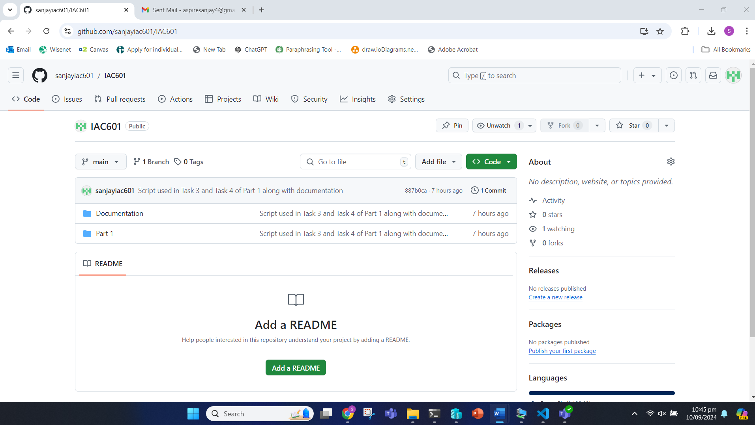

# Part 2 Automated Deployment of Cloud Services for Media Labs

### Task 1: Planning and Design of Cloud Infrastructure

#### Task 1.1

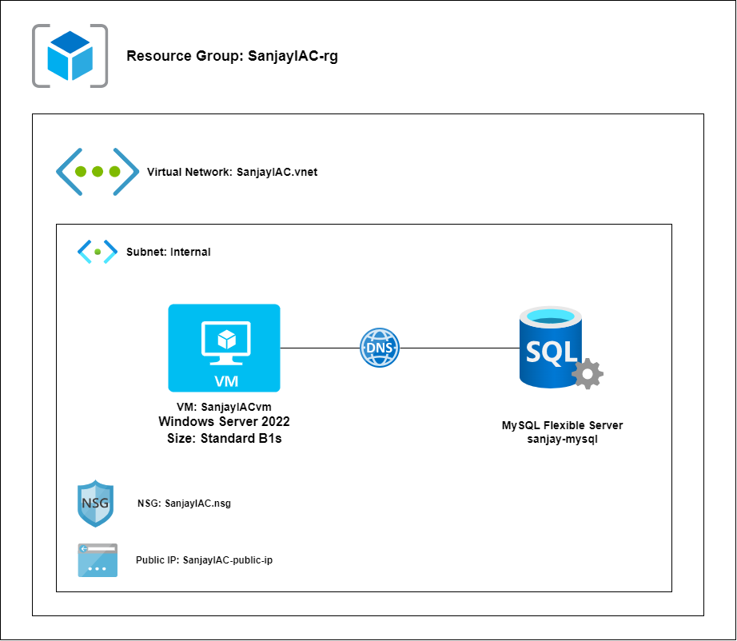

### Task 2: Analysis and Evaluation of Legal and Regulatory Requirements

#### Task 2.1

For Media Labs to maintain security and compliance standards while automating deployment to Azure, they should consider the following legal and regulatory requirements:

1. General Data Protection Regulation (GDPR): Implementation: Ensure that any personal data stored in the VM or MySQL database is encrypted at rest and in transit. Application:

* For the VM, enable BitLocker encryption.
* For MySQL, enable data encryption.
* Use SSL/TLS for all connections.

1. Payment Card Industry Data Security Standard (PCI DSS): Implementation: If handling payment card information, ensure that the database and VM are properly isolated, and access is strictly controlled. Application:

* Configure the NSG to allow RDP access only from specific IP ranges.
* Set up Azure SQL Database firewall rules to restrict access.

1. Health Insurance Portability and Accountability Act (HIPAA): Implementation: If dealing with health information, ensure that all data is encrypted, and access is logged. Application:

* Enable Azure Monitor and Log Analytics to track all access to the VM and database.
* Configure auditing on the Azure SQL Database.

1. SOC 2 Compliance: Implementation: Ensure that proper access controls, monitoring, and incident response procedures are in place. Application:

* Use Azure Role-Based Access Control (RBAC) to manage permissions.
* Set up Azure Security Center for threat detection and response.

### Task 3: Scripts Design and Development

#### Task 3.1 Azure Platform Deployment

**Main:**

**# Resource group**

**resource "azurerm_resource_group" "rg" {**

**name = var.rg_name**

**location = "AustraliaEast" # Replace with your desired region**

**}**

**# Network**

**resource "azurerm_virtual_network" "vnet" {**

**name = var.vnet_name**

**address_space = ["10.20.0.0/16"]**

**location = azurerm_resource_group.rg.location**

**resource_group_name = azurerm_resource_group.rg.name**

**}**

**### subnet**

**resource "azurerm_subnet" "subnet-vm" {**

**name = "SanjyaIac-subnet1"**

**resource_group_name = azurerm_resource_group.rg.name**

**virtual_network_name = azurerm_virtual_network.vnet.name**

**address_prefixes = "10.20.1.0/24"**

**}**

**# Public IP**

**resource "azurerm_public_ip" "public_ip" {**

**name = var.public_ip**

**location = azurerm_resource_group.rg.location**

**resource_group_name = azurerm_resource_group.rg.name**

**allocation_method = "Dynamic"**

**}**

**# Network security group**

**resource "azurerm_network_security_group" "nsg" {**

**name = var.nsg_name**

**location = azurerm_resource_group.rg.location**

**resource_group_name = azurerm_resource_group.rg.name**

**security_rule {**

**name = "RDP"**

**priority = 1000**

**direction = "Inbound"**

**access = "Allow"**

**protocol = "Tcp"**

**source_port_range = "*"**

**destination_port_range = "3389"**

**source_address_prefix = "*"**

**destination_address_prefix = "*"**

**}**

**security_rule {**

**name = "HTTP"**

**priority = 1001**

**direction = "Inbound"**

**access = "Allow"**

**protocol = "Tcp"**

**source_port_range = "*"**

**destination_port_range = "80"**

**source_address_prefix = "*"**

**destination_address_prefix = "*"**

**}**

**}**

**# Network interface card**

**resource "azurerm_network_interface" "nic" {**

**name = "SanjayaIac-nic"**

**location = azurerm_resource_group.rg.location**

**resource_group_name = azurerm_resource_group.rg.name**

**ip_configuration {**

**name = "my_nic_configuration"**

**subnet_id = azurerm_subnet.subnet.id**

**private_ip_address_allocation = "Dynamic"**

**public_ip_address_id = azurerm_public_ip.public_ip.id**

**}**

**tags = {**

**environment = "dev"**

**}**

**}**

**# Virtual machine**

**resource "azurerm_windows_virtual_machine" "vm" {**

**name = "SanjayIac-vm"**

**location = azurerm_resource_group.rg.location**

**resource_group_name = azurerm_resource_group.rg.name**

**network_interface_ids = [azurerm_network_interface.nic.id]**

**size = "Standard_B1ms"**

**os_disk {**

**name = "myOsDisk"**

**caching = "ReadWrite"**

**storage_account_type = "Standard_LRS"**

**}**

**source_image_reference {**

**publisher = "MicrosoftWindowsServer"**

**offer = "WindowsServer"**

**sku = "2022-datacenter-azure-edition"**

**version = "latest"**

**}**

**admin_username = "azureuser"**

**admin_password = "Aspire@2023"**

**tags = {**

**environment = "dev"**

**}**

**}**

**#### Database Server ##**

**resource "azurerm_subnet" "subnet-db" {**

**name = "${var.vnet_name}-db-subnet"**

**resource_group_name = azurerm_resource_group.rg.name**

**virtual_network_name = azurerm_virtual_network.vnet.name**

**address_prefixes = ["10.20.2.0/24"]**

**service_endpoints = ["Microsoft.Storage"]**

**delegation {**

**name = "fs"**

**service_delegation {**

**name = "Microsoft.DBforMySQL/flexibleServers"**

**actions = [**

**"Microsoft.Network/virtualNetworks/subnets/join/action",**

**]**

**}**

**}**

**}**

**# Private DNS zones within Azure**

**resource "azurerm_private_dns_zone" "default" {**

**name = "sanjayIac.mysql.database.azure.com"**

**resource_group_name = azurerm_resource_group.rg.name**

**}**

**# Private DNS zone Network Links**

**resource "azurerm_private_dns_zone_virtual_network_link" "default" {**

**name = "mysqlfsVnetZonetest.com"**

**private_dns_zone_name = "sanjayiac.mysql.database.azure.com"**

**resource_group_name = azurerm_resource_group.rg.name**

**virtual_network_id = azurerm_virtual_network.vnet.id**

**}**

**# Azure MySQL Flexible Server**

**resource "azurerm_mysql_flexible_server" "fs_server" {**

**location = "AustraliaEast"**

**name = "SanjayIac-mysqlfs-iac601"**

**resource_group_name = azurerm_resource_group.rg.name**

**administrator_login = "sanjay"**

**administrator_password = "Aspire@2024"**

**backup_retention_days = 7**

**delegated_subnet_id = azurerm_subnet.subnet-db.id**

**geo_redundant_backup_enabled = false**

**private_dns_zone_id = azurerm_private_dns_zone.default.id**

**sku_name = "GP_Standard_D2ds_v4"**

**version = "8.0.21"**

**zone = "1"**

**maintenance_window {**

**day_of_week = 0**

**start_hour = 8**

**start_minute = 0**

**}**

**storage {**

**iops = 360**

**size_gb = 20**

**}**

**depends_on = [azurerm_private_dns_zone_virtual_network_link.default]**

**}**

**### DB NSG**

**resource "azurerm_subnet_network_security_group_association" "flexi-server-nsg-association" {**

**subnet_id = azurerm_subnet.subnet-db.id**

**network_security_group_id = azurerm_network_security_group.nsg.id**

**}**

### Task 4: Deployment Services to the Azure Platform and Testing

#### Task 4.1

Pre-Deployment Process

Terraform Init

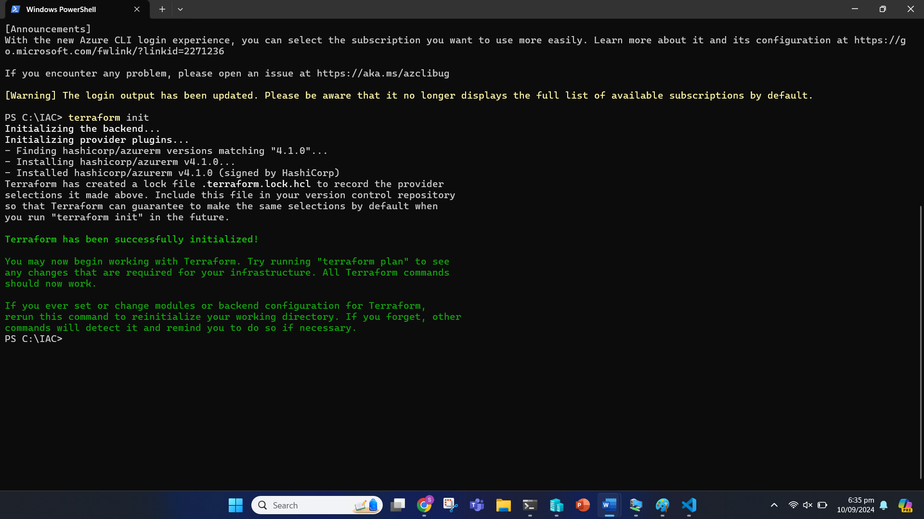

Terraform Validate

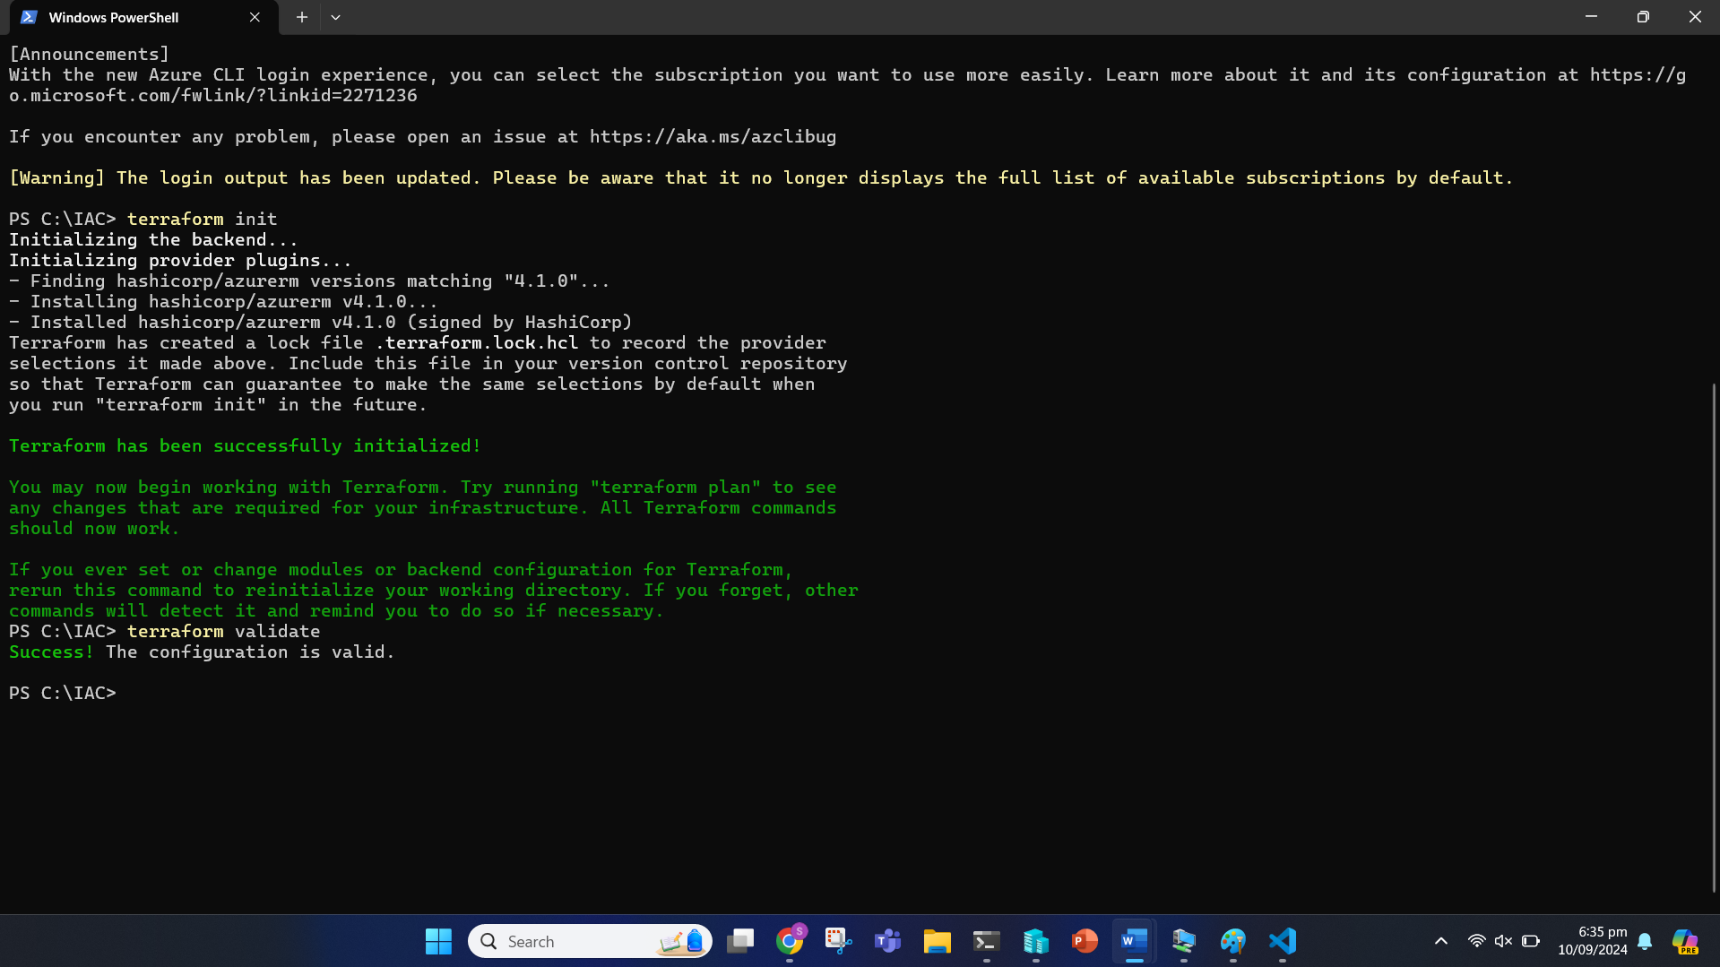

Terraform Plan

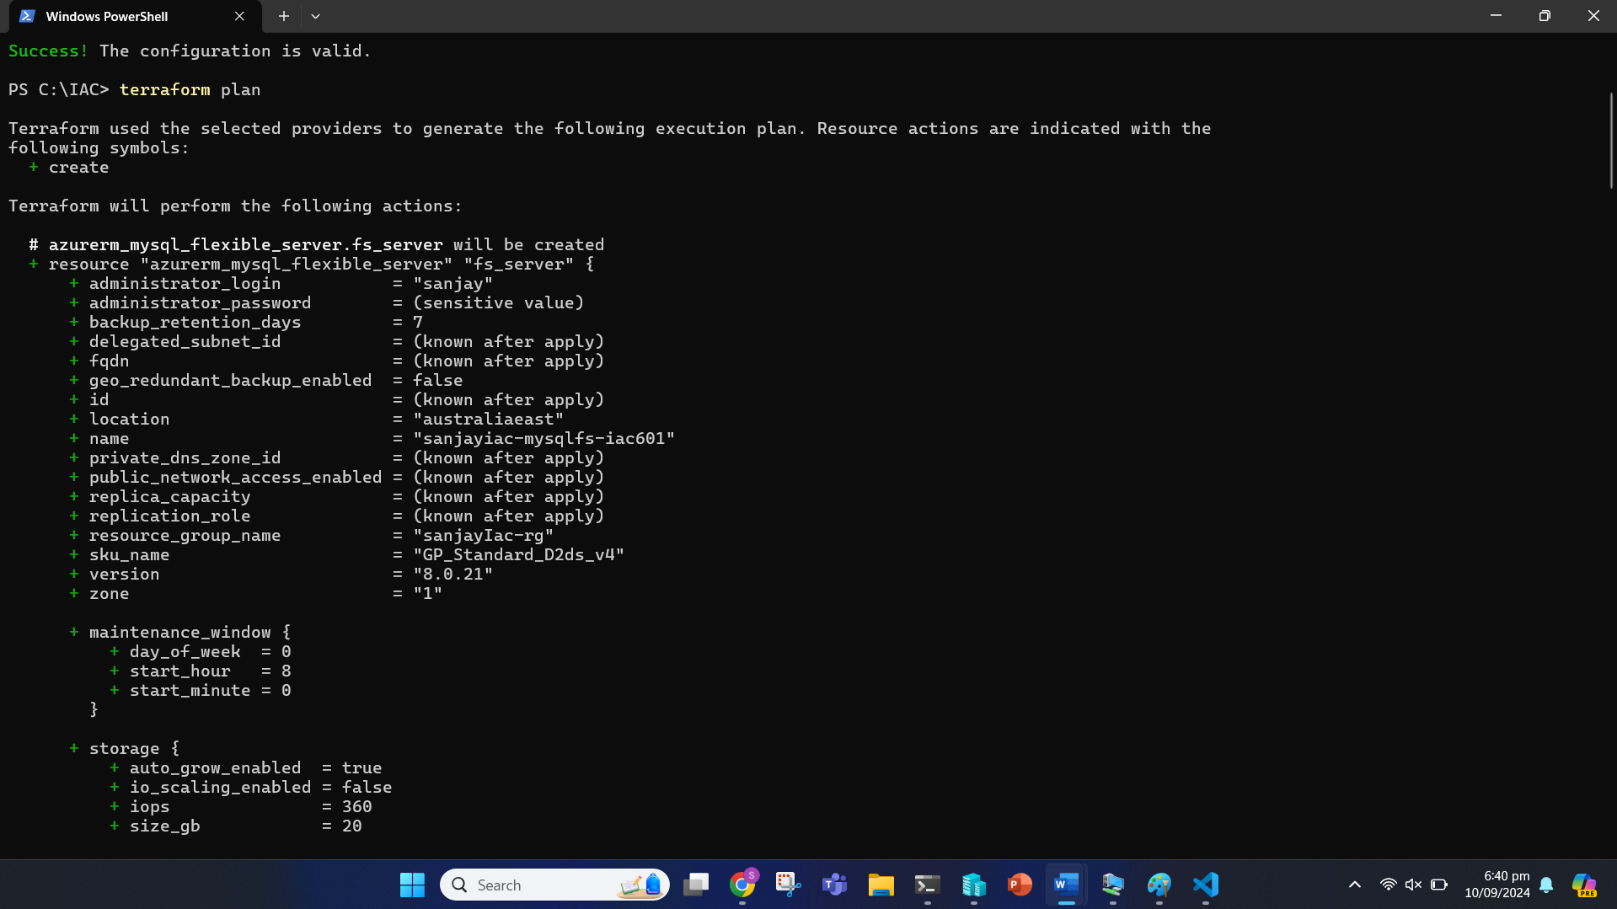

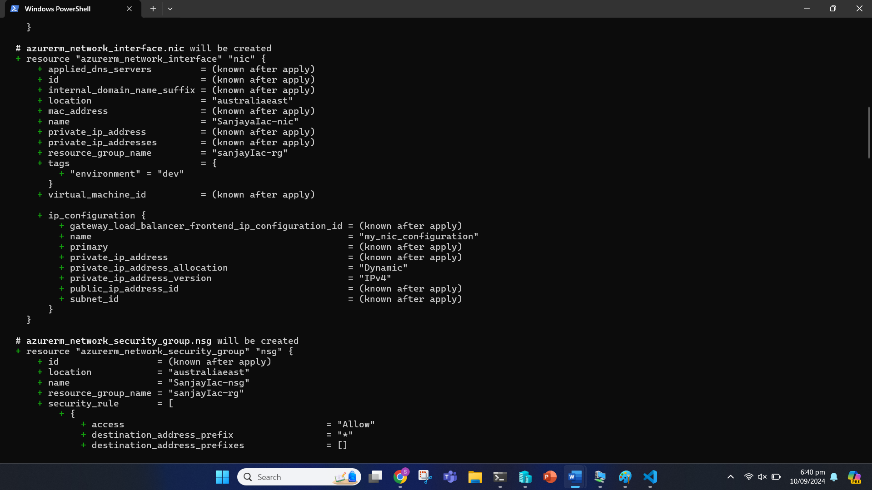

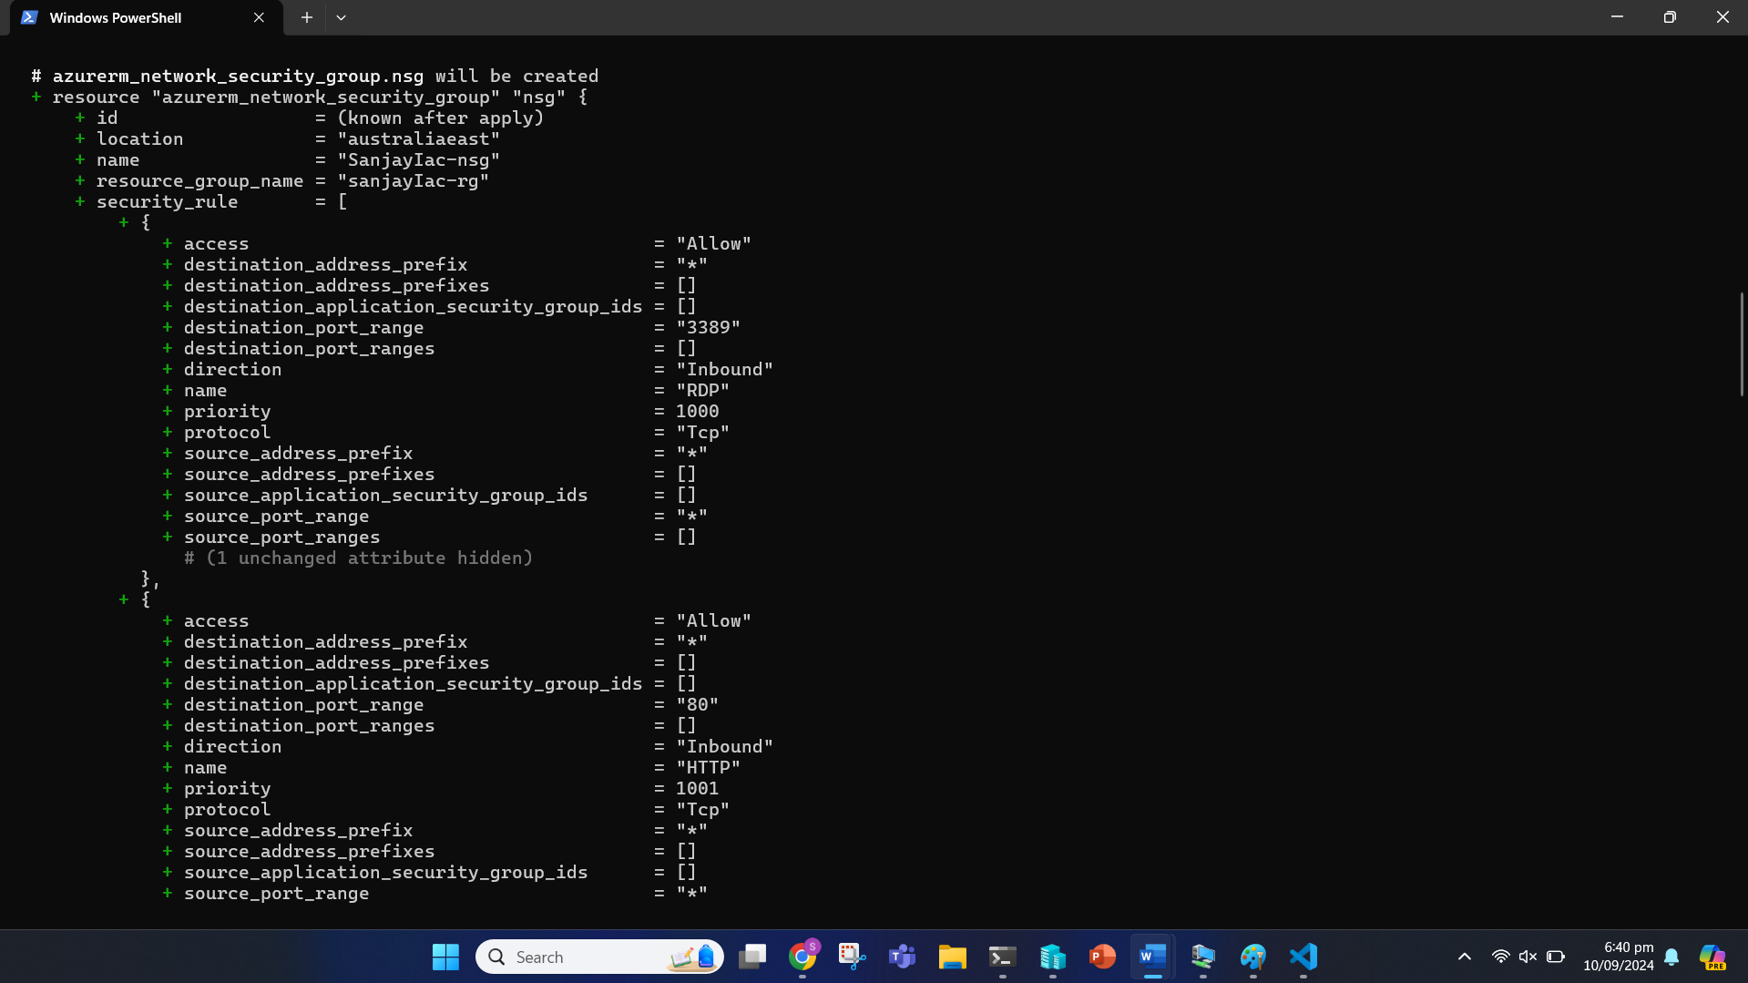

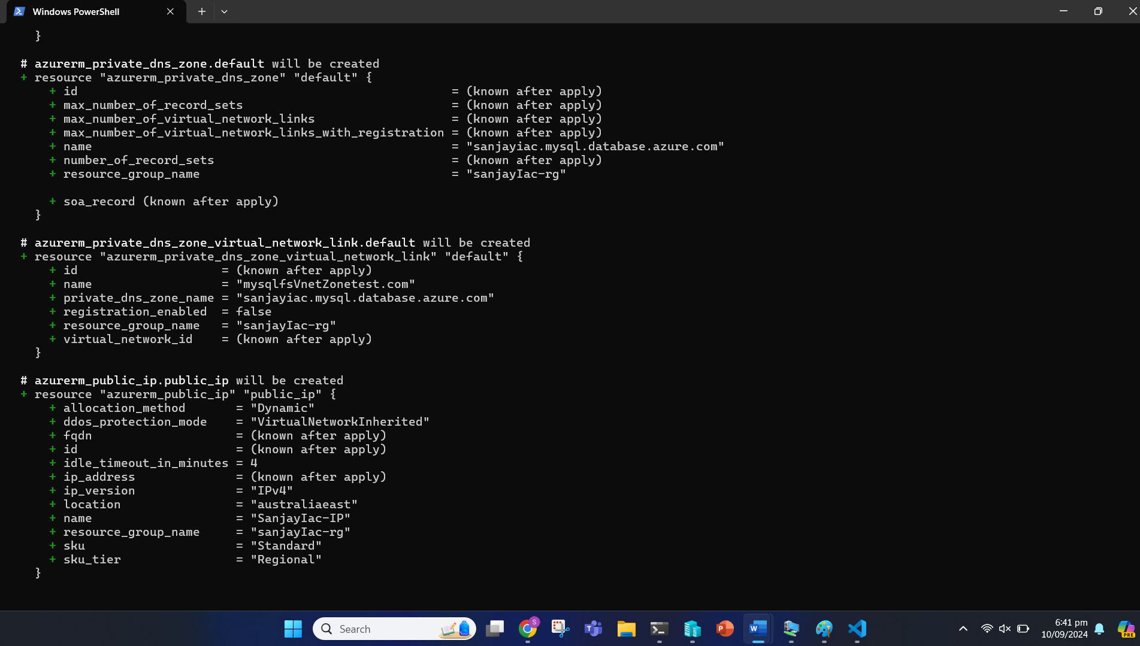

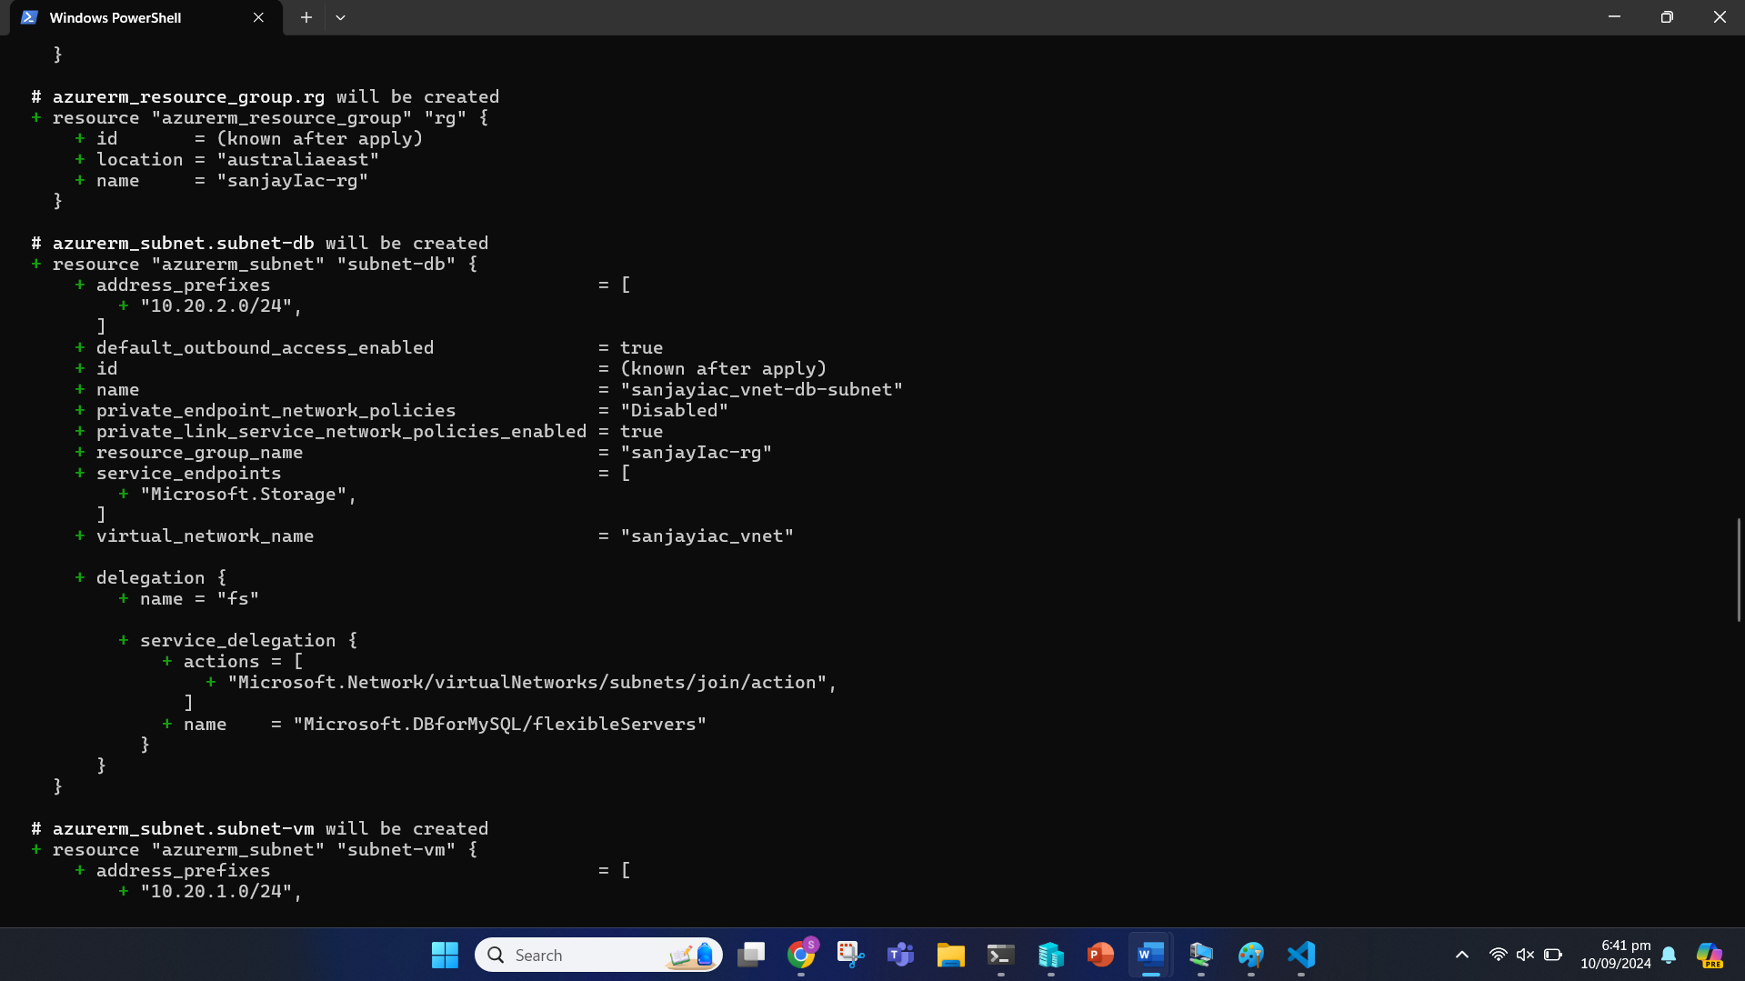

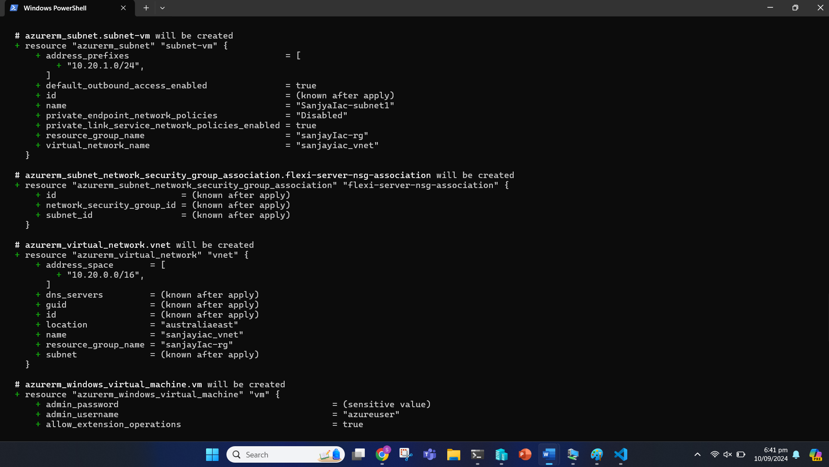

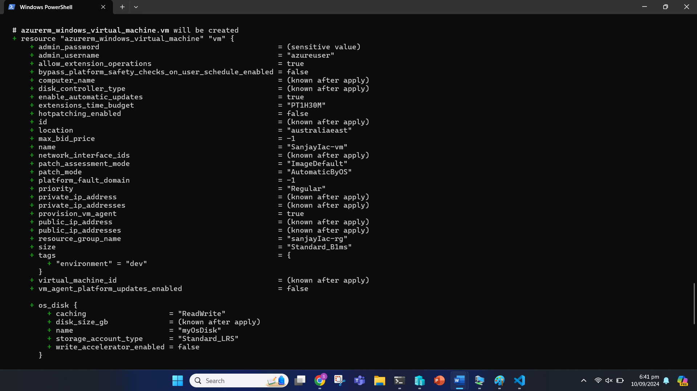

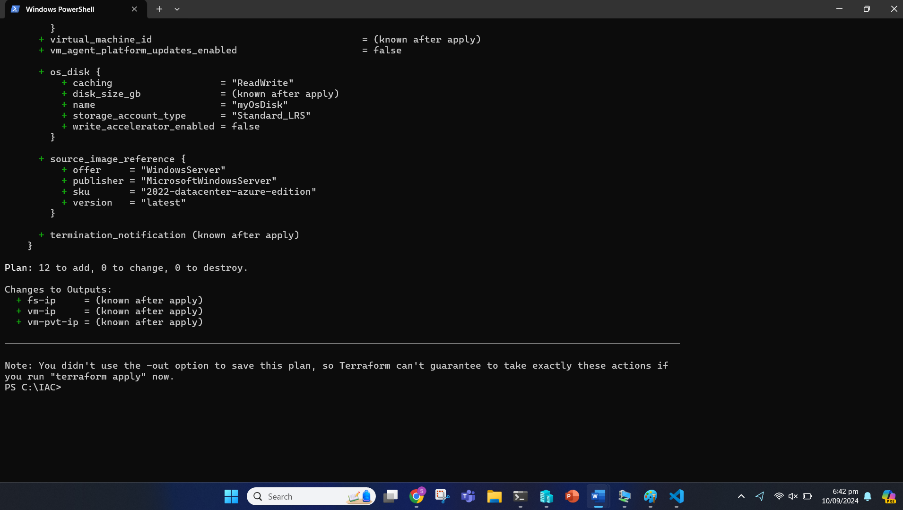

Terraform Apply

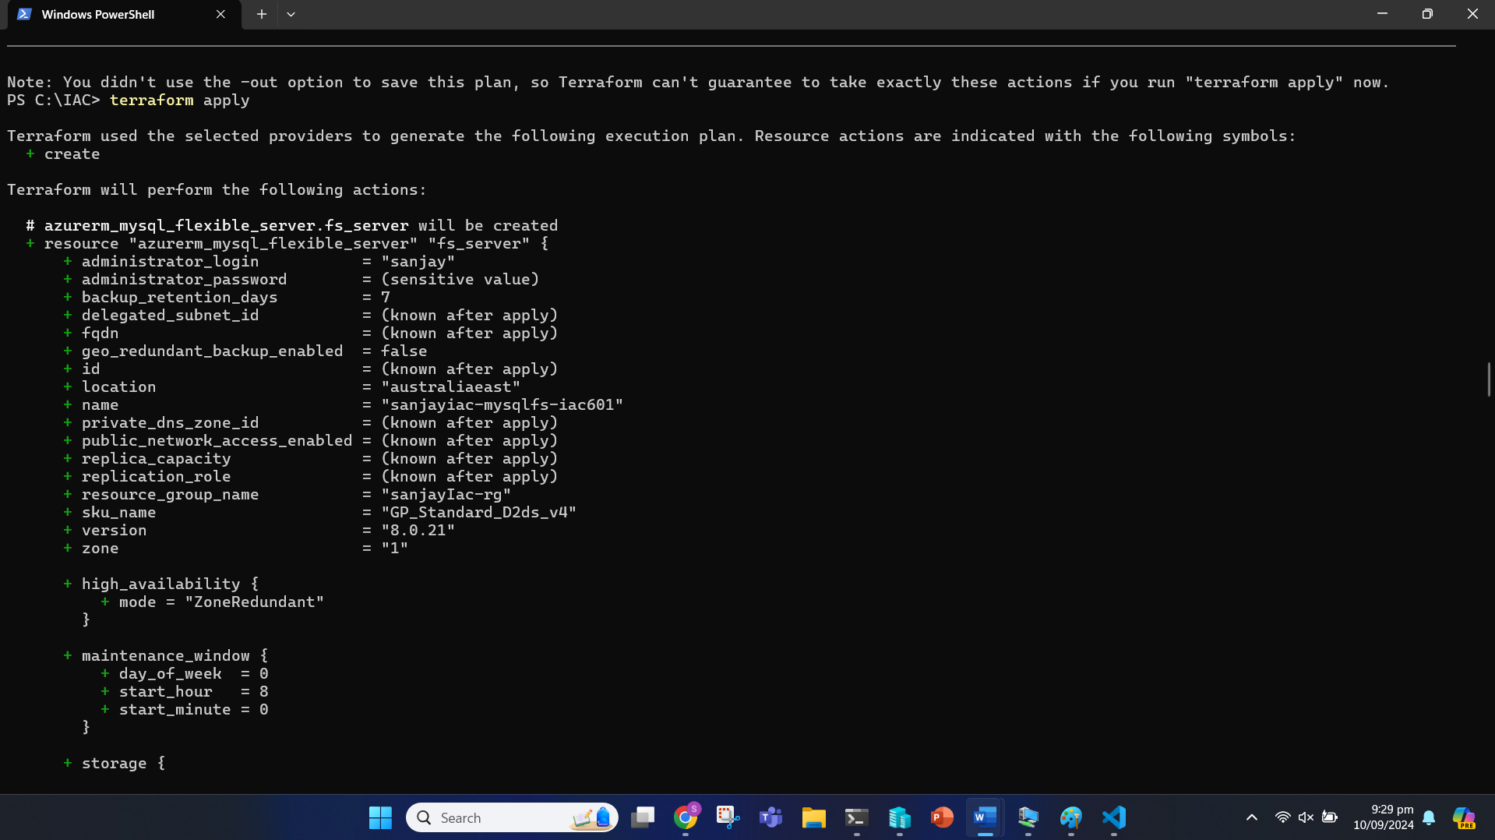

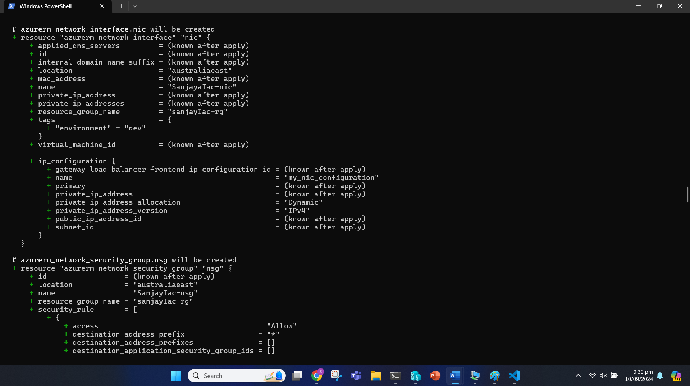

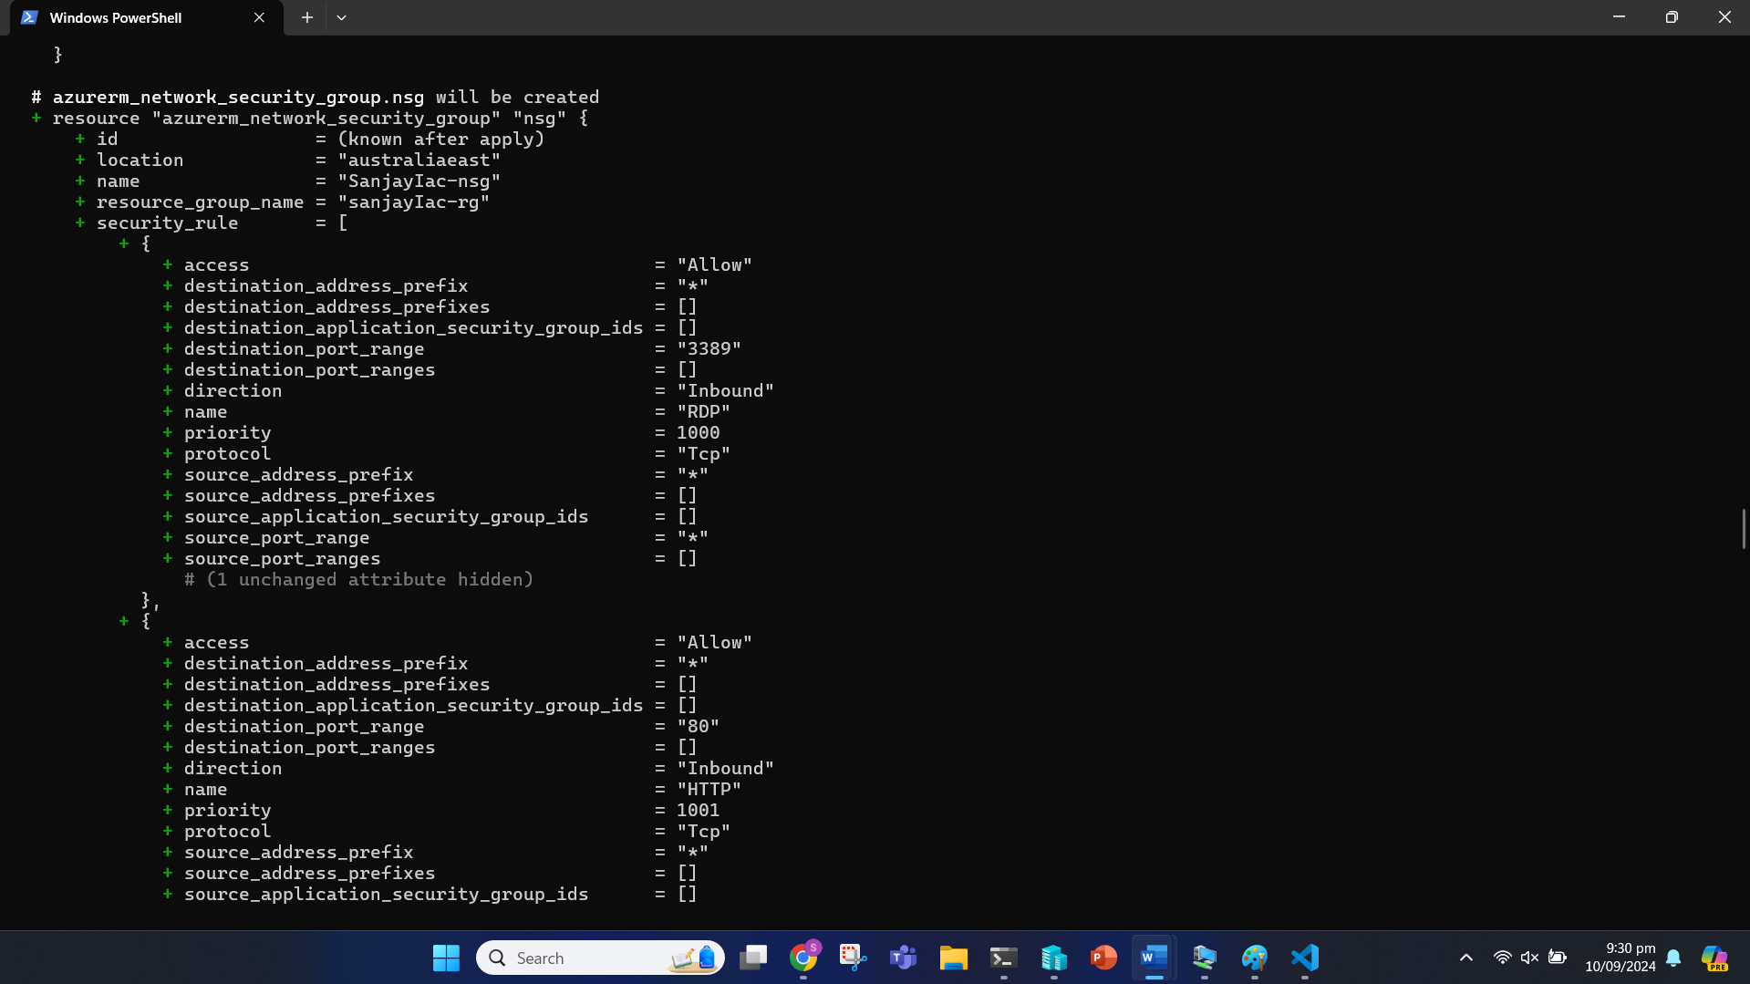

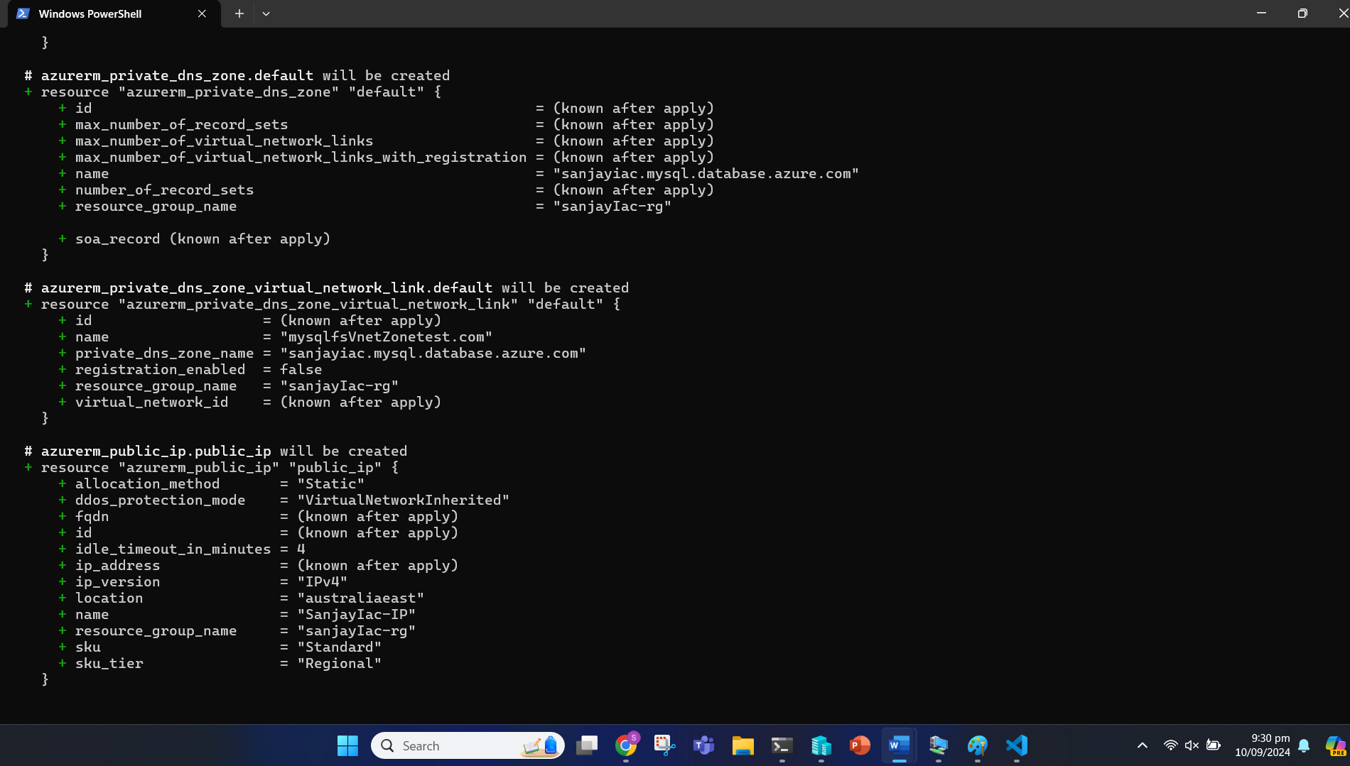

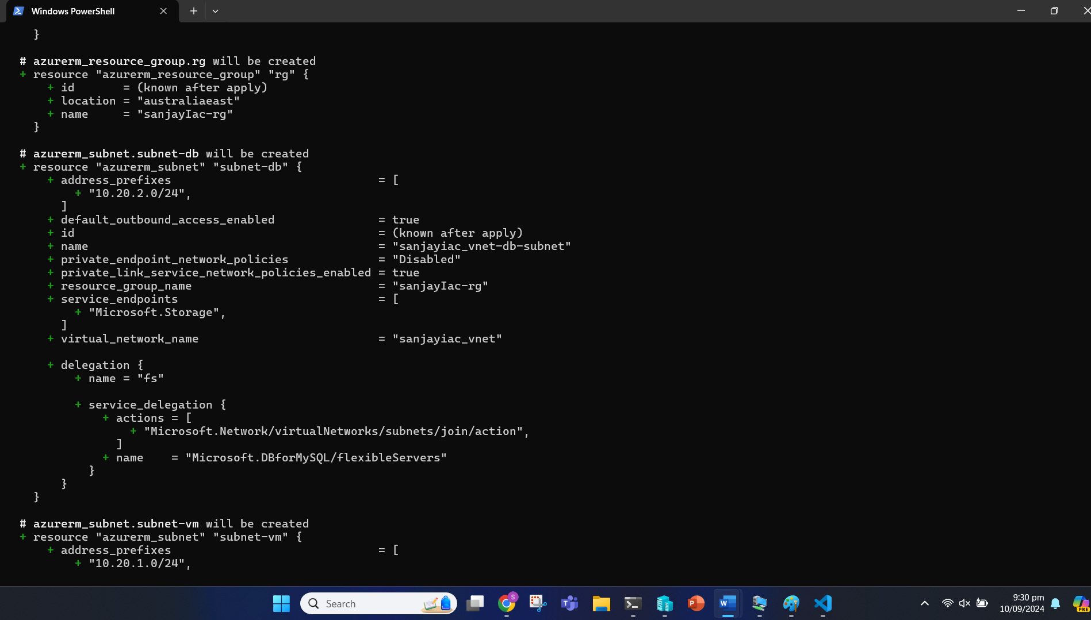

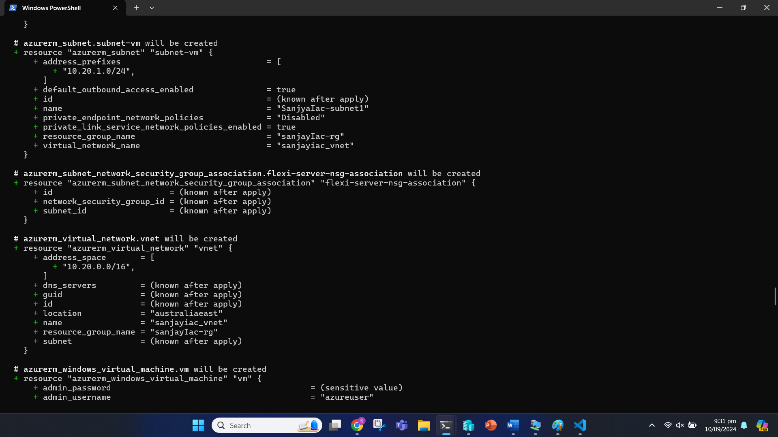

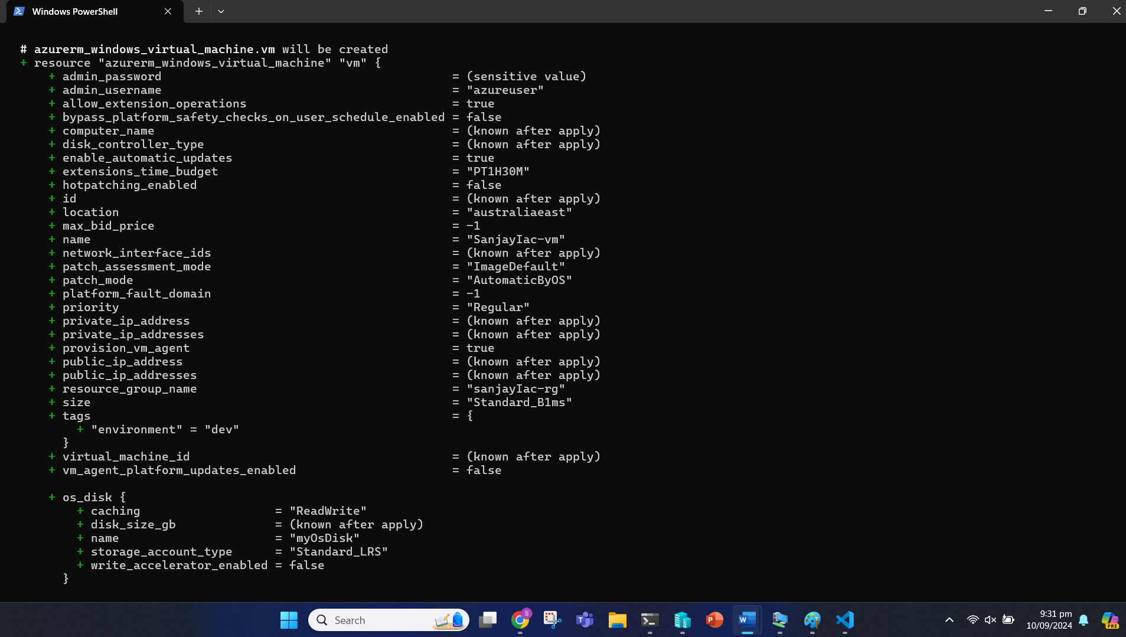

Enter ‘yes’ during prompt.

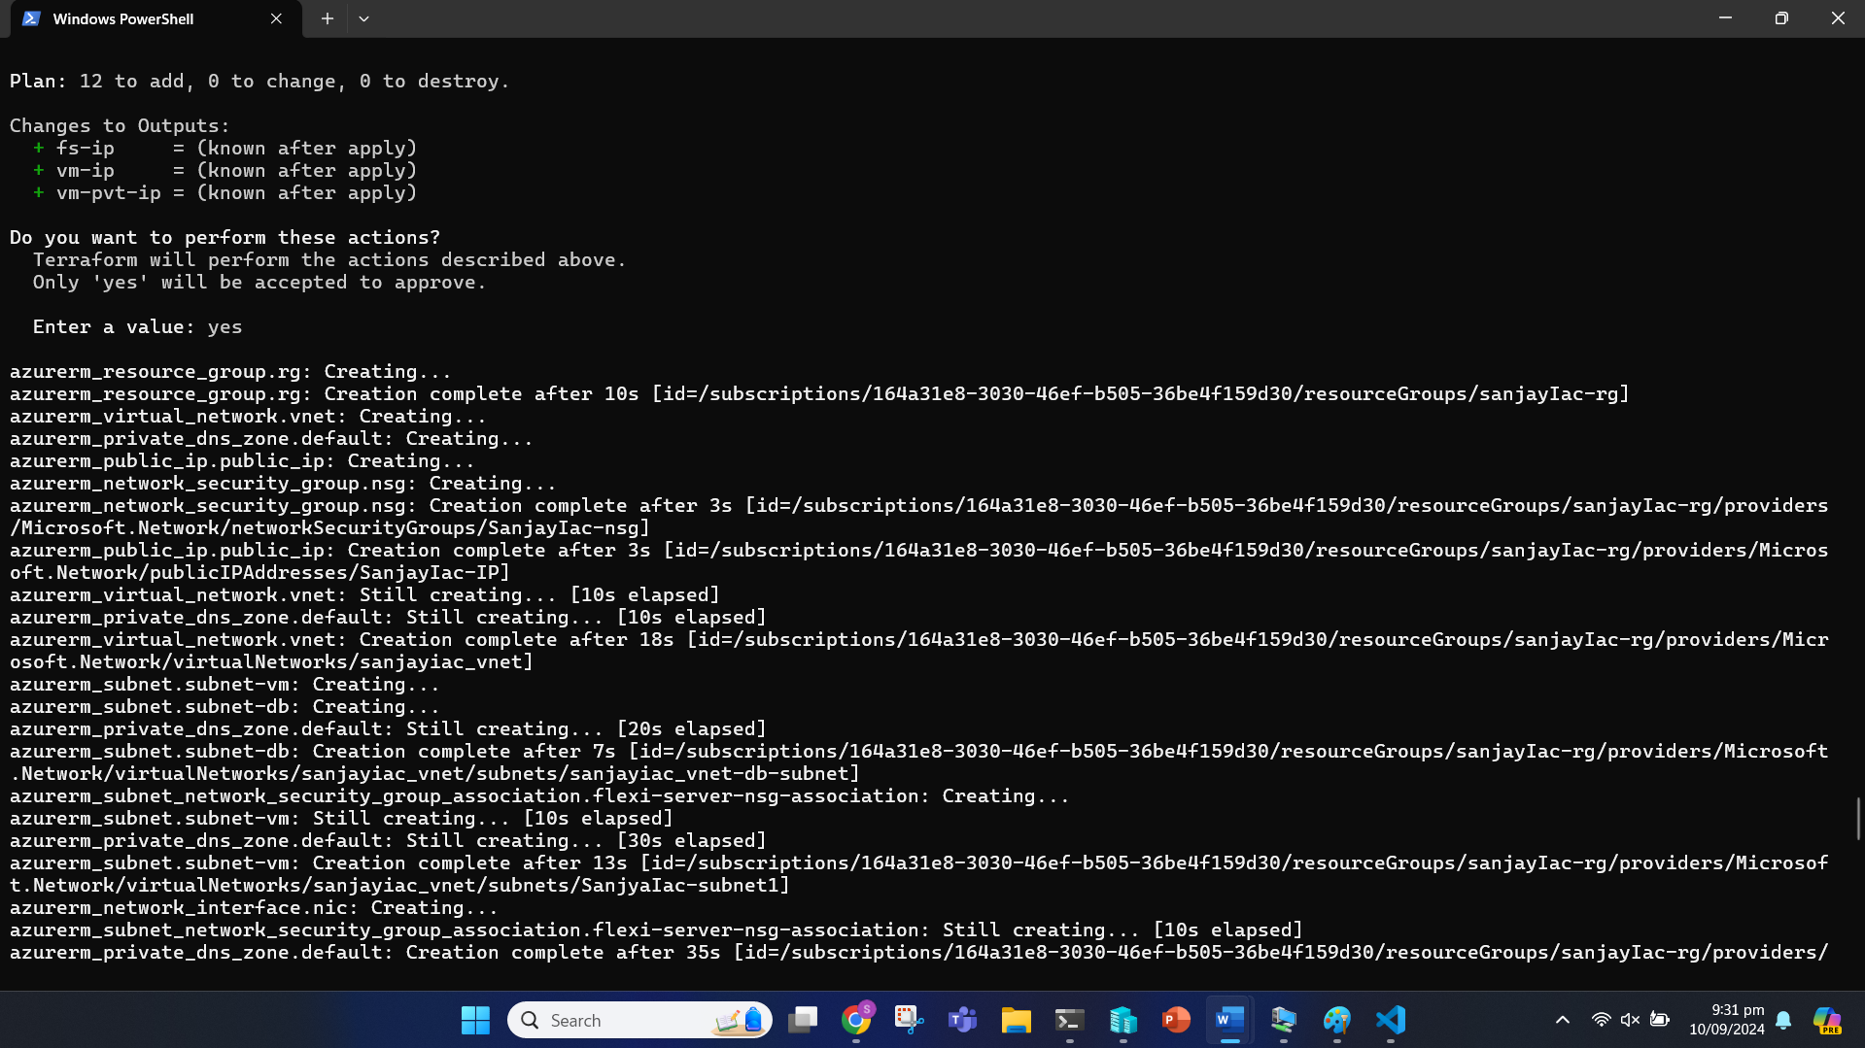

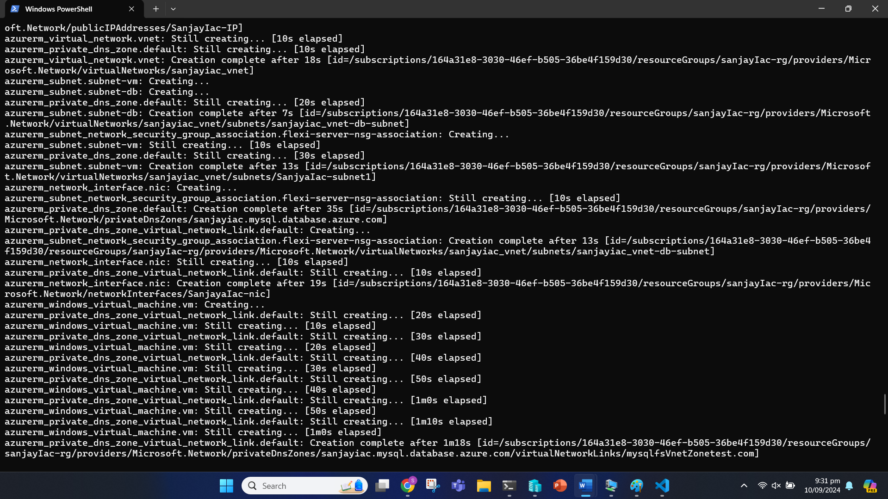

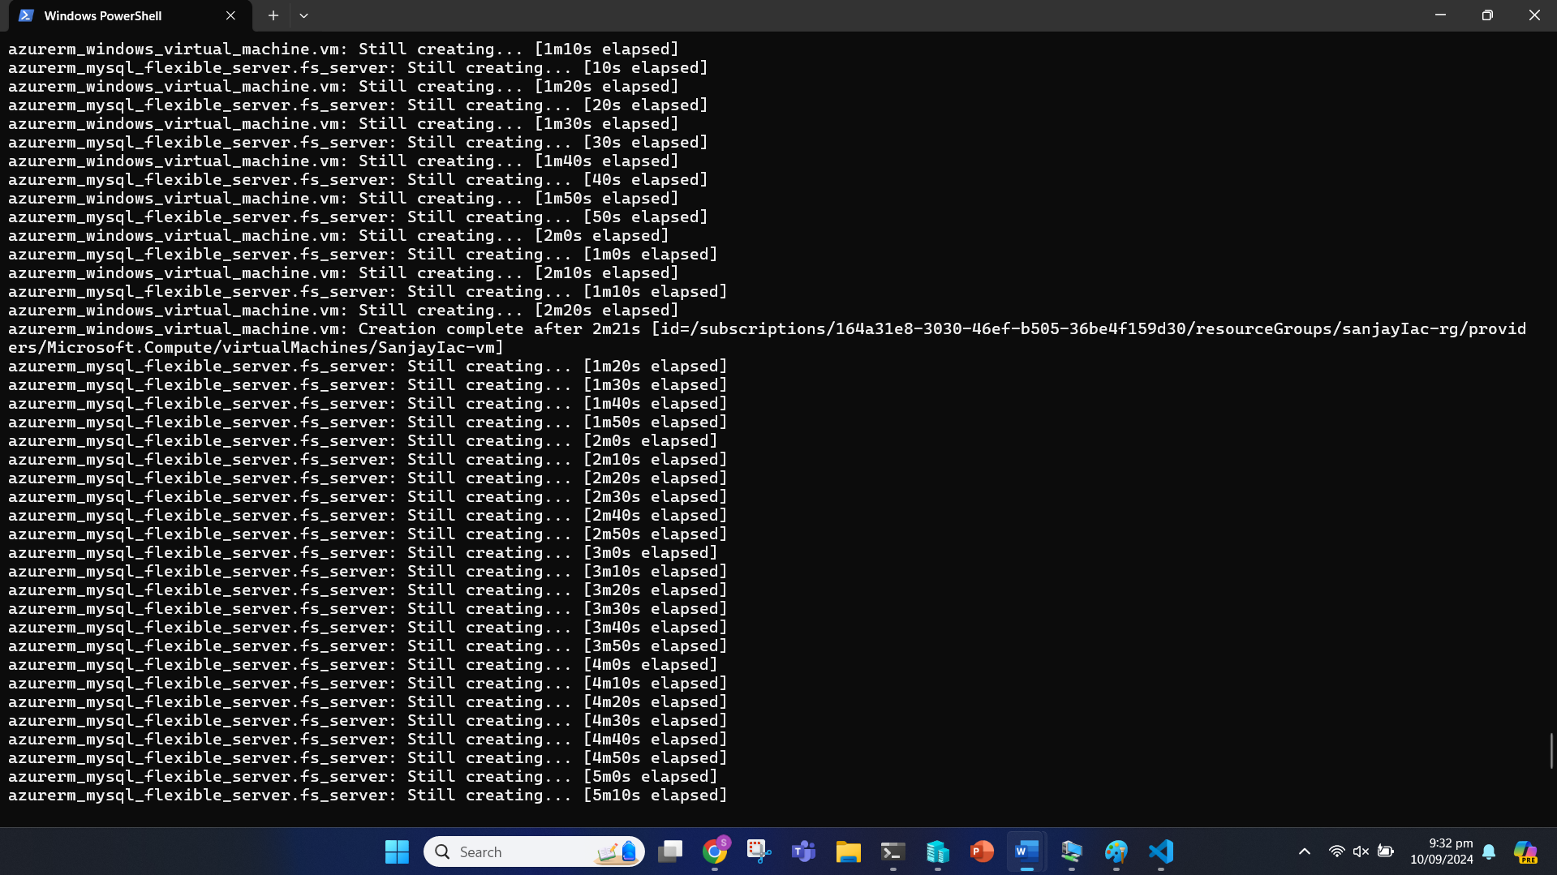

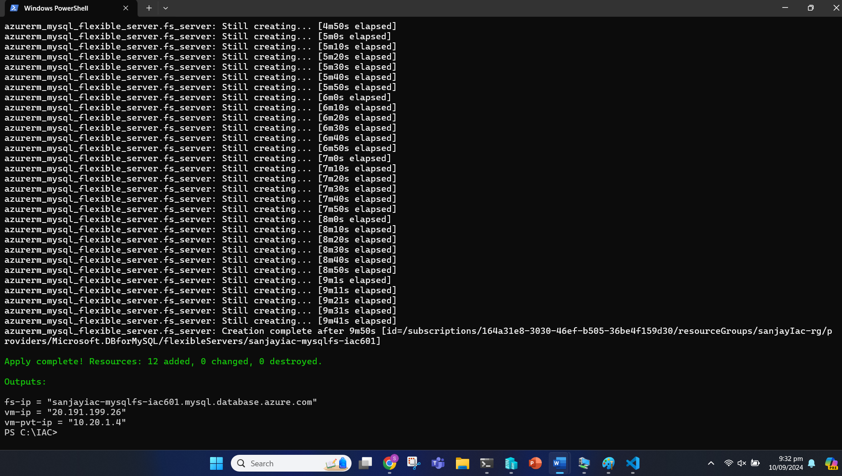

Virtual Machine

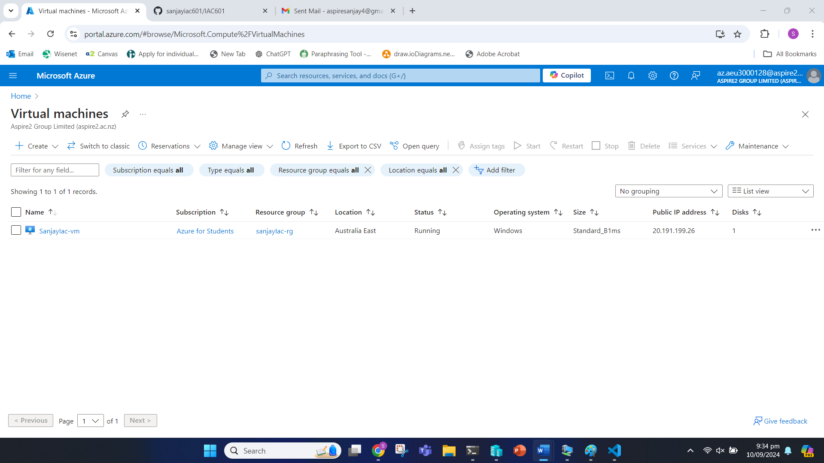

Azure Database for MySQL felxible servers

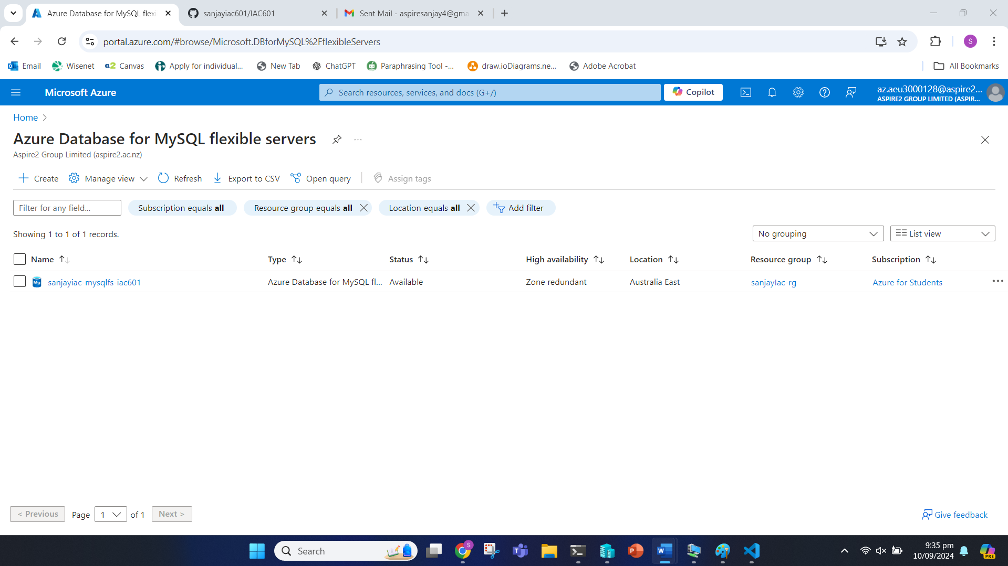

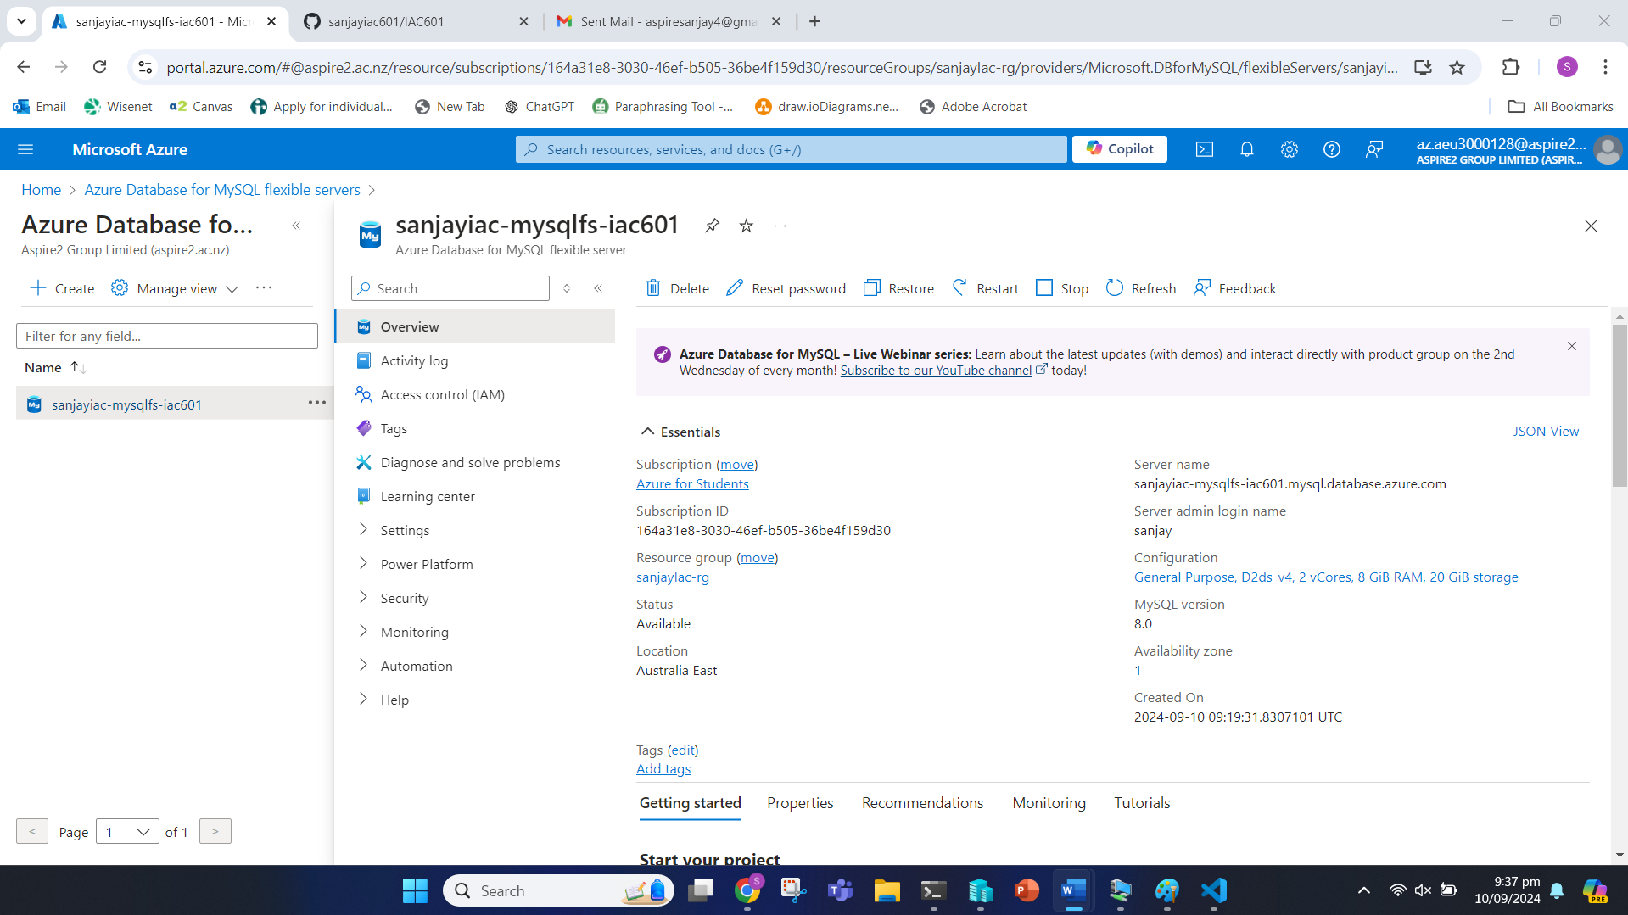

Virtual Networks

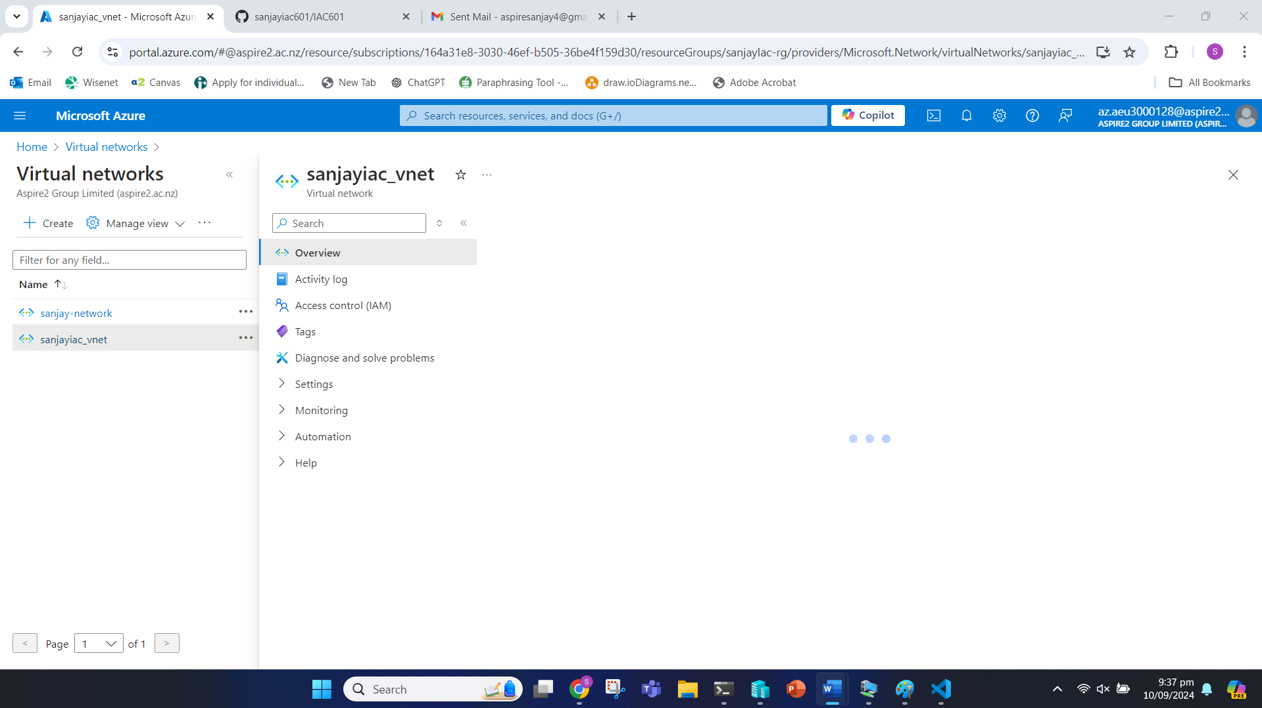

Network Security Group

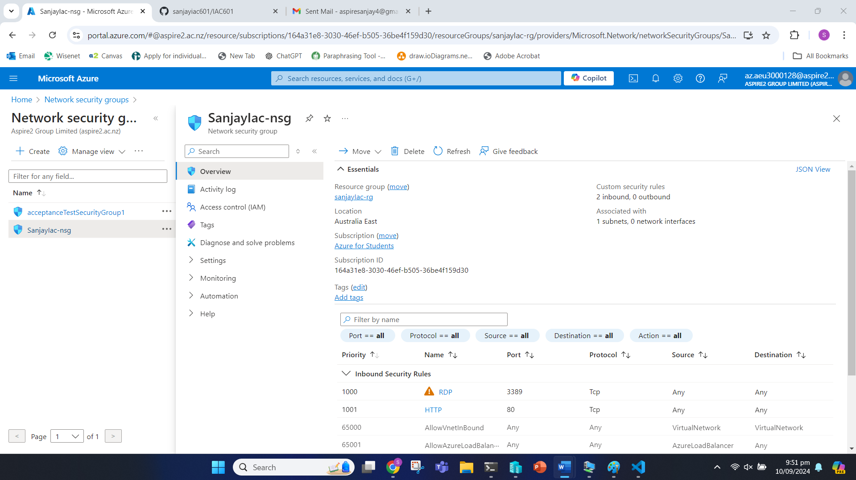

Network Interface

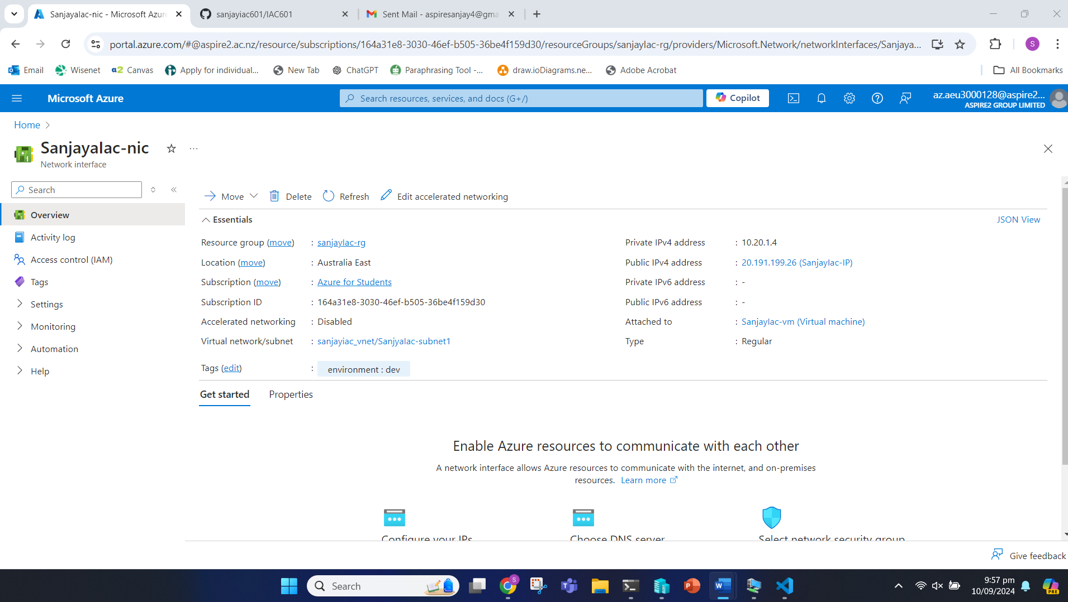

Post-Deployment Process

We have the public IP address: 20.191.199.26. We can test the RDP access to the Azure VM by using this public IP address. We use Remote Desktop Connection to connect to the VM.

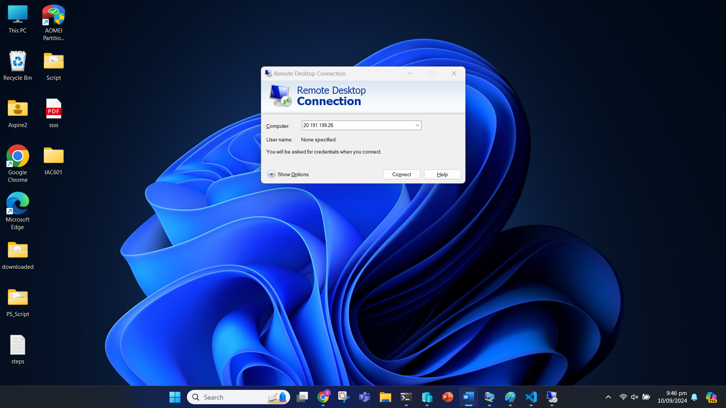

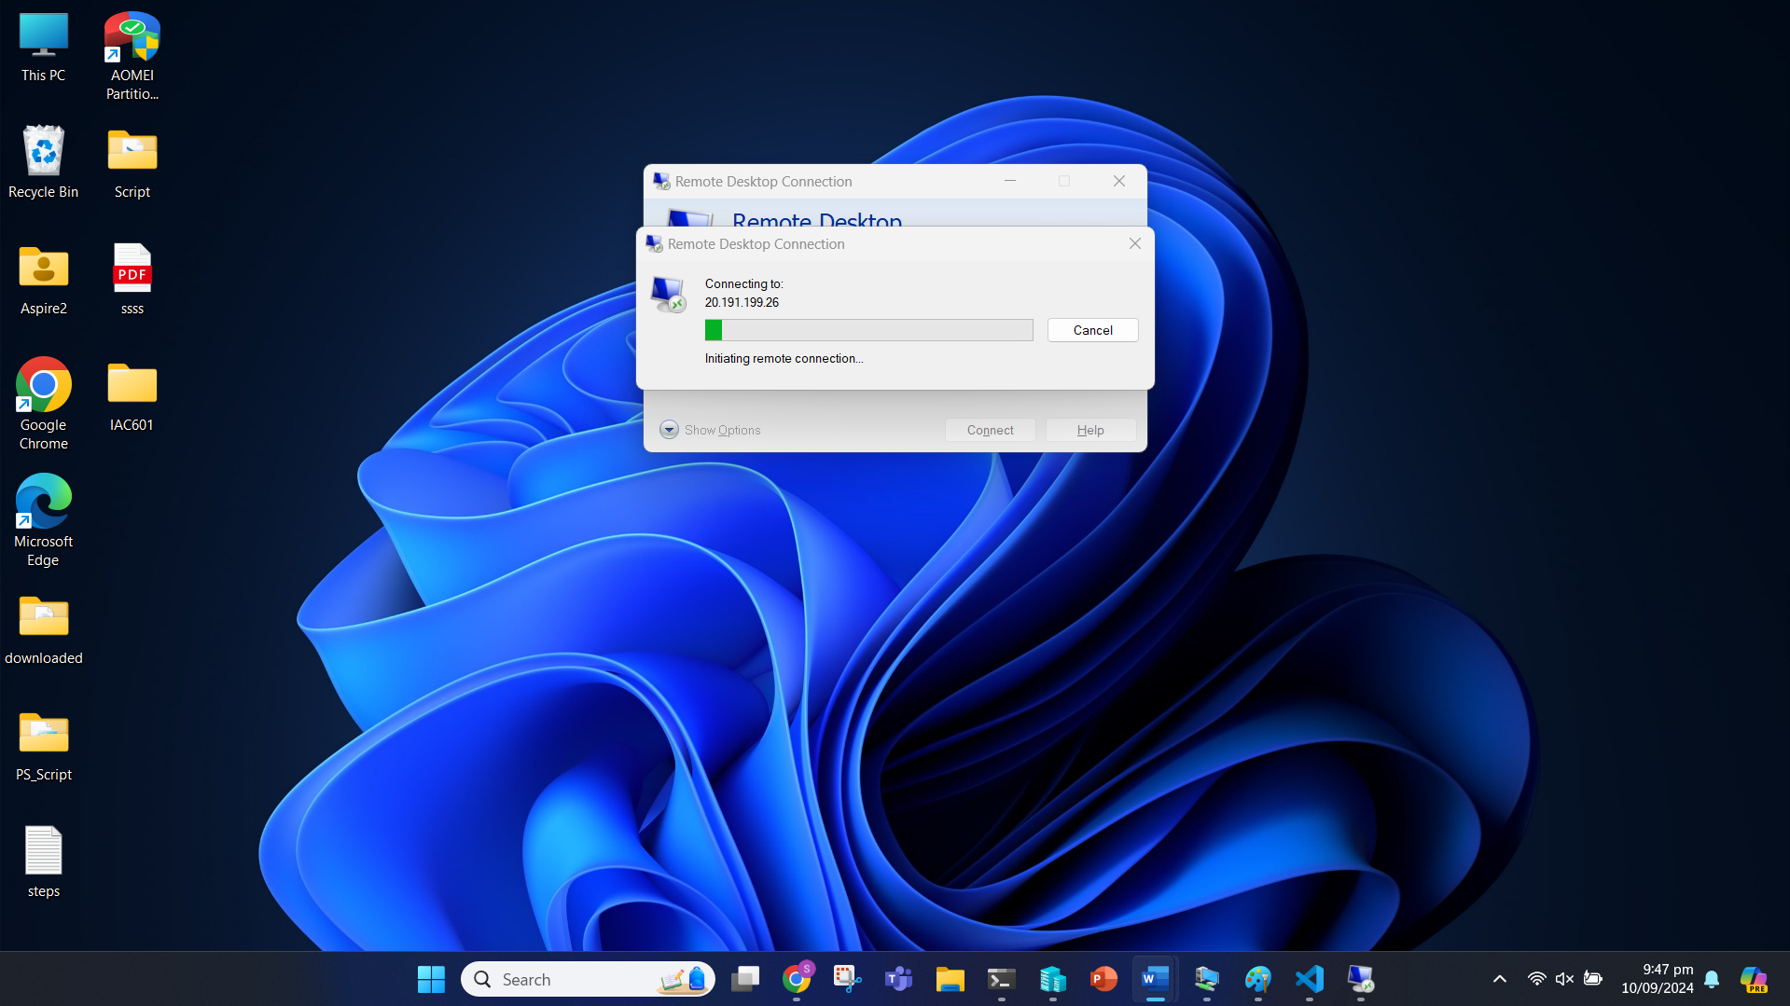

### Task 5: GitHub Repository

#### Task 5.1

We have made changes to our documentation too and now we also need to add the script we created in Part 2 to the git.

We can see the changes made from the previous commit with “git status” command.

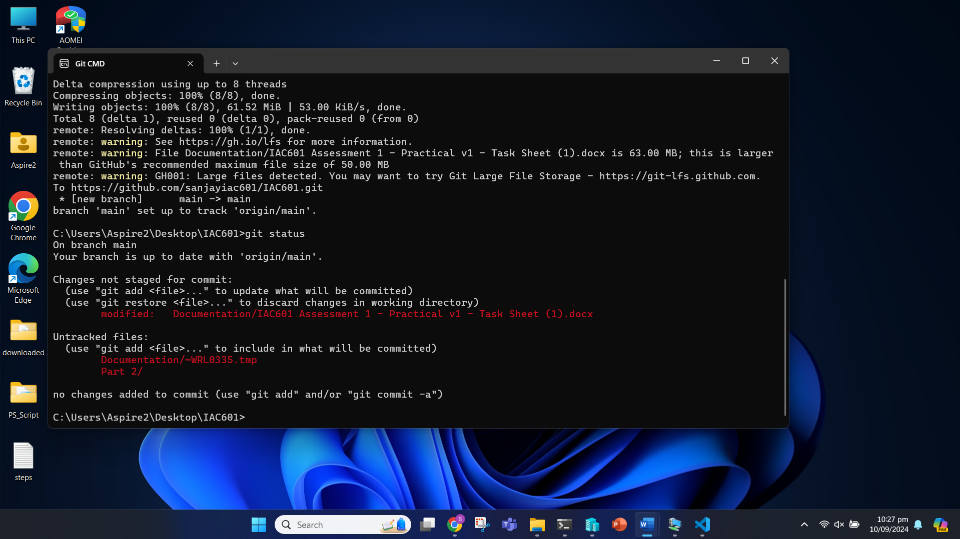

We add them in git with “git add”.

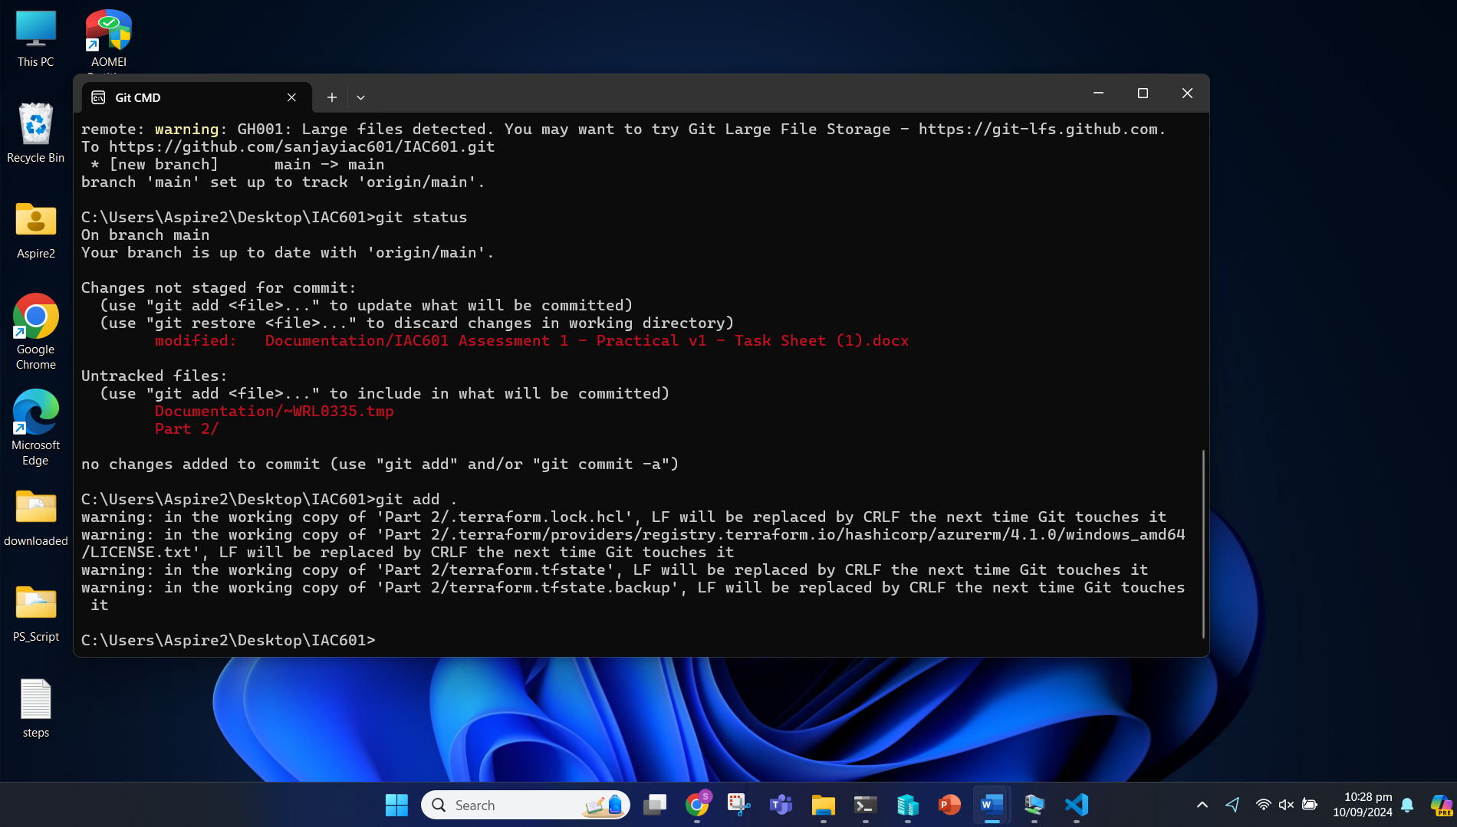

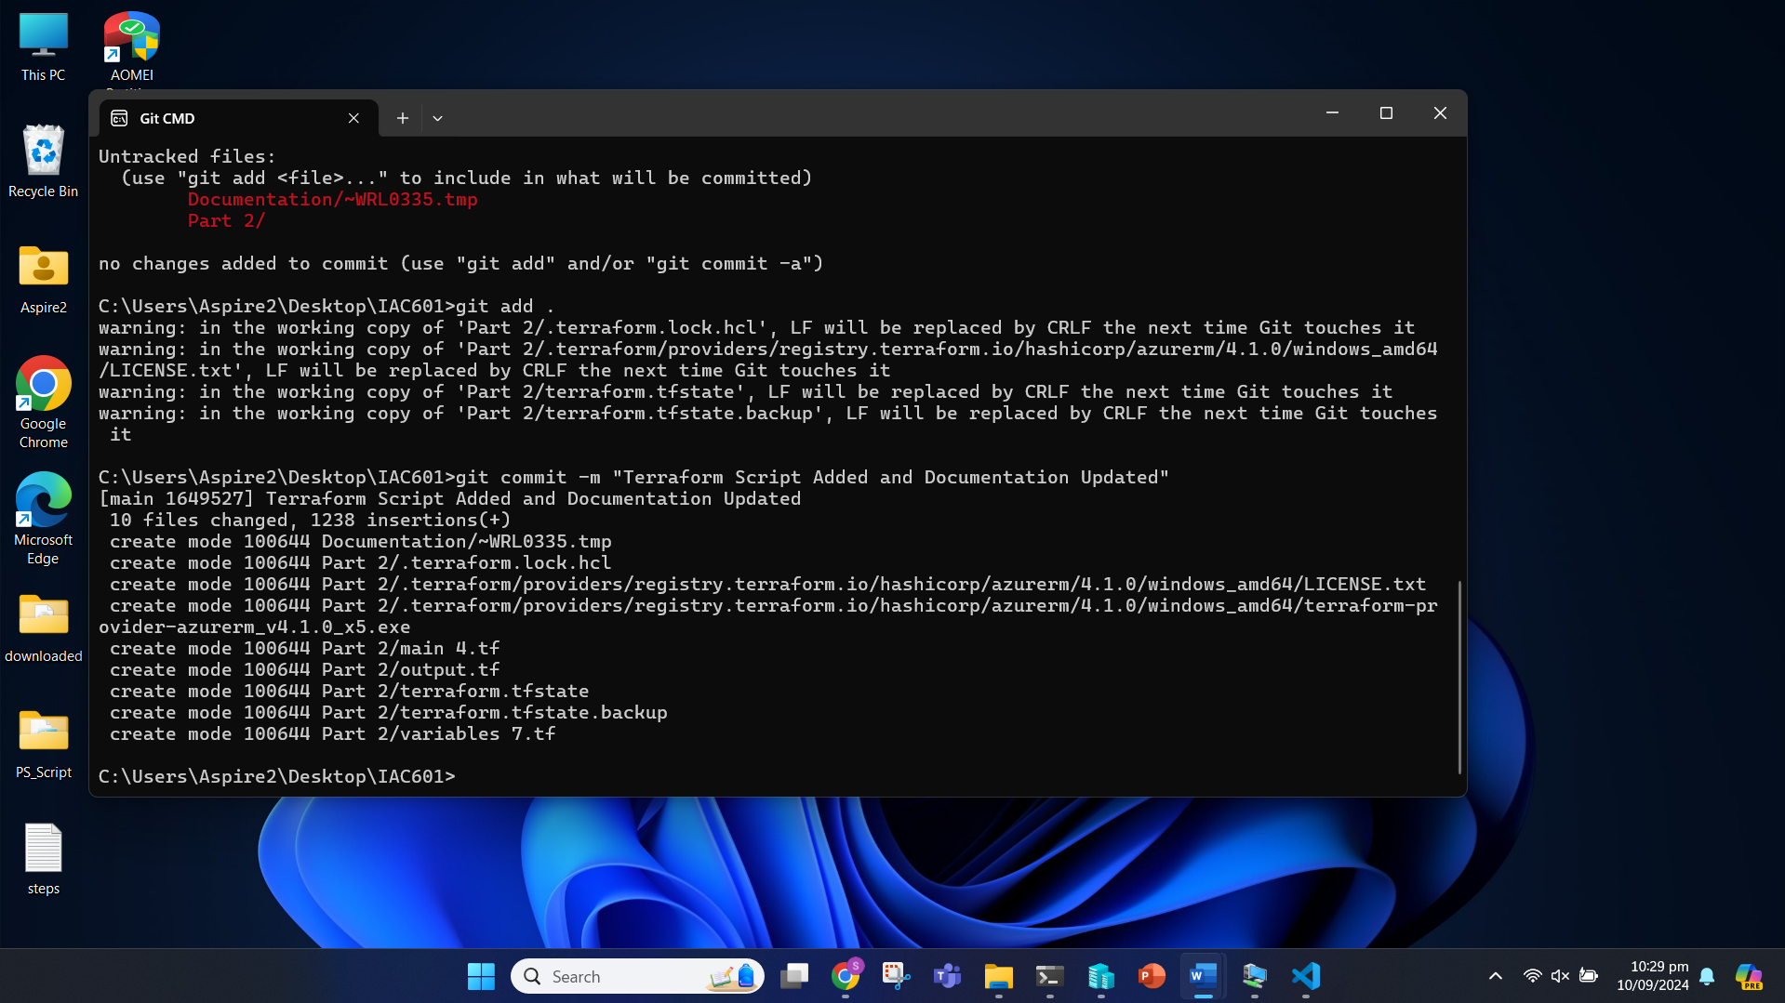

Now, we can push the commit to the main branch.